Listening ★ Speaking Reading Grammar Writing

Topic: “Should couples live together before marriage?”

Instructor:  KJ (Kaapjoo Park) & Jiwon Lee | Level:  Intermediate (adults) | Students:  4 | Length:  30 Minutes

Materials:
Lead-in (2min), Pre activity (about 4 min)
-Pictures related to the concept of marriage (Appendix 1) - 3 copies
-Tape
-2 post-its that say ‘affirmative,’ 2 post-its that say ‘oppose,’ paper cup
-Marker

Main activity (about 18 min) : Debate
-Cartoon picture (Appendix 2) -1 copy
-4 pieces of blank paper
-Marker

Post activity (6 min)
-Advice Column from Dear Abby (Appendix 3) - 4 copies
-Expressions for giving advice (Appendix 4) - 2 copies
-2 pieces of blank paper
-Marker

SOS activity (3 min)
-Word bank worksheet (Appendix 5) - 4 copies
-Answer sheet (Appendix 6) -1 copy

Aims:
-Main aim: Ss will be able to present arguments about their position on the topic of cohabitation before marriage and express their opinions.
-Secondary aim: Ss will be able to consider and discuss the “controversial” topic of moving in before marriage.
-Personal aim: We want to manage the pair work well so that there is more student talk time and student interaction. Pair work can help shy students express their opinion comfortably to their partner and encourage them to speak up during whole-class activities.

Language Skills:
-Reading: Ss will read an advice column (from Dear Abby) on cohabitation before marriage.
-Listening: Ss will listen to teacher’s instructions and classmates’ opinions during debate.
-Speaking: Ss will engage in a debate (“Should couples live together before marriage?”)
-Writing: Ss will write a response to a person in need of advice regarding cohabitation before marriage.

Language Systems:
-Phonology: ‘marriage’ [măr′ĭj] , fiancé/ fiancée [fē′än-sā′] , divorcee [dĭ-vôr-sā′]
-Lexis: fiancé/fiancée, newlyweds, spouse, partner, soul mate, divorcee
(vocabularies related to people in relationships)
-Grammar: Usage of modals of advice (must > should > may want to > might as well)
-Function: make reasonable assertions or suggestions by using strong and weak form of advice
-Discourse: debate (listening to other students’ arguments and persuade logically)

Assumptions:
- Ss have a general sense of what marriage proposal, honeymoon, pregnancy are.
- Ss might have imagined themselves getting married someday.
- Ss might have personal beliefs about marriage.
- Ss have been exposed to scenes about marriage in dramas and movies.
- Ss have been to a wedding (family’s or friends’) at least once.

Anticipated Problems and Solutions:
-Students might not have thought deeply about the topic of cohabitation before marriage
→ In the pre activity, familiarize students with the topic so that they can easily prepare for the debate in the main activity.

-The flow of the debate might get too personal
→ Set up rules before the actual debate
(Don’t get too personal about the topic. Don’t ask personal questions like “Have you ever lived together before marriage?” or “If you haven’t experienced living together with your boyfriend, how could you be sure that living together before marriage doesn’t work out?”)

-Students might have difficulty during the debate (continued silence, going off-topic)
→ monitor how the students are doing and facilitate communication by asking helpful questions and by guiding students in the right direction (intervene if necessary)

-There is a lot of time left
→ Start SOS activity (Word bank worksheet)

References:
Picture #1 (marriage proposal)
http://diamondsbyeyal.com/wp-content/uploads/2013/05/best-marriage-proposal-ideas-san-diego-lenoce78.jpg

Picture #2 (wedding)
https://www.google.co.kr/search?q=marriage+proposal&hl=ko&biw=911&bih=439&site=webhp&source=lnms&tbm=isch&sa=X&ved=0ahUKEwiMno2S7dvMAhWKo48KHan9DYMQ_AUIBigB#hl=ko&tbm=isch&q=%ED%95%9C%EA%B5%AD%EB%93%9C%EB%9D%BC%EB%A7%88+%EA%B2%B0%ED%98%BC+%EC%9B%A8%EB%94%A9&imgrc=8yJ8o10YNXjm4M%3A

Picture #3 (honeymoon)
http://cpeuny.egloos.com/v/2676298

Picture #4 (moving in together after marriage)
http://www.cruxnow.com/wp-content/uploads/2014/09/CohabitationC-717x450.jpg

Picture #5 (getting pregnant)
http://americanpregnancy.org/week-by-week/7-weeks-pregnant/

Picture #6 (meeting parents)
http://herintalk.com/wp-content/uploads/2014/05/meeting-her-parents-www.healthydunia.com_.jpg

Cartoon picture “Try Before You Buy” Couple
https://www.google.co.kr/search?q=Cartoon+picture+%E2%80%9CTry+Before+You+Buy%E2%80%99+Couple&biw=1280&bih=929&source=lnms&tbm=isch&sa=X&ved=0ahUKEwiwjKL5yOPMAhVMs48KHSMSAgcQ_AUIBigB#tbm=isch&q=%E2%80%9CTry+Before+You+Buy%E2%80%99+Couple+cartoon

Dear Abby (Advice Column)
http://www.uexpress.com/dearabby/2013/1/24/unmarried-couple-doesnt-see-eye-to

Expressions for giving advice
http://asociacionahi.jimdo.com/resources/writing/letter-giving-advice/

SOS activity (word bank worksheet) : dialogue from video clip on cohabitation before marriage
https://www.youtube.com/watch?v=l10-wdvo7yc (52sec~1min 53sec)

Lead-In
Materials:
- Pictures (Appendix 1), tape, marker, 2 post-its that say ‘affirmative,’
2 post-its that say ‘negative,’ paper cup
Time | Set Up | Student Activity | Teacher Talk
2min | Whole class | Looking at the picture and sharing their thoughts | Preparation (before class):  -Arrange 2 tables to face each other  -Cut out two sets of 6 pictures  -have the ‘wedding’ picture ready for  lead-in.  Greeting and arousing S interest on today’s topic:  Hi everyone! How have you been?  Who has recently been to a wedding? (Wait for S response)  If S answers YES: “Whose wedding?”  If S answers NO: “But, you all have been to a wedding before right? Something similar to this picture?” (show students the wedding picture)  Eliciting:  Who are they?  (Wait for S response)  1. “Yes, they are a bride and a groom, getting married. (write ‘bride’ and ‘groom’ on the board)  “How else could we call them?”  (Wait for S response)  2. “Yes, you could call them ‘newlyweds’ because they just got married.  (write ‘newlyweds’ on the board)  “What’s the noun form of ‘marry’?”  (Wait for S response)  “Good. Marriage. Be careful of the pronunciation.”  (tell them to pronounce ’marriage’)  “How else could we call them?”  (Wait for S response)  3. “Also, you could call them ‘spouse,’ husband or wife.”  (write ‘spouse’ on the board)  4. “Then, how do we call a woman/man who is engaged to get married?”  (Wait Ss response)  “Yes, fiancé/fiancée.”  (write ‘spouse’ on the board)  “They have the same pronunciation. There is an “e” after “é” to indicate that it refers to a woman.”

Pre-Activity
Materials: already prepared in Lead-in
Time | Set Up | Student Activity | Teacher Talk
50sec  1min  1min 30sec  40sec | Whole class  Pair  Whole class  Whole class | Listening to the instructions  Talking with their partner, ordering the pictures & putting them on the board  Exchanging ideas on the concept of marriage  Expressing their support for or opposition to the topic | Instruction:  “Now, I will give you 6 pictures related to marriage. With your table partner, talk about the concept of marriage and try to come up with just 1 sequence.  Demonstration:  (Draw 6 squares on the board)  “After deciding the order with your table partner, put the pictures on the board in that order by using tape. I will give you 1min.”(hand out the pictures to 2 groups)  “Ready, set, go!”  Pair work  (teacher monitors, prepares tape for them)  “Group 1 please explain why you ordered it this way.” (Group 1 explains)  “Group 2 please explain why you ordered it this way.” (Group 2 explains)  Possible teacher talk:  “Why do you think your group and the other group have the same/ a different sequence?”  “Which group has a more liberal /conservative view of marriage?”  “How did you interpret the pictures?”  “Any questions you have for the other group?”  “What if we move this picture right in front of that picture?” (Teacher moves a picture and ask Ss what they think about the different order)  Mini-survey:  “Who supports living together before marriage?” (Wait for Ss to raise their hands)  “Who opposes living together before marriage?” (Wait for Ss to raise their hands)  * If there is an equal number of students for the affirmative and negative side, divide students in this way for the debate in the main activity.  Instructions:  “Those who support, please sit at this table.”  “Those who oppose, please sit at that table.”  *If there is an unequal number of students for the affirmative and for the negative, randomly divide students into two.  (get the paper cup with the post-its inside)  Instructions:  “Let’s pick the sides using post-its.”  “Pick one post-it from the paper cup.”  (students pick one)  “Those who pick the post-it that says  ‘affirmative,’ please sit at this table.”  “Those who pick the post-it that says  ‘negative,’ please sit at that table.”  “In a few minutes, we’re going to do a deb-ate on whether couples should live together before marriage. This is an interesting, but controversial topic.”

Main Activity
Materials: cartoon picture (Appendix 2) , 4 pieces of blank paper
Time | Set Up | Student Activity | Teacher Talk
1min  1min 30sec  1min  30sec  3 min  3 min  4 min  4 min | Whole class  Whole class  Whole class  Pair  Whole class  Whole class  Pair  Whole class  Whole class | Guessing and analyzing the picture  Coming up with sub-topics  Listening to the instruction  Each group picks one sub-topic  Each group reveals the topic they chose  Listen to the rules and answer ICQ  Preparing for argument  Engage in 1st round of debate  Engage in 2nd round of debate | Eliciting ideas for the cartoon picture:  (show a cartoon)  “First, I’ll show you a cartoon.”  “What do you think about this picture?”  (Wait Ss response)  “Yeah, marriage is a big commitment. So, there is a trial period for marriage.”  “Does anybody know what cohabitation is? (Wait for Ss response)  If no response: “Cohabitation means to live together in a sexual relationship, especially for people who are not legally married.”  Eliciting many sub-topics:  “Now, let’s think about the sub-topics to debate on. Just throw your ideas out.”  (Wait for S response)  If S responds: write them on the board.  If no response: suggest some sub-topics  - How about the sub-topic like “Can living together before marriage help build a better relationship?”  - “Do you think that living together before marriage could lead to long- lasting happy marriage life?  - Do you think living together before marriage is more romantic or not?”  - What could be another important  factor? (hand gesture for money)  (Wait for S response)  “Yes! You could talk about the financial advantages & disadvantages too.”  (Write on the board)  Instruction about picking 2 sub-topics:  “Let’s pick 2 sub-topics to focus on.”  “So, the affirmative side picks one sub-topic, the negative side picks one sub-topic. I’ll give you about 20sec to pick one topic for each group.” “Ready, set, go!”  Choosing sub-topic from each group (20sec)  Deciding 2 sub-topics:  (after 20sec, ask both groups)  “(ask the affirmative side) “Which topic did you pick?”  “(ask the negative side) “Which topic did you pick?”  Setting the rules:  <Rule 1>  “There are 3 stages to our debate.”  (Write the 3 stages on the board like this)  1st stage: Affirmative side speaks  (1 min)  2nd stage: Negative side speaks  (1 min)  3rd stage: Q&A session (2 min)  “In the 1st stage, the affirmative side makes their own argument for #1 sub-topic (for 1min).”  “In the 2nd stage, the negative side makes their own argument for #1 sub-topic (for 1min).”  “The 3rd stage is Q&A session (for 2min). You can ask questions to the other group, ask for clarification of their argument, rebut the other side’s argument.”  “So, we will do the same for sub-topics #2.”  <Rule 2>  Most important rule: Don’t get too personal about the topic  (Don’t ask personal questions like “Have you ever lived together before marriage?”)  ICQ:  -June, what is the last stage of the debate? (Q&A session)  -Steffy, What’s the most important rule?  (Don’t get too personal)  (hand out 4 pieces of blank paper to students)  “You can write your arguments down for all 2 sub-topics with your team partner. I will give you 3 min and then we will start the debate.”  Prepare your team’s argument for 2 sub-topics (3min)  (teacher monitors Ss)  Debate on #1 sub-topic starts.  “Let’s start with the first sub-topic. First, let’s hear the affirmative side’s argument.”  (One teacher monitors the flow of debate, One teacher monitors the time)  Debate on #2 sub-topic starts.

Post Activity
Materials:
- Advice Column from Dear Abby (Appendix 3)
-Expressions for giving advice (Appendix 4) : as a reference
-2 pieces of blank paper for students to write on

Time | Set Up | Student Activity | Teacher Talk
1min  3min  2min | Whole class  Pair  Whole class | Listening to the teacher and understanding what the activity is about  Writing advice  Presenting their advice | “Now, let’s do some writing.  Instruction:  “Who knows Abby?”  (Wait for Ss response)  “Yes, she’s known for giving advice to people.”  “This time, you will be Abby and you will give advice to a woman who has some worries.”  “You will find out what her worry is in this part.” (point to that part on the worksheet)  “And below, you will see Abby’s advice.” (point to that part on the worksheet)  “You don’t have to write the same advice as Abby. This is just an example.”  “You will work with your table partner and I will give you 3 minutes to write advice to this woman.”  (Write this on the board)  Writing: 3 minutes  Length: 5-6 lines  “And then, we will share what you wrote.”  ICQ:  June, how many lines do we have to write? (5-6 lines)  Grace, what do we have to write? (advice to the woman)  (hand out the writing worksheet & ‘Expressions for giving advice’ worksheet ) “Try using some of the expressions in this handout.”  Writing starts  “Let’s hear from this group. Please, read what you wrote.”  (group presents)  (ask students from the other group) “What do you think of their advice?”
SOS Activities
Materials:
Word bank worksheet (Appendix 5)
Answer sheet (Appendix 6)
Time  3 min | Set Up  Individually | Student Activity  Doing word bank worksheet | Teacher Talk  “Now, let’s do a word bank worksheet related to cohabitation before marriage.”  “There are 7 missing words. Fill in the missing words by referring to the word bank. (hand out word bank worksheet)”  “For those of you who want to see the Answer sheet (Appendix 6), I will leave one copy on my desk. Please share it with other students at the end of class.”


6 pictures related to marriage (Appendix 1)











Cartoon picture “Try Before You Buy’ Couple (Appendix 2)

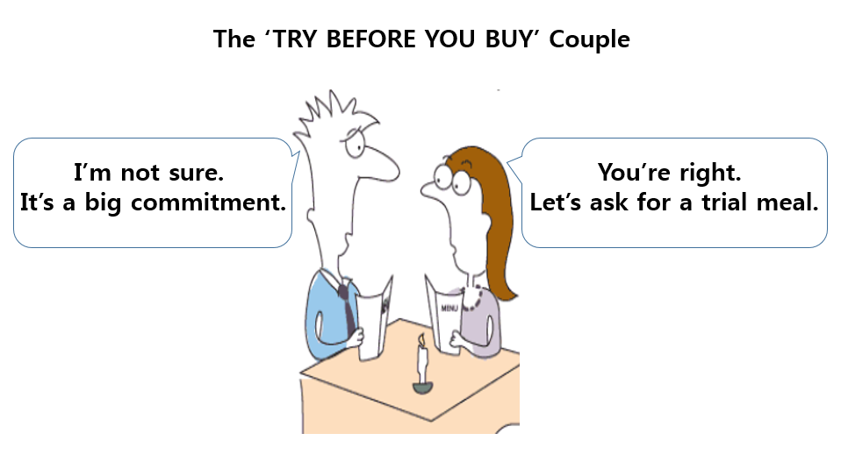

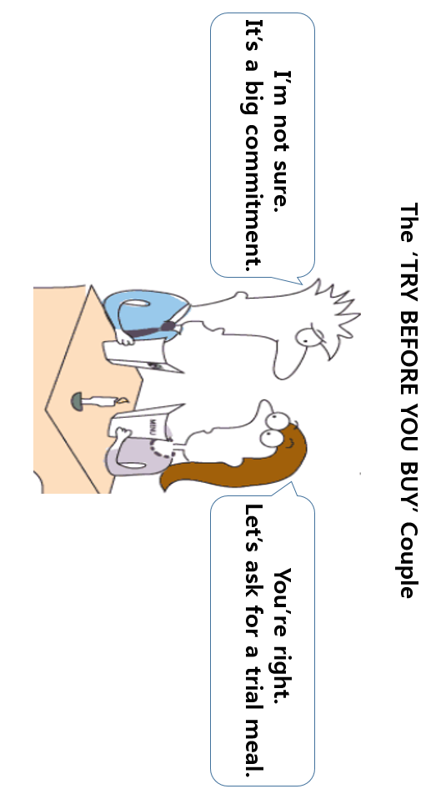

Advice Column (Appendix 3)


DEAR ABBY:
I am a woman in my early 20s and in my first serious relationship. I adore "Paul." We have a wonderful, respectful relationship. One day I hope we'll be married.
I feel strongly that we should not live together before we are married. He disagrees. He feels couples need to know each other's habits fully before they make a lifelong commitment…
What can I say to Paul and friends who disagree with me to defend my "old-fashioned" logic?

-- TRADITIONALIST IN CHICAGO

DEAR TRADITIONALIST:
I don't think you should argue with them on the subject at all. Just say that although many couples live together today without marriage, you aren't comfortable with it.
You are not the only person who feels this way. Many people with strong religious convictions feel the way you do about it. In my opinion, this is something that couples should work out between themselves.

Expressions for giving advice (Appendix 4) : as a reference

For giving advice
- Why not...?
- Why don`t you...?
- You should...
- It would be a good idea to/if...
- Have you considered/thought about...?
- If I were you, I would...
- I think the best thing would be to/if...
- One/Another suggestion is to...
- The best advice I can give you is to...

For showing result
- This will/would mean that...
- Then, ...
- That way, ...
- If you do this, ...
- By doing this, ...
- The result of this would be...

[e.g. Why not start a new job. That way, you will be able to earn more money.]

Word bank Worksheet (Appendix 5)

Topic: “Should couples live together before marriage?”
Directions: Fill in the blank by choosing the correct word from the word bank.
M: I’m just going to take this to a statistical place to start off and say these days, there’s such a high rate of _____________ . Back in the day, you didn’t live together until you were married and everybody stayed together. Why? think of the psychology behind it. You base your relationship not on what can I deal with with this person and living with them. You base it off of the _____________ , the love. So, when you finally did move in together, nothing could break this love apart.
W: Well, back in the day you didn’t live as long either. So, that has a lot to do with that statistic just so you know. But, I think that you should move in together before you get married as a _____________ because you need to discover all their faults and their _____________ and can they compromise, how do they handle ________________ , which could be a touchy subject because if you discover that you’re not compatible before you tie the _____________ , you could end up in divorce.
M: Yes, yes. If you find out you’re not compatible, that’s what I’m saying. Find out that you’re compatible and then move in together. It has nothing to do with…..
W: Wait.
M: moving in together and then what?
W: But, that’s the best test. When you’re with them _____________ and you’re with them and you’re discovering all the…
M: Alright.
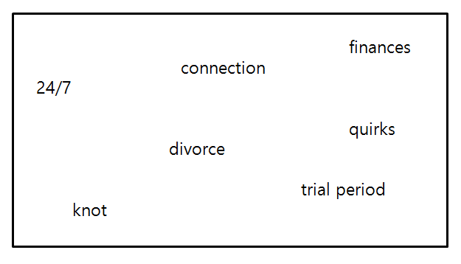
Word bank Worksheet (Appendix 6) –Answer sheet

Topic: “Should couples live together before marriage?”
Directions: Fill in the blank by choosing the correct word from the word bank.

M: I’m just going to take this to a statistical place to start off and say these days, there’s such a high rate of divorce. Back in the day, you didn’t live together until you were married and everybody stayed together. Why? think of the psychology behind it. You base your relationship not on what can I deal with with this person and living with them. You base it off of the connection, the love. So, when you finally did move in together, nothing could break this love apart.
W: Well, back in the day you didn’t live as long either. So, that has a lot to do with that statistic just so you know. But, I think that you should move in together before you get married as a trial period because you need to discover all their faults and their quirks and can they compromise, how do they handle finances, which could be a touchy subject because if you discover that you’re not compatible before you tie the knot, you could end up in divorce.
M: Yes, yes. If you find out you’re not compatible, that’s what I’m saying. Find out that you’re compatible and then move in together. It has nothing to do with…..
W: Wait.
M: moving in together and then what?
W: But, that’s the best test. When you’re with them 24/7 and you’re with them and you’re discovering all the…
M: Alright.

