Listening Speaking Reading ★ Grammar Writing

Topic: Conditionals 'if clauses'

Instructor:  KJ (Kaapjoo Park) | Level:  Intermediate (adults) | Students:  5 | Length:  30 Minutes

Materials:
Lead-in (2 min), Pre activity (about 4 min)
-Pictures related to the concept of ‘Conditionals’ (Appendix 1 & 2) - 1 copy
-Marker

Main activity (about 18 min) : Formulation/Matching Card Game

-Formulation of Conditionals (Appendix 3) – 3 copies
-2 sets of cards (Appendix 4: If cards/Action cards) -1 copy
-Marker

Post activity (6 min)
-2 pieces of blank paper
-Marker

SOS activity (4 min)

-Youtube song (“If you were a sailboat”)
-Song lyric worksheet (Appendix 5) - 5 copies
-Answer sheet (Appendix 6) -1 copy

Aims:
-Main aim: Ss will be able to describe the result of something that might happen (in the present or future) or might have happened but didn't (in the past) accurately using “if clause”.
-Secondary aim: Ss will be able to use 4 kinds of conditionals appropriately in speaking and writing.
-Personal aim: I want to help SS have some grammatical knowledge and be able to speak an English to some degree of proficiency and say what we really want to say. Also I want to manage the group work well so that there is more student talk time and student interaction.

Language Skills:
-Reading: Ss will read full sentences of their writing using ‘if clause’ in a post activity
-Listening: Ss will listen to teacher’s instructions and classmates’ sentences during describing pictures and presenting their writing.
-Speaking: Ss will engage in discussing matching card game and choosing a writing topic (“If I were……”)
-Writing: Ss will write a few sentences for a topic of “If I were someone, I would……”

Language Systems:
-Phonology: would[wʊd/wəd;əd, would’ve [wʊdəv], wouldn’t [wúdnt];
won’t [woʊnt], want [wɑ:nt/wɔ:nt]
-Lexis: if, when, is, were, will, would, had, hadn’t, have, would’ve, unless (if not)
(vocabularies related to conditional clause & main clause)
-Grammar: Usage of conditionals (zero, first, second, third)
-Function: Make conditional description of real life situation or unreal imaginary situation, imagining/guessing what will be happening, happened or didn’t happen
- -Discourse: Take part in a conversation or discussion with partner to complete sentences or select a topic for writing using ‘if clause’ (collaboration and compromise).

Assumptions:
- Ss have a basic grammar knowledge of using ‘if clause’.
- Ss might have used conditionals in speaking and writing.
- Ss might have ideas how to use 4 conditionals appropriately.
- Ss have heard many songs/poems using ‘if clause’.
- Ss have talked to people or describe something using ‘if clause’ in real situation or imaginary situation.

Anticipated Problems and Solutions:
-Students might confuse using 4 types of conditionals properly
→ In the pre activity, familiarize students with the ‘if clause’ in various situation so that they can readily make sentences using proper verbs in conditional clause and main clause in the main activity
→ In the post activity, students will imagine unreal situation and write a few sentences using second conditional ‘if clause’

-Students might have difficulty during the matching card game (continued silence, wrong interpretation of the picture in ‘if cards’)
→ monitor how the students are doing and facilitate communication by asking helpful questions and by providing students with clues/hints (intervene if necessary)

-There is a lot of time left
→ Start SOS activity (Gap-fill worksheet for song lyric)

References:
All images (Appendix 1, 2, 4) were copied from Google search:
https://www.google.com/?gfe_rd=cr&ei=SpBBV9SGD-TC8geGt5boCw&gws_rd=cr&fg=1

Conditionals: formulation:
https://www.youtube.com/watch?v=h-Np7dmvw0U

The rule of matching card game :
http://www.teach-this.com/resources/grammar/conditionals

The example sentences for matching card game:
http://www.edufind.com/english-grammar/type-1-conditional/
http://www.englishteachermelanie.com/grammar-the-1st-first-conditional/

SOS activity: Song ("If You Were A Sailboat")
https://www.youtube.com/watch?v=8hOwLap5Je8

SOS activity: Song Lyric ("If You Were A Sailboat")
http://www.azlyrics.com/lyrics/katiemelua/ifyouwereasailboat.html

Lead-In
Materials:
- Pictures (Appendix 1), tape, marker

Time | Set Up | Student Activity | Teacher Talk
2min | Whole class | Looking at the picture and sharing their thoughts | Preparation (before class):  -Arrange 2 tables to face each other  -Have the ‘Money’ picture posted on white board and be ready for lead-in.  Greeting and arousing S interest on today’s topic:  “Hi everyone!  What is it?  Yes, It’s lots of money.  Eliciting  What can you do with these lots of money?”  Wait for Ss response  “Yes, you can do many things with lots of money”  “How about a big house?”  Put up ‘House’ picture on the board  “How about fancy sports car?”  Put up ‘sports car’ on white board.  Can anybody make a sentence describing this situation of ‘lots of money, a big house and fancy sports car’ using ‘if clause’?  "If I had a lot of money, I would buy a big house and a fancy sports car."  Write Ss answer on the board  "What do we use after 'if'?"  Ask Ss the meaning of conditional clause and main clause and check that they have understood the concept  "Do I have lots of money?"  No."What am I doing?"  “Just imagining”.  “So for imaging a unreal situation, we need to use past tense ‘had’ in ‘if clause’ and ‘would’ in main clause”

Pre-Activity
Materials:

- Pictures (Appendix 2), tape, marker

Time | Set Up | Student Activity | Teacher Talk
30sec  2min  2min | Whole class  Group work  Whole class | Listening to the instructions  Talking with group members, analyzing the pictures and writing a sentence at each paper.  Speaking and listening the situation of pictures | Instruction:  “Now, I will give you 3 papers containing 2 pictures. With your table partner, talk about the concept of conditionals and try to come up with appropriate sentences for two matching pictures in each paper”.  Hand out 3 papers containing 2 pictures to each group  “I will give you 2 min”  “Ready, set, go!”  Group work  (teacher monitors)  “Group 1 please presents your description of your pictures”. (Group 1 explains)  “Group 2 please presents your description of your pictures”. (Group 2 explains)  “Great! You guys did good job”

Main Activity
Materials: Marker, Formulation set (Appendix 3-3 copies), Two sets of cards (If cards & Action cards: Appendix 4)
Time | Set Up | Student Activity | Teacher Talk
4min  30sec  1min  12min | Whole class  Whole class  Whole class  Individual work | Guessing, remembering, analyzing , and memorizing the knowledge of conditionals  Listening to the instruction  Watch demonstration and answer ICQ | Eliciting ideas for the conditionals:  “First, do you remember how many different types of conditionals have you learned?”  Wait for Ss response  “Yes there are four types of conditionals”  “I’ll give the formulation of 4 types of conditionals”  Hand out Appendix 3  “Can anybody explain what is zero conditional?”  “How about June? Can you do that?”  Write June’s explanation on board  “Sara, can you explain 1st conditional?”  Write Sara’s explanation on board  “Jiwon, can you explain 2nd conditional?”  Write Jiwon’s explanation on board  “Grace, can you explain 3rd conditional?”  Write Grace’s explanation on board  “Steffy, Which conditional type is not really a conditional ?  (answer: Zero conditional)  “Today, we are focusing on second conditional ‘if clause’  “OK Now let’s play a making sentence game”  Instruction  “Ss make second conditional sentences by matching pairs of cards together. The 25 'Action' cards are dealt out to 5 people (each will have 5 action cards) and the 'If' cards are placed in a pile on the desk”  “The first player turns over the top ‘If’ card and makes the beginning of a second conditional sentence using the picture on the card”  “All the players look at their action cards and try to find an appropriate match to complete the first conditional sentence. The player with a matching card tries to complete the first conditional sentence”  “If everyone agrees the sentence is suitable, the player with the matching action card discards both cards by setting the two cards aside. The second player then turns over the next 'If' card and so on clockwisely”  “The first player to get rid of all their action cards is the winner.”  Demonstation  “For example, what do you think about this picture?”  If the picture showed a person staying up late, the student might say,  “If you stayed up late…”  “And what will be a matching action card?  Wait for Ss response  “Thant’s right. The action card might be  ‘you would feel tired tomorrow’  ICQ  Steffy, how many action cards will you have?  (answer: 5 action cards for each person)  Grace, How do you decide whether the action sentence is right?  (answer: everyone should agree on the sentence)  “Jiwon, who will be the winner?”  (Answer: the first player to get rid of all their action cards)  “June, what are you going to do the completed matching cards?”  (Answer: the player discards both cards by setting the two cards aside)  “Sara, If you start a game first, who is a next turn?”  (Answer: who sits left hand side of Sara)  Matching card game start  “OK Let’s play a game starting from Sara”  “Did you guys have fun?”

Post Activity
Materials:
-2 pieces of blank paper for students to write on

Time | Set Up | Student Activity | Teacher Talk
1min  3min  2min | Whole class  Group work | Listening to the teacher Writing sentences  Reading their writing  Writing sentences  Presenting their sentences | “Now, let’s do some writing.  Instruction:  “Who knows Comic Super heroes?”  (Wait for Ss response)  Write Ss answer on the board  “Who knows fairy tale characters?  Write Ss answer on the board  “Are they real?”  Wait for Ss response  “No, they are imaginary characters”  “Do you know any unreal life characters who you want to be?”  Write Ss answers on the board  “This time, you will be anyone (imaginary character) you want to be and write what you want to do with that character”  Which conditional is often used to express this situation?  Wait for Ss response  (second conditional)  “You will work with your table partner to choose ‘who want to be’ and write a few sentences together using ‘If I were….…, I would……….’  “I will give you 3 minutes to write”  “And then, we will share what you wrote”  ICQ:  June, how many sentences do we have to write? (a few)  Grace, what do we have to write? (If I were someone, I would……)  Hand out a blank paper to each team  Writing starts  “Let’s hear from this group. Please, read what you wrote.”  (group presents)  (ask students from the other group) “What do you think of their writing?”
SOS Activities
Materials:
Song from Youtube (If you were a sailboat)
Gap-fill worksheet for song lyric (Appendix 5)
Answer sheet (Appendix 6)
Time  4 min | Set up  Individually | Student Activity  Listening a song and filling in the missing word of song lyric | Teacher Talk  “Now, let’s do a gap-fill worksheet for a song ‘If you were a sailboat’  “There are missing words in the song lyric of worksheet (Appendix 5). While you are listening a song form Youtube, please fill in the blanks in the worksheet  Hand out a worksheet (Appendix 5)  “For those of you who want to see the Answer sheet (Appendix 6), I will leave one copy on my desk. Please share it with other students at the end of class.”

Appendix 1

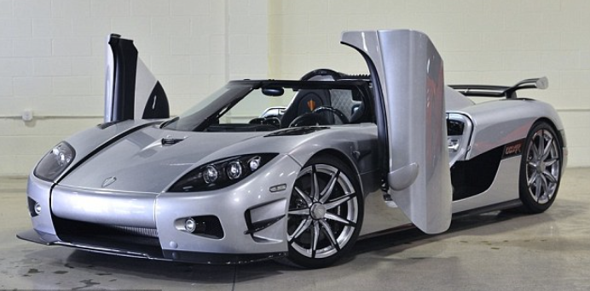

Appendix 1: Answer
- "If I had a lot of money, I would buy a sports car and a big house."

Appendix 2

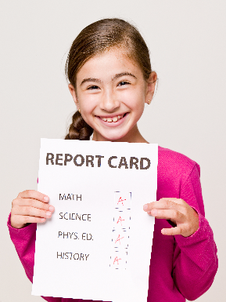

Appendix 2: Answer
If Stephanie can’t drink coffee in the morning, she gets a terrible headache.
If you always lie, nobody believes you.
If Rebecca studies harder, she will pass the exams
If I were a boy, I would play football.

If Lisa hadn’t cheated, her boyfriend wouldn’t have broken up with her.

Appendix 3

Formulation of Conditionals: There are 4 conditionals using ‘if’
General truth
If you heat ice, it melts
It is also possible to use ‘when’ instead of ‘if’, because it is not a real conditional sentence: When you heat ice, it melts.
I see her quite often
If I see her tomorrow, I will speak to her.
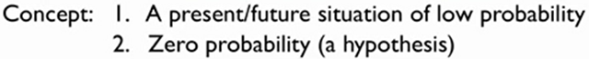
I don’t often see her
If I saw her tomorrow, I would speak to her.
I am not a lawyer
I were a lawyer, I wouldn’t take on this case.
I didn’t see her yesterday.
If I had seen her, I would have spoken to her.

Appendix 4

Matching card game/Group work

you would feel tired tomorrow She wouldn’t be fat

I would drive to work we wouldn’t have our picnic

I would be happier we would have a big party

I would come with you! I would give you some advice

Peter would be healthier

I would go to the concert I would never speak to you
with you! again

I would go to the baseball I would go to the party game with you tonight

You would make yourself sick! I would go to see a doctor

You would be fat I would buy a big house

I would miss her I would buy some new handbags

I would tell her She would be in big trouble

I would forgive her I would finish that letter

I would go out every night! you would cancel
the business meeting

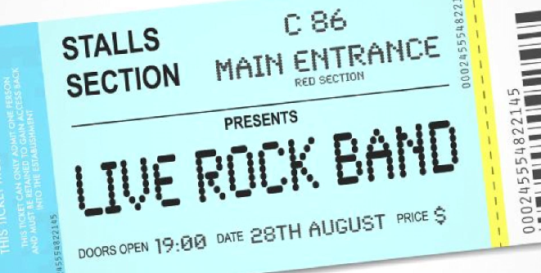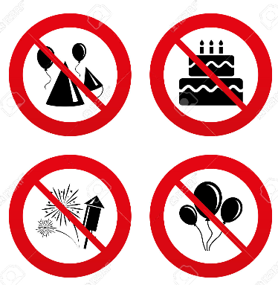

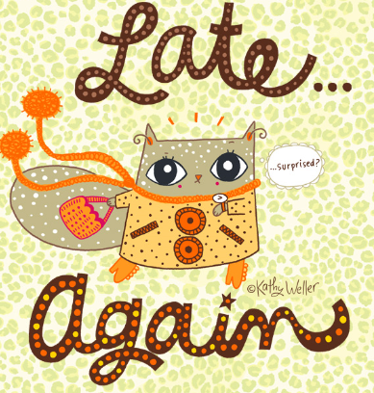

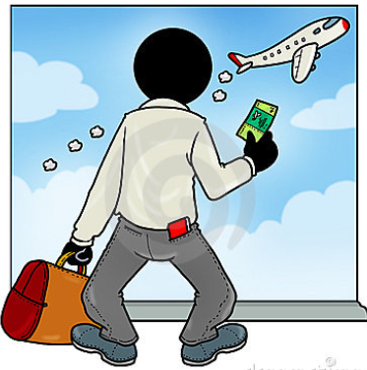

Appendix 4: Answer
Demonstration:
If you stayed up late tonight, She wouldn’t be fat if she didn’t eat so much!
you would feel tired tomorrow.
If I missed the train today, If it rained, we wouldn’t have our picnic.
I would drive to work.
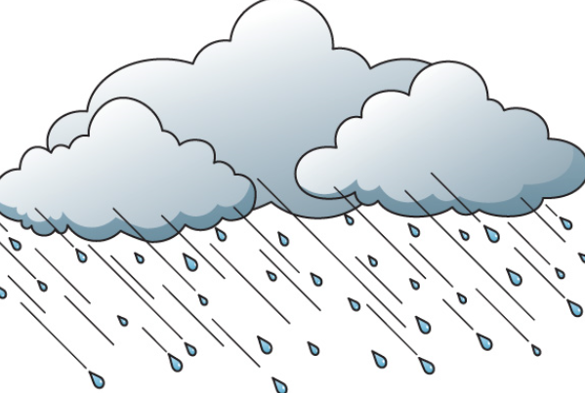
If you went shopping today, Peter would be healthier if he didn’t smoke. I would come with you!
If you gave me a ticket, If you didn’t come to my birthday party,
I would go to the concert with you! I would never speak to you again
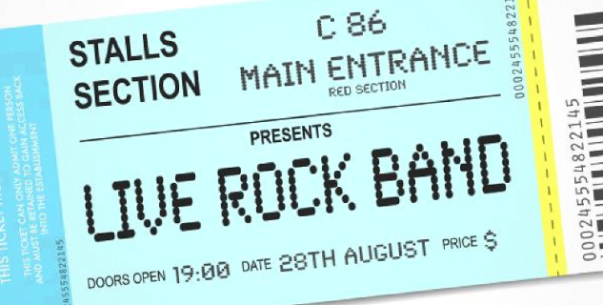
If you are too much ice cream, If I studied today,
You would make yourself sick! I would go to the party tonight.

If I had enough money, If I saw her, I would tell her
I would buy some new handbags.
If Sally wa late again she would be
in big trouble If I had time, I would finish that letter.

If you miss the plane you would
cancel the business meeting If I lived in a big city, like NYC,
I would go out every night!

Post Activity (total 6 min)/pair work
1 min eliciting, 3 min writing 2 min presenting
Writing about If I were someone, I would/could……….
Eliciting: Who wants to be (imaginary character)?

Examples
Comic super heroes (Superman, Batman, Wonder woman, Spiderman, Flashman, Ironman, Aquaman)
Fairly tale princess (Cinderella, Snow White, Princess Elsa)
Billionaire, Sport star, Celebrity (actor, actress), Singer, Medical doctor, lawyer, President, CEO, School principle, Boy/man, the Most prettiest girl, Young girl, College student, etc

Team decide who wants to be
Start writing using “if”
Presenting team’s writing.

Appendix 5
SOS Activity
Instruction & computer preparation: 1 min
Listening Song & Fill in the blank of the song Lyric (3 min 40 sec)
KATIE MELUA LYRICS
"If You Were A Sailboat"
If __________ a cowboy I ________ trail you,
If __________ a piece of wood ________ nail you to the floor.
If __________ a sailboat I _________sail you to the shore.
If __________ a river I ________ swim you,
If __________ a house I _________ live in you all my days.
If __________ a preacher ________ begin to change my ways.
Sometimes I believe in fate,
But the chances we create,
Always seem to ring more true.
You took a chance on loving me,
I took a chance on loving you.
If I was in jail I know _________ spring me
If I was a telephone _________ ________ me all day long
If was in pain I know _________ ________ me soothing songs.
Sometimes I believe in fate,
But the chances we create,
Always seem to ring more true.
You took a chance on loving me,
I took a chance on loving you.
If I was hungry you ________ feed me
If I was in darkness you _________ __________ me to the light
If I was a book I know ___________ __________ me every night
If ___________ a cowboy I _________ _________ you,
If ___________ a piece of wood _________ _________ you to the floor.
If ___________ a sailboat I __________ __________ you to the shore.
If ___________ a sailboat I __________ __________ you to the shore

Appendix 6: Answer

If you're a cowboy I would trail you,
If you're a piece of wood I'd nail you to the floor.
If you're a sailboat I would sail you to the shore.
If you're a river I would swim you,
If you're a house I would live in you all my days.
If you're a preacher I'd begin to change my ways.
Sometimes I believe in fate,
But the chances we create,
Always seem to ring more true.
You took a chance on loving me,
I took a chance on loving you.
If I was in jail I know you'd spring me
If I was a telephone you'd ring me all day long
If was in pain I know you'd sing me soothing songs.
Sometimes I believe in fate,
But the chances we create,
Always seem to ring more true.
You took a chance on loving me,
I took a chance on loving you.
If I was hungry you would feed me
If I was in darkness you would lead me to the light
If I was a book I know you'd read me every night
If you're a cowboy I would trail you,
If you're a piece of wood I'd nail you to the floor.
If you're a sailboat I would sail you to the shore.
If you're a sailboat I would sail you to the shore

