Listening Speaking Reading Grammar Writing

Topic: Shopping at the supermarket

Instructor:  Yoon ji hye(grace),  Kang sara(sara) | Level:  Intermediate | Students:  4 students | Length:  30 Minutes

Materials:

- Candies, Oranges, apples, salt and water etc. (realia) – lead in
- Whiteboard / marker-- pre activity
- A picture of breakfast tray(x1)-- pre activity
- Countable/uncountable and some/any worksheet(x4) – pre activity
- Example & dialogue worksheet(x2),apron, character card – main activity
- Worksheet(x4)– post activity

Aims:

- Main aim: Ss will be able to describe the amount of things they want to buy at supermarket.
- Secondary aim: Ss will be able to know countable & uncountable and use some/any at supermarket.
- Personal aim: Get them interested in grammar and use it in their real life.

Language Skills:

- Listening: Ss will listen to other team’s dialogue and supermarket vocabularies
- Speaking: Ss will discuss with their partner for making dialogue and will speak dialogue
- Writing: Ss will write dialogue and memo for shopping
- Reading: Ss will read sentences about some/any and example dialogue sheet

Language Systems:

- Phonology : coffee/cheese, fruit/juice
- Lexis : vocabularies used at supermarket : cashier, customer, milk, flour etc.
- Grammar : countable vs uncountable, some/any
- Function : They can describe the amount of things at supermarket.
- Discourse : Learning and talking about some/any, and making dialogue

Assumptions:
Students already know
- Supermarket vocabularies
- They have experience for buying at supermarket
- How to work in pairs
- How to class in set up & finish

Anticipated Problems and Solutions:
- Ss might not understand what Teacher said : T can explain again and speak slower
- Ss need more time for activity : T can encourage them or provide some help
- T can't make sure every Ss understood or not : T can ask them what they understood

References:

countable & uncountable
https://kr.pinterest.com/pin/542613455084154444/
matching word definition
http://www.dictionary.com/browse/list?s=t

Lead-In
Materials: Candies, Oranges, apples, salt and water etc. (Realia)

Time | Set Up | Student Activity | Teacher Talk
4min | Whole  class | Listening Teacher’s talk and answer for some questions | “Good morning, everyone! How are you today? Do you like to go to supermarket? Which section is your favorite?” (Ss might answer)  “There are a lot of items in supermarket, right? I have brought some items from the supermarket, (Show Ss a orange) Do you know what this is?”  (Ss might say something, like “orange”.)  “How many orange do I have? Can you count this?” (Ss say “yes” or “no”)  “Ok, How about this?”(show other things)  (explanation)  “So, There are some things you can count, and there are some things you cannot count. Right?  When you describe the amount of something, if you’re clear about countable nouns and uncountable nouns, It would be very helpful.

Pre-Activity
Materials: A picture of breakfast tray(x1)
Countable/uncountable and some/any worksheet(x4)

Time | Set Up | Student Activity | Teacher Talk
2min  3min  1min | Whole  Class  individual | Listening Teacher’s explanation & instruction  Doing Worksheet | “Ok, now we’re going to talk about some/any. (write some/any on the board)  How we use these two? Who knows? Who can explain?” (Ss might answer something)  (Show Ss a picture of breakfast tray Appendix1)  “Ok, everyone, Look at this picture, what things do we have here? Can you make a sentence using some?  (let Ss say some sentences, like “There is some milk on the tray.”  “There is some fruit.” Write them on the board )  Ok, good, Then how about things we don’t have? Can you make a sentence using any?  (“There isn’t any jam.” “There aren’t any cookies.” Etc.)”  “So, Some is usually used in affirmative sentence.”  And Any is used in negative sentences.”  CCQ  “When do you use ‘some’?”  “When do you use ‘any’?”  “Ok, Now, I’ll give you guys a worksheet, There are 2 questions, number 1, there are some items you can buy at the supermarket, think about which are countable and which are uncountable and you need to circle on the “countable things”.  And number2, you’re choosing between some and any.  OK, You have 2 minutes.”  (Distribute a worksheet to each student, Appendix2)  ICQ  “Number 1, Can you circle on uncountable nouns?”  “How much time do you have?”  “Ok, Time’s up”  “Let’s check the answers.”

Main Activity
Materials: example & dialogue worksheet, apron, character card

Time | Set Up | Student Activity | Teacher Talk
4min  6min | Whole class  In pairs | Listening Teacher’s explanations & instruction and Answering questions  Working with partner | Ok, now we will make dialogue with your partner!  You can imagine that when you go to the supermarket you want buy something right? And sometimes you make shopping list for shopping!  Demo  For example if i pick the card ‘mom and daughter’ me and grace will be a mom & daughter and there are some characters  We have to apply the characters and make dialogue  (show them our dialogue and read)  You will pick the card and you can see the characters  You need to apply the character you pick to dialogue and when you make dialogue you have to use some & any  And you have to write items more than nine!  Dialogue will use for post activity~!  I will give you 6minutes for making dialogue  ICQ  Are you working in pair?  How many items you have to write?  Ok let’s pick a card  Let’s start!!  Time warning  2minutes left!  Time’s up!

Post Activity
Materials: dialogue worksheet and check list

Time | Set Up | Student Activity |  | Teacher Talk
2min  6min | Whole  Class | Listening Teacher’s instruction  Listening and writing  Checking list |  | As I told you we will use a dialogue!  Now you will listen to other team’s dialogue and you have to listen carefully!  Because you have to write list what they will buy  (assign first team and second team)  Ok, june & kj can you start?  Did you listen carefully?  Ok, steffy & jiwon can you read?  Everybody very good!  Now we will check the list  Steffy and jiwon what they want to buy??  (check the list right or not)  June and kj~ is that right?  Ok good!  June and kj what they want to buy?  (check the list)  Steffy and jiwon Are they right?  Thank you everyone you did good job!!  Did you enjoy the class?  Ok, thank you^.^ !!
SOS Activities
Materials: matching word worksheet

Time | Set Up |  | Student Activity | Teacher Talk
3min | Whole class |  | Listening  and Solving | We have little time!  I will give you matching word work sheet~  You can solve it for 3min and you can talk to each other for finding answer!  (Appendix7)  Let’s start!!  Ok, time’s up!  Let’s check the answer!  Everybody good job today!!
(Appendix1) Pre-activity

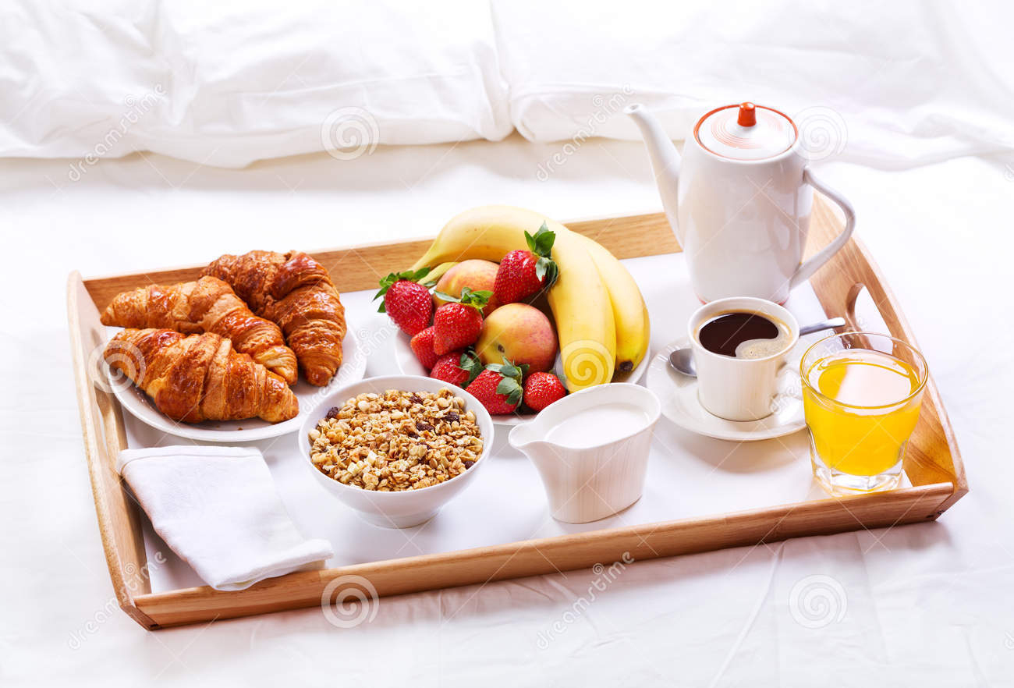

(Appendix2) Pre-activity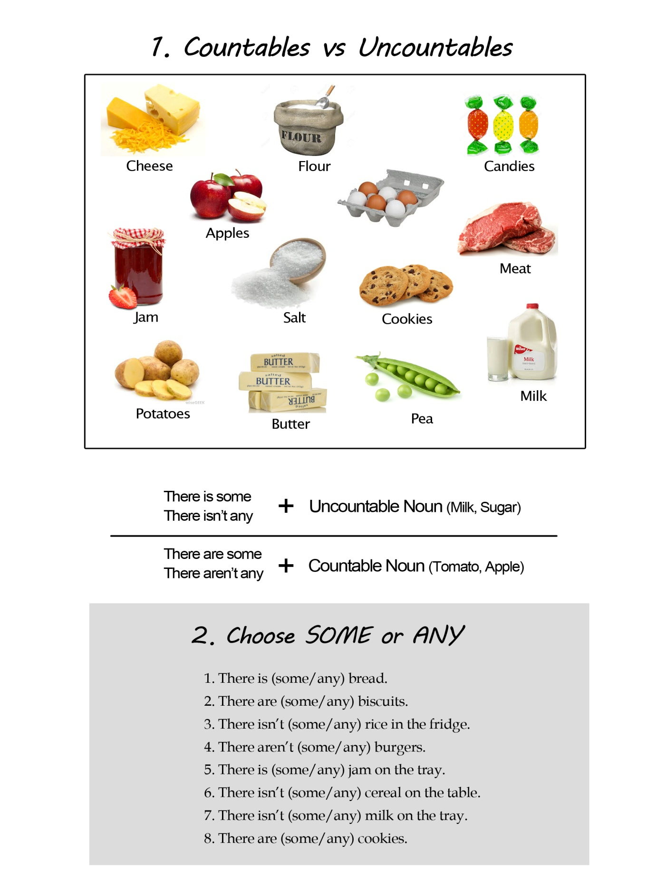
Main activity
make dialogue with your partner~!
Example (normal customer and clerk)
Customer : Excuse me, I need some cheese and milk, where can I find them?
Clerk : You'll find them on Aisle 8. It's to the left.
Customer : OK, Thanks, how about Oranges? I also need some fruit.
Clerk : There are some oranges in fruit section. All of the fruit is on sale now, There are so many people, and I just checked there aren’t any apple at the moment, you need to hurry.
Customer : Oh, Thank you for letting me know!
Clerk : You’re welcome. Enjoy your shopping!
List

Dialogue

Character card – main activity
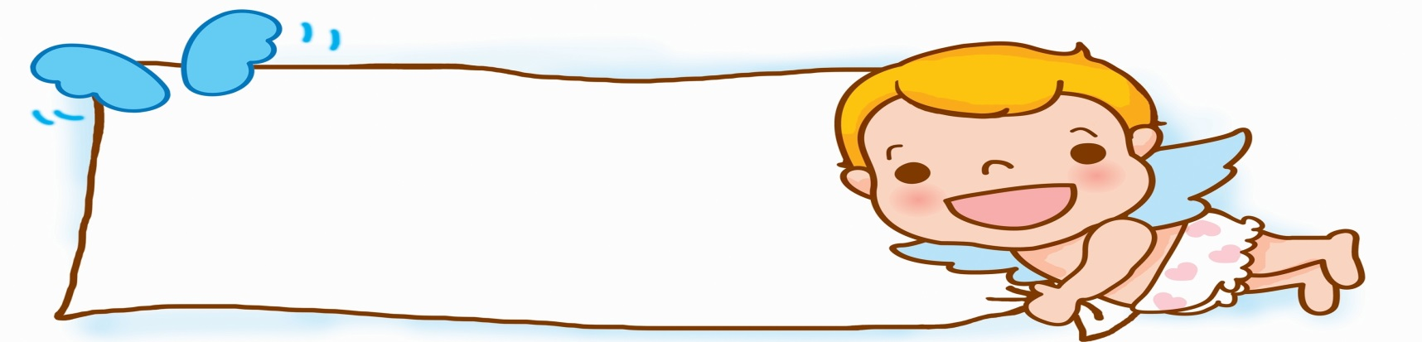
Sister: person who wastes money for buying a lot of items
Brother: person who wants to stop her

Mother : wants to buy healthy food

Son (6years old) : wants to buy sweets and chips

(Newlyweds)
Wife: she can’t cook and she wants to buy premade food
Husband: he wants to eat like real food

Customer: she is flirting with handsome clerk
Clerk: he is too arrogant
Because many girls like him

Check list – post activity

What do they want to buy?-? What do they want to buy?-?

(Appendix7) S.O.S activity
Matching word!!
1.dairy a an employee, as in a market or department store, who collects payments for customer purchases.

2.grocery b food typically sold at a delicatessen, as cold cuts, salads, and pickles.

3.deli c a person employed, as in an office, to keep records, file, type, or perform other general office tasks.

4.list d an establishment, as a room, building, or buildings, where milk and cream are kept and butter and cheese are made.

5.aisle e A store selling foodstuffs and various household supplies

6.cashier f One that buys goods or services, as from a store or business.

7.clerk g a walkway between or along sections of seats in a theater, classroom, or the like.

8.customer h A series of names, words, or other items written, printed, or imagined one after the other
Answer
1.dairy an employee, as in a market or department store, who collects payments for customer purchases. 6.cashier

2.grocery food typically sold at a delicatessen, as cold cuts, salads, and pickles. 3.deli

3.deli a person employed, as in an office, to keep records, file, type, or perform other general office tasks. 7.clerk

4.list an establishment, as a room, building, or buildings, where milk and cream are kept and butter and cheese are made.
1.dairy
5.aisle A store selling foodstuffs and various household supplies
2.grocery
6.cashier One that buys goods or services, as from a store or business.
8.customer
7.clerk a walkway between or along sections of seats in a theater, classroom, or the like.
5.aisle
8.customer A series of names, words, or other items written, printed, or imagined one after the other
4. list

