Listening Speaking ★ Reading Grammar Writing

Topic: Make milk ice cream

Instructor:  June  Steffy | Level:  Intermediate (Adults) | Students:  4 students | Length:  30 Minutes

Materials:
- Eliciting (Realia of ingredient (milk, salt, sugar, ice)/picture – 1 realia for teacher/ 1 copy for teacher = pre-activity)
- Making the ice cream (1 set of ingredient for group – need to prepare 2 sets = main activity)
- Container activity (post-activity)
- Words search activity (5 copies for students = SOS activity)
- Small and big zipper bags/ Plastic spoons/Containers (1 for each group – need to prepare 2)
- Toppings
- White board and marker

Aims:
-Main aim: Ss will be able to make ice cream. Ss will also be able to read and understand the recipe

-Secondary aim: Ss will be able follow the instruction and share their opinions after experience.

-Personal aim: I want Ss to enjoy making ice cream and tasting each other’s ice cream.

Language Skills:

-Reading: Ss will read the recipe in main activity.
-Listening: Ss will listen to other student’s thoughts on post-activity and main activity. Ss will listen to teacher’s instruction.
-Speaking: Ss will share their opinion on pre-activity by realia and pictures. Ss will share their container activity (post activity).
-Writing: Ss will write their thoughts and opinion during post activity.

Language Systems:

Phonology: L sounds (saLt, miLk…)
Lexis: vocabularies and words that Ss have to guess on realia and pictures during pre-activity. (Sugar, salt, milk, ice…)
Grammar: Imperative sentences in main activity (Add, Put…)
Function: Express the ideas and reactions on post activity.
Discourse: Guessing and eliciting on pre-activity, Reading and comprehension for recipe, sharing ideas with class, and listening to class.

Assumptions:

Students already know
- How to read the recipe
- What ice cream is
- Vocabularies that are used in the activities
- What kind of activities teacher trying to do
- Familiar with classroom setting

Anticipated Problems and Solutions:

- Students may not be able to understand the instruction given each time.
→ Repeat the instructions. The best way is to do ICQ (Introduction Check Question).

- Students may need more time to read. (Enjoy the silence)
→ Give them around 1-2 minutes to wrap up.

- Every student might have same thoughts.
→ It actually does not really matters because this is free opinion game that shows your opinions, ideas, reactions or desire.

- They might not follow the instruction or recipe
→ Demo together step by step and slow down until everyone is following

-There is a lot of time left
→ Start SOS activity

References:

Main Activity
-Ice cream
https://www.google.co.kr/search?q=ice+cream+flavors&source=lnms&tbm=isch&sa=X&ved=0ahUKEwiXwsri8oXNAhUCFZQKHXNSBu8Q_AUIBygB&biw=1366&bih=602#imgrc=mmJi8Nqw0GTzRM%3A

SOS Activity
- Word search activity
https://www.superteacherworksheets.com/generators/wordsearch.php#ws

Lead-In
Materials: no materials needed

Time | Set Up | Student Activity | Teacher Talk
1min | Whole class | Share what they did during the weekend | Hi, everyone! How was everyone’s weekend? Do you love cooking? Do you usually cook?

Pre-Activity
Materials:
Realia 1-4/ Appendix 1
Time | Set Up | Student Activity | Teacher Talk
5 min | Whole class  Show realia 1  Show realia 2  Show realia 3  Show realia 4  Show picture 1 | Students guessing | Show Realia 1 (sugar)  T: By looking at this, what do you think this is?  (Wait for the students’ response)  Do you want to touch it/taste it?  (Let students to touch/taste)  What do you think?  (Wait for the student’s response)  --------------------------------------------------  Show Realia 2 (salt)  T: By looking at this, what do you think this is?  (Wait for the students’ response)  Do you want to touch it/taste it?  (Let students to touch/taste)  What do you think?  (Wait for the student’s response)  --------------------------------------------------  Show Realia 3 (milk)  T: By looking at this, what do you think this is?  (Wait for the students’ response)  Do you want to touch it/taste it?  (Let students to touch/taste)  What do you think?  (Wait for the student’s response)  --------------------------------------------------  Show Realia 4 (ice)  T: By looking at this, what do you think this is?  (Wait for the students’ response)  Do you want to touch it/taste it?  (Let students to touch/taste)  What do you think?  (Wait for the student’s response)  --------------------------------------------------  Show Picture 1  T: What do you think are these flavors?  (Wait for students’ response)  Do you like ice cream?  When do you usually eat ice cream?  Do you have any special memories about the ice cream?  What is your favorite flavor?

Main Activity
Materials:
Ingredient/ Appendix 2
Time | Set Up | Student Activity | Teacher Talk
20 min | Whole  Class | Hand out the appendix 2 | T: I will give you the recipe for ice cream and by group, lets try to make an ice cream!  T: I will give you 1 min to read the recipe.  ICQ: How many minutes do you have?  A= 1 min  CCQ: What do you do when you put the small zipper bag of milk into the large one?  A= shake it  *** For demo, we will do step by step together with students ***  ICQ: #1. Where do you put your milk?  A= Small zipper bag  #2. Where do we add sugar?  A= with Milk/ small zipper bag  #5. How many spoons of salt to we add?  = 5
Post Activity
Materials:
No materials needed
Time | Set Up | Student Activity | Teacher Talk
5 min | Whole  Class | Tasting the ice cream together and sharing the opinions. | T: Now, we are making ice cream, so we need container! But simple container is not fun enough so lets decorate the containers while your partner is shaking the ice cream.  (Show the example container)  (Write on board what is needed in the container  1. Flavor name and drawing  2. When can you enjoy this flavor?  3. Make a short story when you would enjoy.)

SOS activity
Materials:
Appendix 3
Time | Set Up | Student Activity | Teacher Talk
5 min | Whole class | Hand out the appendix 3 | T: We have some spare of time.  (Show the activity sheet)  What is this?  (A= Words search activity)  How you do it?  (A= Search for the words)  T: We have 5 minutes to do this activity, The first one who finish first will win.

Appendix 1 – Pre-activity

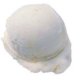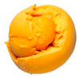

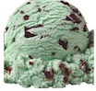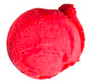

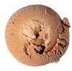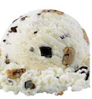
Appendix 1 – answer sheet

LEMON MANGO

MINT CHOCOLATE RASBERRY
ESPRESSO COOKIES & CREAM
Appendix 2 – Main Activity

MILK ICE CREAM RECIPE

INGREDIENT : MILK, ICE, SUGAR, SALT, TOPPINGS

MATERIALS : ZIPPER BAG (SMALL/ LARGE)

- PUT ALL THE MILK IN THE SMALL ZIPPER BAG

- ADD SUGAR (DEPEND ON YOUR TASTE) INTO SMALL ZIPPER BAG WITH MILK

- ZIP IT!

- PUT THE ICE ON THE LARGE ZIPPER BAG

- ADD 5 SPOONS OF SALT TO THE ICE

- PUT THE SMALL ZIPPER BAG INSIDE THE LARGE ZIPPER BAG

- ZIP IT!

- SHAKE IT SHAKE IT UNTIL IT TURNS INTO ICE CREAM!

- ADD YOUR OWN TOPPINGS!

Appendix 3 – SOS activity

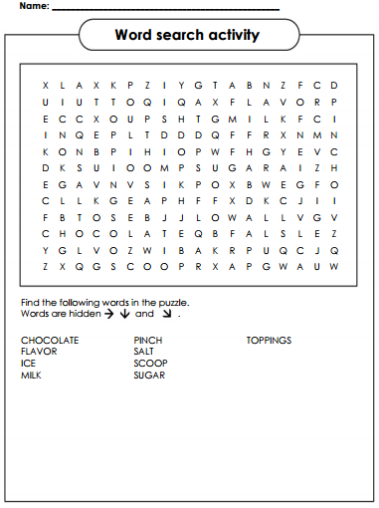

Appendix 3- answer sheet

