Listening Speaking Reading Grammar Writing

Topic: Getting along with different types of people

Instructor:  Sang Ji Lee  (Lilly) | Level:  High intermediate | Students:  5 students | Length:  30 Minutes

Materials:
- Picture of people with different personalities
- White board and board marker
- Vocabulary worksheet (5copies)
- Fill in the blanks worksheet (5copies)
- Personality test worksheet (5 copies)
- Computer for audio file and the picture

Aims:
- Main aim: Ss will be able to improve vocabulary and listening skills on the topic.
- Secondary aim: Ss will be able to improve fluency on the related topic.
- Personal aim: I want Ss to improve their ability to express themselves freely on the related topic

Language Skills:
- Reading: Audio Script about Personality Types
- Listening: Audio File on Personality Types
- Speaking: Personality traits, Personality Test
- Writing: Fill in the blanks, Matching vocabulary

Language Systems:
- Phonology: /b/ vs. /v/
- Lexis: palatable, introspective, trigger
- Function: Explain
- Grammar: ‘Whether A or B’
- Discourse: Monologue

Assumptions:
Students already know
- that they should be active during the class
- they should not discourage other students in any way

Anticipated Errors and Solutions:
- Unresponsive class
→Direct questions individually to trigger a domino effect.
- Ss cannot solve the questions
→Play the audio one more time, explain the vocabulary briefly again etc.
- If certain students dominates the discussion
→ask them to give other students a chance to speak.

References:
https://www.youtube.com/watch?v=dP1j09iJRK8&feature=youtu.be

Lead-In
Materials: None
Time | Set Up | Student Activity | Teacher Talk
1min | Whole class | Answering teacher’s questions | Good morning! How are you today?

Pre-Activity
Materials: Board, Board makers, Visual Aid, Vocabulary Worksheet
Time | Set Up | Student Activity | Teacher Talk
5mins  5mins | Whole class  Individuals | Answering teacher’s questions  Solve and Answer | Elicit  Can you guess how many main personality types are there? (quickly encourage one student is the class is being reluctant to answers) Let’s say that researchers find that there are 4 main personality types. Can you guess What are they? (Show students Visual Aid) Can you guess these people’s personalities? Which person looks more compatible with you and why? Do you believe a person have only one personality type?  Model  Write the subject ‘different types of personalities’ on the board.  CCQ  “Do your friends have similar personality types?  “What do you think of yourself?”  New Vocabulary  (Handout the Vocabulary worksheet)  Now I will give you 2 minutes to solve this worksheet. All pictures correspond to the words next to them. So try to guess their meanings and match them with their definitions on the right hand side. After that we will check your answers.  ICQ  What will you do with the work sheet?  Are you working in groups?  Check Answers  (After 2 mins) Okay now let’s answer them in turn.  (Pick one student)  What is the meaning of …..?  (If he gives the correct answer: Right! Is everyone agree?)  (If he gives the wrong answer: Do you all agree with him/her?)  (change to another student after that)

Main Activity
Materials: PC, Audio file, Listening Worksheet, Board and Marker
Time | Set Up | Student Activity | Teacher Talk
2mins  6mins | Whole Class  Individually | Listen to the instructions,  Read the worksheet  Listen and fill the blanks | 1.Filling in the blanks  Instructions  Now we will listen to an audio and then fill in the gaps according to it. Before we start to listen I will give you one minute to skim through the text. Go ahead.  ICQ  What will you do with the worksheet?  Are you working as a team?  Demonstration  (Play the audio file)  (after audio ends)  Did you all fill the blanks or want me to play it once more? (play it once more if needed)  Check answers  Okay….(Student name) What will come to the first blank?  (use the same procedure with the vocabulary worksheet)

Post Activity
Materials: Nothing
Time | Set Up | Student Activity | Teacher Talk
7mins | Whole class | Answer the questions and discuss | Discussion  So which type represents your main  personality? What other traits do you have? Which personalities do you think you are most compatible with? Do you think this classification of personalities in 4 main categories is sufficient? If not What else should be added? (Encourage all students to elaborate on their answers instead of giving short replies)

SOS Activity
Materials: Worksheet #3 (Personality Test)
Time | Set Up | Student Activity | Teacher Talk
3mins  5mins | Whole class  Whole class | Take the test  Answer the questions and elaborate on them | Instruction  Now I will give you a small personality test which considers your forehead shape and associates it with your personality. I will give 2 minutes for you to check it, then we will check everyone’s results.  Discussion  Now who has ….. forehead? (according to the test) Okay read your personality. (pick any student with that trait) Do you think it suits you? (repeat for other 6 forehead types) Do you think this test is accurate?

- Visual Aid

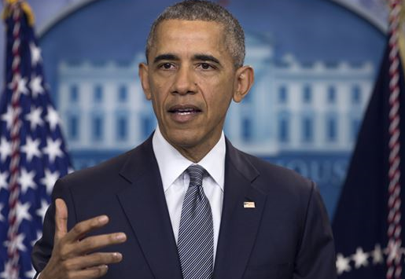
- Worksheet #1
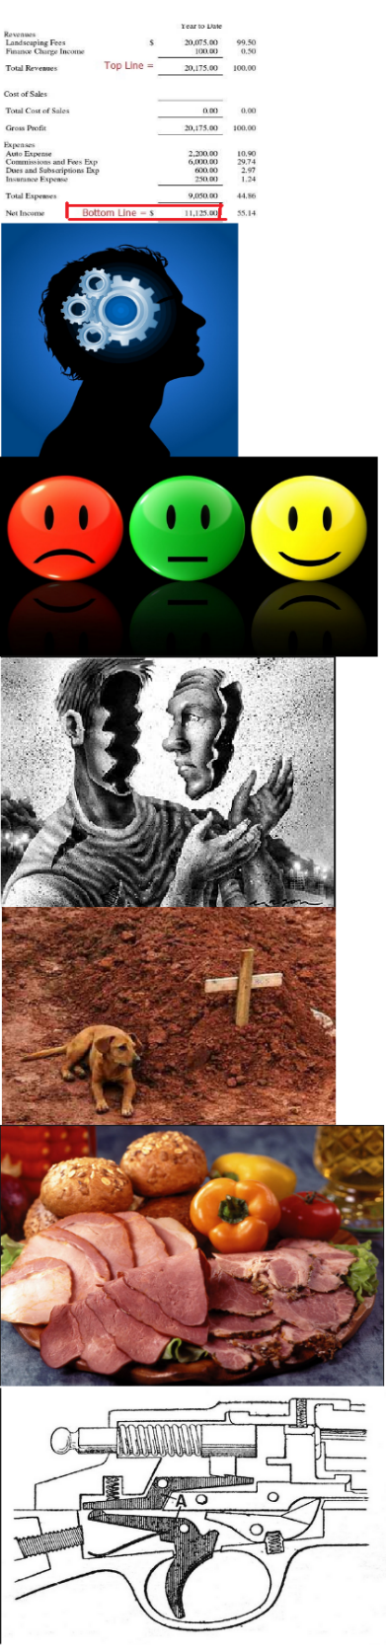
Match the words with their definitions.

Bottom Line ▪
Logical ▪
Emotional ▪
Introspective ▪
Loyal ▪
Palatable ▪
Trigger ▪
▪Examining and considering your own ideas, thoughts, and feelings, instead of talking to other people about them
▪The part of a gun that you pull when you shoot
▪Relating to emotions
▪Using reason and good judgment
▪Acceptable
▪The most important fact in a situation
▪Always liking and supporting someone or something
- Worksheet #2

Fill in the blanks below.

Experts agree that your character is a mix of personality types.
Direct people are, well, direct! They are ______ _____ and they get to the point.
They are natural leaders and Quick decision makers who tend to be ______ and say what’s on their mind.
Thinker/analyzers are also ________ in their approach but unlike direct people they love details. They are natural planners.
Social extroverts are more _________ or feeling based. They draw a lot of their motivation or lack thereof from their feelings.
Relational people are relational. They are__________. They are caring and they are considerate. They draw a lot of their identity from close relationships because they are _______.
Whether you are a direct person, the thinker analyzer, the social extrovert or the relator what we can all learn from each other includes whether you are giving or receiving feedback, remember, you have the power to make it more ________ to the other person or the other gender or the other personality by realizing the differences along with the _______.
- Worksheet #2 (Answer)

Experts agree that your character is a mix of personality types.
Direct people are, well, direct! They are bottom line and they get to the point.
They are natural leaders and Quick decision makers who tend to be vocal and say what’s on their mind.
Thinker/analyzers are also logical in their approach but unlike direct people they love details. They are natural planners.
Social extroverts are more emotional or feeling based. They draw a lot of their motivation or lack thereof from their feelings.
Relational people are relational. They are introspective. They are caring and they are considerate. They draw a lot of their identity from close relationships because they are loyal.
Whether you are a direct person, the thinker analyzer, the social extrovert or the relator what we can all learn from each other includes whether you are giving or receiving feedback, remember, you have the power to make it more palatable to the other person or the other gender or the other personality by realizing the differences along with the triggers.

- Worksheet #3

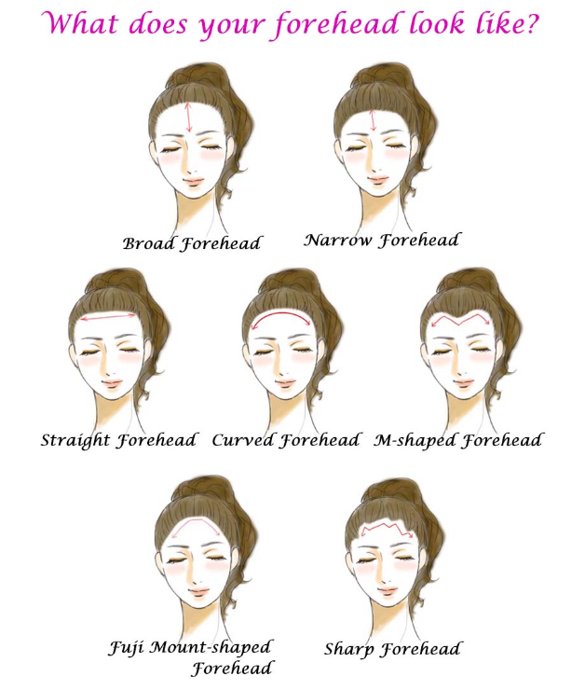

- Worksheet #3
