x Listening Speaking Reading Grammar Writing
Topic: Talking About Dream

Instructor:  Kimberly | Students Competency Level  Intermediate | Number of Students:  10 | Lesson Length:  55minutes
Materials:(List the Names of all materials used in the lesson. Materials must be shown at the end of this document)
- White Board and Markers,
- Picture of Airplane Wall Chart
- Role Situation Cards
- Angry
- Animal
- Fire
- Stocking
- Movie

Aims:(What students will be able to achieve by participating in the activities of the lesson. (Ss gain or get by doing…)
- Improve speaking skills by role play and discussion with a group and answering teacher.
- Activate, increase interest, and participate with fun in an English communication activity by sharing stories of teacher and students.
- Improve listening skills by role play and discussion with a group, responding to teacher.
- Improve writing skills by planning the role play
- Improve interaction and communication skills by having discussion in a group and planning a role play

Language Skills:(Lists what activities language skills students will be using by participating in the activities of the lesson.)
- Reading: (Where did reading occur in the lesson?)
Role cards, note taking
- Listening:(Where did listening occur in the lesson?)
Teacher talk, during the role play, discussion
- Speaking: (Where did speaking occur in the lesson?)
Role play, small group discussion, answering teacher
- Writing: (Where did writing occur in the lesson?)
Notes, planning

Language Systems: (Lists what language systems students will be using by participating in the activities of the lesson.)
- Phonology: (sound)
Role play, discussion, teacher talk
- Function:(situation)
Introduction, job functions
- Lexis: (meaning)
Vocabulary about jobs
- Grammar:(language structure)
Be verbs, possessive and description
- Discourse: (communication)
Discussion, responding the teacher, role play

Assumptions:(What students must already be able to do and what concepts must already be mastered before the lesson in order to achieve the aims of the lesson.)
- All students understand the basic of role play and will enjoy introducing their dream to other students
- All students probably have a dream when they were child.
- All students have probably tried hard to achieve their dreams

Anticipated Errors and Solutions:(What things might go wrong in the lesson and what the solution will be. An SOS activity should also be included)
- If students may not have many ideas → Solution: Teacher gives them little examples.
- If activity lasts too long → Solution: T cuts the unnecessary parts.
- If activity finished too soon → Solution: Teacher makes suggestion and shares ideas.
- If certain students are shy → Solution: Teacher encourage them, gives feedback, and changes roles for them.

References:

Lead-Inor Pre-Task Part (Warm-Up Part to activate and create interest in the lesson.)
Materials: (List the Names of all materials used in the Lead-Inor Pre-Task Partof the lesson. Materials must be shown at the end of this document)
- Picture of Airplane Wall Chart
Time: | Classroom Set Up: | Student Activity and Goals: | Teacher Procedure &Instructions:
1min  5min  5mins | Whole  Whole  Students | Students greet the teacher.  Students listen to teacher.  Students talk their story | Greeting  Tell teacher’s stories about the dream in interesting gesture.  Elicit the stories from students.  Let’s do a role play about the dream.

Pre-Activity or Task Familiarization Part (Presentation PartPresenting the language structure to be covered in the lesson. Prepares students for the communication activity.)
Materials: (List the Names of all materials used in the Pre-Activity or Task Familiarization Part of the lesson. Materials must be shown at the end of this document)
- White Board and Markers,
- Role Situation Cards
- Angry
- Animal
- Fire
- Stocking
- Movie

Time: | Classroom Set Up: | Student Activity and Goals: | Teacher Procedure &Instructions:
3min  2min  4min  5min | Whole  Group  Group  Whole | Students listen what Teacher says.  Students move into group.  Students read role cards and share with group members.  Students prepare for role plays | Introduce the role play and describe setting. Classroom during the presentation.  Divide students into groups.  Hand out role cards. Ask students to discuss role and pick roles.  Ask students to prepare for Role Play. Teacher facilitates. Make note to help plan role play.  Transition now time to present role plays.

Main Activity or Task Realization Part(Practice to Production PartTeacher lead practice of the language presented and move to communication based more student centered activity)
Materials: (List the Names of all materials used in the Main Activity or Task Realization Partof the lesson. Materials must be shown at the end of this document)
- White Board and Markers,
- Role Situation Cards
- Angry
- Animal
- Fire
- Stocking
- Movie

Time: | Classroom Set Up: | Student Activity and Goals: | Teacher Procedure &Instructions:
1min  2 x  7min  6min | Whole  Groups  Groups  Whole | Students get ready for role play but don’t use cards in role plays.  Everything below happens twice.  Students do activity. One group at a time other group watches listens and enjoys.  Students listen what teacher says. Students applaud other students. | Teacher gives instruction for each group to come to front and present and enjoy role play and starts role play.  Students can’t use role cards or notes.  Everything below happens twice.  T monitors role playing. Gives encouragement to students and facilitates class feedback to role play students.  Gives students feedback, and comments. Facilitates class members’ feedback.

Post Activity or Post Task Part (Wrap-Up PartClose the Lesson on a high note to and consolidate language learned in a communication based activity new situation.)
Materials: (List the Names of all materials used in the Post Activity or Post Task Part of the lesson. Materials must be shown at the end of this document)
- White Board and Markers,
- Role Situation Cards
- Angry
- Animal
- Fire
- Stocking
- Movie

Time: | Classroom Set Up: | Student Activity and Goals: | Teacher Procedure Instructions:
3 min | Whole | Students answer the teacher’s question  Students listen | Teacher asks students how they like their role.  Teacher asks students to share their idea job and discuss each other and present a partner’s idea job.  Close by giving student feedback about their accomplishment and improvement.

Picture of Airplane Wall Chart
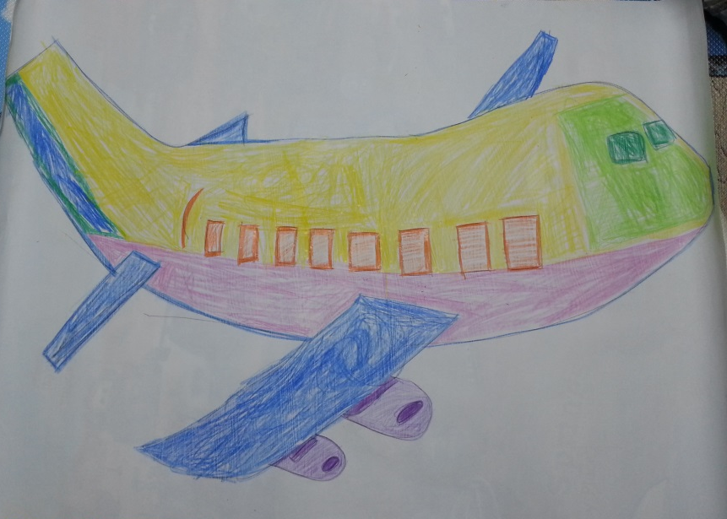

Role Situation Cards

Angry
(Female Teacher)
- 20years old
- Very young and smart but angry all the time
- Ugly

Animal
(Female Student)
- 30years old
- To be a vet is her dream
- Always looking for animals
- Treat everything as animals

Stocking
(Male Student)
- 20years old
- To be fashion designer is his dream
- Likes his teacher and is angry

Fire
(Male Student)
- 25years old
- To be a fire fighter is his dream.
- Always looking for dangerous situation and fire

Stocking
(Male Student)
- 40years old
- To be a movie director is his dream
- Always carries a camera to make a movie of everything

