Listening Speaking Reading Grammar Writing

Topic: How to describe the character of a person

Instructor:  Amy (Ahn mi young) | Level:  High intermediate | Students:  5 students | Length:  30 Minutes

Materials:
◾ White board and board markers
◾ Visual aids for pre activity (6 copies each)
◾ Information gap worksheets for Main activity (6 copies each)
◾ Profession cards and a personal adjective sheet in post activity
◾ SOS activity worksheets (6 copies each)

Aims:
◾ Main aim: Ss will be able to express the character of a person by using idioms
◾ Secondary aim: Ss will be able to understand better the subtleties of personality
adjectives through group discussion.

Language Skills:
◾Reading : Ss will read scripts in main and post activities.
◾Listening : Ss will listen to T's instruction, interacting with group members.
◾Speaking : Ss will explain and discuss their opinion during post activity.
◾Writing : Ss will write memo to fill the gaps in worksheet #3

Language Systems:
◾ Phonology: sound of the end of word (/bl/, /-ʃəs/)
◾ Lexis: New vocabularies in the main-activity
◾ Grammar: relative pronoun (a person who is)
◾ Function: character idioms
◾ Discourse: expressing opinion

Assumptions:
Ss already know
◾ How the class is set up and run
◾ Four language skills and systems
◾ Ss have already known some easy vocabularies for them

Anticipated Errors and Solutions:
◾ Ss may have some difficulties understanding some idioms.
-> Give as many synonyms as possible to help their understanding.
◾ Ss may not be familiar with some of the vocabulary in post activity
-> Provide students with examples and describe meaning.

References:
https://mikeastbury.wordpress.com/2015/05/15/speaking-games-personality-adjectives/
https://www.reddit.com/r/Rabbits/comments/4kxz18/pick_a_bunny_personality_test/?

Lead-In
Materials: None
Time | Set Up | Student Activity | Teacher Talk
1min | Whole class | Answering teacher's questions | Hello everyone! How are you today?  do you remember that we talked about our personality last week?  I think we are getting to know each other.

Pre-Activity
Materials: Visual aid, White board, Board markers, worksheet #1
Time | Set Up | Student Activity | Teacher Talk
5min  6min | Whole class | Ss do a personality test | Procedure  1. Brain storming  Elicit  "Please look at this picture. What do you see in this picture?"  "This is sort of a personality test."  "After we try it and talk about it."  "Pick one rabbit that you like the most."  "Did everyone pick one?  "What did you pick?“  "How was this test? Do you think it is right?"  Model  (Write 'How to describe the Character of a person' on the white board.)  "Think about all the different people you live and work with. There are probably some people you get along with well, and others you don’t.  People have their own character. When we try to describe someone's character, there is a variety of expressions.  We are going to learn how to describe the character of a person."  CCQ  "Do you believe that you know about yourself? your personality?  What can we use to know our  2. New vocabularies  Instruction  "I believe that you already know some adjectives about personality. Look at the words and pictures in this worksheet #1. Let’s guess Which picture goes with the adjective in the list."  "I’ll give you a worksheet, but start it right now.“  (Distribute the worksheet #1)  Demonstration  "Please look at the paper, let's see the first one."  "How does he look?"  "Which word do you think match with? yes, correct.“  "Now, let’s do all the blanks by yourself."  ICQ  what do you do with the worksheet?  Are you working in group?  How much time do you have?  "Let's get it started."  Monitoring  Monitor discreetly. Answer students if they ask questions.  Give time warning:  1minute 30seconds left. (Be flexible with time. Give 1 more minutes if they need it.)  "Okay, time's up, let's check answers together."  Check answers  " Can you tell me the answer one by one from Tina."  (Explain more if needed)

Main Activity
Materials : worksheet #2
Time | Set Up | Student Activity | Teacher Talk
6min | Pairs |  | 1. Prediction  Instruction  "I will give you another worksheet. It is about some idioms.  because the idioms have a different meaning when used together from each word, it is hard to guess their meaning sometimes."  "There are two kinds of worksheets which have different information. You have to share information with your partner to fill in the blanks by asking question and answering."  "I will give 4minutes."  (Distribute the worksheet #2)  Demonstration  "Look at the paper, and we do first one together."  "Can someone who has a A worksheet read the first one? and can someone who has B worksheet read the answer? good."  ICQ  What do you write in blanks?  Are you working in pairs?  How mush time do you have?  "Ready go!"  Monitoring  Monitor discreetly. Answer students if they ask questions.  Give time warning:  1minute 30seconds left. (Be flexible with time. Give 1 more minute if they need it.)  Check answers  "Now, check your answer together."  Check answers with teacher.  "How to say person who is...?."

Post Activity
Materials: profession cards and a personal adjective sheet
Time | Set Up | Student Activity | Teacher Talk
10min | Whole  class | Students in groups play a profession and personality game. | 1. Speaking game with personality adjectives  Instruction  "Now, we are going to play a professions and personality adjectives game. There are 60 profession cards and 20 personality cards."  "I will give you 6 profession cards each, and one of you as a judge picks one personality card by turns. When the judge shows you the personality card that is picked, you choose a profession card in your hand which best matches the personality adjective and explain why. And then the judge will pick a winner. Then the role of judge moves clockwise and the next judge picks up a personality card."  (Distribute worksheet cards)  Demonstration  "There are 5 players, 4 players who  are competing and one judge. If the  Judge’s card is ‘wise’, the 4 players  select professions. The 4 cards the  judge has to choose between are  surgeon, newspaper editor, lawyer and  diplomat. Each player gives their  reasons for their selection and the  judge can ask a few follow up  questions. After a short discussion the  judge then picks a winner (the judge’s  decision is final). Players don’t win by  having the right card, they win because  they give the best or most interesting  explanation."  ICQ  How many profession cards do you  have?  What does the judge do?  What do players do?  Who will end up a winner?  "Let's start from Ashley."  Monitoring  Monitor how is this game going. Help Ss when they are confused.  2. Conclude Lesson  "Does anyone have any question about what we learned today? Vocabularies, concepts, anything?"  Summarize today's lesson by checking new vocabulary and the contents in the text. Then do error correction about grammar and pronunciation during discussion and speech.

SOS Activity
Materials : worksheet #
Time | Set Up | Student Activity | Teacher Talk
If needed | Individually  Whole class | Individually working on a cross words puzzle worksheet  Students check the answer. | 1. Fill in the blanks  Instruction  "Here, I have crosswords puzzle of character idioms that we learned."  I want you to work on this puzzle by yourself."  “When you finish, raise your hand and I will check the answer individually.”  ICQ  “What are you working alone?”  “What should you do after finishing?  Monitoring  Monitor discreetly.  Answer check  Check the answers together

◾ Visual aid
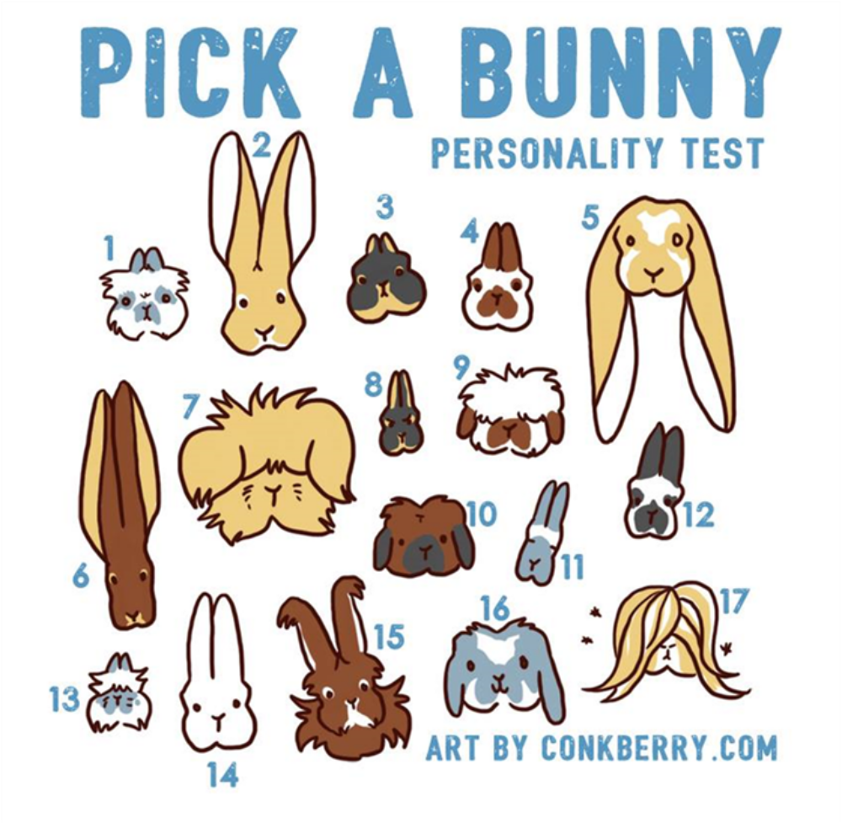

1)Jersey Wooly : People might think you're high maintenance. You have a circle of people you truly love, but you can be a bit guarded towards others. You're pretty much adorable, except when you're molting. Then you're really weird looking.
2) Flemish Giant : You are honest, gentle and take your responsibilities seriously. People tend to see just one aspect of your personality at first, but you are patient - over time they see your depth and charm and love you even more for it.
3) Netherlands Dwarf : You have a reputation for being snippy but it's only because you like to take things seriously and do things right. No small talk or fluff. People that appreciate that appreciate you!
4) Mini Rex : You're friendly, fun and pretty much everybody loves you. You're really good at what you do and that can sometimes intimidate people, but deep down everyone knows you have the softest heart around.
5) English Lop : You're kind of a weirdo. In all the best ways. You like to laugh and be sil ly, and you're a great listener and friend. Life's too short to be anything less.
6) Belgian Hare : You're timeless, classic and sometimes unappreciated. You're often the one starting the trends, but don't get much credit for them. But it's okay - you love a challenge and know that creating is much more fun than following.
7) English Angora : People see you as high maintenance, but it's questionable why, considering everything you own is covered in wool. You're very DIY and willing to put in the time and patience to make sure your work is quality.
8) Britannia Petite : You have a small group of friends that you love dearly. Everyone else is crazy and can go away now. You're proud, smart and maybe a little stubborn, but the people you let in appreciate that about you. You don't have time to worry about the rest of the world, you have too many important things to do.
9) American Fuzzy Lop : You might be a bit of an underdog but you're more about the journey than the destination. When you do something, you do it well, more for you than anyone else. You never want to stop learning.
10) Holland Lop : You're adorable and everyone loves you. Literally everyone. You're pretty much the life of the party. But you worked hard to get where you're at and don't mind sharing that with people - you actually really love teaching others and helping them on their way.
11) Himalayan : You are super weird yet everyone's favorite person, even if you do that creepy scanning thing. You're chill, kick back and like to just coast. Life is good.
12) English Spot : You are so pretty. And so busy. And everyone thinks you are so awesome. CAUSE YOU ARE!
13) Li onhead : You are constantly changing and evolving. People might not take you seriously because of it, but you'd rather have the strength to be flexible and change, than be stuck in the same box your whole life.
14) New Zealand : You're practical, down-to-earth and like things that make sense. You're very logical and pride yourself on not being overly emotional. You might not be fancy, but people look up to you.
15) French Angora : You like to make friends and let a bit more emotion in, because connection is important to you. You like to share - things, knowledge, time, everything.
16) Mini Lop : You're just an all-around cool person. You know a lot of things, have a lot of friends and are just generally awesome. And floppy and cute.
17) Peruvian Cavy : People constantly overlook you or just see you as something weird like a pile of hair, but you're smart, awesome and don't mind squeaking at people to get your way.
◾ Worksheet #1
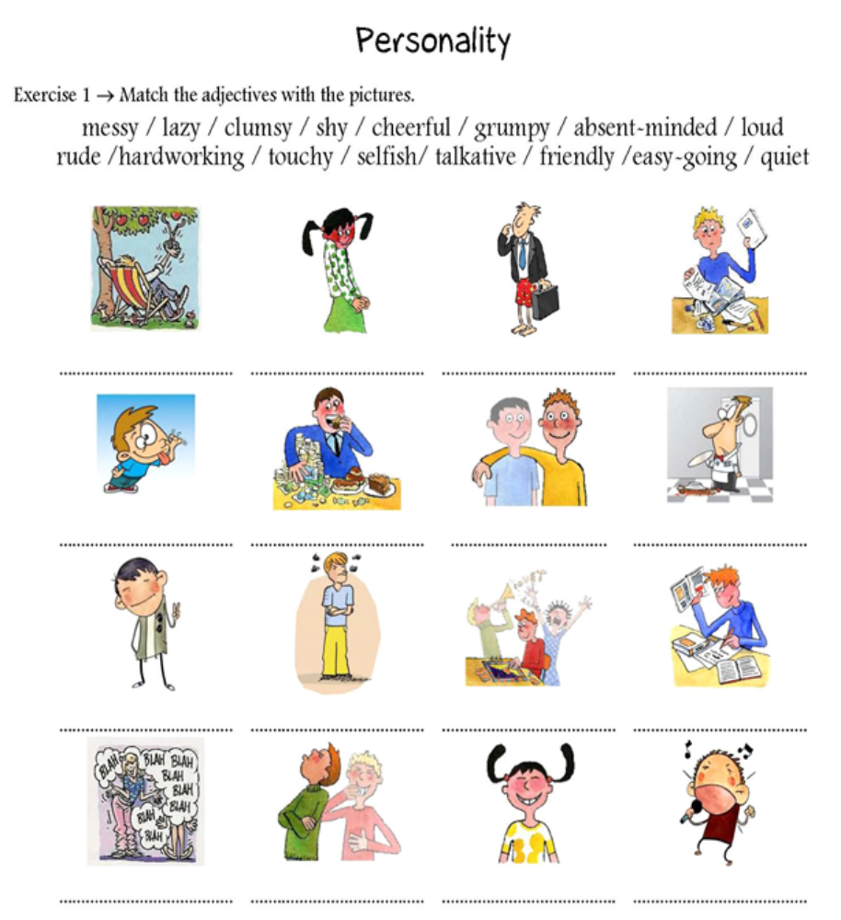

◾ Worksheet #2
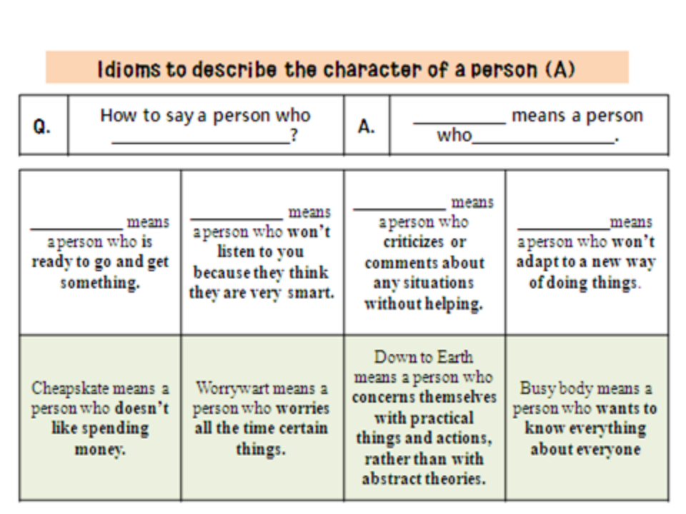

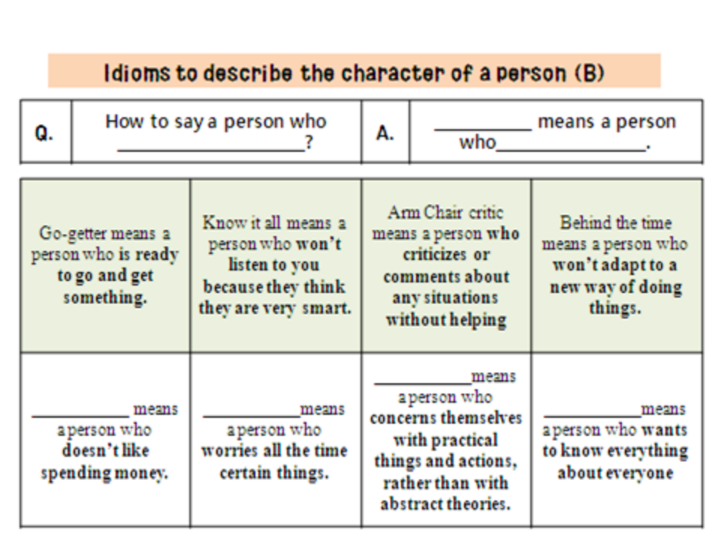

◾ Worksheet #3 (SOS activity)
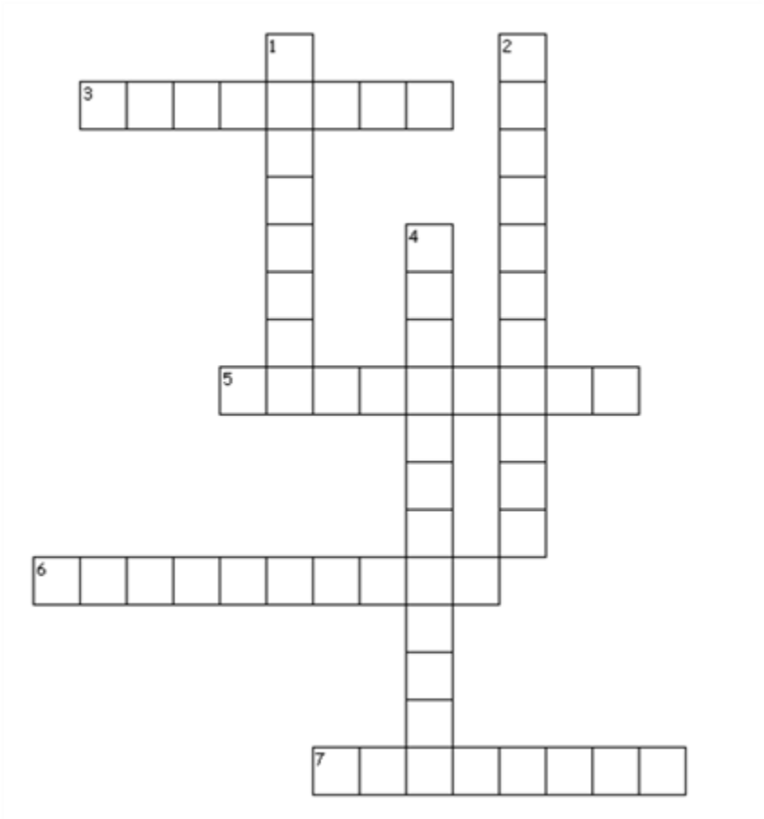
Crosswords puzzle - Character idioms
▶ Across
3. a person who is ready to go and get something
5. over smart, smart alec
6. someone who hates spending money
7. a person who is always want to know everything about everyone.
▶ Down
1. Set in one's ways
2. a person who is realistic, sensible, humble.
4. old fashioned, they won't adapt to a new way of doing things

