Listening ☑ Speaking Reading Grammar Writing

Topic: How does the etiquette of eating together in your country differ from other countries?

Instructor:  Yujin Hong  (Ashley) | Level:  High-intermediate (Adult) | Students:  5 students | Length:  30 Minutes

Materials:
- Computer and beam projector
- White board and board marker
- Visual aids in pre-activities
- Worksheet #1 for the pre-activity (6 copies)
- Worksheet #2 for the main activity (6 copies)
- Worksheet #3 for the post activity (6 copies)
- Worksheet #4,5 for the SOS activity (3 copies each)

Aims:
- Main aim: Ss will be able to talk about table etiquettes and practice use of imperative sentences.
- Secondary aim: Ss will be able to know how table etiquettes in Korea differ from ones in other countries by discussing in a group.
- Personal aim: I want to encourage Ss to actively participate in speaking during the class and to emphasize fluency over accuracy.

Language Skills:
- Speaking: Ss will discuss about the topic in a group and answer teacher’s questions.
- Listening: Ss will listen other students’ opinion.
- Reading: Ss will read worksheets
- Writing: Ss will make memos on their worksheets

Language Systems:
- Phonology: /e/, /3:rp/
- Lexis: etiquette, differ from, utensil, cutlery, slurp, burp, blow one’s nose
- Grammar: Imperatives
- Function: listing items (various table etiquettes), giving information
- Discourse: discussion

Assumptions:
- Students know language systems and four language skills.
- Every student is Korean and has been living in Korea long enough to know what etiquettes of eating together in Korea are.

Anticipated Errors and Solutions:
- If the students keep silence,
- Give a clear instruction and do demonstration to encourage them to speak.
- If the students need more time for ‘post activity’ but the time’s almost done,
- Let them to do it at home and use it as a material for review in the next class.

References:
https://www.youtube.com/watch?v=bdeFdFEbuqk (video, 2:10)
http://www.businessinsider.com/table-manners-around-the-world-2015-9
http://www.telegraph.co.uk/travel/food-and-wine-holidays/A-guide-to-table-manners-around-the-world/
http://www.armoredpenguin.com/crossword/

Lead-In
Materials: None

Time | Set Up | Student Activity | Teacher Talk
2mins | Whole class | Answering teacher’s questions | Good afternoon, everyone! How are you? Did you have a lunch? Where did you go? What kind of the place was it?

Pre-Activity
Materials: Computer, Video 1, Whiteboard, Board markers, Worksheet #1

Time | Set Up | Student Activity | Teacher Talk
4mins  4mins  2mins | Whole class  Groups  Whole class | Answering teacher’s questions  Working in groups  Checking answers  Answering teacher’s questions | 1. Brainstorming  Eliciting  “I will show you a video. Here, a man called Jack is living in Japan for the first time and he is invited to his girlfriend’s family dinner. Let’s see what happened together.”  (Show the students the video)  “Do you think Jack knows about Japanese culture well? Did he make mistakes while having a dinner with his girlfriend’s family? How many mistakes did he make?”  (Write down what students mentioned)  “Very good. Thank you. Like this, if you don’t know table etiquettes around the world, it is highly possible to make a mistake or be in a trouble when you eat with someone from other countries.  Modeling  “So today, we are going to talk about ‘what does the etiquette of eating together in Korea differ from other countries’”  (Write down the topic on the board)  2. New vocabulary & grammar  (Hand out worksheet #1)  Instruction  “Let’s look at the worksheet. There are four photos and each photo shows a dining etiquette in France, Mexico, Japan and China.”  [Make two groups]  “In groups, speak with partners to find our what etiquette each photo represents. Closely look at their hand positions, utensils and dishes and you will find the answer easily. I will give you 3 minutes.”  Demonstration  “Alright. Let’s look at the first one. XXX, what do you see in the image? Very good. He is sitting on the chair putting his both hands on the table. So the answer is ‘Keep hands on the table all the times.’ It is to show you are not armed and applicable to most of the European countries. Okay, let’s do the rest of them with your partners.”  ICQ  “How many minutes do you have?”  Monitoring  Answer students if they have a question.  “Time’s up, everybody. Let’s check the answers.”  Answer check  France: Keep hands on the table all the time.  “Did anyone get what the image for Mexico means? (Give time to think and answer) In the heading, it says ‘Do’s and Don’ts’ so it would be perfect if you make a sentence in the imperative. Very good. ‘Use your hands for Tacos’. This is applicable to Italy when you eat Pizza.”  (Do the same for Japan and China)  Japan: Keep chopsticks horizontal on the side of your plate.  China: Leave a bit of food on the plates to show you had enough to eat.  3. CCQ  “Seeing the worksheet #1, does the proper way of eating together in other countries differ from Korea?”  “What grammatical mood is good to use when we give instructions or advices? It starts with a verb.”

Main Activity
Materials: Whiteboard, Board markers, Worksheet #2

Time | Set Up | Student Activity | Teacher Talk
10mins | Whole class | Discussing in a group | 1. Discussion  Instruction  “Now we are going to discuss about the topic altogether. ‘How does the dining etiquette in Korea differ from the other countries?’ Imagine that you are in France and invited to a house dinner by one of your friends. Some etiquette is similar but some will be very different.  Before start, I will give you 1 minute to prepare individually. It will be very helpful if you think about your own personal experiences. Let’s start.”  “Okay, time’s up. Are you ready?”  (Arrange the seating to a horseshoe shape)  (Hand out worksheet #2)  “Let’s talk about it until XX:XX”  ICQ  “Which country’s etiquette we are going to talk about?”  “How long we are going to discuss?”  Demonstration  “Let’s imagine you got a cold and you are invited to a dinner. You have a runny nose. Can you blow your nose at the table? No, do not blow your nose at the table and go to a toilet.”  Monitoring  Give them some hints to encourage them to keep speaking.  Write down key words on the board.  Feedback  Ask how many they were able to find and compliment students for their participation.

Post Activity
Materials: Whiteboard, Board markers, Worksheet #3

Time | Set Up | Student Activity | Teacher Talk
6mins  2mins | Pairs  Whole class | Working in groups | 1. Free Production  Instruction  (Hand out worksheet #3)  “Let’s look at the worksheet. There are a few sentences explaining more dining etiquettes around the world. Check ‘Yes’ if it is similar to Korea, check ‘no’ if not. XX, can you read the sentence on the bottom of the page? Thank you. Write down name of the countries the etiquette is applicable to.”  Demonstration  “Let’s do the number one together.”  (Let them know the meaning of ‘slurp’)  “Very good. Now work in the same groups for the rest of them. I will give you five minutes.”  ICQ  “How many minutes do you have?”  “Who are your partners?”  Monitoring  Assist students if they need any help.  Give a time-warning “two minutes left”.  Answer check  Check the answers minimizing teacher talk.  2. Conclusion  “Very good, everyone. Today we were able to know how dining etiquettes in this country differ from other countries and I hope this will help you when you eat together abroad or eat with someone from other countries.”  “Do you have any questions? If not, let’s finish today’s class. Thank you for your participation.”

SOS Activity
Materials: Worksheet #4,5

Time | Set Up | Student Activity | Teacher Talk
If needed | Pairs  Whole class | Working in groups  Answering teacher’s questions | Instruction  (Hand out worksheet #4 to three students and #5 to the other two students.)  “Let’s do the puzzle information gap in groups. This is a crossword puzzle game but there is no clue. Team A and team B should help another team to find answers. XX, please read the instruction on the top. Very good. Let’s work in groups until XX:XX”  ICQ  “Team A, do you have answers for across or down? And team B?  Demonstration  “For number 1, team B has the answer so please help team A to fill in the blank. We can say “this is a 4-letter word that begins with B or ends in P.” Team A is going to ask ‘what does that mean?’ or ‘how do you spell that?’”  Answer check  Check answers together
Worksheet #1

The Do’s and Don’ts of Dining Etiquette

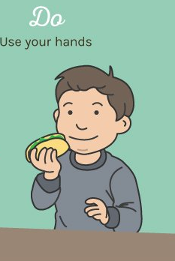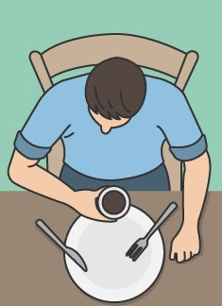 France Mexico

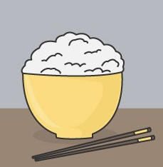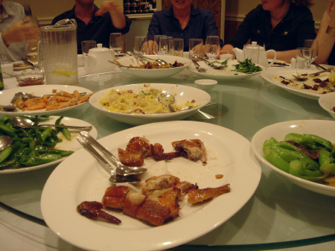 Japan China

Worksheet #2

How does the etiquette of eating together in your country
differ from other countries?

- 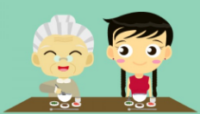
- 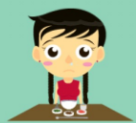

- 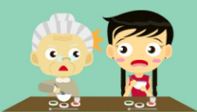

- 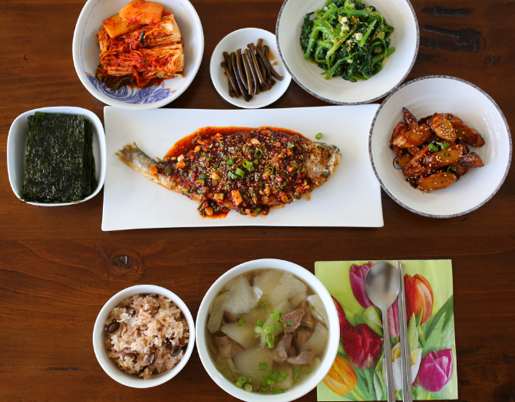

- 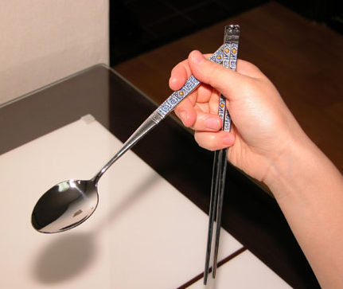

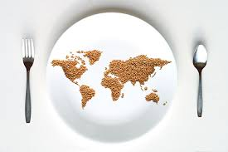Worksheet #3

Dining etiquettes all around the world
Which of these are similar or applicable to your culture?

Y N Comments
In Japan, slurping indicates that the food is good.
( ) ( ) ( )
In Canada, show up fashionably late rather than on time or early.
( ) ( ) ( )
In Thailand, do not use fork to put food in your mouth. Use fork to push food onto your spoon.
( ) ( ) ( )
In India, eat only with your right hand.
( ) ( ) ( )
In China, do not turn over the fish on the plate.
( ) ( ) ( )
In Italy and France, do not use knife when you eat salad or pasta.
( ) ( ) ( )
In China, accept a dish using both hands, especially when you are accepting from elders.
( ) ( ) ( )

* In the comments section, write down name of the countries that you think the sentence is similar to (excluding Korea).
Worksheet #4

Puzzle Information Gap A
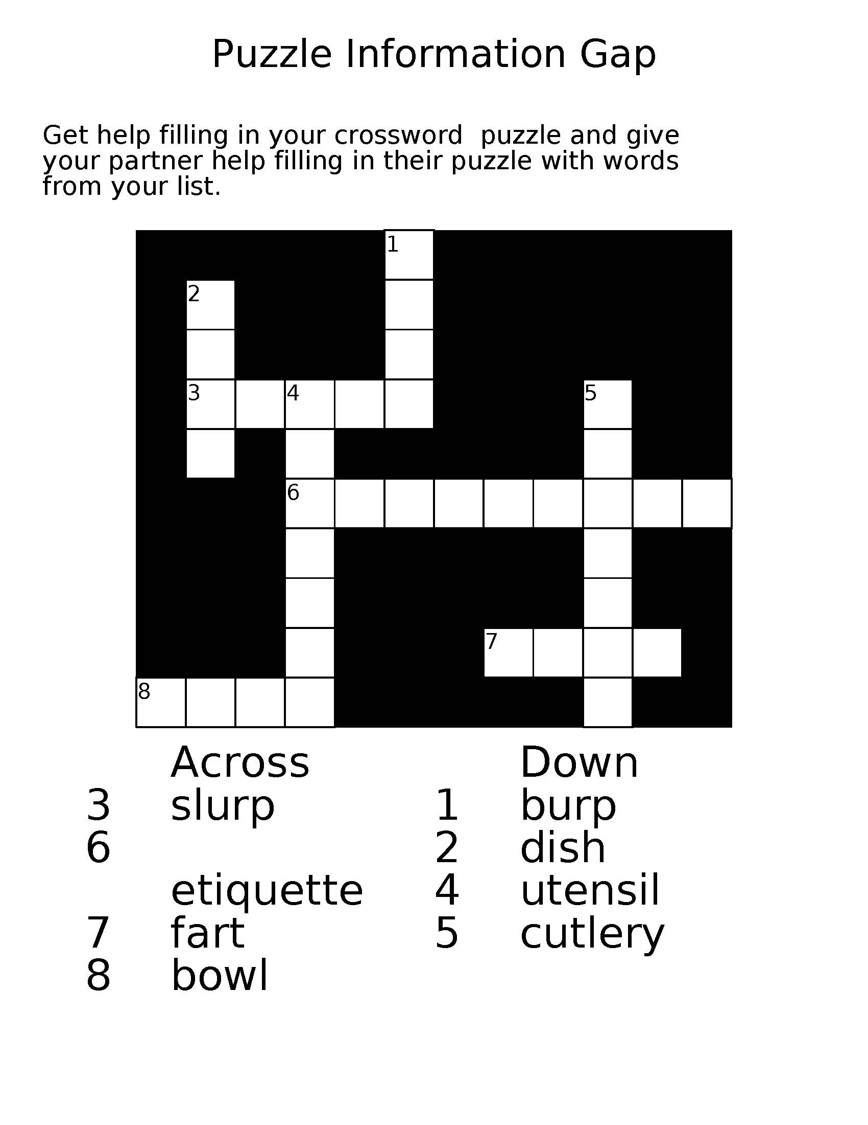
Across
3 slurp
6 etiquette
7 fart
8 bowl

Worksheet #5

Puzzle Information Gap B
Down
1 burp
2 dish
4 utensil
5 cutlery

Appendix.

List of Korean dining etiquettes

- Do not blow your nose.
- Do not hold the bowl of rice or soup in your hand during the meal.
- When having a meal with the elderly, wait for the elders to hold their spoon first.
- The rice bowl is on the left and soup bowl is on the right.
- Do not hold the spoon and chopsticks together in one hand during the meal.
- Do not flip the fish on the dish.
- Do not serve yourself alcoholic drinks
- Accept bowls with both hands
- Do not stick chopsticks straight up into the rice bowl.
- Eat as quietly as possible.

