Listening Speaking Reading Grammar Writing

Topic: Difference between 'Clean up', 'Clean off', and 'Clean out'

Instructor:  Sang Ji Lee  (Lilly) | Level:  High intermediate | Students:  5 students | Length:  30 Minutes

Materials:
- Picture of messy desk
- White board and board marker
- Computer for audio file and the picture
- Fill in the blanks worksheet (5copies)
- Discussion worksheet (5copies)
- Simple discussion worksheet (5copies)

Aims:
- Main aim: Ss will be able to understand the difference between 'Clean out', 'Clean off', and 'Clean up'
- Secondary aim: Ss will be able to know how to use them.
- Personal aim: I want Ss to be interested in phrasal verb.

Language Skills:
- Reading: Ss will skim through the lyrics.
- Listening: Ss will listen to a song.
- Speaking: Ss will discuss and share their idea.
- Writing: Ss will write their stories.

Language Systems:
- Phonology: Clean up [kli:n ʌp], Clean off [kli:n ɔ:f], Clean out [kli:n aʊt]
- Lexis: Clean out, Clean off, Clean up
- Function: Prediction
- Grammar: Phrasal verb
- Discourse: Discussion

Assumptions:
Students already know
- four language skills and language systems
- they should not discourage other students in any way

Anticipated Errors and Solutions:
- Students may need more time to work on the worksheet
- give students little more time to finish it
- If students give the wrong answer
- give them a gesture to predict the correct answer

References:
https://www.youtube.com/watch?v=5T5Y7tRtZaI
https://www.youtube.com/watch?v=HW4JqAqZxus
http://thesecretyumiverse.wonderhowto.com/how-to/cleaning-frequency-chart-often-should-you-clean-certain-items-your-home-0161157/

Lead-In
Materials: None
Time | Set Up | Student Activity | Teacher Talk
3min | Whole class | Answering teacher’s questions | Good morning! How are you today?  Let’s look around.  What does your desk look like?  Is it clean?  How about our class?  Is it tidy or messy?

Pre-Activity
Materials: Visual Aid, Worksheet #1, Board, Board marker
Time | Set Up | Student Activity | Teacher Talk
2min  3min  3min | Whole class  Whole class  Whole class | Answering teacher’s questions  Guessing the blanks  Filling in the blanks while listening to a song | Elicit  (Show visual aid on the board)  Look at him.  What is he doing?  How is his desk?  What does his desk need?  (Handout the worksheet)  Now, we will listen to a song.  Before we listen to it, let’s guess the lyrics and fill in the blanks.  I’ll give you 3 minutes.  Please, fill in the blanks individually.  1 minute left.  Time’s up.  Who can tell us the answer of the first blank?  Who has a different answer?  (Pick the other student)  How about a second one?  (Pick another student)  How about a third one?  And what about last two?  Let’s check the answer while listening to the song.  (Play the song)  Did everyone complete the blanks?  Let’s listen to it one more time.  (Play the song)  The first blank is ‘Clean’  The second one is ‘Clean up’  The next is ‘Clean’  And the last two are ‘up’  Everyone did good job.  Alright, everyone.  Have you heard about the words ‘clean out’ and ‘clean off’ other than clean up?  Model  (Write the subject ‘Clean up, Clean off, and Clean out’ on the board)

Main Activity
Materials: Worksheet #2
Time | Set Up | Student Activity | Teacher Talk
4min  6min | Whole class  Whole class | Filling in the blanks  Checking the answers | Instructions  (Handout the worksheet)  Let’s guess the answers of the blanks individually and please fill them with using 'Clean up', 'Clean off', and 'Clean out'.  I’ll give you 3 minutes.  Then we will look at it together.  ICQ  What are three words that go to the blanks?  How much time do you have?  Right, let’s get started.  Monitoring  Monitor discreetly.  1 minute left.  Time’s up.  Demonstration  Let’s look at the first chimney picture.  Clean ____ (wait for students’ answer)  Yes, clean ‘out’ the chimney.  ‘Clean out’ is to clean the inside of something thoroughly.  (Use a gesture)  (Write ‘to clean the inside of something’ under ‘clean out’ on the board)  The next one is a blackboard.  (Pick a student)  Could you read out your answer?  Right!  ‘Clean off’ is to remove something from the surface of something by brushing, rubbing, etc.  (Use a gesture)  (Write ‘to remove something from the surface of something’ under ‘clean off’ on the board)  How about the fish tank?  (Pick a student)  Let’s move on to the room picture.  (Pick a student)  Clean ____ (wait for student’s answer)  ‘Clean up’ is to make an area clean or neat.  (Write ‘to make an area clean or neat’ under ‘clean up’ on the board)  (Check answers of other blanks)  CCQ  (Erase the definitions on the board)  Which one is to make an area clean or neat?  Does ‘clean out’ mean cleaning the outside of something?  When do we use word ‘clean off’?

Post Activity
Materials: Worksheet #3
Time | Set Up | Student Activity | Teacher Talk
6min  3min | Groups  Whole class | Writing a short story or making a role-play | (Handout the worksheet)  Now, you will create a short paragraph which has 'clean up', 'clean off', and 'clean out' those three words.  Or, you can make a role-play.  Choose one.  But, both a paragraph and a role-play should contain the three of them.  You will work in a group.  Let’s divide into groups of two.  (Make groups)  I’ll give you 6 minutes.  ICQ  What words should be in a paragraph or a role-play?  Are you working individually?  Monitoring  (Monitor discreetly)  3 minutes left.  1 minute left.  Times up.  Let’s share what you have.  CCQ  What did we learn today?  When do we use ‘clean up’?  What about ‘clean off’?  And ‘clean out’ is?  (Use a hand gesture)

SOS Activity
Materials: Worksheet #4
Time | Set Up | Student Activity | Teacher Talk
4min | Whole class | Discussing | (Handout the worksheet)  How often do you clean your house?  Let’s start with a bedroom.  Bed pillows are recommended to be cleaned every 3 to 6 months.  In my case, I clean bed pillows every 2 months.  What about you?
- Visual Aid

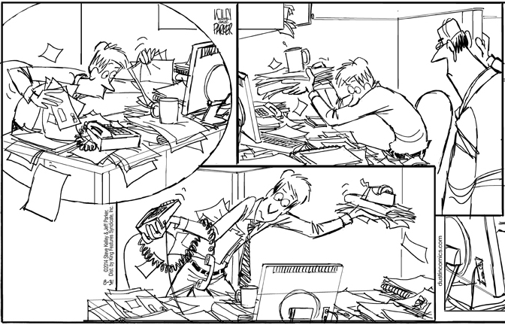
- Worksheet #1

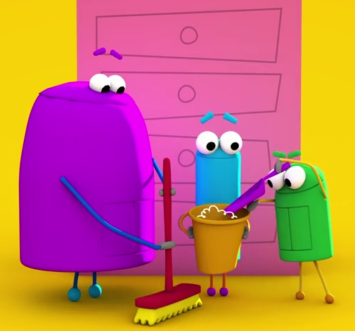
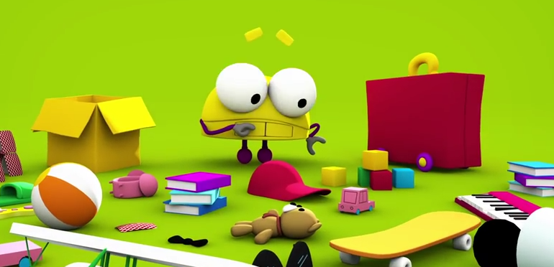
No offense,
But this place is a giant mess
In fact it looks kind a like a hurricane
picked a fight with a tornado
A disaster top to bottom,
So put these toys back where you got 'em
Because rooms don't _______ themselves
Though if they did, well, that'd be awesome!
But those haven't been designed
So now it's _______ _____ time
Go clean up, clean up
Come on, it's clean up time!
Some things go in boxes
Some things of yours belong in drawers,
Some things go in closets
So pick those things up off the floor
Because the bottom line
Is that it's clean up time
So clean up, clean up
Come on, it's clean up time!
It's more fun to make the mess than _______ it
Nonetheless I mean it: it's clean _____ time!
It's clean _____ time!
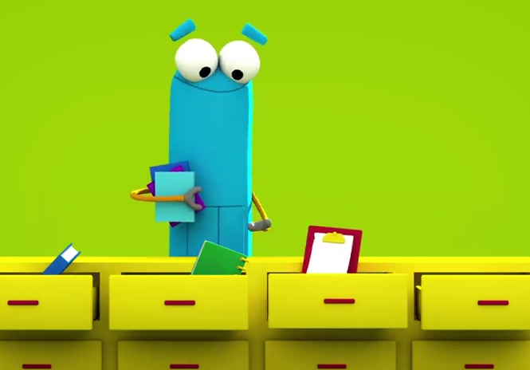


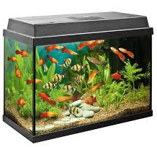
- Worksheet #2
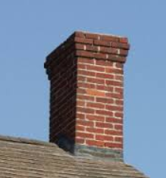

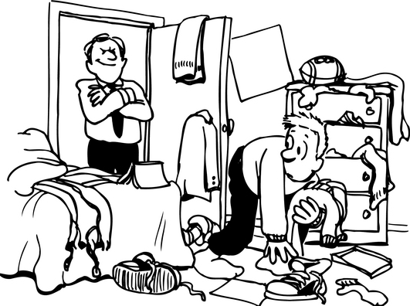

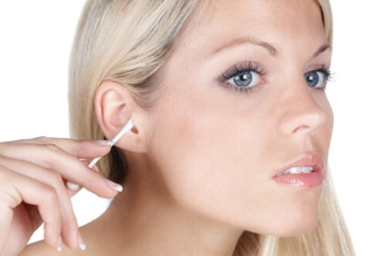
Clean ____ the chimney Clean ____ a blackboard Clean ____ the fish tank

Clean ____ your room Clean ____ your make-up Clean ____ your ears
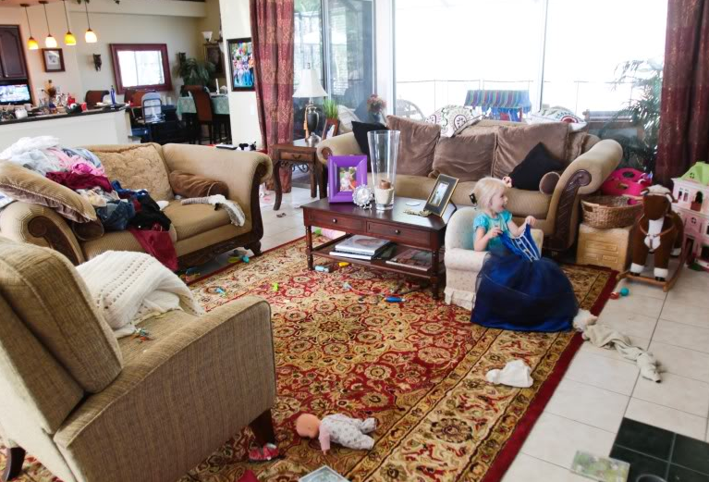
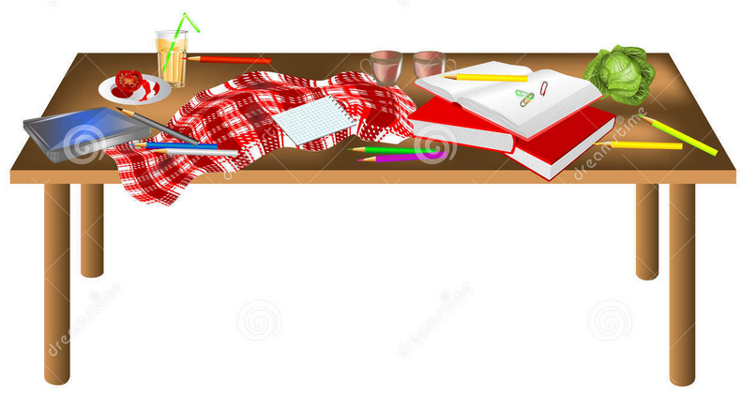
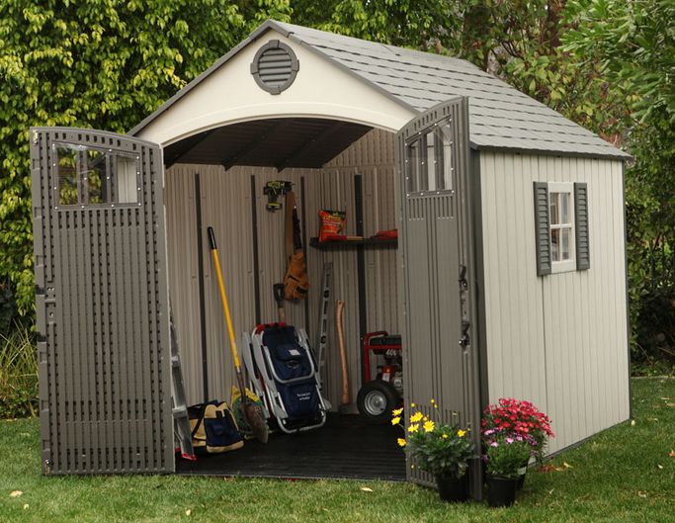

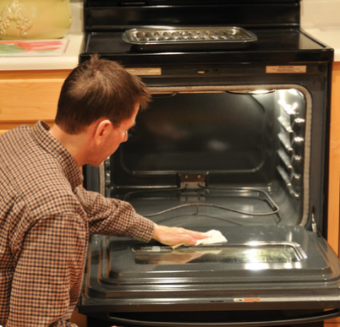
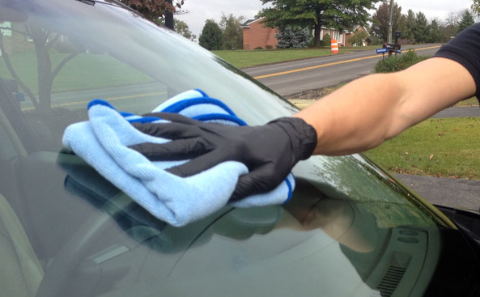

Clean ____ the house Clean ____ the table Clean ____ the shed

Clean ____ the oven Clean ____ the windshield Clean ____ your city
- Worksheet #2

Clean out the chimney Clean off a blackboard Clean out the fish tank

Clean up your room Clean off your make-up Clean out your ears

Clean up the house Clean off the table Clean out the shed

Clean out the oven Clean off the windshield Clean up your city
- Worksheet #3
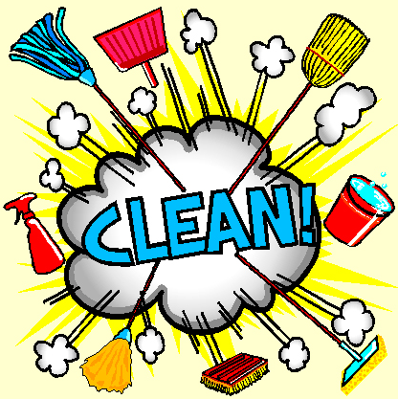
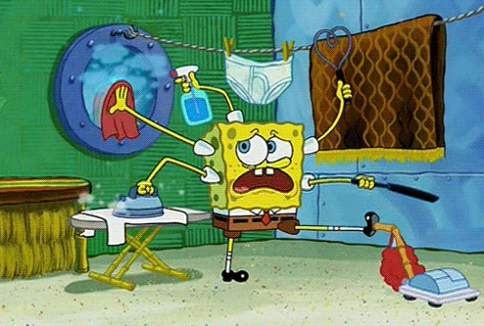
Using the 3 words, 'clean up', 'clean off', and 'clean out', write a short story or make a role-play with your partner.
- Worksheet #4
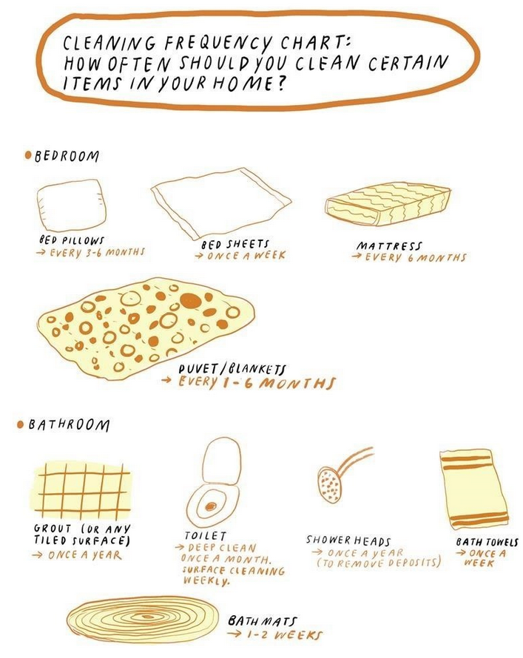
- Worksheet #4


