Listening Speaking Reading Grammar Writing

Topic:

Instructor:  Kang Eun Jung  ( Emily ) | Level:  High Intermediate ( Adult ) | Students:  5 Students | Length:  30 Minutes

Materials:
- the picture about today’s topic ( picture#1 ) : pre activity ( 5 copies )
- White board and board markers
- Fill in the blanks worksheet #1 : pre activity ( 5 copies )
- Fill in the blanks and spot differences ( worksheet # 2, # 3 )
: main activity ( 5 copies )
- video about today’s topic ( video # 1 ) : main activity
- video and worksheet about directions ( video # 2, worksheet #4 )
: post activity ( 5 copies )
- puzzle about today’s topic ( worksheet #5 ) : sos activity

Aims:
- Main aim : Ss will be able to improve their grammar skills by
understanding the topic ( prepositions ) and speaking together
- Secondary aim : Ss will be able to talk and share various expressions related to the positions and directions
- Personal aim : I want Ss to respect and understand other opinions.

Language Skills:
- Reading : Ss will read scripts of worksheet # 1 and worksheet # 2
- Listening : Ss will listen to other students’ video and music about the topic
- Speaking : Ss will talk to other Ss about directions and prepositions
- Writing : Ss will take notes about their opinions during the class

Language Systems:

- Phonology : over ; “v” , beyond ; “ b”
- Lexis : new words in the video
( beyond, across, behind, among, around the corner )
- Grammar : preposition
- Function : give a direction, and find out the place
- Discourse : role-playing, game

Assumptions:
Students already know

- How the class is set up and run ( there will be 2 and 3 students at each table )
- Four language skills and language systems
- There is / there are ~

Anticipated Errors and Solutions:
- If Ss need linguistic help to express their opinions during games
→ give them linguistic support by providing definitions and some examples.
- If some Ss keep quiet for fear of speaking to the other during games
→ encourage them to speak with ease, but if they need, correct their errors immediately during the game
- If certain students dominates the class
→ ask them to give other students a chance to speak

References:

Pictures, puzzle, game

http://www.google.com

video

http://www/youtube.com

Lead-In
Materials: None

Time | Set Up | Student Activity | Teacher Talk
1min | Whole  class | Answering teacher’s questions | Hi, everyone. How are you today?  Where is my coffee? The one on the table? Thank you.

Pre-Activity
Materials : Board, Board makers, picture #1, worksheet # 1

Time | Set Up | Student Activity | Teacher Talk
3min  1min  2min  2min | Whole  Class  individual  Whole  class | Answering teacher’s questions  Students fill in the blanks  Students check their answers | Procedure :  Brainstorming  Elicit  “ Frist, look at the picture and let’s talk about it.”  ( Show the picture #1 )  Can you explain this picture ?  Where is different ?  Additional explanation  Over the sea, there is the sun on the left and there is no sun on the right.  On the sandcastle, there is a flag on the left, and there is no flag on the right.  Model  Write the subject “ prepositions for positions” on the board.  CCQ  What is placed after a preposition?  2. New Vocabulary  Instruction  “ We are going to fill in the blanks before talking to each other.  ( distribute worksheet #1 )  Demonstration  “ Look at the number 1. What do you think is correct answer?”  “ Let’s do the rest of the questions by yourself. I will give you 2 min.  ICQ  How much time do you have to finish?  Are you doing by yourself?  “ Let’s get started “  Monitoring  Monitor discreetly. Answers students if they ask questions.  Give time warning :  1 minute left.  ( Be flexible with time. Give 1 more minute if they need )  “ Time’s over “  Check answers  Let’s check the answers together  After checking the answers, praise the students for a job well done. “Good job class! “

Main Activity
Materials: worksheet #2, worksheet # 3, computer for playing music #1 and video #1

Time | Set Up | Student Activity | Teacher Talk
4min  3min  3min  1min | individual  Whole  Class  Pairs | Students listen to the music and find out prepositions  Watch the video and talk each other  Students spotting the differences in the team  Explain the differences | 1. prediction  “ As I mentioned before, today’s topic is – prepositions for positions “  “ First of all, I will make you a group. And listen to this music and fill in the blanks.”  ( Distribute the worksheet # 2 )  ICQ  Are you working in pairs?  Do you fill in the blanks?  ( play the music # 1 )  “ Ok, everybody. Let’s fill in the blanks related to prepositions in the lyrics. And share the answer with others.“  2. Watching the video and game for the main idea.  Instruction  “ Now, we are going to watch a video introducing prepositions for positions. While watching the video, you can write down the prepositions in the video. “  ( distribute worksheet # 3 )  Demonstration  “ First find out the prepositions in the video while taking a note on the worksheet # 3. And then using the prepositions we will role play later.”  ICQ  Do you need to take a note while watching?  ( Play the video # 1without stopping )  Game  “ OK, could you please let me know the prepositions in the video? “  “ Now, please look at the worksheet # 3  Let’s spot the differences between the pictures in the team. I will give you 3min.“  ICQ  Are you in a group?  How much time do you have?  Monitoring  Monitor directly.  Time warning : one minute is left  “ Time is over.”  Feedback  “ Who will you explain the differences of the positions? “  “Thank you, good job.”

Post Activity
Materials: worksheet # 4, computer for playing video #2

Time | Set Up | Student Activity | Teacher Talk
3min  3min  3min | Group  pairs  Whole class | Students watch the video and talk in a group during the role-playing.  Students prepare for directions while talking to each other  Answers re-elicited questions of today’s lesson | Free production  ( watching the video and talk )  Instruction  “ Now, we will have a role-playing game in 2 groups. Before role-playing, you will watch the video related to the direction prepositions. Using the prepositions, you will give a direction to your partner.“  ( play video # 2 without stopping )  ( distribute worksheet #4 )  Demonstration  Do you see the picture of the map on the worksheet #4?  For example, you can ask three questions about wherever you want to find. And then your partner will give you 3 directions. Please write the directions on your paper.”  I will give you 3minutes to talk to each other .  ICQ  Are you working in groups?  How much time do you have to finish?  “ Let’s start.”  Monitoring  Monitor discreetly. Help students if they have questions.  ( give Ss time warning. 1min. give 1 more min if needed )  Feedback  “It’s time to listen to other team’s directions. Which team wants to do first? Yes, thank you.”  Conclude Lesson  Where is placed prepositions?  What is followed by preposition?  You did a good job. Remember today’s lesson. Have a good day.”

SOS Activity
Materials: worksheet #5

Time | Set Up | Student Activity | Teacher Talk
3min  2min | Whole class  Whole class | Students have a game  Students talk to each other about answers | Spot the differences  Instruction  “ Now, we are going to talk about differences in the two pictures.  Find out the differences individually first and then let’s talk to each other together. I will give you a 3 minutes to find out”  ( Distribute the worksheet #5 )  ICQ  How much time do you have to find out individually?  Time warning : 1 min is left  Check answer  “ Talk about the answers together.”

- Picture # 1

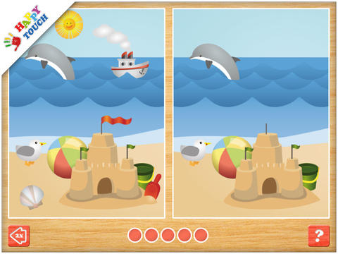

* Worksheet # 1

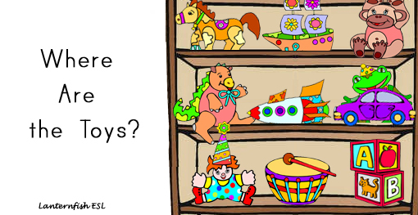

Worksheet # 1

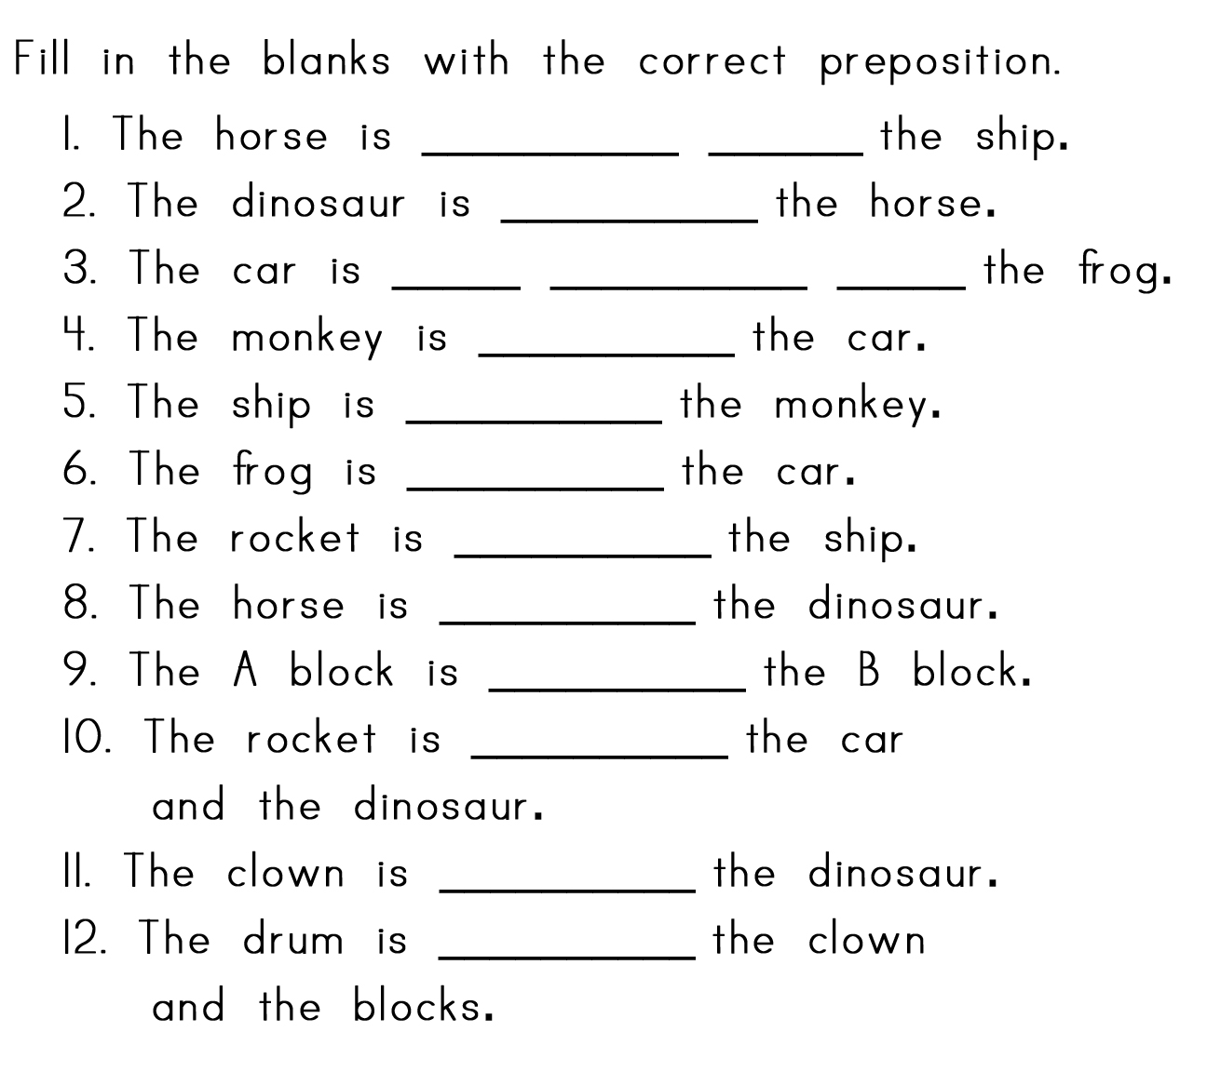

worksheet #2

Somewhere over the rainbow
- Judy Guarland -

Somewhere ( ) the rainbow, way ( ) high
There's a land that I've heard ( ) once ( ) a lullaby.
Somewhere ( ) the rainbow, skies are blue
And the dreams that you dare to dream,
Really do come true.
Someday I'll wish ( ) a star
And wake ( ) where the clouds are far ( ) me.
Where troubles melt ( ) lemon drops,
Way ( ) the chimney tops,
That's where you'll find me.
Somewhere ( ) the rainbow, blue birds fly
Birds fly ( ) the rainbow
Why then, oh why can't I?
Somewhere ( ) the rainbow, blue birds fly
Birds fly ( ) the rainbow
Why then, oh why can't I?
If happy little bluebirds fly ( ) the rainbow
Why, oh why can't I?

Worksheet # 3

While watching the video, write down all the prepositions that you see and listen to.

Worksheet # 4

Look at the map. Your are in front of the your house. Ask the direction of your partner and give the direction to her .
( While role-playing, please write down the answer B on the paper )

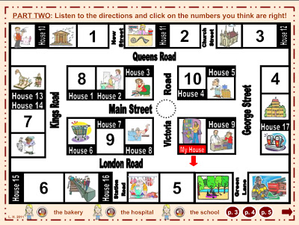

- A :
B :

- A :
B :

- A :
B :

Worksheet # 5 ( sos )



