Listening Speaking Reading Grammar Writing

Topic: Improving Reading Skills Using Comics as a Material

Instructor:  Jai Hee (Eva) Kim | Level:  High-intermediate  (Adults) | Students:  5 Students | Length:  30 Minutes

Materials:
•White board, board markers
•Computer
•Projector(Computer-connected)
•Vocabulary poster, pictures - Pre-activity
•Comic strip worksheets, picture frames (5 copies each) - Main activity
•Questions worksheet (5 copies) - Post-activity
•Vocabulary matching & fill-in-the-blanks Worksheet (5 copies) - SOS activity

Aims:
•Main Aim : Ss will be able to improve their speed in reading to understand
the main idea or the gist.
•Secondary Aim : Ss will be able to speak a more natural and conversational language.
•Personal Aims : I want the Ss to have fun reading during my class.

Language Skills:
•Reading : Comic strip (main activity)
•Listening : T's instructions, interacting with group members
•Speaking : Group activities, Mime and Dubbing (post-activity)
•Writing : Questions worksheet (post-activity), Vocabulary worksheet (SOS activity)

Language Systems:
•Phonology : 'augh' from 'Laughed' [/laf/] Vs. 'augh' from 'Caught' [/kôt/]
•Lexis : Vocabulary during pre-activity ("Stuff up", "Tuck into", etc.)
•Grammar : Phrasal verbs and idioms
•Function : Complaining / Asking for sympathy
•Discourse : Dialogue / Monologue

Assumptions:
Ss already know
•how the class is set up and run (a table of 3, and a table of 2 student groups)
•phrasal verbs and idioms
•the comic strip "Garfield" and that it is funny
•the language skills and systems

Anticipated Errors and Solutions:
•If time is running out, shorten the discussion time
•If there is more time than planned, give Ss extra time for discussion (SOS)
•If Ss make grammatical errors, note it for another grammar teaching class
•Review pre-activity(spiraling) if Ss make vocabulary mistakes

References:
•Pictures for vocabulary (Pre-activity) : Google images
•Garfield comic strip (Main activity) : Square Root of Minus Garfield
•Vocabulary worksheet (SOS activity) : Definitions & sentences from Google,
The Free Dictionary,
Merriam Webster Dictionary

Lead-In
Materials:
Time | Set Up | Student Activity | Teacher Talk
1min | Whole Class | •Greeting  •Answering T's questions | Procedure  •Greeting  -Hello, everyone!  •Eliciting  -Who knows a famous comic strip that introduces a fat, orange cat?  -Yes, "Garfield"! Garfield is one of my favorite comics!  •Introducing the topic  - Garfield is bred by, or rather breeds his owner, Jon. Let's see what Jon has been up to today and maybe you can relate his experience to yours.

Pre-Activity
Materials: Vocabulary poster, pictures, white board, sticky tape
Time | Set Up | Student Activity | Teacher Talk
4min | Whole  Class | •Answering T's questions  Sticking pictures on the posters and reading vocabulary | Procedure  Vocabulary(Phrasal Verbs)  (Stick the vocabulary poster on the board with sticky tape.)  •Instructions  -Everyone may choose 2 pictures each and each person will first show a picture to the class up close and then stick the picture below the matching verb.  •Demonstration  -Let me demonstrate one as an example.  -Which phrase does this picture match?  (Show the first picture on "stuff up a nose" and stick it on the poster below the matching vocabulary.)  -Why don't _____ start, and move clock-wise?  (Let Ss choose two pictures each but upside down so they cannot see.)  -You may all look at your pictures now.  -_____, which phrase does your picture match?  -_____, which expression goes well with your picture?  •CCQ  -Everybody, please stand up.  -Simon says, tuck your shirt into your pants or skirts.  -Simon says, stuff your finger up your nose. Hahaha!

Main Activity
Materials: Comic strips worksheets(2 copies), picture frames(2 copies each), glue(2 tubes), Questions worksheets(5 copies)
Time | Set Up | Student Activity | Teacher Talk
2min  5min  3min  4min | Groups  /Pairs  Whole  Class  Whole  Class | •Answering T's questions  •Interacting with partners  •Reading out loud  •Answering T's questions | Procedure   Task 1 : Sequencing  •Instructions  -I hope you all remember that we are going to read an episode from the "Garfield" comics.  -The comic strips are, however, not complete.  -It is your duty to complete it by placing the individual frames on the missing parts.  (Distribute both the worksheet and the cartoon frames.)  •Demonstration  -Let's try one frame as an example.  (Choose cut #1 and show to class.)  -This is Jon. He says to Garfield, "I can't believe it!" and by the looks of it, he is all cleaned-up and what he is saying is usually the beginning of a conversation, therefore, it goes to the first missing frame.  -Now in groups, find the correct/logical order of the frames so the whole comics make sense.  -The two of you will work as a pair and the three of you as a group. (Gesture.)  -I will give you 5 min.  •ICQ  -What do you do with the individual picture frames?  -Are you working in groups?  -How much time do you have?  -You may begin.  •Monitoring  (Discreetly monitor and aid those in trouble doing the exercise.)  (Give time warning if needed.)  -Time is up.  •Reading/Checking Answers  (Distribute a tube of glue for each group)  -Let's go over this together.  -Let's take turns to read one speech bubble each.  -As we go through it together, you may glue the frames in the correct places if you want.  (Distribute Questions Worksheet)  -Now let's work on the worksheet together.   Task 2 : Skimming to Find the Gist  •CCQ : Guessing the Title  (Ask a S to read the question & then answer)  -Yes, the answer is, #2.   Task 3 : Scanning to Find Details  •CCQ : Finding the Details  (Ask a S to read the question & then answer)  -1) A : He stuffed a breadstick up his nose.  -2) A : Twice - knocked the candle over, and while brushing his teeth   Task 4 : Improving Comprehension Level  •CCQ : Anwering Interpretive Questions  (Ask a S to read the question & then answer)  -1) A : Jon tried to take his anger out on the cab driver...  -2) A : Probably not...

Post Activity
Materials:
Time | Set Up | Student Activity | Teacher Talk
2 min  4min  3min  2min | Groups  /Pairs  Whole  Class | •Answering T's questions  •Interacting with partners  •Interacting with all Ss | Procedure  (Get a timer ready in hand.)  •Instructions  -In your groups, make a short scene to act out without dialogue by putting together each person's unlucky or unfortunate moment that happened in real life.  -Each group will come to the front and mime their own scenes and the other group will have to guess in 15 sec.  -Remember, miming means no speaking, but only body language.  •Demonstration  -Let me give you an example.  (Mime my own experience and make Ss guess.)  -You have 4 min. to prepare the scene first.  •ICQ  -What will you be preparing?  -Are you allowed to speak?  -Are working as an individual?  -How much time do you have?  -You may start now.  •Monitoring  (Discreetly monitor and add ideas if Ss have trouble writing)  (Give time warning if needed)  -Time is up.  -Each group please mime your scene in front of the class. The other group must guess the correct situation within 15 sec.  •Error Correction & Feedback  -I hope today's activity helped you improve your reading and comprehension skills.  -Did you enjoy the activity?  -What were your difficulties?  (Have students freely analyze their own difficulties and errors. This would still be part of their speaking moment)  -You guys did a good job! Have a great day!

SOS Activity
Materials: Vocabulary definitions & fill-in-blanks worksheets(5 copies)
Time | Set Up | Student Activity | Teacher Talk
(If needed) | Whole  Class | Ss do the exercises | (Distribute the worksheets)

[Pre Activity : Vocabulary Poster]

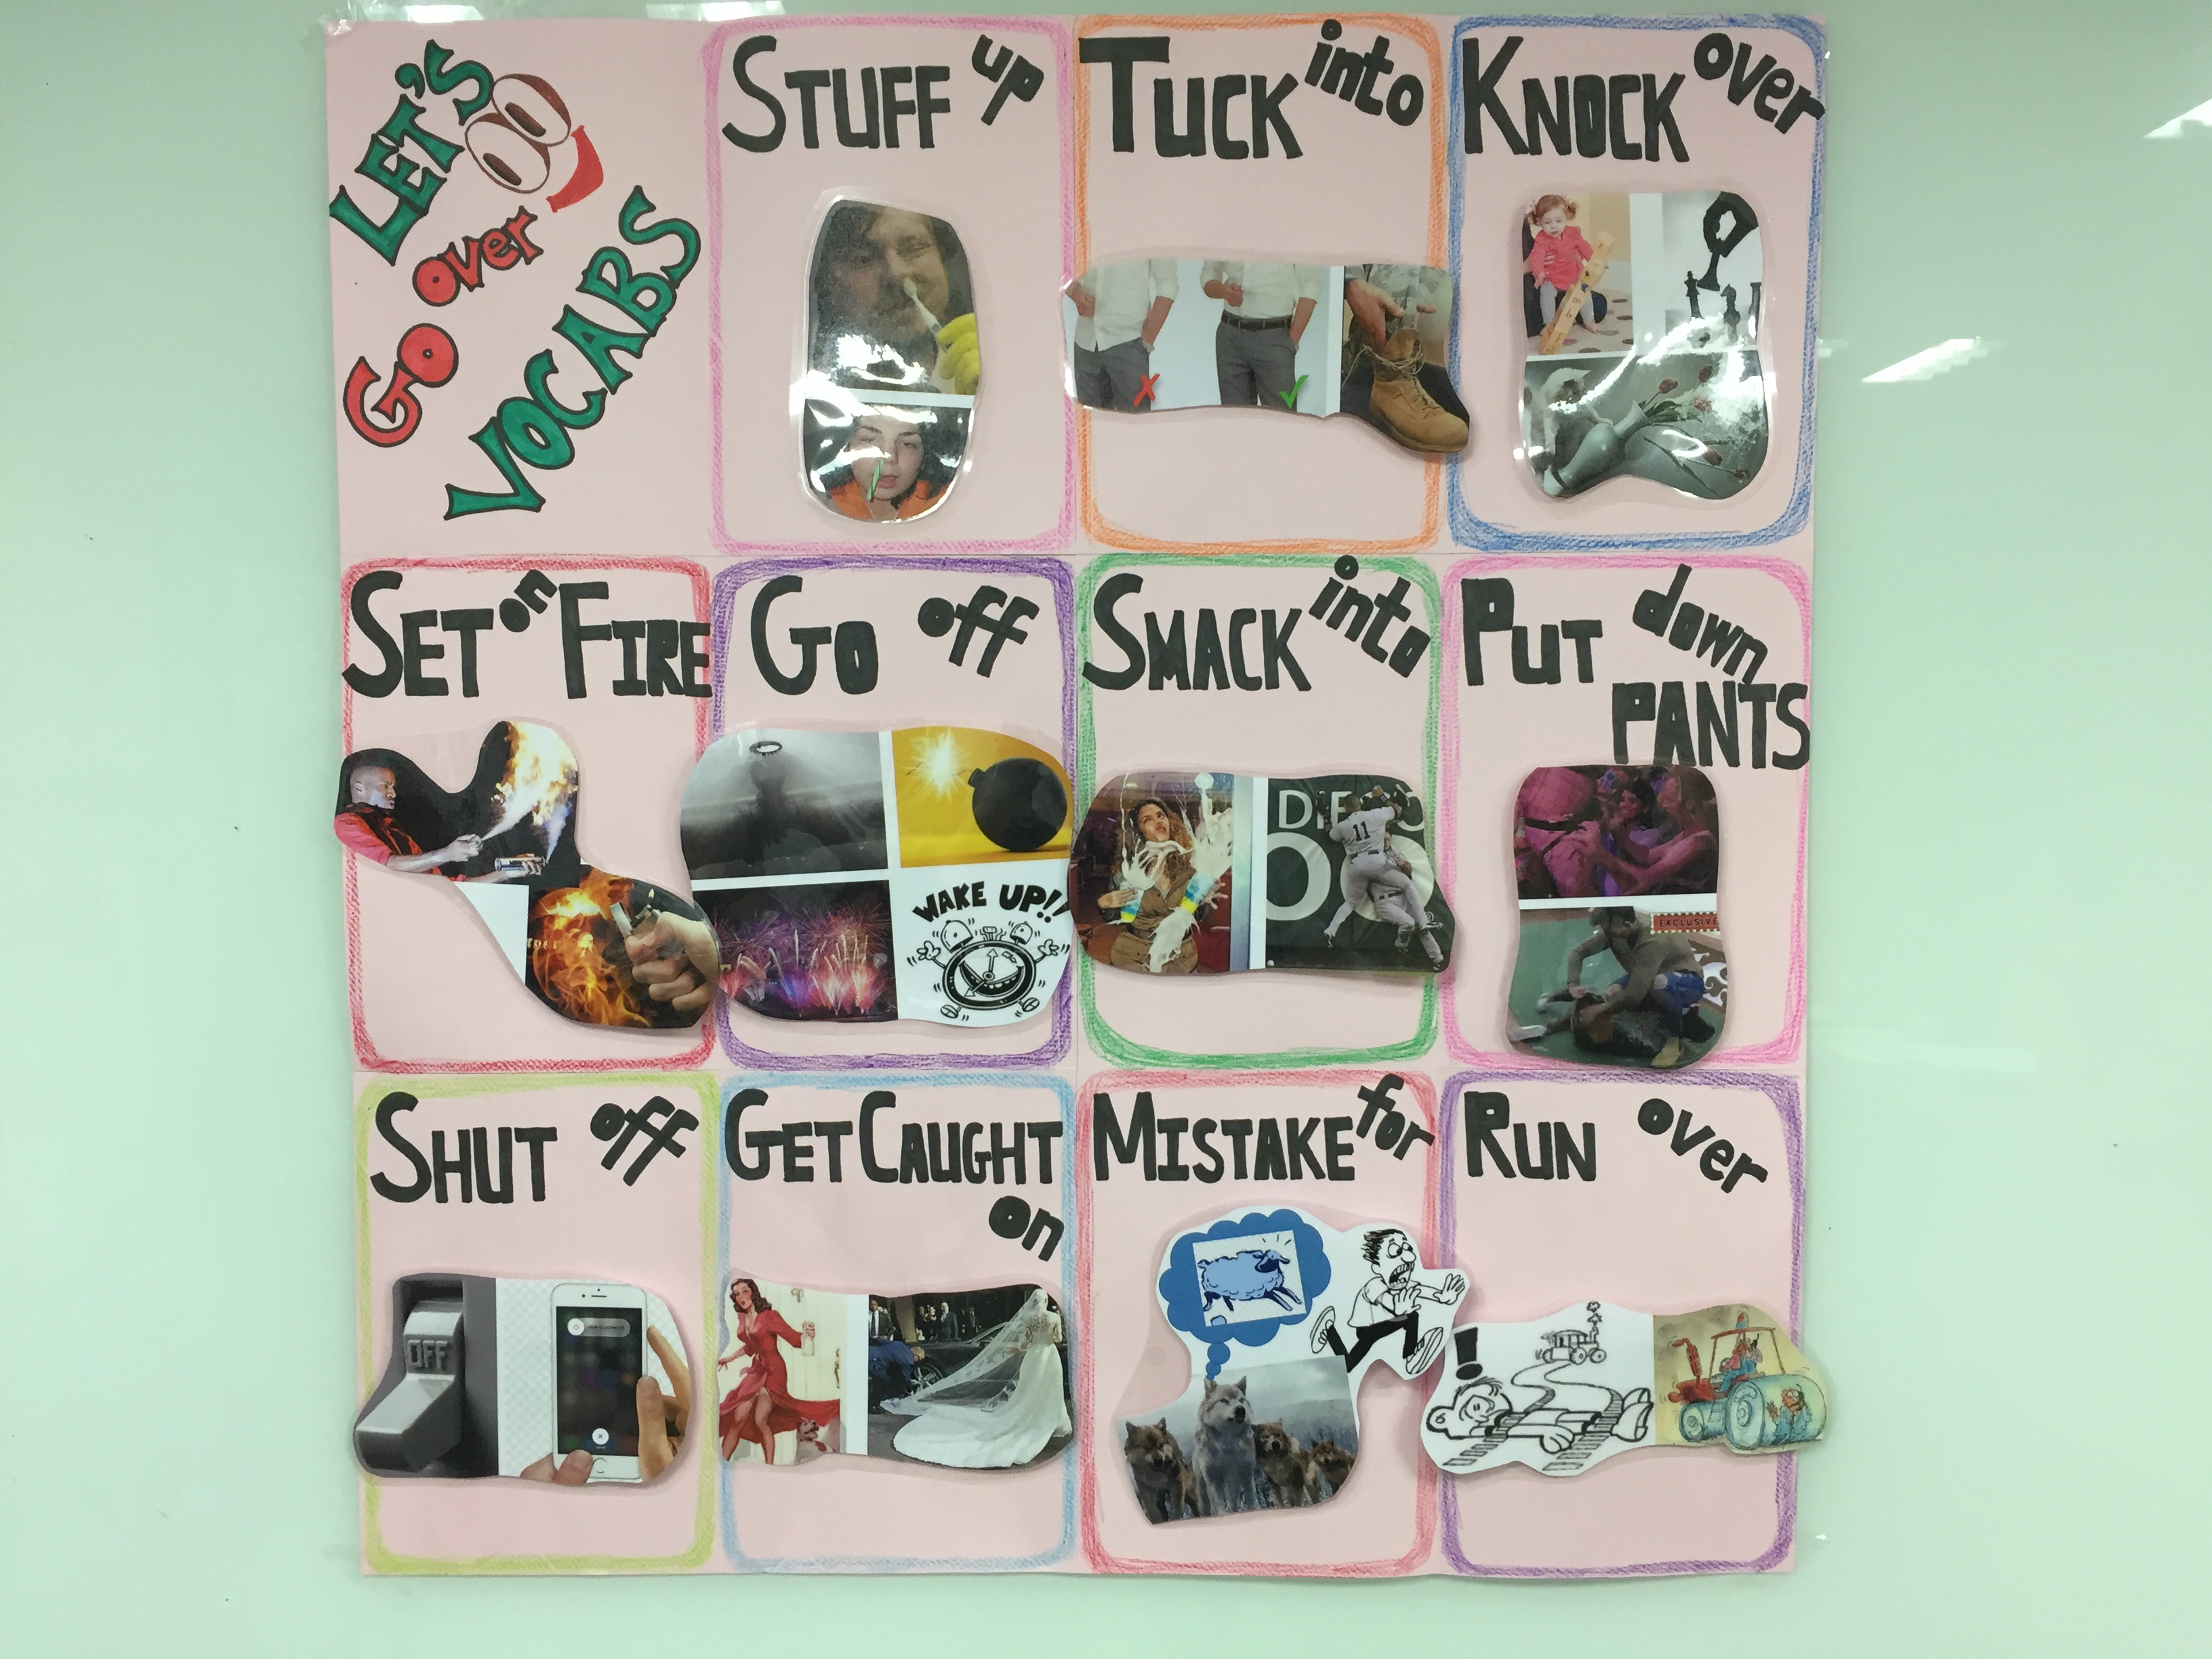
[Main Activity : Sequencing Garfield Comic Strips in Correct Order]

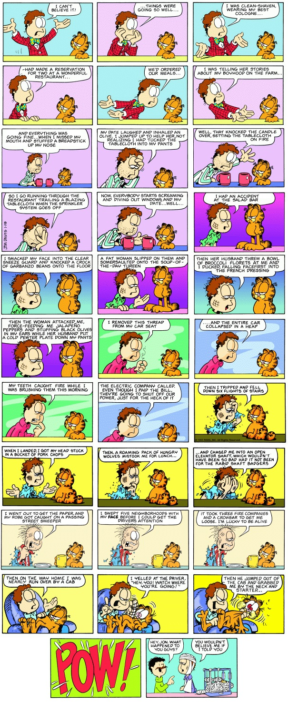
[Main Activity : Questions Worksheet]

1. Skimming : Get the Main Idea
Choose the correct title for this particular comic strip.
(1) Jon's Unbelievably Unlucky Date
(2) Jon's Terrible, Horrible, No Good, Very Bad Day
(3) Jon's Major Car Accident

2. Scanning : Find the Details
1) What was Jon's first behavior that was the start of his misfortune?

2) How many times did Jon cause fire today?

3. Checking for more comprehension abilities
1) Do you think Jon tried to take his anger out on anyone?

2) Would anybody believe Jon if he told his whole story?

[SOS Activity : Vocabulary Worksheet]

1. Match the verbs with the correct definitions
1. | stuff up | a. | Explode, detonate; also, make noise, sound, especially abruptly
2. | get caught on | b. | Cause to ignite and burn
3. | go off | c. | To gather something up and fold or thrust it into something so as to secure or confine it
4. | smack into | d. | to collide with, knock down, and often drive over
5. | tuck into | e. | Take someone or something for someone or something else
6. | run over | f. | (used especially in relation to water, electricity, or gas) stop (or cause something to stop) flowing
7. | knock over | g. | To become held, entangled, or fastened
8. | mistake for | h. | To force something upward or up into something
9. | shut off | i. | To hit something abruptly and cause it to topple or fall to its side
10. | set on fire | j. | to strike sharply, especially into a flat object

2. Fill in the blanks with the correct verbs from the above list.
1) I moved the lamp because every time I walked by it, I ________ it ________.
2) Someone ________ ________ my bike which broke it into pieces.
3) The drought and high wind combined to ________ the woods ________ ________.
4) I'm sorry, I ________ you ________ your sister because you two look so much alike.
5) I wrote the number on a piece of paper and ________ it ________ my pocket.
6) The engines ________ ________ automatically when too much energy is being wasted.
7) He tried to hide the book by ________ it ________ the chimney.
8) Fireworks were ________ ________, signaling the end of the race.
9) The dog ________ ________ the mirror not knowing what a reflection is.
10) Her dress ________ ________ ________ the sliding door and all the men opened their eyes widely.

