Listening Speaking Reading XX Grammar Writing
Topic: We Can Do It
Language Target (Auxiliary Verb)
Instructor:  Olivia |  | Students Competency Level  Pre-intermediate |  |  | Number of Students:  8 |  |  | Lesson Length:  56 minutes
Materials: (List the Names of all materials used in the lesson. Materials must be shown at the end of this document)
White Board and Marker
Activity Pictures
Cooking
Swimming
Singing
Dancing
Baseball
Basketball
Aims: (What students will be able to achieve by participating in the activities of the lesson. (Ss gain or get by doing…)
- Improve Ss speaking skills by talking to communication activity.
- Improve Ss listening skills by listening to S’s stories.
- Ss can consider about English words and practice the grammar during the activities of the lesson.
- Ss can learn about interaction with other students and feel comfortable during the group activity discussing time.
- Ss can improve their understanding of auxiliary verbs by completing the work sheet.
Language Skills: (Lists what activities language skills students will be using by participating in the activities of the lesson.)
- Reading: (Where did reading occur in the lesson?)
Read about the work sheet
- Listening: (Where did listening occur in the lesson?)
Sharing Ss stories about activity work sheets
- Speaking: (Where did speaking occur in the lesson?)
Ss stories about their stories, Answering, Feedback
- Writing: (Where did writing occur in the lesson?)
Writing sentence about we can do it activity in work sheets
Language Systems: (Lists what language systems students will be using by participating in the activities of the lesson.)
- Phonology: (sound)
Teacher feedback, instruct direction, T and Ss Talk
- Lexis: (meaning)
Words about activity worksheets and discuss Ss.
- Grammar: (language structure)
Auxiliary Verb
- Discourse: (communication)
Share question and answer, playing activity
Assumptions: (What students must already be able to do and what concepts must already be mastered before the lesson in order to achieve the aims of the lesson.)
- All Ss know about Auxiliary Verb and use of axillary tense.
- All Ss can through answering and their opinion.
- All Ss already know the auxiliary verb used to discuss.
Anticipated Errors and Solutions: (What things might go wrong in the lesson and what the solution will be. An SOS activity should also be included)
- When they don’t know how to explain by English.
- If Ss don’t understand T will show and tell about T’s stories.
- If Ss are wrong give positive reaction so that they can solve their problems by themselves.
References:
Lead-In or Pre-Task Part (Warm-Up Part to activate and create interest in the lesson.)
Materials: (List the Names of all materials used in the Lead-In or Pre-Task Part of the lesson. Materials must be shown at the end of this document)
Time: | Classroom Set Up: |  | Student Activity and Goals: | Teacher Procedure & Instructions:
1 min  7 min  10min | Whole  Whole  Whole |  | Ss greet the teacher.  Ss listen to T.  Ss talk their opinion and story. | Greeting teacher  Tell teacher's Story about I can do it. Let's discuss about stories with Ss.  Ask Ss to share their story about what they can and cannot do.
Pre-Activity or Task Familiarization Part (Presentation Part Presenting the language structure to be covered in the lesson. Prepares students for the communication activity.)
Materials: (List the Names of all materials used in the Pre-Activity or Task Familiarization Part of the lesson. Materials must be shown at the end of this document)
Activity Pictures
Cooking
Swimming
Singing
Dancing
Baseball
Basketball
Time: | Classroom Set Up: |  | Student Activity and Goals: |  |  | Teacher Procedure & Instructions:
5 min  3 min  6 min | Whole  Whole  Whole |  | Ss listen How to do T.  Ss do prepare for discuss their opinion.  Ss share their opinion. |  |  | Ss understand the language target and explain by teacher demonstrate.  Ask Ss to prepare for worksheet. T will help and facilitates.  T gives the work sheet.
Main Activity or Task Realization Part (Practice to Production Part Teacher lead practice of the language presented and move to communication based more student centered activity)
Materials: (List the Names of all materials used in the Main Activity or Task Realization Part of the lesson. Materials must be shown at the end of this document)
White Board and Marker
Auxiliary Verbs Worksheet
Time: | Classroom Set Up: |  | Student Activity and Goals: |  |  | Teacher Procedure & Instructions:
1 min  1 min  2 min  7 min  4min  5 min | Whole  Groups  Wohle  Groups  Whole  Whole |  | Ss get ready for activates.  Ss make a group Ss do activity.  Listen T instructions and prepare to activity.  Ss watch listens and enjoys.  Ss listen to other Ss discuss.  Ss listen what T says. |  |  | T gives Auxiliary Verbs Work Sheet  Make four groups of two people each.  T monitors their activities.  Introduce We can do it activity and how to do activity.  T watches each groups and facilitates class to activities.  T watches discussing Ss and positive feedback.  Give Ss positive feedback and comments.
Post Activity or Post Task Part (Wrap-Up Part Close the Lesson on a high note to and consolidate language learned in a communication based activity new situation.)
Materials: (List the Names of all materials used in the Post Activity or Post Task Part of the lesson. Materials must be shown at the end of this document)

Time: | Classroom Set Up: |  | Student Activity and Goals: |  |  |  | Teacher Procedure Instructions:
3min  1min | Whole  Whole |  | Share about activity work sheet Ss opinion.  Thank teacher and say goodbye |  |  |  | Close by giving Ss feedback about their improvement. By ask Ss to describe another classmate using language target.  Close by giving feedback.

Auxiliary Verbs Work Sheet
1. EX ) I Can ___drive a car_____.
- I Can ________________.
1.
2.
3.
4.
5.
2. EX) I can’t swim___.
- I can’t _____________.
1.
2.
3
3. EX) __Olivia __ can ride a horse____.
- ___Partner’s name__ Can _________________.
1.
2.
3.
4. EX) I will learn to swim___.
- I will ____________________.
1.
2.
3
5. EX) __Olivia will learn to swim ____.
- __ Partner’s name__ will __________.
1.
2.
3.
Direction: write about what I can do or I can’t do. And then write your partner’s three possible things. Next, write three thinks about what you will do and partner will do.

Activity Pictures
Cooking
Swimming
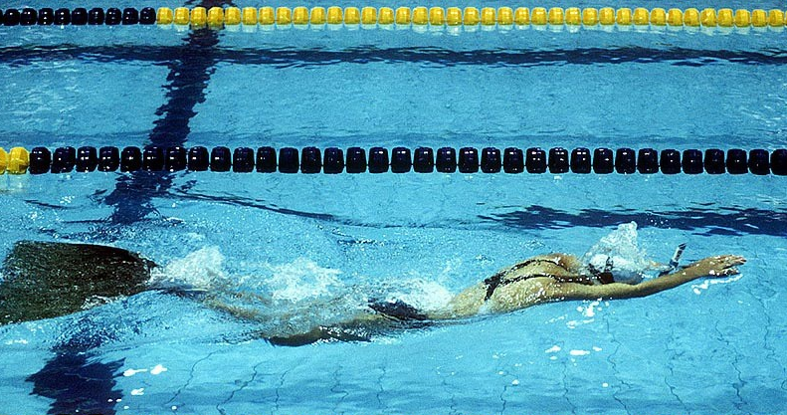
Singing

Dancing
Baseball
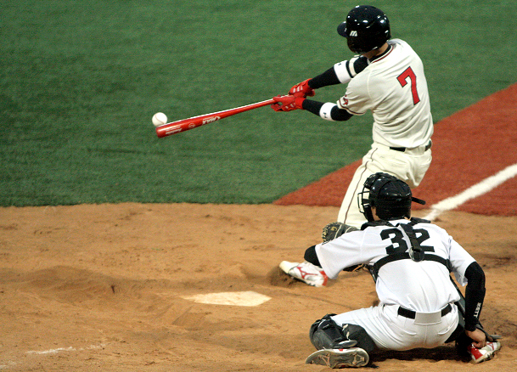
Basketball

Auxiliary Verbs Work Sheet
