Listening Speaking Reading XXXGrammar Writing
Topic: Where is my dog?

Instructor:  Seong Mi | Students Competency Level  Upper beginner | Number of Students:  6 | Lesson Length:  56min
Materials: (List the Names of all materials used in the lesson. Materials must be shown at the end of this document)
- Preposition Flash Cards
*In
*On
*Under
*In front of
*Next to
*Between
*Behind
- Wall Chart : What Is Different Between The Left and Right Picture?
- Paper and Pens
- Whiteboard
Aims: (What students will be able to achieve by participating in the activities of the lesson. (Ss gain or get by doing…)
- Ss can increase interests by listening to T’s story and telling their stories.
- Ss will be accustomed to expressing the location of objects by using prepositions.
- Ss can improve communication skills by listening to other students’ sentences
describing the location and drawing them
Language Skills: (Lists what activities language skills students will be using by participating in the activities of the lesson.)
- Reading: (Where did reading occur in the lesson?)
Preposition Flash Cards, by making Ss’ own sentences describing the location.
- Listening: (Where did listening occur in the lesson?)
Teacher’s talk, by listening to T and other students during all the activities.
- Speaking: (Where did speaking occur in the lesson?)
By telling Ss’ stories, repeating what T says, answering “what is different”
question.
- Writing: (Where did writing occur in the lesson?)
By making Ss’ own sentences describing the location.
Language Systems: (Lists what language systems students will be using by participating in the activities of the lesson.)
- Phonology: (sound)
listen and repeat, Ss’ stories, doing “what is different” activity.
- Function: (situation)
Teacher’s story(where is my dog?).
- Lexis: (meaning)
Expressions using prepositions.
- Grammar: (language structure)
Prepositions about the location
- Discourse: (communication)
Ss’ stories, making their own sentences together.
Assumptions: (What students must already be able to do and what concepts must already be mastered before the lesson in order to achieve the aims of the lesson.)
- All Ss know the meaning of the word ‘where’.
- All Ss understand the concept of space.
- All Ss know be verbs.
Anticipated Errors and Solutions: (What things might go wrong in the lesson and what the solution will be. An SOS activity should also be included)
- Some of Ss can’t repeat what T says when Ss practices speaking the expressions
using preposition.
☞ T says again and let Ss repeat more than twice.
- when doing “what is different” activity, Ss can’t find the difference.
☞ T gives a hint that describes the position when letting Ss know the answers.
References:

Lead-In or Pre-Task Part (Warm-Up Part to activate and create interest in the lesson.)
Materials: (List the Names of all materials used in the Lead-In or Pre-Task Part of the lesson. Materials must be shown at the end of this document)

None

Time: | Classrom Set Up: | Student Activity and Goals: | Teacher Procedure & Instructions:
1min  3min  8min | Whole  Whole  Ss – W | Greeting  Ss listen to T with interest.  Taking turns, Ss speak their experiences joyfully. | Greeting.  T says an event happening yesterday to Ss.(T and her brother were looking for their dog and found it .)  Elicit the stories from Ss. Ask Ss if they have an experience where they lost something and found it  in the house.

Pre-Activity or Task Familiarization Part (Presentation Part Presenting the language structure to be covered in the lesson. Prepares students for the communication activity.)
Materials: (List the Names of all materials used in the Pre-Activity or Task Familiarization Part of the lesson. Materials must be shown at the end of this document)

- Preposition Flash Cards
*In
*On
*Under
*In front of
*Next to
*Between
*Behind

Time: | Classroom Set Up: | Student Activity and Goals: | Teacher Procedure & Instructions:
1min  4min  3min | Whole  Whole  T - Ss | Listen carefully  ,watching the cards.  Repeat what T says  twice.  Each S answers the question. | As T shows each card and describes the cards.  Teacher says again and let Ss repeat what T says twice.  T asks each student where s ball is and listen to their answer. If a student is wrong, T will give a positive response and correct the answer.

Main Activity or Task Realization Part (Practice to Production Part Teacher lead practice of the language presented and move to communication based more student centered activity)
Materials: (List the Names of all materials used in the Main Activity or Task Realization Part of the lesson. Materials must be shown at the end of this document)

- Paper and Pens
- Preposition Flash Cards
*In
*On
*Under
*In front of
*Next to
*Between
*Behind

Time: | Classroom Set Up: | Student Activity and Goals: | Teacher Procedure & Instructions:
3min  1min  3min  2X  15  min  1min | Whole  Groups  Groups  Groups  S-S  Whole | Listen.  Move to make groups.  Ss prepare in a group.  Everything below happens twice.  Ss participate.  Listen with pleasure. | T gives instructions of describing the location and drawing activity. (Make 3 sentences describing the location of objects. If one group says 3 sentences slowly, the other group draws the picture, referring to what they listened to and understood.)  Divide Ss into 2 groups.  Ask Ss to make 3 sentences describing the location  of objects and monitor Ss are doing well.  Everything below happens twice.  Let one group say their sentences and the other group draw referring to what they listened to and understood. And Monitor.  Give Ss positive feedback and comments.

Post Activity or Post Task Part (Wrap-Up Part Close the Lesson on a high note to and consolidate language learned in a communication based activity new situation.)
Materials: (List the Names of all materials used in the Post Activity or Post Task Part of the lesson. Materials must be shown at the end of this document)

- Wall Chart : What Is Different Between The Left and Right Picture?
- Whiteboard

Time: | Classroom Set Up: | Student Activity and Goals: | Teacher Procedure Instructions:
3min  3min  5min  2min | Whole  Whole  Whole  Whole | Watch and listen  with interests.  Focus on what T is  doing.  Ss join and answer.  Listen and give a big hand to each other. | T puts a wall chart on the board and introduce the chart.  T gives introductions to Ss and shows first.  (T asks Ss to find the difference between two pictures and describe of using the language target it.)  Ask “What is different?” of each student.  Close activity and give Ss encouraging feedback and let Ss give a big hand to each other.

Preposition Flash Cards

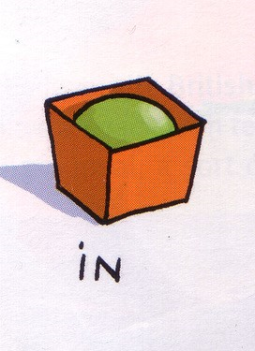
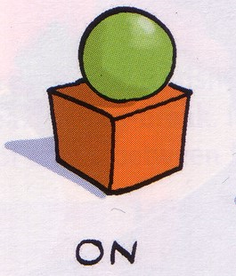

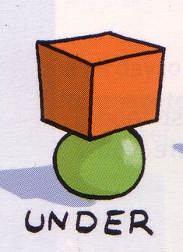
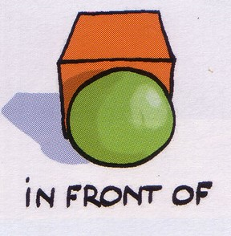
Preposition Flash Cards
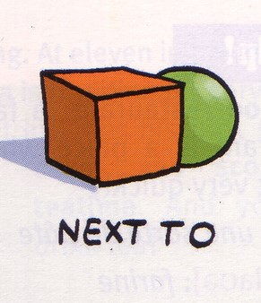
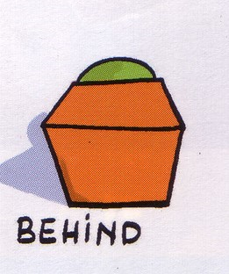
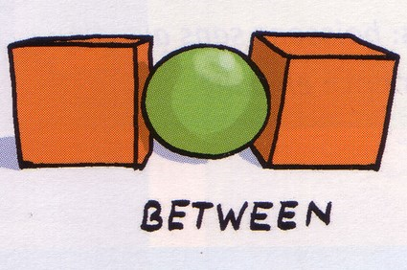

Wall Chart : What Is Different Between The Left and Right Picture?
