Listening Speaking Reading Grammar Writing

Topic: Free time activities

Instructor:  Hyunjin Oh (Jinny) | Level:  Intermediate | Students:  4 | Length:  30 Minutes

Materials:
- Board and a marker (pre-activity)
- Ranking worksheet (pre- activity)
- Truth or Lie worksheet (main-activity)
- How often do you…? Questions worksheet (post-activity)
- Word order worksheet (SOS activity)

Aims:
- Main aim: Ss will be able to divide adverbs of frequency by ranking them.
- Secondary aim: Ss will be able to share ideas what they do in free time through conversation activity.
- Personal aim: I want Ss to use more variety adverbs of frequency when they talk.

Language Skills:
- Reading: Ss will read adverbs on a few worksheets and some sentences on how often do you..? worksheet.
- Listening: Ss will listen teacher’s talk and other students’ opinions.
- Speaking: Ss will talk about what they do in free time.
- Writing: Ss will rank the adverbs on the worksheet.

Language Systems:
- Phonology: often (some people pronounce the T in often but many others do not.)
- Lexis: frequency, frequent, frequently
- Grammar: How often do you…?
- Function: To ask what things to do in free time
- Discourse: conversation about what Students do in free time

Assumptions:
- Ss don’t use many different adverbs.
- Ss may confuse with the position of the adverbs.

Anticipated Problems and Solutions:
- Some students may have difficulty ranking the adverbs by themselves.
- Make them work with classmates.
- Ss might have no idea about the topic.
- Give some lists which Ss can refer to.

References:
- https://giftsandcollectiblesgalore.wordpress.com/2012/12/07/a-secret-list-for-the-hard-to-buy/question-mark-face/ (question mark photo on ranking worksheet)
- http://www.grammar.cl/Basic/Adverbs_Frequency.htm (ranking information)
- http://busyteacher.org/11221-5-advantageous-tips-adverbs-of-frequency.html (truth or lie game)
- http://www.ecenglish.com/learnenglish/lessons/word-order-adverbs-frequency(SOS activity)
- http://www.englisch-hilfen.de/en/grammar/adverbien1.htm (SOS activity)

Lead-In
Materials: board and a marker
Time | Set Up | Student Activity | Teacher Talk
1min  3min | Whole class  individually | Listening teacher’s talk and speaking  Speaking | Hi, guys! How was your weekend?  (Wait Ss responses)  What do you do in your free time?  (Wait Ss responses)  How often do you…?  (wait Ss responses)  How often do you go to a library after class?  (wait Ss responses)  (Teacher tries to draw out adverbs of frequency from students as many as possible)

Pre-Activity
Materials: a raking worksheet, board, markers
Time | Set Up | Student Activity | Teacher Talk
1min  3min  1min  1min | Whole class  In pair  In pair  Whole class | Listening teacher’s talk  Complete the worksheet  Write the ranking on the board  Check the answers | (Hand out the worksheet)  Introduction  As you can see, there are 9 adverbs. You need to rank. I will give you 3min to finish it and fill the blanks with your partner.  I.C.Qs  What will you do with the adverbs?  (ranking)  How much time do you have?  (2min)  Who work with you?  (partner)  Okay, let’s start.  (Draw 2 pyramids on the board and  give time warning)  1minutes left.  Okay, time’s up.  If you are ready to share, please write them on the board.  It’s not the exact numbers, but percentage can give more concrete definition to the words.

Main Activity
Materials: Truth or lie worksheet
Time | Set Up | Student Activity | Teacher Talk
3min  7min  5min | Whole  Class  In pair  In pair | Listening teacher’s talk  Making sentences and sharing ideas with partner  Speaking sentences and guessing a not true sentence | We will play a game which is True or Lie. I will give you examples.  Modeling  I seldom go shopping at Hyundai department.  I often go hiking on the weekends.  I usually go to window-shopping.  Two of them are true, the other is Lie. You should find “Lie”. Can you guess what Lie is? (Wait Ss responses )  Yes, third one is Lie. I sometimes go window-shopping.  Instruction  (Hand out the worksheets)  There are 9 different adverbs on the paper. Your team makes a sentence with the adverb which is next to number.  When you make a sentence, think about what you do in free time. I will give you a paper which you can refer.  If you don’t have any idea, you can get some ideas on the internet as well.  As I told you, one should be a lie.  We will take 3 turns for each team.  Group 1 will read first 3 sentences and then Group 2 will guess which sentence is not true. And Group2 will read their first three sentences.  I will give you 7 min to prepare.  I.C.Qs  What is related to your sentences?  (free time activities)  How much time do you have? (7min)  Who work with you? (partner)  Are three sentences all truth? (No)  Can you use your phone to search?  (yes)  (monitor Ss activities  And give time warning)  1minutes left…  Okay time’s up  Group 1 will go first. Please read your  First 3 sentences. (Group 1 read)  Okay, Group 2, please guess what’s the lie. (Group 2 guess)  (Do this game until they take turn 3 times)  Which team is good at lying?  (Wait Ss responses)

Post Activity
Materials:
Time | Set Up | Student Activity | Teacher Talk
1min  5min | Whole class  In pair | Listening teacher’s talk  Reading the cards and answering the questions | Instruction  In this time, you and your partner work together. There are 10 questions for each team.  One will pick a card and read the question to your partner. The partner will answer. And the answer should pick another card. This activity will end when your team has no cards. I will give you 5 min.  I.C.Qs  How much time you have? (5min)  Who work with you? (partner)  Will you keep asking questions? (No)  Okay, let’s start  (Monitor Ss activity)  Time’s up.  Good job! See you tomorrow ☺
SOS Activities
Materials: word order worksheet
Time | Set Up | Student Activity | Teacher Talk
1min  3min  1min | Whole class  Individually  Whole class | Listening teacher’s talk  Completing the worksheet  Speaking and checking the answers together | Instruction  Read first paragraph and finish the worksheet by yourself. I will give you 3 min.  I.C.Qs  How much time do you have? (3min)  Are you going to work with partner?(No)  Okay, let’s start.  (monitor Ss activity)  Time’s up  Let’s check together  Good job, guys. See you tomorrow☺

Rank adverbs of FREQUENCY

sometimes often (frequently) never occasionally usually
always seldom rarely (hardly ever) normally (generally)

100%

90%

80%

70%

50%

30%


10%

5%

0%

Truth or Lie Game (Group 1)

1. always

2. sometimes

3. seldom

1. usually

2. occasionally

3. never

1. often

2. rarely (hardly ever)

3. normally (frequently)

Truth or Lie Game (Group 2)

1. sometimes

2. rarely (hardly ever)

3. normally (generally)

1. always

2. usually

3. seldom

1. never

2. occasionally

3. often

Free time activities
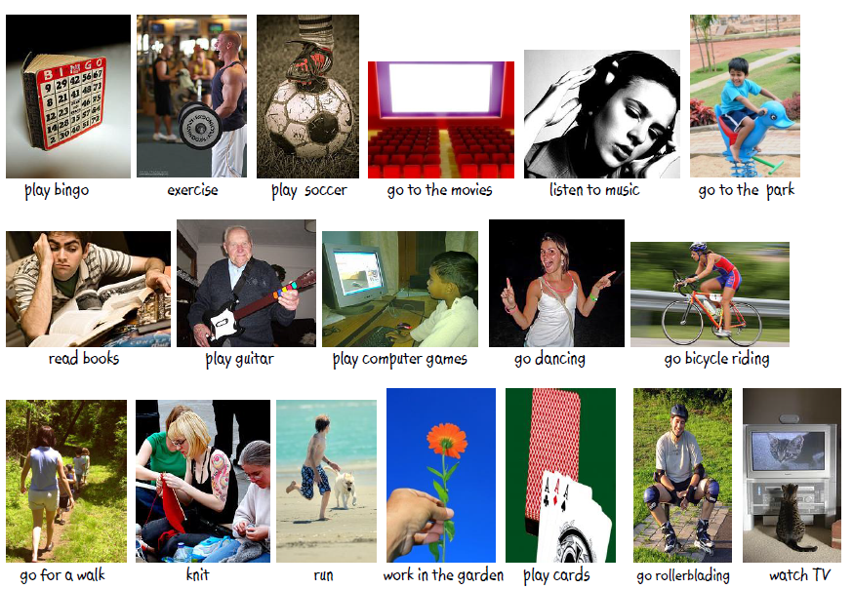
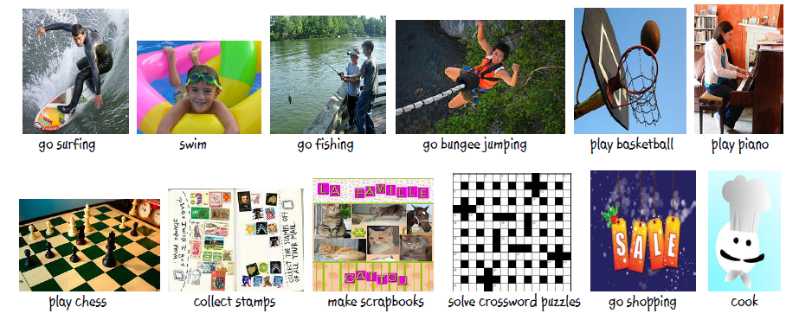

How often do you…? Worksheet
Cut out these cards. Answer these questions with a complete sentence that contains an adverb of frequency.
Student A: How often do you play bingo when you have free time?
Student B: I rarely play bingo when I have free time.

How do you often  work out? | How often do you  go to the movies?
How often do you  listen music after class? | How often do you  drink coffee?
How often do you  read books when you have free time? | How often do you  go dancing on Saturday nights?
How often do you  go for a walk  when you have free time? | How often do you  watch TV after class?
How often do you  go shopping on weekends? | How often do you cook when you have free time?

Word order with adverbs of frequency
Below are ten sentences containing adverbs of frequency, but in some of them the word order is incorrect. Your job is to decide which sentences are correct and which are incorrect. If there are some errors, then change the sentence to make it correct.
- I rarely watch TV, nowadays there’s nothing on!

- She always is late. I wish she’d just get up a bit earlier.

- I usually plan essays well in advance.

- Shopping centers frequently are packed with people, it makes me anxious.

- I buy never mushrooms, I hate them.

- I work on Saturdays sometimes.

- Sometimes I work on Saturdays.

- I dance rarely in clubs, I’m too self-conscious!

- Do you go to the cinema often?

- I never am hungry, because I snack throughout the day.

*often, usually, sometimes and occasionally can go at the beginning of a sentence
*Sometimes these adverbs can go at the end of a sentence.

