Listening Speaking Reading Grammar Writing

Topic:
Starbucks is more expensive than Juicy (comparative)

Instructor:  Anabel(sanghee) | Level:  Intermediate | Students:  4 student | Length:  30 Minutes

Materials:
- White board and markers
- Two pictures of Coffee store, clues – pre activity
- Board game and comparing cards, dices– main activity
- Blind test work sheet #1 (4 copies), horses
realia (2type of coffee) and tumbler, Tiny cups, –Post activity
- Fill out worksheet #2 (4 copies) –sos activity

Aims:
- Main aim: Ss will be able to realize the structure of comparative during speaking
and writing on their own.
- Secondary aim: Ss will be able to speak the comparative degree by main-activity.
Ss will be able to guess and find what is more expensive coffee
by comparing two things at post activity.
- Personal aim: I want Ss to understand and express the comparative degree at my teaching time. I want to speak clearer instructions than before.

Language Skills:
- Reading: Ss will refer to what T wrote on the board at main activity.
- Listening: Ss will listen to T’s instructions and Ss’s comparative sentences.
- Speaking: Ss will speak comparative sentences and opinions watching 2type of pictures.
- Writing: Ss will write down what they compare on blind test worksheet.

Language Systems:
- Phonology: hotter[hɑ:t ə(r)], bitter[|bɪtə(r)], bigger[|bɪgə(r)],
- Lexis: New vocabularies (bitter, comparative degree, instant, blind test, Go ahead, Go back, miss a turn, dice etc…)
- Grammar: comparative (better, bigger, smaller, more bitter…)
- Function: Give guide (to compare coffees, stores)
- Discourse: pre activity- speaking their opinion during comparing and share
experience at the coffee stores.
Main activity- compare 2picture when you pick cards
Post activity- Guess more expensive coffee after taking to partner.

Assumptions:
- Students already know that how to class is set up and run.
(There are 2 students at each table)
- Students already have ever known all kind of coffees.
- Students already have known sort of comparative degree.
- Students already know Language skill and systems

Anticipated Problems and Solutions:
- If student confuse structure comparative degree
- Suggest some example of comparative to understand easily.
- If student doesn’t have ever had coffee before
- Share how flavor is and experience. Try to taste at blind test.
- If students doesn’t understand rule of board game.
- Give more ICQ and demonstrations.
- If activity is late too long
- T cuts unnecessary part (post activity- instruction2)

References:
- Picture:
- http://post.naver.com/viewer/postView.nhn?volumeNo=3926823&memberNo=11971&vType=VERTICAL
- https://images.google.com/ (searching ‘coffee’, ‘bomb’ )
- Board game:
- http://www.sparklebox.co.uk/6941-6950/sb6941.html#.V4nWu7iLTIU
- Work sheet 2
- http://englishlinx.com/cgi-bin/pdf_viewer.cgi?script_name=%2Fpdf%2FMatching-Comparative-Superlative-Adjectives-2.pdf&x=103&y=24

Lead-In
Materials:

Time | Set Up | Student Activity | Teacher Talk
1min | Whole  group | Listening and answering | Good morning everyone.  How are you today?  Is it hotter than yesterday?  (students answer)  What kind of coffee stores do you prefer?(students answer stores name)

Pre-Activity
Materials:
Two pictures of Coffee store (Juicy coffee vs Starbucks coffee), clues
White board and markers
Time | Set Up | Student Activity | Teacher Talk
5min | Whole  group | Listening and answering | Elicit  “So, This time,  There are two pictures of coffee store!  #Two pictures of Coffee store  “What is that?[put them on the board]”  “Which one is more famous coffee store?”  Juicy coffee and Starbucks coffee  [write on the board]  “Which one of them has more franchise store?”  What grammar did I use in questions? [comparative]  So Can you compare them by the comparative degree?  [if Ss want, give some clue]  [write on the board what they say]  CCQ  -Which one is older? [Starbucks]  -Which one is cheaper?[Juicy]  Thank you for your answer!!

Main Activity
Materials:
Board game and comparing cards, dices
White board and markers, horses

Time | Set Up | Student Activity | Teacher Talk
5min  10m | Whole group  Whole  group | Listening and answering,  Guessing  Instruction check Q  Answering  Speaking by comparative Individually game | Instruction  We are going to enjoy board game  That is ‘Let’s get coffees’!  What do we need? [board, card, dices]  #show board + Demonstration  Board has go to ★, go ahead, back  Make Q&sentence  [Ss try to guess and then T explain]  #show cards + Demonstration  There are different kind of 11coffee cards and bomb.  And what does the bomb card mean?  [Miss a turn!]  So This game is individually.  When you roll the two dices and pick two cards and then try to compare them as sentence in 20 seconds.  If you get correct answer, you can go  If you don’t answer you have to stay same spot!  And also when A got B’s spot. They roll each dice and then A who get bigger number then B is win  A can stay but B have to go back 1step!  Then A pick two cards, and keep doing.  Demonstration  When you pick Americano and caramel coffee. You can say that  ‘Americano is blander then caramel coffee.’ And then you can go.  But when you pick bomb card and Americano. You miss your turn…give dices to next person.  ICQ  What are we going to do? [board game]  When your turn how many cards can you pick? [two cards]  How much time do you have? [20 s’]  What grammar are we supposed to use?  [comparative]  Let’s play!  [monitoring and time warning per turn]  If Ss say wrong T fix sentence.  If Someone get finish line, game is over  Thank you for obeying the rule!

Post Activity
Materials:
Blind test work sheet #1 (4 copies), White board and markers
realia (2type of coffee) and tumblers, Tiny cups
Time | Set Up |  | Student Activity |  | Teacher Talk
2min  2min  1min  2min  1min | Whole  Group  Individually  Whole group  In pair  Whole group |  | Listening  Guessing  Answering  Tasting and guessing  Writing  Listening and answering  Sharing opinion  Speaking  Checking answer |  | Instruction  # show two tumblers  What is this? [tumblers]  What do you think there are inside?  [guess and then show inside][Americano]  Right! There are 2 type of Americano.  And you don’t know which one is more expensive.  So, you try to find what is more expensive as individually!  I bought one of Americano at ‘Starbucks’.  And another is from subway store.  So which one do you think is more expensive?  [Starbucks coffee]  Right! I will hand out the worksheet#1  And you try to taste 2type of coffee using tiny cup and then write down what you choose on worksheet#1  I will give you 2min!  Demonstration  There are A, B types. After tasting, choose one and then write down answer.  # A is Starbucks coffee.  - It is more bitter then B  - smell is flesher then B  Try to make creative sentence by comparative  ICQ  -What are we going to do? [blind test, tasting]  -After tasting what do you have to do?  [ write down worksheet]  -How much time do you have? 2min  Let’s taste!  #Give two types of coffee individually.  Monitoring and Time warning; 1m left  Time’s up!  Everyone great job!  Instruction2  So now, in pair you share opinions with your partner and then compromise what Starbucks coffee is for 1min  If you and your partner get it, check on the board (T write divided A &B on the board)  ICQ2  Do you share opinions with your partner?  [yes]  How long can you talk? [2min]  Can you choose one opinion as pair?[yes]  Let’s share your opinion!  Monitoring and time warning  If Ss want to taste more T can give  Time’s up!!  Check answers!  __ is more expensive coffee than ___!  So ___ is Starbucks coffee!!  Great job everyone!  Thank you for your attention!  See you on next Wednesday!  Conclude lesson  Today we learn the comparative degree based on coffee which is very common topic.  We can compare different kind of coffees by board game and tasting.  Feed back  It is useful grammar when we compare something.  So I hope Students will use grammar to feel free and improve grammar skill as well.
SOS Activities
Materials:
Fill out worksheet #2
Time |  | Set Up |  | Student Activity |  | Teacher Talk
1min  2min  1min |  | Whole group  Individually  Whole group |  | Listening and answering  Fill the blanks  reading  check answer |  | Instruction  there is comparative worksheet#2  Read ‘directions’ first and then fill the blanks out! In 2min as individually  ICQ  What are we going to do?[fill blanks]  Let’s start!  Monitoring and time warning  Checking answers

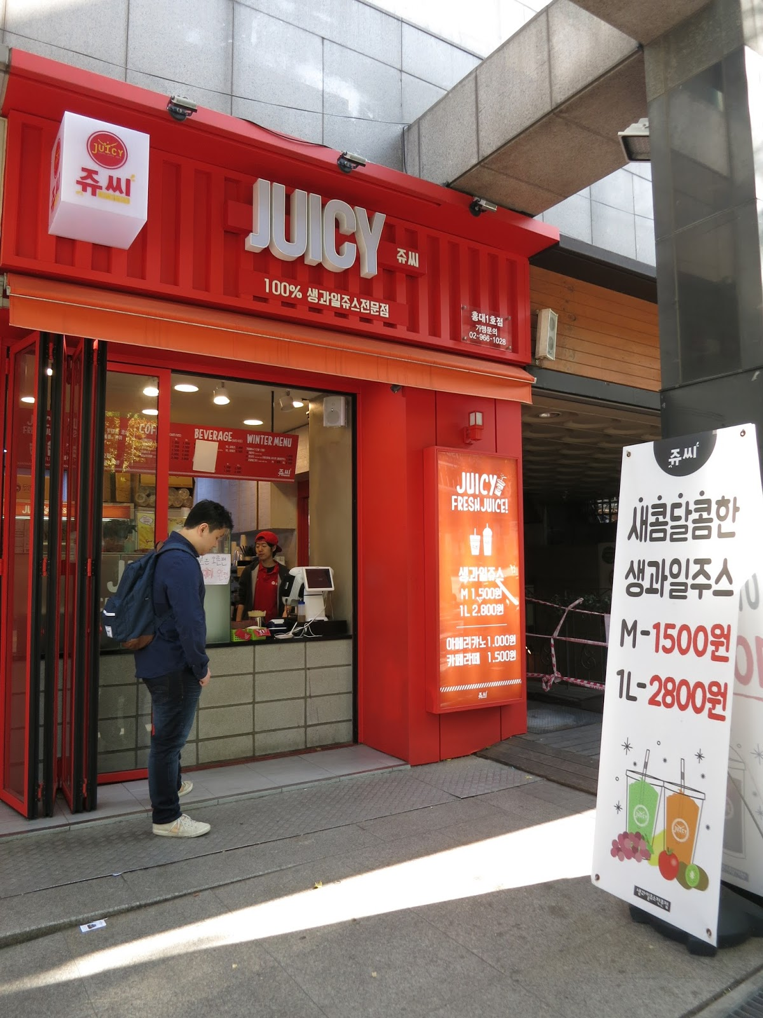
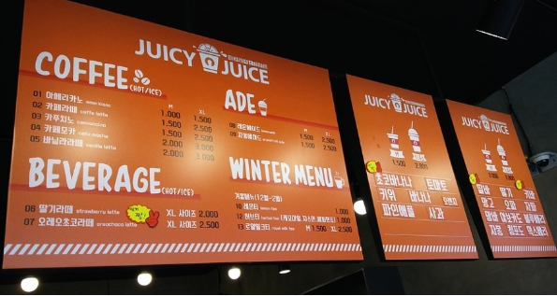
Since 2010
VS
Since 1912
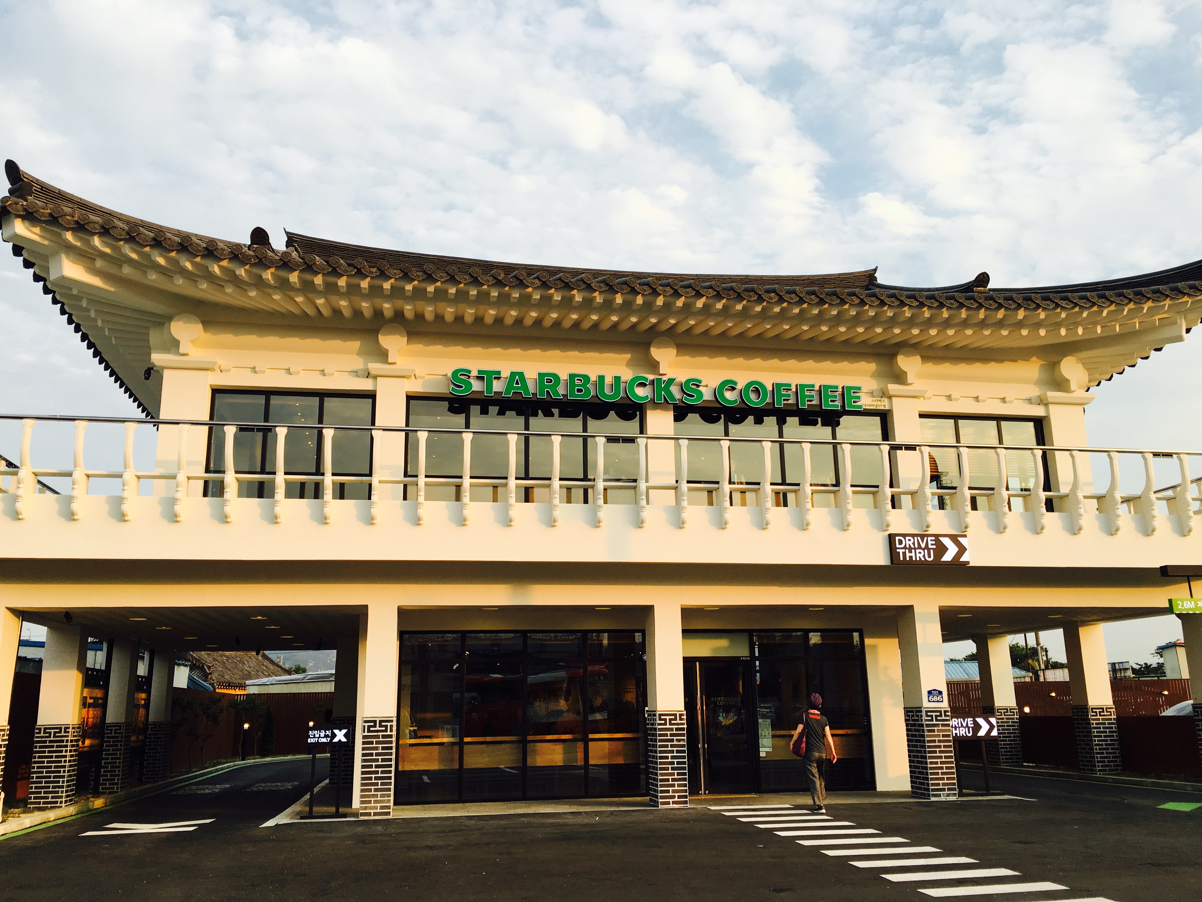
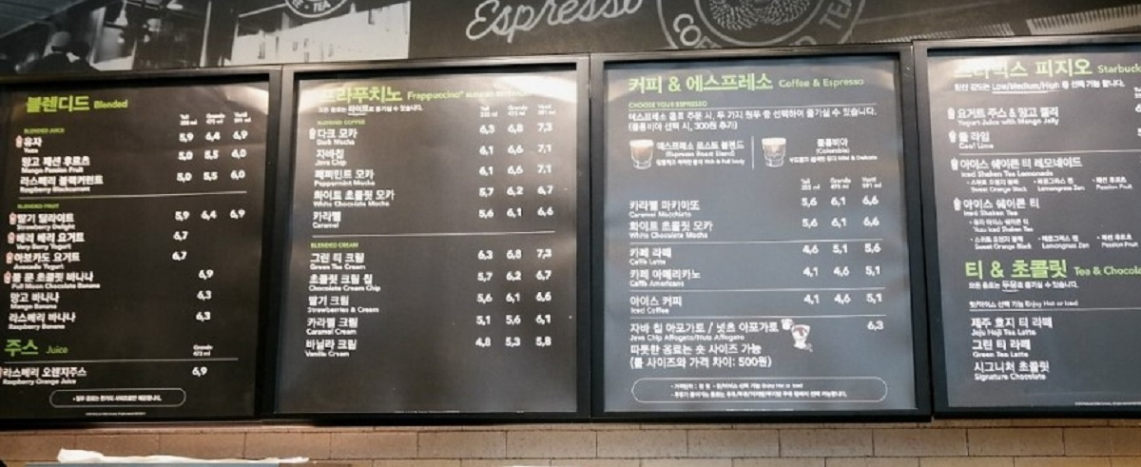
Blind Test worksheet#1
Compare A, B and find more expensive coffee ☺
Q: Which one coffee do you think is from Starbucks??
Why?
A:

B:

Fill Out Comparative worksheet#2
Adjectives can compare two or more nouns or pronouns. Add -er to an adjective to make the comparative form.
Directions: Match the adjective in the left column to its comparative form in the right column.
- Adjectives with 1 or 2 syllables add –er.
- Adjectives ending on –y, change it to –i and then add –er
- Adjectives with 3 syllables add ‘more’ and including adverbs ending in ‘-ly’
1. Big 17. Wide
2. High priced 18. Familiar
3. Tall 19. Fancy
5. Short 20. Fresh
6. Fast
7. Quick
8. Bitter
9. Early
10. Well known
11. Smooth
12. Little
13. Expensive
14. Tiny
15. Popular
16. Famous
Fill Out Comparative worksheet#2
Adjectives can compare two or more nouns or pronouns. Add -er to an adjective to make the comparative form.
Directions: Match the adjective in the left column to its comparative form in the right column.
- Adjectives with 1, 2 syllable add –er.
- Adjectives with 3 syllables add ‘more’ and including adverbs ending in ‘-ly’
- Adjectives ending on –y, change it to –i and then add –er
1. Big bigger 17. Wide wider
2. High priced Higher priced 18. Familiar more familiar
3. Tall Taller 19. Fancy Fancier
5. Short shorter 20 Fresh Fresher
6. Fast faster
7. Quick more quickly
8. Bitter more bitter
9. Early earlier
10. Well-known better -know
11. Smooth smoother
12. Little less
13. Expensive more expensive
14. Tiny tinier
15. Popular more popular
16. Famous more famous

