X Listening ☐ Speaking ☐ Reading ☐ Grammar ☐ Writing

Title:
Do you know the nouns?

Instructor:  GIAN | Level:  intermediate  Age 13-16 | Students:  10 students | Length:  45

Materials:
10 copy of working sheets (4 pages each student)

10 pens

Blackboard

Aims:
After completing this lesion, ss will be able to recognize nouns ,to use nouns effectively, and produce a list of nouns.

Ss will be able to understand more advanced concepts such as distinguishing between common, proper, abstract, and concrete nouns.

(ss will review the grammar of singular and plural)

Language Skills:

Reading
Ss will read and exercise reading

Listening
Ss will listen the reading of T or other Ss

Speaking
Students will speak to all the class about exercise before filling it

Writing
Ss will fill the blank section in the exercise

Language Systems:

Lexis: /s /ies

Function: various and situational

Grammar: Singular and Plural

Discourse: they will discuss about nouns

Assumptions:
Can understand teacher and discuss together: can speak easily on most matters like abstarct assumptions.

Anticipated Errors and Solutions:
Ss will not remember perfectly how to transform from singular to plural
(solution explaining in advance grammatical rules on the board)

Ss will confuse about nouns and not nouns (is very important to make them to understand differences about nouns and i.e. actions ) making examples will solve the situation and make it easy to understand

References:
Educationword.com
Google immagini
Tlsbooks.com
teachers.net
dinocomics.com

Lead-In
Materials:
none
Time | Set Up | Student Activity | Teacher Talk
3 min | Wole class | listening | Introducing the activity:  HI everybody  Today we will make some exercise for checking if you remember from the last lession and after that we will play a little game  Did you brought your pencil case?

Pre-activity
Materials:

Paper sheets

Pens

Time | Set Up | Student Activity | Teacher Talk
3  2 | Whole class | listening  picking materials | Reminding to students about grammar rules (singular and plural)  When to use S when to use IES, ecc.ecc.  Giving one copy of working sheets to each student

Main Activity
Materials:
Paper sheets

pens

Time | Set Up | Student Activity | Teacher Talk
2  10  15  5  5 | Whole class | listening  S reading  Ss listening-writing  S reading  Ss listening-writing  Listening  Underlining the nouns in each talk  Listening the correction  Listening  Listening and underlining  Listening correction | Explaining about nouns:  A none is a place a name or a thing  Let’s complete the exercise together for understanding better  EXERCISE 1  S start reading and after you the next on your right will read and let’s go over like this (if s mistakes try to ask AGAIN or ask to neighbors and if ss answer well ask the why of that answer)  EXERCISE 2  Like exercise 1 each s reading one line and completing together  (if they mistakes singular and plurar explain the grammar error and ask to try again )  READING the story  Teacher reading the dialogue  Asking to Ss to correct together  The noun clown  Here I want you to meet the noun clown  He wont to dress only noun but he mistakes often can you help him? So now delete with pen the words that are not noun  Reading the exercise  Class correction

Post-activity
Materials:
none

Time | Set Up | Student Activity | Teacher Talk
1 min |  | Listening and writing | Home works  For the next time you will write 10 nouns and 10 words that are not nouns

SOS Activity
Materials:
Paper and pens
box
Time | Set Up | Student Activity | Teacher Talk
1  3-5 |  | listening  writing  going home | Suggestion box:  Looks like we have some extra time today.  Pick your pen and a small piece of paper  Write on that paper what would you like to in the next lesions than fold it and put it in the box on my desk before leaving the class.

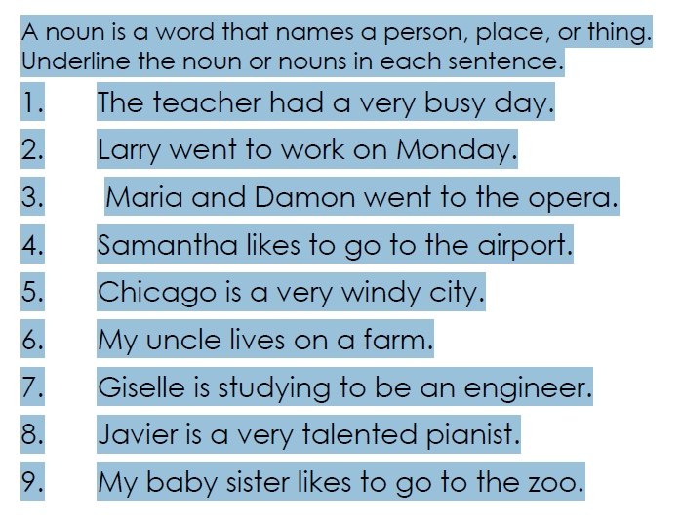

Singular or Plural?
Fill the gaps with the correct form of the nouns (singular or plural).
- They ate some (tomato) .
- You can put (sugar) in your tea.
- We have to buy new (furniture) .
- I need to wash my (hair) .
- We had lots of (fun) .
- The Milfords have a lot of (money) .
- How many (people) were at the cinema with you?
- Could you give some (information) on your project?
- In this hotel, (family) are very welcome.
- Those (man) seem to be very tired.
