Listening Speaking Reading Grammar Writing
Topic: I‘d like to return these!

Instructor:  Eun | Level:  Intermediate(Adults) | Students:  5Students | Length:  30 Minutes

Materials
- Show video for Ss understanding main idea – Lead in
- Each photos (one is saudi the other is korea) -pre activity
- Using the board by reading articles –main activity
- Speaking and preparing for debate –post activity
- A4 papers to writing a letter (government) -SOS activity

Aims:
- Main aim: Ss will be able to list the differences between saudi women and another country..
- Secondary aim: Ss will be able to guess vocabulary in article and share their opinions. .
- Personal aim: I want to give more clear instruction and know information deeply so, Ss will able to know their culture..

Language Skills:
- Reading: Ss will read in each article and find what differences women rights.
- Listening: Ss will listen to their opinions and T’s instructions.
- Writing: Ss will pick 5 key points and write on the board.
- Speaking: Ss will speak team’s opinions in their debate.

Language Systems:
- Phonology: women, female, illegal, legally (similar words)
- Lexis: New vocabulary( ban, obsessed, binding, divination, shamans, heirs…etc)
- Grammar: if I broke the ~, I should~
- Function: Asking for partner opinions, giving suggestion(how to relax about stressful moments)
- Discourse: Guessing and finding what differences in photos.- pre activity
Pick some ideas and summarize sentences –main activity
Think about your ideas and debate each team’s opinion –post activity

Assumptions:
- Ss already know korea’s women rights.
- How the class is set up (2 Ss at each desk)
- Ss already know how to debate and language skills and system.

Anticipated Problems and Solutions
- If students don’t have enough korea’s women rights.
- T should give more information about kore’s women rights..
- If students misunderstand how can the worksheet or activity.
- T should explain to students in minute detail.

References:
https://www.youtube.com/watch?v=r8kV3gKUI84
→ T show the video and let Ss know their situation – Lead in
https://www.google.co.kr/search?q=saudi+women+drive&biw=1920&bih=935&tbm=isch&tbo=u&source=univ&sa=X&ved=0ahUKEwjrhNy-mI_OAhUFHJQKHX5UAYEQsAQIHw
→ Flash cards(saudi) – Pre activity
https://www.google.co.kr/search?q=%ED%95%9C%EA%B5%AD+%EC%97%AC%EC%84%B1+%EC%9A%B4%EC%A0%84&biw=1920&bih=935&source=lnms&tbm=isch&sa=X&ved=0ahUKEwii2Pf0mI_OAhWELpQKHcd-CE0Q_AUIBigB
→ Flash cards(korea) – Pre activity
http://countrystudies.us/north-korea/35.htm
→ Article in korea - Main activity
http://www.dailymail.co.uk/news/article-3534591/Saudi-Arabia-s-cleric-defends-ban-women-driving-expose-evil.html
→Article in saudi - Main activity

Lead-In
Materials:
Watch the video
Time | Set Up | Student Activity | Teacher Talk
3min | Whole  class | Listening/Answering Teacher’s questions. | “Good morning everyone!”  “How are you today?”  “Now, I will show video to you”  (T show the video)  “What did you feel when you watched in video?”  (student answer)  “Maybe, it shows unfair in saudi women’s rights.”

Pre-Activity
Materials:
Photos (show three each of others)
Time | Set Up |  | Student Activity | Teacher Talk
5min | Whole  Class |  | Finding ,  Guessing  and answering | Elicit  Show students flash cards (appendix1)  “Look at three each of photos”  “What do you come up in these photos?”  (Wait Ss responses)  “These are show saudi Arabia womens and the others are Koreas womens right?”  “What do you think about her has injury?”  (wait to Ss respond)  “Maybe, because of their situation. It makes her hurt and she has her’s delicate feeling hurt”  “What do you think about most difference images and atmosphere when did you see each photos?”  (Write down their opinions on the board)  “What do you think about what is unfair in photos? just tell me word.”  (Answer is women rights)  (Write down their opinions)  (If Ss don’t respond what I want)  (→ I will give some clues )  CCQ  “Which one is korea and saudi in these photos?”  “What is unfair in these photos?
Main Activity
Materials:
Articles about saudi and korea women rights.
On the board
Time |  | Set Up | Student Activity |  | Teacher Talk
5min  3min  5min |  | Whole  Group  Whole group  In pair | Reading  Writing  Think about how you can summarize in your team.  Read about summarize sentences for other team. |  | T gives two different articles in two team(appendix2)  “Make two teams and read two different articles”  “These articles are interesting and useful for you”  “Let’s read in 5min in your team”  (Wait to finish reading article)  ICQ  -What time do you read in articles?  - Is it ok to read other team’s artcle?  Instruction  “Now, each team picks 4 key points”  Think about your team key points and write on the board in 3min”  “If you picked key points, your team should write on the board”  (Ss write on the board in each team’s opinion)  Demonstration  “In my team picks theses key points for examples, defends on ban to drive the other is women hold equal social status.”  ICQ  -How many pick 5 key points in your team?  -What time do you have?  Instruction  “Now, we are going to summarize it for the other team in 4 sentences in 5min and then, we should read aloud your sentences for other team”  Demonstration  “My team summarizes sentences in article. One is north korea roles of women were changed the other is saudi has unfair women rights”  (T read aloud for student’s understanding)  Monitoring  T monitors how do each teams make 4 summarize sentences.  ICQ  -How many do you make summarize sentences?  -What time do you have?  -Read aloud for your team?  (If Ss don’t understand or how can’t make summarize sentence, T should tell key words.)  Checking answers  “Wow guys make good summarize sentences.”  “One of article shows legal and equal women rights right?”  (Maybe, Ss answer no and it is not equal)

Post Activity
Materials:
White board and marker
Time | Set Up | Student Activity |  | Teacher Talk
3min  5min  1min | In pair  In pair  Whole group |  | Listening  Speaking in debate  Listening | [T give blank a4 paper to each team ]  “Guess! What are we going to do?”  (Just guessing and carouse their curiosity)  Instruction  “Now, we are going to do debate!”  Team 1 is saudi women who follow the law  “Team 2 can be women break the law”  “Think about in 3min and prepare to do debate”  Demonstration  “If i was team 1, I should say” follow the rules are important because safe my -life and don’t go to the jail. “  “If I was team2, I should say” break the rules make me find free life and don’t hide my-self. “  “Should concern about family, own-life, free to all thing, dangerous situation and all things.”  ICQ  -How many times do you have in preparation?  -Is it individually activity?  CCQ  -Where is unfair women rights in article?  -What prohibits in saudi article?  What if korea banned driving by women, what would you do?  “Time’s up guys, we going to start to do debate”  “Are you ready? Let’s start to do it in 5min”  Monitoring  Teacher monitors each teams do well in debates and tell students how much time left  “Time’s up guys. Thank you so much and share your ideas, good participation.”
SOS Activities
Materials: blank a4 paper.
Time | Set Up |  | Student Activity | Teacher Talk
1min  4min  1min | Whole group  individually  Whole group |  | Listening  Writing a letter  Listening | Instruction  (Give a blank a4 papers all students)  “We are going to write a letter to saudi government and organization”  “Think about how to write and start it in 4min and do individually”  “1 team is women who follow the law”  “2 team can be women who break the law”  “You should concern about family, dangerous situation, identity, all of things.”  Demonstration  “If I were 1 team, I should write “follow the law make me safety and don’t hurt to my family”  “The other team should write “break the law makes me don’t hide my life and free oneself from restriction.”  ICQ  -What time do you have in your writing?  -Is it work to do in pair?

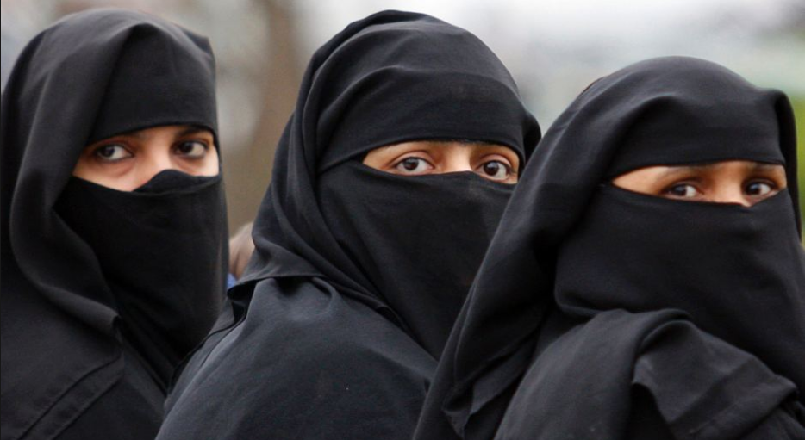
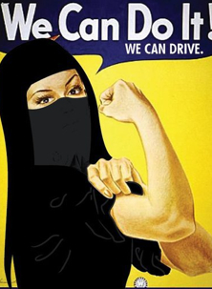
Appendix1

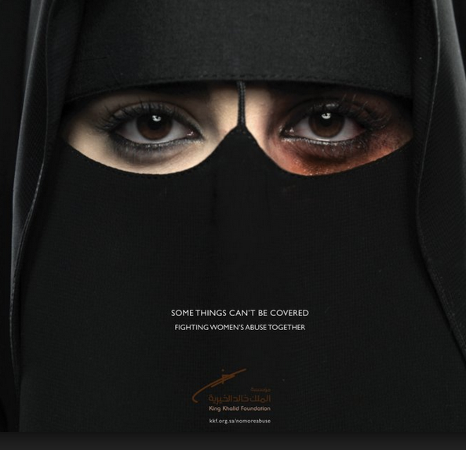

(Appendix1)

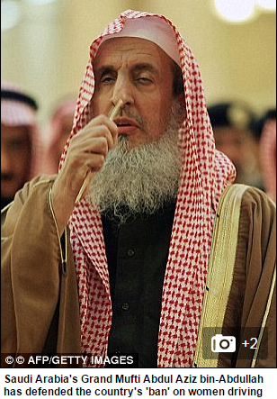
(Appendix2)
Saudi Arabia’s top cleric defends ban on women driving as it would ‘expose them to evil’

Saudi Arabia’s top cleric has defended a ban on women driving claiming it would ‘expose them to evil’
.
Grand Mufti Sheikh Abdul Aziz bin-Abdullah al-Sheikh added ‘obsessed’ men with ‘weak spirits’ could end up causing female drivers harm.
Women driving in Saudi Arabia is not technically against the law, but is banned in practice because women are not able to obtain driving licences.
Some exceptions have been made in rural areas if a woman driving is essential for her family life.

According to The Independent, the religious leader was speaking on a Saudi television channel and also claimed women driving alone could cause problems for families as they ‘would not know where they were’.
Last year campaigner Loujain al-Hathloul was jailed for 10 weeks after violating the ban by driving from the United Arab Emirates to the Saudi border.
And in February 2015, Saudi historian Saleh al-Saadoon caused controversy in trying to justify the ban, claiming women ‘could be raped’ if their cars broke down.
The historian was speaking on Saudi Rotana Khalijiyya TV and added his opinion that in countries like America sexual crimes 'are no big deal' to women.
But some progress on women’s rights has been made recently, with females allowed to stand and vote in municipal elections for the first time last December.
The Grand Mufti is known for being outspoken and earlier this year ruled that chess is forbidden for Muslims because it is a 'waste of time' and promotes gambling.
He issued the fatwa ahead of a major chess tournament in Mecca in January.
Muslims often follow personal religious guidance given by senior clerics, but their declarations are not legally binding.
(Appendix2)

The Role of Women
North Korea Table of Contents
In the Chosn Dynasty, women were expected to give birth to and rear male heirs to assure the continuation of the family line. Women had few opportunities to participate in the social, economic, or political life of society. There were a few exceptions to limitations imposed on women's roles. For example, female shamans were called on to cure illnesses by driving away evil spirits, to pray for rain during droughts, or to perform divination and fortune-telling.
Few women received any formal education in traditional Korean society. After the opening of Korea to foreign contact in the late nineteenth century, however, Christian missionaries established girls' schools, thus allowing young Korean females to obtain a modern education.
The social status and roles of women were radically changed after 1945. On July 30, 1946, authorities north of the thirty eighth parallel passed a Sex Equality Law. The 1972 constitution asserted that "women hold equal social status and rights with men." The 1990 constitution stipulates that the state creates various conditions for the advancement of women in society. In principle, North Korea strongly supports sexual equality.
In contemporary North Korea, women are expected to fully participate in the labor force outside the home. Apart from its ideological commitment to the equality of the sexes, the government views women's employment as essential because of the country's labor shortage. No able-bodied person is spared from the struggle to increase production and compete with the more populous southern half of the peninsula. According to one South Korean source, women in North Korea are supposed to devote eight hours a day to work, eight hours to study (presumably, the study of chuch'e and Kim Il Sungism), and eight hours to rest and sleep. Women who have three or more children apparently are permitted to work only six hours a day and still receive a full, eight-hour-a-day salary.

(Appendix2)

