☐ Listening ☐ Speaking ☐ Reading ☐ Grammar ☐ Writing

Title: Where do you want to go for travel?

Instructor:  Mi Jang (Mia) | Level:  Intermediate | Students:  10 students | Length:  45 minutes

Materials:
- Realia: the pictures of countries’ flags
- Realia: Big world map board made by T – printed world map in a big hardboard &
Small printed names of each country’s capital city attached velcroed tapes on the back
- Blackboard with magnets or sticky tapes
- Computer connected to the Internet
- Speaker
- Worksheet #1 for main activity
- Worksheet #2 for post-activity

Aims:
- Ss will learn how to speak in English to a travel agent.
- Ss will learn how many countries in the world are and what and where their capitals are.
- Ss will learn how to book a flight ticket and a hotel.
- Ss will be able to improve their listening skills by listening and repeating the conversation played by T.
- Ss will be able to share their travel experiences with other Ss so get to know each other better.

Language Skills:
- Reading: Questions on the worksheets
- Listening: the speakers’ conversations about how to book a flight ticket and a hotel.
- Speaking: Sharing Ss travel experiences by talking around, comparing answers with other groups and in pairs
- Writing: taking notes when listening for details

Language Systems:
- Phonology: I’d like to -, 24th /th/ sound
- Function: request
- Discourse: conversation between customer and travel agent

Assumptions:
Ss already know:
- How the class is set up and run (there will be 2 Ss at each table)
- The teacher’s style of teaching and the pace of the course
- All students have travel experiences.
- All students are high school students.
- Travel agent’s role – what do they do?

Anticipated Errors and Solutions:
- Ss may not be able to understand the conversation easily
→ Give them one or two more chances to listen the conversation over and over until they get the gist of the content
- Ss may not know some vocabularies on the conversation
→ Make them to guess what the word would mean based on the previous sentence and the next sentence.
- If a S in a group seems not participated enough
→ Give him or her a hint and encourage other Ss in the group to ask him or her questions

References:
- Number of countries in the world
http://www.naver.com

- Visual aid for countries’ flags
http://google.com

- Listening file for main activity
https://www.youtube.com/watch?v=Lq_dctfldXw

- Listening file for SOS activity
https://www.youtube.com/watch?v=ORuyEayNSc8

Lead-In
Materials:
Realia: the pictures of countries’ flags

Time | Set Up | Student Activity | Teacher Talk
3 min | Whole Class | Answering T’s questions  Getting the right answers to which country’s picture T’s holding | Hello everyone. How are you today? Does everyone likes traveling? Before we talk about today’s topic, travel, let me start with a little game. Here I brought some pictures of countries’ flags. You guys all know there are a lot of countries in the world, right?  Can you guess how many countries in the world?  (Wait for about 3 Ss’ answers)  There are 237 countries in the world map and 229 countries according to the world bank’s statistics.  So, among the over 200 countries, can you guess what country’s flag is this?  (Showing Ss the picture of one country’s flag)  Ask Ss for 2 more countries.

Pre-activity
Materials:
Big world map board made by T – printed world map in a big hardboard
Small printed names of each country’s capital city attached velcroed tapes on the back
Blackboard, magnets (or sth to attach the board to the blackboard such as sticky tapes etc.)
Time | Set Up | Student Activity | Teacher Talk
5 min  1 min  2 min | 4 people in a group | Listening to T’s instruction  Answering to T’s questions  Working on the board matching in a group  Following T’s instruction  One S in each group come front to post the board in the front of the class and comparing their work with other groups’ work | Procedure:  1. Instruction  Elicit  (Distribute each board and printed names of each country’s capital city to each group)  Work in a group of 4 people. Guess right as many countries’ capitals as possible. You can attach the printed name of capital to each applicable country. You have 5 minutes.  CCQ  What is on the board?  What is the capital of this country, Korea?  What is printed in the small name cards?  ICQ  Where do you attach the name cards?  How much time do you have?  2. Monitoring  - Walking around the classroom and watching Ss while they are working on it  - Answering Ss if they ask questions  - Checking if Ss work together in a group  3. Checking answers  Let’s check what you have done.  Can one S each group come front with the board and put it on the blackboard here?  (Pointing the blackboard)  Ok, let’s see if there is any difference.  (If there is difference, give them the answers, if not, move on to the main activity)

Main Activity
Materials: Computer connected to the Internet, website url: https://www.youtube.com/watch?v=Lq_dctfldXw, speaker, worksheet #1

Time | Set Up | Student Activity | Teacher Talk
2 min  1 min  2 min  5 min  1 min  1 min  2 min  1 min  3 min  5 min | Whole Class  Individually  Pairs  Whole Class | Listening to T’s instruction  Answering to T’s question  Listening to what T’s playing  Answering to T’s question  Listening to T’s instruction  Answering to T’s questions  Listening to what T’s playing  Writing answers on the worksheet while listening  Listening to what T’s playing  Finishing writing answers  Sharing answers and discussing the reasons to pick that answer  Listening to what T’s playing and figuring out the answers | Procedure:  1. Listening for the main idea (general understanding)  Instructions  Put you pens down and close your eyes. Listen to the 2 people talking. Think what each person’s role is and what each person wants to do. Just listen for the general conversation between two speakers. What are they talking about in stuff.  ICQ  What are you going to listen?  CCQ  Can you take notes?  How many people will be talking?  (Play the video on Youtube from 0:12 to 1:51)  Do you want to listen again?  If yes, have them listen one more time.  If no, have them speak out what they have heard freely.  CCQ  What each person’s role?  There were two parts of speaking.  What was the first part about?  How about the second part?  2. Listening for Details  Instructions  Now, I am going to play only the first part. Answer the questions on the worksheet as you listen. Work individually. You can now take notes if you need.  CCQ  What are you supposed to do?  Are you working alone?  (Distribute the worksheet)  (Play from 0:12 to 1:04)  Let Ss write answers as they listen.  Do you want me to play it one more time?  If yes, play one more time.  If no, give Ss one more instruction to do.  Ok, let’s move on to the second part of speaking then.  On the worksheet, below the first part you’ve just answered, there are the questions for the second part of speaking.  So, here the second part of speaking comes.  (Play from 1:04 to 1:52)  Let Ss finish writing their answers for 1 min after listening.  3. Peer Critique – Teaching Each Other  Now compare the answers with S seating next to you. If the answers are different, explain why you chose that as an answer.  4. Checking answers  (Play from 0:12 to 1:52, stop for each sentence for each answer, and explain why the answer is this.)

Post-activity
Materials: Worksheet #2

Time | Set Up | Student Activity | Teacher Talk
8 min  3 min | Whole Class  Pairs  Whole Class | Listening to T’s instructions  Follow the instructions  Answering to T’s questions  Enjoying the activity  Listening to T’s instruction  Listening and Repeating | 1. G.T.K.Y  Instructions  Everyone stands up and walks around the class to share your experience or information each of you have about travel. Here is another worksheet with the questions you can ask to your classmates. You should be talking one to one, in a pair. After finishing asking and answering all the questions, you can move on to another friend to talk with. You don’t have to write what your partner’s saying, just listen. You have 8 minutes to talk around.  CCQ  Are you working in pairs?  For how long?  What questions are you going to ask to your partner?  What will you do next after you’ve done with one partner?  Monitoring  Monitor discreetly. Making sure Ss talking each other in pairs and walking around to find the different partner.  2. Conclude Lesson  Listen & repeating instruction  We will listen to some sentences we’ve just learned today. You will have to repeat what you’ve heard after listen.  (Play from 3:42 to 4:30)  Alright! So, that’s it for today. From now on, you all should be confident when you talk to the travel agent because that’s what today’s lesson was all about. Thank you for attending today and see you tomorrow!

SOS Activity
Materials: Computer connected to the Internet, website url: https://www.youtube.com/watch?v=Lq_dctfldXw, speaker

Time | Set Up | Student Activity | Teacher Talk
5 min | Whole Class | Listening to T’s instruction  Answering to T’s questions  Listening to what T’s playing  Making a movement to stand on the left or right section to answer the question of T’s asking | 1. Y/N Questions  Instruction  For the last 5 minutes since we have some time left for the class time, we are going to play a game, called “Answering to Yes or No Questions.” Let the divide your seats into the two sections, left section on the left side and right section on the right side of the classroom. And then, we are going to listen to another conversation now. After finishing listening, I am going to ask 5 yes or no questions regarding the facts from that conversation. If you think the question’s answer is yes, please stand on the left section. And, if you think the answer is no, you can stand on the right section. I am going to tell you the answer after you make your move. If your answer is wrong, you can walk to the back, stay there, and watch other Ss playing until the game’s over. You guys also can think of the answers in the back in your mind.  ICQ  (Draw a picture on the blackboard as below if Ss seem doesn’t understand.)  Let Ss say which section is for yes and no.  Where is yes?  Where is no?  If you think the answer is yes of what I am going to ask you, which section do you have to go to?  Blackboard  No  Yes  So, I am going to play the audio now. Let’s get it started!  (Play from 2:35 to 4:02)  Do you need to listen again?  If yes, play it again.  If no, let Ss decide the answer and move to the applicable section.  1st question: She is lost and wants to go back to her hotel.  2nd question: The best way to get back to her hotel is take the bus.  3rd question: There is a subway station near her hotel.  4th question: The subway takes longer than the bus to get to her hotel.  5th question: She lives in the same town where two men live.  Ok, let’s see how many people are survived. Candies and chocolates for the survivals!

Realia: the pictures of countries’ flags

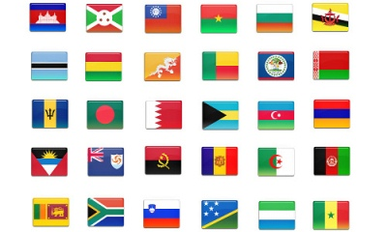

World Map Board
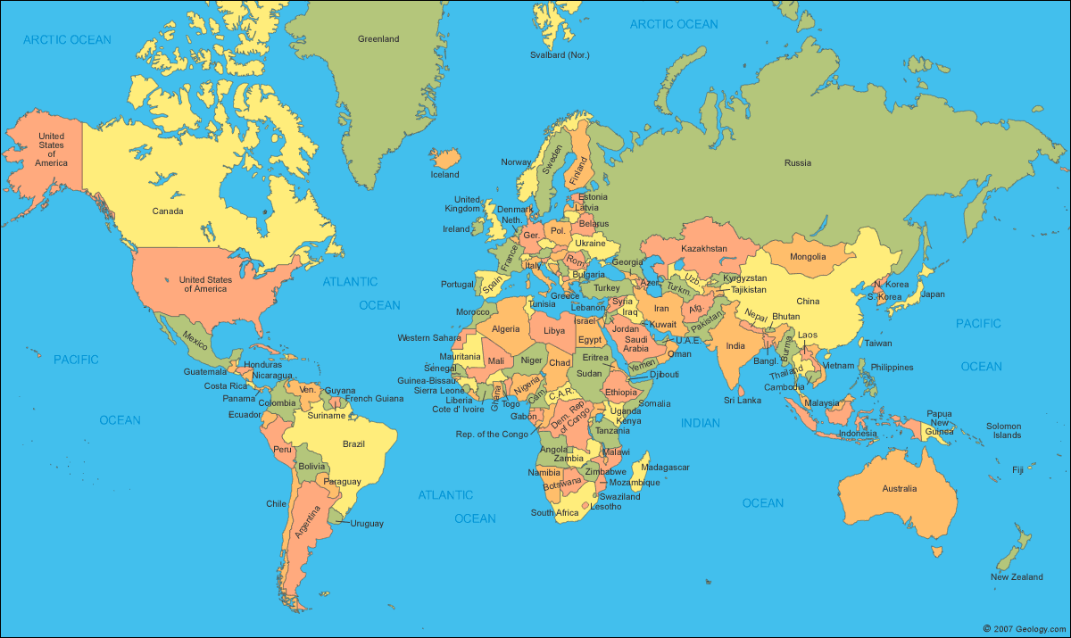
Worksheet #1
Please write the answers of the questions below.

[1st Listening Part]
Q1. Who are the two speakers? Can you guess what their job is?

Q2. Where and when does the man want to travel?

Q3. Does the man need a one-way trip ticket or a round trip ticket?

Q4. Write what will be printed in his boarding pass?

Q5. How will he make a payment for the ticket?

[2nd Listening Part]
Q1. What does “budget hotel” mean?

Q2. What does he want near the hotel?

Q3. What are the rates for 1 person?

Q4. How is the room and what kind of bed will be in the room?

Q5. How long and what date is he going to stay at the hotel?

Worksheet #2
Get To Know You Survey

- List the countries you have traveled.

- Who did you travel with?

- When did you travel?

- Why did you travel that country?

- What did you like the most about that country?

- Will you recommend others to travel that country?

- List what you have done and seen in that country.

- Where do you want to travel next time?

- Why?

- What do you think the most important thing to bring when to travel?

- What can we learn from traveling?

- Can you travel alone?

- Make your own question.

