☐ Listening ☐ Speaking ☐ Reading ☐ Grammar ☐ Writing

Title:

Instructor:  Kimmy | Level:  Intermediate | Students:  9 | Length:  35min

Materials:
- Realia
- PPT
- Worksheet #1, #2
- Board and Marker
- Music

Aims:

- Main aim: Ss will be able to improve grammar skills about comparative by using discussion and worksheet.
- Secondary aim: Ss will be able to share their own ideas.
- Ss will be able to practice using the comparative by discussing.

Language Skills:
- Reading: Ss will read PPT and worksheet.
- Listening: Ss will listen teacher’s talk and other students’ opinions.
- Speaking: Ss will talk about their opinions during the discussion and answering the questions.
- Writing: Ss will writing some sentences about comparative.

Language Systems:
- Phonology: Drilling
- Function: discussing
- Lexis: Using comparative adjectives
- Grammar: Comparative
- Discourse discussion about the topic

Assumptions:
- All Ss can speak and write in English.
- Ss may already have heard about comparative.
- All Ss know many adjectives.

Anticipated Problems and Solutions:
- If Ss may not have many ideas.
T gives them little examples.
- If activity lasts too long.
T cuts the unnecessary parts.
- If Ss are shy.
T encourages them and gives positive feedback.

References:
http://bit.ly/2aKyOlR

https://www.google.com/imghp?hl=ko

http://www.onestopenglish.com

Lead-In
Materials:
- worksheet #1
- Computer (to play the music)
- Board and marker

Time | Set Up | Student Activity | Teacher Talk
2min  3min | Whole class | Listening teacher’s talk and speaking  Listening and answering  Writing  Answering | Hello everyone! How was your weekend?  (Wait Ss responses)  I saw the news; this summer is hotter than last summer. Do you agree with that?  Instruction  Ok, now we’re going to listen to the song.  The title is ‘stronger’  I’ll give the worksheet before you listening and then listen to the music and fill in the blank.  I’ll play the music once but if you want play one more.  ICQ  Will you just listen to music?  Then what will you do?  What is the title of the song?  (Play the music)  Do you want to listen again?  (If Ss want to listen again, play one more)  Now, check the answer  (Check the answer on the board)

Present
Materials:
- PPT

Time | Set Up | Student Activity | Teacher Talk
10min | Whole class | Answering  Listening and Drilling  Answering  Listening and answering | Can you guess today’s topic?  (Ss answer)  I’ll show some images. Let’s look at it.  We are going to learn about comparative.  (On 2nd slide)  Reflect + Drilling  Comparative adjectives have three types  Fist, one syllable. Can you tell me the form?  It form is adjective + er than. I’ll read an examples here and repeat after me. I’ll read first one and you guys say the next one (read e.g. on slide)  Second is two syllables ending in ‘y’. this ‘y’ will change to ‘I’ and add er. For example, (read e.g. on slide)  Well done!  The last third is two or more syllables. It comes more blah blah than. e.g. (read e.g. on slide)  Next is Double the consonant.  Do you know what it is?  (Wait Ss responses)  Great! As you can see it vowel + consonant will be double consonant.  But there’s an exception.  If the consonant is w, don’t double the consonant.  CCQ  Can we put double the consonant after the ‘w’?  When should we put double the consonant?  Now, we’re going to practice.  Tell me the next one.  (On 4th, 5th, 6th slide)  This is an irregular comparative.  Reflect  Can you tell me what are these comparative in here?  (On 7th slide)  It’s the last comparative.  As + adjective or adverb + as  This comparative form can express equality.

Practice
Materials:
- PPT
-worksheet
-half piece of papers

Time | Set Up | Student Activity | Teacher Talk
10min | Individually | Listening and answering  Writing  Answering  Listening and writing  Presenting | (On 8th slide)  Use the adjectives to make at least two comparisons.  Any volunteer?  (On 10th slide)  Could you describe this picture by using the comparative as…as?  (Wait Ss responses)  (On 11th slide)  How about these pictures?  Well done guys!  Now I’ll give you a worksheet.  Fill in the blanks individually.  I’ll give you 3minutes.  ICQ  Do you work in pair?  How much time do you have?  Ok, guys’ times up!!  Let’s check the answers.  (checking the all answers)  I have half piece of papers in here.  Describe two your favorite food by using the comparative.  You have 3minutes.  Now, let’s hear some ideas. Do we have any volunteers?  (listen to 1-2 students tell their ideas)

Produce
Materials:
- None
Time | Set Up | Student Activity | Teacher Talk
10min | Pair | Listening  discussing | Now, we’re going to do discussion with your partner.  The topic is ‘When you eat the cereal prefer the crunchy cereal or soggy cereal’  ICQ  What are you discussing about?  (If someone don’t know the soggy mean)  Something is unpleasantly wet.  (If pair have same opinions)  sharing your opinions about why do you think of that  Ok, guys’ times up!  Today, we learned about the comparative.  Who can tell me about it?  (Wait Ss answer)  Great! Thank you for everything.

SOS Activity
Materials:
- Realia (red apple, green apple)

Time | Set Up | Student Activity | Teacher Talk
4min | Whole class | Listening teacher’s talk and answering. | Oh, we have extra time.  I bought some fruits. This apple is 2500won and this one is nearly 900won. What do you think?  (Wait Ss responses)  Could you compare red apple with green apple?  (Ss answer)

Worksheet#1

You know the bed feels
Sleeping here alone
You know I dream in color
And do the things I want
You think you got the of me
Think you had the last laugh
Bet you think
that everything good is gone
Think you left me broken down
Think that I'd come running back
Baby you don't know me
cause you're dead wrong
What doesn't kill
you makes you
Stand a little

Doesn't mean I'm lonely
when I'm alone
What doesn't kill
you makes a
Footsteps even
Doesn't mean I'm over
cause you're gone
What doesn't kill
you makes you ,
Just me myself and I
What doesn't kill
you makes you
Stand a little
Doesn't mean I'm lonely
when I'm alone

Worksheet #2
- Read the sentences and put the correct names under the picture
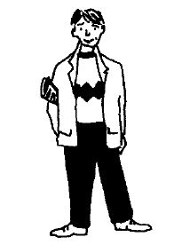
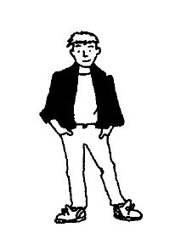
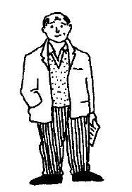
1 Alan is older than Sean,
but he isn’t as old as Jordan.
Jordan isn’t as short as Sean,
but he’s shorter than Alan

a b c

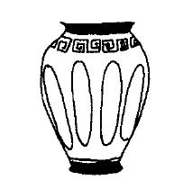
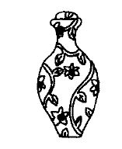
2 The Egyptian vas is
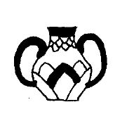
not as tall as either the
Greek of the Chinese
vases, while the longer
neck of the Chinese
vase makes it more
attractive than the others

a b c

- Look at chart. Compare Miss Bennet with her brother and her best friend Tina Robbins:
Example: (Miss Bennet / tall / Tina Robbins) Miss Bennet is taller than Tina Robbins.

1. (Miss Bennet / short / her brother John)

2. (Her best friend / young / Miss Bennet)

3. (Miss Bennet / fat / Tina)

4. (Miss Bennet / slim / her brother)

