Listening Speaking Reading ■ Grammar Writing

Topic: Look as a Linking Verb

Instructor:  Jennis Choi | Level:  Intermediate (Adult) | Students:  8 students | Length:  30 Minutes

Materials:
♦Realia : some pictures.
♦White board and board marker
♦Vocabulary worksheet (8 copies)
♦Main activity worksheet(8 copies)
♦ SOS worksheet(8 copies)

Aims:
♦Main aim:Students will be able to improve their grammar skills by their own sentences.
♦Secondary aim:Students will be able todiscuss with “look”.
♦Personal aim: I want them to use the grammar while they talk.

Language Skills:
♦Speaking: Students will talk about the topic in a group.
♦Listening: Students will listen to other students’presentation.
♦Reading: Students will read the sentences on the worksheet.
♦Writing: Students will make sentences using the topic.

Language Systems:
♦Phonology:/r/ vs /l/
♦Lexis: angry/mad, disgusted, frustrated, lonely, homesick, worried, bored, proud, embarrassed, jealous(adjective)
♦Grammar: He/She looks…They look….
♦Function:describing subject and giving information.
♦Discourse: presentation.

Assumptions:Students already know
♦What will shape of our desk is and how many classmates this class has.
♦What we will learn and have activities.

Anticipated Errors and Solutions:
♦If students may not be able tounderstand the activity,
- I will show a demonstration to them.
♦If students do not finish their work because of time,
- I will give them to homework.

References:https://www.google.co.kr
SOS activity : http://www.puzzlefast.com/ko/puzzles/20160811105863

Lead-In
Materials:None
Time | Set Up | Student Activity | Teacher Talk
1min | Whole class | Answering teacher’s questions | Good afternoon, everyone.  Anna, you are so pretty. Luxy, how does she look? Boram, how does she look?

Pre-Activity
Materials:Visual Aids, Whiteboard, Board markers, worksheet#1
Time | Set Up | Student Activity | Teacher Talk
1min  3mins  1min | Whole class  individually  Whole class | Answering teacher’s questions  Answering worksheet’s questions  Checking answers | 1. Brainstorming  Eliciting  (show the students pictures)  “I will show you some pictures. How does he look? How does she look?  How do they look?  Additional explanation  We can use “look” when we describe a person or people.  Modeling  Show the subject ‘He/She looks, They look’.(write or put the paper on the board)  2. Vocabulary  Instruction  “We are going to learn the some vocabularies with pictures.  I will give you the paper. First, look at the pictures, and thenthink about the meaning. Next fill the blanks. I will give 1minuteto finish.”  (Distribute the worksheet #1)  Demonstration  “She looks...(with gesture)”  ICQ  What will you do?  Are you working with in group?  How much time do you have?  Let’s start.  Monitoring  Answer students if they have questions.  “Time’s up, everybody. Let’s check the answers.”  Check answers  “ Let’s check the answer together”  -Let students answer one by one.  -Write the spellings if necessary.  “What a nice work!”

Main Activity
Materials: Whiteboard, Board markers, Worksheet #2.
Time | Set Up | Student Activity | Teacher Talk
10mins | Whole class  group  Whole class | Answering teacher’s questions.  Preparing their role play and presentation.  Giving presentations | 1. Role play  Instruction  “We will visit a very nice coffee shop.  Oh! There are so many people.You will be customer or crew. 2 students will be customers and 2 students will be crews.Please talk about your customers or crews. You can use thosequestions and answers.”(worksheet #2)  Demonstration  Show simple role play with students.  [Make groups]  “Please prepare your presentation. I will give you 2 minutes.”  ICQ  “What do you need to give your presentation?  Can you share your opinion? ”  “How long we are going to prepare?”  “Let’s start.”  “Okay, time’s up. Are you ready?”  “Let’s start, first is your team..”  Monitoring  Give them some hints to encourage them to keep speaking.  Feedback  “Do not read sentences. Speak loudly and clearly. Other students have to pay attention to the reports.”  “Great job. Very good”

Post Activity
Materials:Whiteboard, Board markers, Worksheet #3
Time | Set Up |  | Student Activity |  | Teacher Talk
10 mins | Whole class |  | Writingthe worksheet #3 |  | 1.Free Production  Instruction  (Hand out worksheet #3)  “Did you remember what we learned?Great! Please describe your friend or friends,and then tell us.I will give you 2minutes. If you have time, please draw your friend(s) in the box.  ICQ  “What will you do? How much time do you have?Let’s start.”  Monitoring  Answer the student’s questions if they need it.  Feedback  “Good job!”  2. Conclusion  “Today we learned “he looks, she looks, they look…”and adjective words. When you can use ‘look’? Yes, describing people and giving information. It helps you when you talk with friends.Thank you for your presentation and see you tomorrow.”
SOS Activity
Materials:worksheet #4
Time |  | Set Up |  | Student Activity |  | Teacher Talk
If needed |  | Pairs |  | Finding the words. |  | Instruction  “Let’s find the words. There are the words which we learned. Please circle on the word.I will give you 3 minutes.”  Demonstration  “The first word is…”  ICQ  “How much time do you have?  Can you talk with your partner?”  Monitoring  Monitor discreetly. If they ask questions, answer it.  Feedback  “It is time to check the answer.Stop your work. Good jobs ”  Writing  “Please write your speech. If you did not finish it, it will be your homework.”

Visual aid
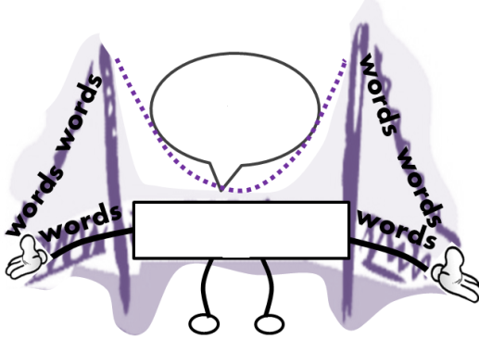
He looks ______________.
She looks _____________.
They look _____________.
look
looks
angry/mad | bored
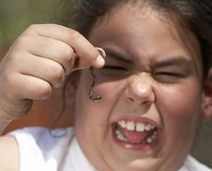disgusted | embarrassed
frustrated | 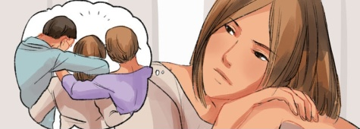homesick
jealous | lonely
proud | worried

Worksheet # 1
He looks________.
She looks ________.
They look ________.

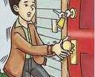
Angry
Disgusted
Frustrated
Lonely
Homesick
Worried
Bored
Proud
Embarrassed
Jealous

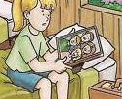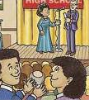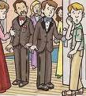
<Homework>
Anger
Disgust
__________

__________

__________

__________

__________

__________

__________

__________

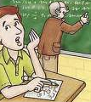

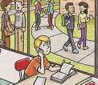

He _____ _______.
She ____ _______.
They ____ ______.

Worksheet # 2 Role play

At the coffee shop

- Q : How does he look?
A : He looks _______.(adjective)
- Q : How does she look?
A : She looks ________. (adjective)
- Q : How do they look?
A : They look ________.(adjective)
- Q : Does he look ______________?(adjective)
A : Yes, he does. He looks ____________.(adjective)
(or)No, he does not. He looks ____________.(adjective)

Worksheet # 3
Describe your friend(s).

_____________________________________

_____________________________________

_____________________________________

_____________________________________

_____________________________________

_____________________________________

_____________________________________

SOS Worksheet # 4

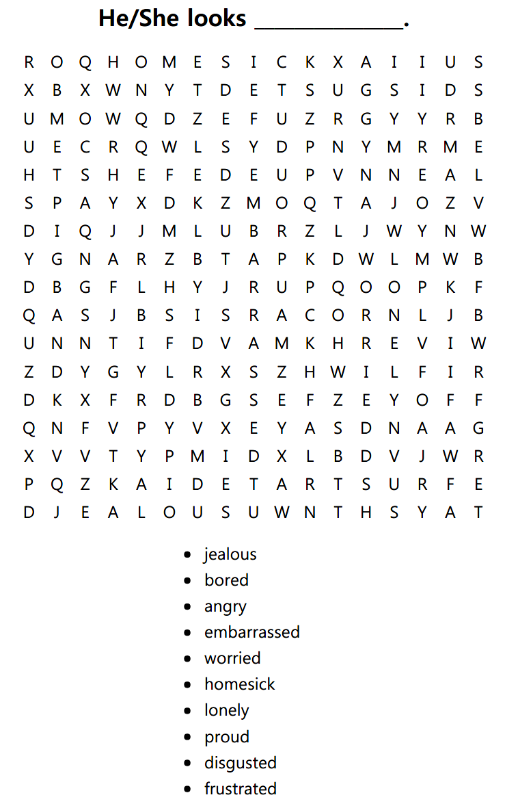

answer
