☐ Listening ☐ Speaking ■ Reading ☐ Grammar ☐ Writing

Topic: Hybrids

Instructor:  Kimmy  Joanne | Level:  Intermediate | Students:  10 Students | Length:  30 Minutes

Materials:
- PPT
- Reading text ‘Hybrids’
- Work Sheet (#1-answering questions, #2-Matching hybrids, #3-Imagine your hybrids)
- Flash cards
- Board and Marker
- Computer & Projector

Aims:
- Ss will be familiar with key vocabulary thought T’s explanation and guiding questions.
- Ss will able to get main idea by skimming the reading text and answering guiding questions.
- Ss will improve scanning skill by answering the work sheet.

Language Skills:
- Reading: Reading the text “Hybrids” and work sheet.
- Listening: Listening to teacher’s instructions, presentation, and classmate’s ideas.
- Writing: answering the work sheet.
- Speaking: Sharing ideas and explaining each other.

Language Systems:
- Lexis: Hybrid, Including, Fleece, Calmer, Mane, Purr, Pipeline, tentacles, Laboratory
- Phonology: /F/, /P/
- Function : Asking and giving information

Assumptions:
- Students are aware of animal species.
- Students can speak and write in English but not very accurately
- Students know how to skim and scam.

Anticipated Errors and Solutions:
- If students need linguistic help to express their opinions during discussion.
→ give some examples and explains the sentences.
- If students don’t participate in the activity
→ find out the problem and solve it (give motivation to do the activity).
- If students need problems to follow the activity
→ make students help each other first then give advice.

References:
- Reading material
http://www.onestopenglish.com/
- Animal Image
http://bit.ly/2bgo1xt
https://www.google.co.kr/
- Video
https://youtu.be/_uAiaOrPESQ

Lead-In
Materials: PPT
Computer and projector
Time | Set Up | Student Activity | Teacher Talk
3 min | Whole  Class | Listening to teacher’s talk and answering | 〮 Good afternoon.  This is Kimmy and Joanne teacher.  How are you guys today?  (Ss answer: great, good, find…)  That’s great! Well, yesterday I talked with my mother on a video call  So, I saw my puppy his name is Zzang-gu.  I really miss him.  Anyway what’s your favorite animals?  (Ss answer)  Show PPT ‘Hybrid Animals’.  We’re going to learn about animal design.  Can you guess these images mean? These images are point just one word.  (Ss guess)  This word is referring to anything that is a mixture of other things  Do you know what the hybrid means?  (Ss answer: no, yes)  (show the next sild)  Loin has a tiger’s baby then what will we call it?  It’s a tigon. Mother is lion father is tiger will be a tigon that’s different with liger.  We called it hybrid animal.  Next one is tomato plus potato then will be…? Tell me the word  (Ss answer)  It calls a tomtato or pomato.  Human plus fish will be…?  Yes, it’ a mermaid.  And another human plus bull will be…?  It calls minotauros.  Ok, now you can guess the word, hybrid right?  Do you have any ideas of other hybids?

Pre-Reading
Materials: Reading text ‘Hybrids’
Time | Set Up | Student Activity | Teacher Talk
1 min  3 min  1 min | Whole class  Individually  Whole class | Listening to teacher’s talk  Reading the text individually  Answering the questions | 〮 Alright Class, now you figure out what the hybrid is.  〮 So, do you how many hybrid animals are there?  〮 And have you ever heard about the name of the animals?  So, we are going to read the text about it.  There are several hybrid animals in the reading material. So, I will ask you these questions again after you read.  If you don’t know some vocabularies, just skip it. We will figure it out later.  So, let’s read it.  Monitoring  If students need help  → Support students to give some examples  〮 Are you guys done reading it?  (If students need more time → give several minutes.)  So, how many animals in the text?  (Students answer : 4 hybrid animals)  What was the name of the animals?  (Students answer: Eclyse, Rama, Lawerence, Octosquid)

Main Reading
Materials: Flashcard
Board and marker
Worksheet #1, #2
Time | Set Up | Student Activity | Teacher Talk
5 min  1 min  3 min  1 min  3 min  1 min | Whole  class | Listening and answering teacher’s questions  Answering the worksheet while reading the passage again  Finding answer together  Doing another worksheet  Finding answer together | When you read the text. Did you know every words?  (Ss answer)  We’re going to talk about some words now that might have confused you.  First one is ‘including’  (acting)  What did I do?  (Ss answer)  Yes, it is  Next one is ‘fleece’.  Here is an image you can guess the meaning of ‘fleece’.  (Ss answer)  Good, ‘fleece’ is another word for…?  (Ss try to say it)  Stating with w  And then ‘calmer’. What am I doing?  (Ss answer)  Yes, that’s the ‘calmer’ I’m more quiet than her.  Next one is ‘mane’.  Mane mean is this  (show the flash cards)  Can you guess?  (Ss answer)  Right, it means the hair that lion of horse has it  I’ll draw the picture and guess.  (draw the picture)  This one is the ‘purr’. So do you understand?  (Ss answer)  ‘laboratory’  (draw the picture)  These things are in the same place. Scientists doing work for find something new one like a cure.  Next word is a word ‘pipeline’  Here is a picture. Do you guess what is mean?  (Ss answer)  It means a large pipe which is used for carrying oil.  The word ‘tentacles’  Let’s see the picture.  Tentacle meaning is an animal such as an octopus are the long thin with suction cups.  Now I’ll give the worksheet. Read the text and answer the question but you should write the full sentence. You have 3minutes  ICQ  How much times do you have?  Are you work in pair?  (Give the worksheet #1)  Ok!! Times up. Let’s check the answers.  (check the answer)  Great! Here is another worksheet.  (show the worksheet)  (give the worksheet #2)  Eclyes is here. Choose one word in the box and match the species under the picture.  Also, write the species of Dad & mom and describe the characteristics for the animals in full sentence.  If you want, you can write the species or draw the picture.  I’ll give you 3 minutes.  ICQ  How much times do you have?  What should you write in the box?  Times up! Let’s check the answers.

Post Reading
Materials: Board and Marker
Worksheet #3 (Imagine your hybrids)
Time | Set Up | Student Activity | Teacher Talk
1 min  3 min  4 min | Whole class  Individually  Whole  Class | Listening to teacher’s talk  Doing the activity  Comparing their work | 〮 Now, we are going to do a fun activity called ‘Imagine your hybrids’.  (Distribute the worksheet #3)  〮 If you see the worksheet, there are a lot of animals. You can choose more than 2 animals to create your imagined hybrid animals. You can draw picture or just write the description of the animals. It’s up to you. I will give you 3 minutes to finish it.  ICQ  How many animals can we choose from the box?  (Students answer: more than 2!)  Monitoring  (Observing students doing well.)  〮 Time’s up  Did you guys finish?  Let’s share your work together.  (Each student introduce their work one by one  → If time is enough  Volunteers introduce their work.  → If time is not enough)  〮 Alright, everyone seems to have really good work.  〮 So, how was the today’s lesson?  (Students answer: good!)  What we have learned today?  (Students answer: Hybrid)  〮 Good job everyone!  This is Kimmy and Joanne teacher.  See you next class

SOS Activity
Materials: Computer and screen
Time | Set Up | Student Activity | Teacher Talk
5 min | Whole  Class  Whole  Class | Listening to teacher’s talk  Watching the videos | 〮 We have few minutes to finish the class. Before we finish the class, let’s watch a video. It’s is about interesting hybrid animals.  (Watching the video)  5 of the strangest hybrids animals  https://youtu.be/_uAiaOrPESQ  (4:41 minutes)  〮 Which animals did you watch?  Can you describe the animals?  〮 Good job everyone!

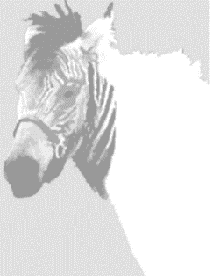

Hybrids: Reading

1 Eclyse
This is a real zebra crossing! Eclyse is a zorse which is the cross between a zebra and a horse. Her father is the zebra, and her mother is the horse. Her mother, Eclipse, lives on a safari park in Germany but went to Italy for a short time. There she stayed in a field with some horses and zebras, including Ulysses who thought she was very nice! When Eclipse came home she surprised her owner with a baby zorse. Eclyse looks most like a horse but she has stripes on her face and back, and the rest of her is white. She is friendly like a horse and quite tame, and you can ride her. However, sometimes she’s wild like a zebra and she starts leaping around like crazy!
2 Rama
Meet Rama the cama, the cross between a camel and a llama. Rama lives in Dubai, in the United Arab Emirates. His father is the camel, and his mother is the llama. They are very different in size. His mum is small and weighs 76 kilograms, while his dad is very big and weighs almost 450 kilograms! Rama has short ears and a long tail, like a camel, but he doesn’t have a hump. His feet are like a llama’s and his fleece is like a llama’s too. However, because Rama is much bigger than a normal llama his owner hopes there will be a lot more wool to sell. His owner also thinks that he will be calmer than a camel, and so easier to work with.
3 Lawrence
Lawrence is big, very big – he weighs about 450 kilograms and eats around 23 kilograms of raw meat in a meal. What is he? He’s a liger, of course! A liger is the cross between a lion and a tiger. Lawrence’s father is the lion and his mother is the tiger. He has a mane and some light stripes, so he looks like a golden tiger but with more hair around his face. Lawrence can ‘speak’ both lion and tiger: he roars like a lion and purrs like a tiger! The tiger half of him means he likes swimming, and the lion half means he’s very friendly with the other big cats. Lawrence lives in a safari park in Shenzhen, in southern China.
4 Octosquid
One minute octosquid was swimming almost a kilometre deep in the sea in Hawaii, and the next minute it was in a laboratory. It swam into a sea water pipeline and up into the laboratory, the creature looked very strange. Scientists think it may be a new species. They called it octosquid because it has the head of an octopus and eight tentacles like an octopus too. However, the body is like a squid which normally has ten short arms around its mouth. It is 30 centimetres long and bright red. One scientist said it was not unusual to see strange-looking fish swimming in the very deep. He said that below 200 metres it’s a very different world with very different creatures. The octosquid lived for three days in the laboratory.

Hybrids: Reading
Worksheet #1
Vocabulary
Hybrid Including Fleece Calmer Mane
Purr Pipeline Tentacle Laboratory

Write the answers in full sentence.
● TRUE if the statement agrees with the information
FALSE if the statement contradicts the information

_____① Eclyse has stripes.
_____② Lawrence can only speak lion.
_____③ Octosquid is still alive.
● Short answer questions.
④ Which creatures have tentacles?
⑤ If you were an owner of Rama, what would you do to him?
⑥ Which creature’s name is also a hybrid?
⑦ Which creatures are on show for the public?
⑧ Create a new title of the text.

Hybrids: Reading
Worksheet #2
Choose one word in the box and match the species under the picture.
Also, write the species of Dad & mom and describe the characteristics for the animals.
Liger Octosquid Zorse Cama
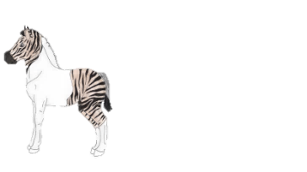
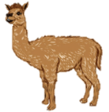
② Rama
Dad
Mom
①
②
③

The characteristics
① Eclyse
Dad
Mom
①
②
③

The characteristics

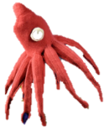
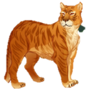
④ Octosquid
Dad
Mom
①
②
③

The characteristics
③ Lawrence
Dad
Mom
①
②
③

The characteristics

Worksheet #3
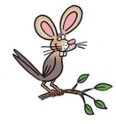
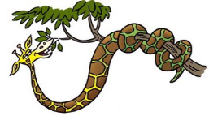
Imagine your hybrids
Draw or write your imagined hybrid animals
by using more than two animals in the box
Leopard Snake Horse Raccoon Giraffe Tiger
Donkey Dog Cat Rabbit Panda Pig etc…

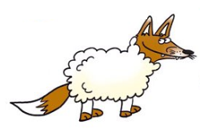

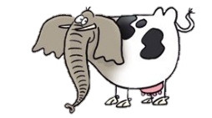

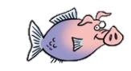

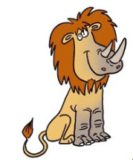
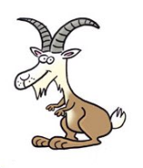

Flash Cards

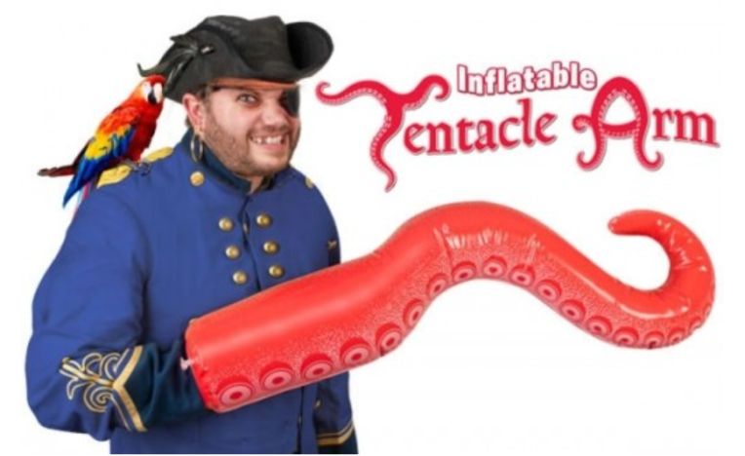
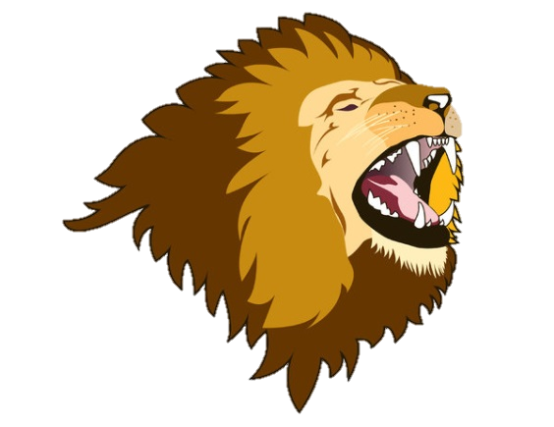
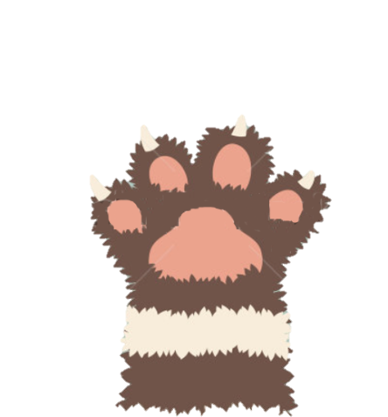
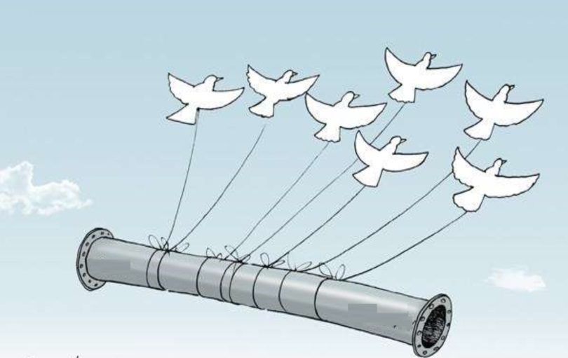
④ Pipeline
③ Fleece
② Tentacle
① Mane

