Integrated Skill Lesson Plan

Title : The weather in my country

Instructor :  Chloe Kim | Level :  Intermediate | Students :  8 to 10 | Length :  30 min

Materials :
- PPT files with pictures showing the season and weather
- Board and markers

Aims :
- Ss will learn how to ask and answer about the weather.
- Ss will learn how to tell the various kinds of weather in his/her country.

Language skills :
- Writing : list of the kinds of weather Ss know
- Reading : teacher’s examples from the board
- Listening : to a chant related to the topic
- Speaking : being able to ask and answer about the weather

Language systems :
- Lexis : snowy, windy
- Discourse : writing about his/her country’s weather

Assumptions about students :
- Ss know how to make and read simple sentences.
- Ss are aware of simple words that express the weather.

Possible Problems and Solutions :
- Ss know how to make sentences but still makes a lot of mistakes.
: give some hints or guidance during monitoring.

References :
www.google.com
Book : I can write English! Starter 1

Procedures

Lead-in :
Materials :
Time | Set Up | Description of activities
1min | Whole  class | <Greeting>  Hello, everyone! The weather is so nice today, isn’t it? How do you feel about today’s weather?  <Warmer>  T : I want you to write down five things that is related to the weather on a piece of paper.  (Have Ss share their thoughts.)

Presentation :
Materials :
Time | Set Up | Description of activities
4min | Whole class | T : Today we are going to learn how to ask and answer questions about the weather. First, we will be listening to a chant. Please listen carefully.  Chant: Weather! Weather!  My country’s weather!  What is the weather like?  What is the weather like?  Weather! Weather!  My country’s weather!  Sunny! Sunny! It is sunny!  Windy! Windy! It is windy!  Snowy! Snowy! It is snowy!  Rainy! Rainy! It is rainy!  T : Now let’s chant together!  (Teacher and Ss chant together 2 times.)

Practice :
Materials :
Time | Set up | Description of activities
2min  3min  5min | Whole  class | (controlled practice)  T : Very good! Now, we are going to try making more sentences. Repeat after me.  - How is today’s weather?  - It is hot!  - It is cold!  - It is freezing!  (Less-controlled practice)  T : Now I want you to look at the pictures on the Powerpoint and tell me how the weather looks like.  (show the first slide of the windy weather and Ss can answer in full sentence. Go onto the next slide and have the next Ss answer.)  T : Now I want you to look at the worksheets and solve the questions. If you have any questions please ask me or the person next to you. I will give you 5 minutes.  (monitor the Ss solving the worksheets and give hints when they are stuck.)  T : Now let’s go over the answers together. Starting from ooo, could you read the question and answer?  (Ss read the question and answer. If someone made a mistake, have other Ss help correct their mistakes.)

Production :
Materials :
Time | Set up | Descriptions of activities
10min  5min | In pairs | T : Now, I want you to work in groups. First, I will give you a 4 cards that shows the weather. Draw the weather on a piece of paper.. Next, write a dialogue asking and answering about the weather. When you explain about the weather, use your body to show how it feels. For example, if you are going to say “It is hot.” Show that you are very hot with body language. (T acts very clearly by waving your hands and wiping the sweat off your face.  I will give you 10 minutes.  CCQ  - Will you be working alone?  - Do you stay still?  - How much time do you have?  Now let’s have each group come out and show their picture and speak out their dialogue!  <Closing>  T : Did your enjoy today’s activity? Try practicing more at home with your family. You all did a great job! See you next time!!

<Chant script>
Weather! Weather!
My country’s weather!
What is the weather like?
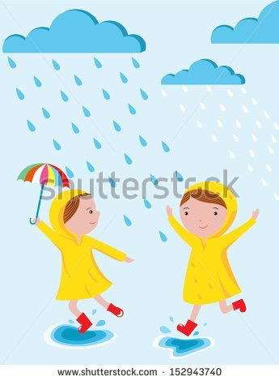
What is the weather like?l
Weather! Weather!
My country’s weather!

Sunny! Sunny! It is sunny!
Windy! Windy! It is windy!
Snowy! Snowy! It is snowy!
Rainy! Rainy! It is rainy!

Worksheet 1

A.Match the sentence with the picture.

It was sunny.

It was windy.

It was snowy.

It was rainy.

Worksheet 2

B. Unscramble the words and write the sentences.

- ( was / rainy / It )

__________________________________________________.

- ( It / windy / is )

__________________________________________________.

- ( It / was / snowy )

__________________________________________________.

- ( is / hot / It )

__________________________________________________.

C. Draw the four weathers you chose.

Write your dialogue.

<Weather card>
freezing | cloudy | fine | dusty
dark | stormy | foggy | warm
snowy | rainy | sunny | clear
dry | windy | hot | cold
freezing | cloudy | fine | dusty
dark | stormy | foggy | warm
snowy | rainy | sunny | clear
dry | windy | hot | cold

