☐ Listening ☐ Speaking ☐ Reading ☐ Grammar ☐ Writing

Topic: Happy Halloween!

Instructor:  Kimmy | Level:  Elementary  7-9 age | Students:  8 | Length:  30 Minutes

Materials:
- Board and marker
- Worksheet #1, 2, 3
- Flash cards

Aims:
- To introduce and talk about the topic of Halloween
- Ss will be familiar with key vocabulary thought T’s explanation
- Ss will be able to improve their listening skill by song and text

Language Skills:

- Listening: teacher’s elicitation, text, Halloween song
- Reading: reading worksheet
- Speaking: Singing and sharing ideas
- Writing: answering the worksheet

Language Systems:
- Lexis: pumpkin, skeleton, goblin, broomstick
- Function: asking and giving information
- Discourse: sharing their own ideas

Assumptions:
- Four language skills and language systems
- Ss can speak and write in English.
- Ss enjoy the activity.

Anticipated Errors and Solutions:
- Ss might not understand some key vocabularies.
→ give more further example and information
- If students need problems to follow the activity.
→ make students help each other first then give advice.
- Ss might go over time.
→ monitor each Ss and group so that they can use their time efficiently

References:
- www.onestepenglish.com
- www.google.com
- www.crayola.com

Pre-task
Materials: White board and markers
- Board and marker
- Flashcards
Time | Set Up | Description of activities
3min | Whole class | T: Hello guy! Do you know what day is the October 31st?  Yes, yesterday I watched the ‘Nightmare before the Christmas’ so, today’s topic is Halloween!  Do you know anything about Halloween?  (Ss answer)  [write the Ss answers on the board]  Great! And I’ll do act let’s guess  [acting and drawing about flashcards]  (Ss answer)  Good job

Task- preparation
Materials:
- Board and marker
- Worksheet #1

Time | Set Up | Description of activities
2min  1min  6min | Whole class | T: Now, teacher will read the text  It’s about the Halloween. So, I will ask you some questions again after you listening.  [write the following on the board]  - What are children’s’ doing?  - What do people make from pumpkins?  ICQ  -How many questions should we figure it out?  -What are these questions about?  Ok, Listen carefully.  (Read the text)  People celebrate Halloween on October 31st.  Children dress up as witches and ghosts.  In some countries they light candles or make lanterns from pumpkins. Do you celebrate Halloween where you live?  Did you find the answers?  (Ss answer)  Great! You guys get all answers!  Now, I’ll show you a video about Halloween song.  Pay attention please. Are you ready to listen?  (Play the video)  How was it? Do you want to listen one more?  [If Ss want listen one more time then play]  Here is the lyrics of this song. We’re going to singing~!  (Sing a song)  Good job~ You guys are such a good singer.

Task Realization
Materials:
- tape
- worksheet #2
- color pencils

Time | Set Up | Description of activities
4min  6min | Whole class  Group work | T: I have a worksheet in my hand. It just a simple worksheet  I believe you can do this easily  I’ll give you 3minutes.  [Monitoring & Do no.3 question]  Let’s check the answers together.  [check No.1 and 2 questions]  Let’s see the no.3 question could you show me your costume?  (If there’s no volunteer, show teacher’s work)  I want to wear you guys’ costume. It’s very nice!  Now, we’re going to do activity. Name is Halloween walk  Ok, stand up please  Here is a line on the floor and could you stay behind the line?  And I’ll ask you to move in different ways.  For example, if teacher said ‘Fly like a bat’ then you should walk like that on the line.  Each group’s best actor will have a prize~ Now here we start  -Walk like a spider  -Fly like a witch  -Float like a ghost  -Walk like a monster  -Walk like a black cat  -Walk like a zombie  -Walk like a mummy  -walk like a skeleton

Post-task
Materials:
- worksheet #3
- color pencils
Time | Set Up | Description of activities
8min | Individually | T: Well done, this time we will design a Halloween pumpkin and write the describe of your pumpkin in 3 sentences  We are call the Halloween pumpkin is Jack-o-lantern  You have 5minutes for drawing.  ICQ  -What will you doing?  -How much time do you have?  [Give the worksheet]  [Monitoring & Draw together]  Ok, times up! Now we are going to sharing the idea  I’ll show you my pumpkin  [show the pumpkin and describe]  Next will be……  (Ss share their own idea)  T: wonderful!! I really want to make that on Halloween day  I hope you all enjoyed toady’s activity. There is no homework today! But I have some coloring prints here if you want you can take it. Hope you enjoy the rest of the day!

Lyrics to ‘Happy Halloween’
Worksheet #1
Ghosts and witches skeletons too
Halloween night is scary for you
Ghosts and witches skeletons too
Halloween night is scary for you
See the little goblins walking down the street
Knocking on doors for trick or treat
See all the monsters, big and small, too
They run up behind you and go “Boo”
Ghosts and witches skeletons too
Halloween night is scary for you
Ghosts and witches skeletons too
Halloween night is scary for you
See that broomstick up in the sky
Yes, it’s a witch flying by
See all the little ghosts all dressed in white
Looking so spooky on Halloween night
Ghosts and witches skeletons too
Halloween night is scary for you
Ghosts and witches skeletons too
Halloween night is scary for you
Better watch out
Better watch out
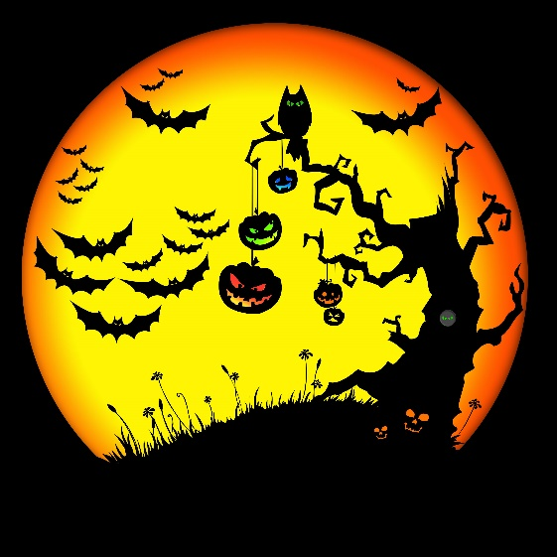
Better watch out
Better watch out
Ghosts and witches skeletons too
Halloween night is scary for you
Ghosts and witches skeletons too
Halloween night is scary for you
Better watch out X 12

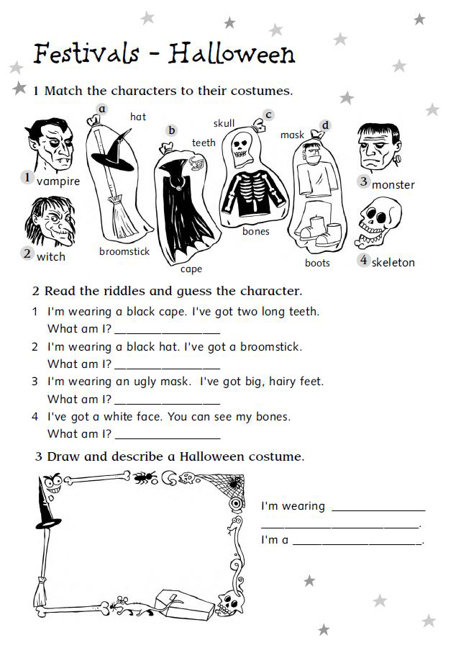
Worksheet #2
Worksheet #3
Let’s draw a Jack-o-lantern

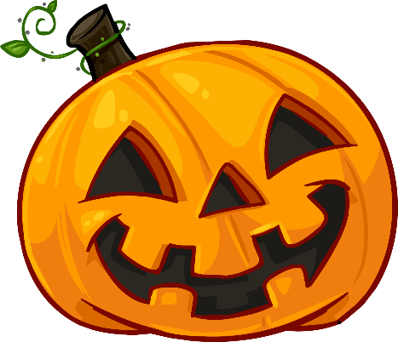
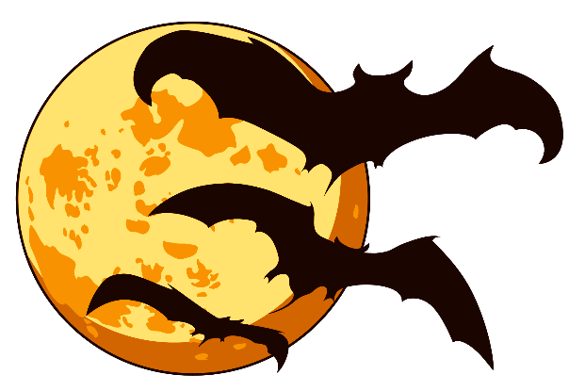
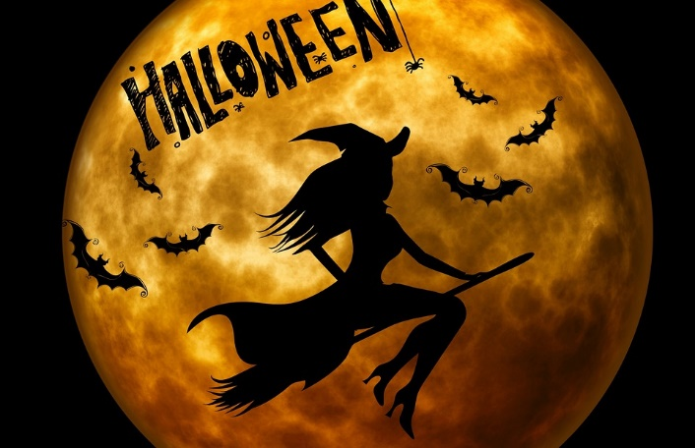
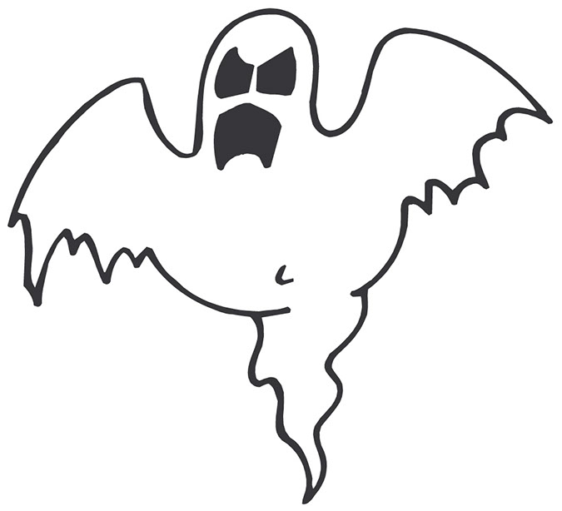
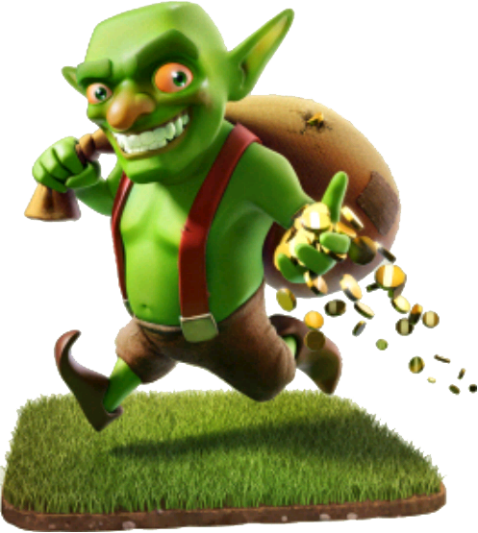
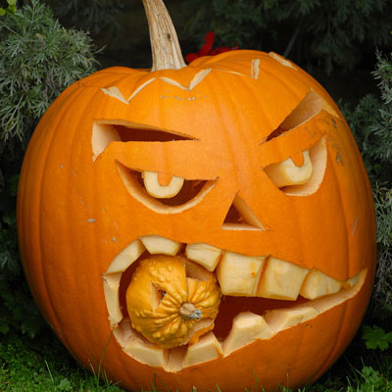
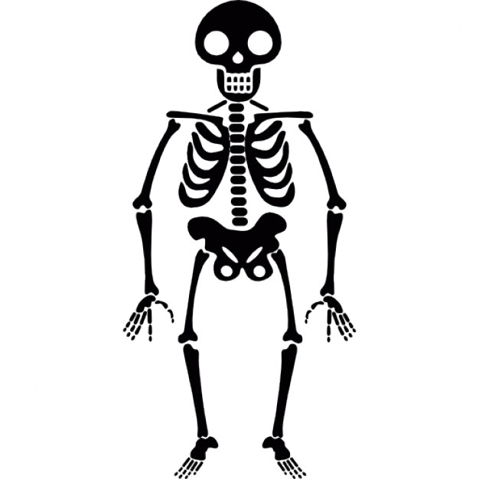
flashcard

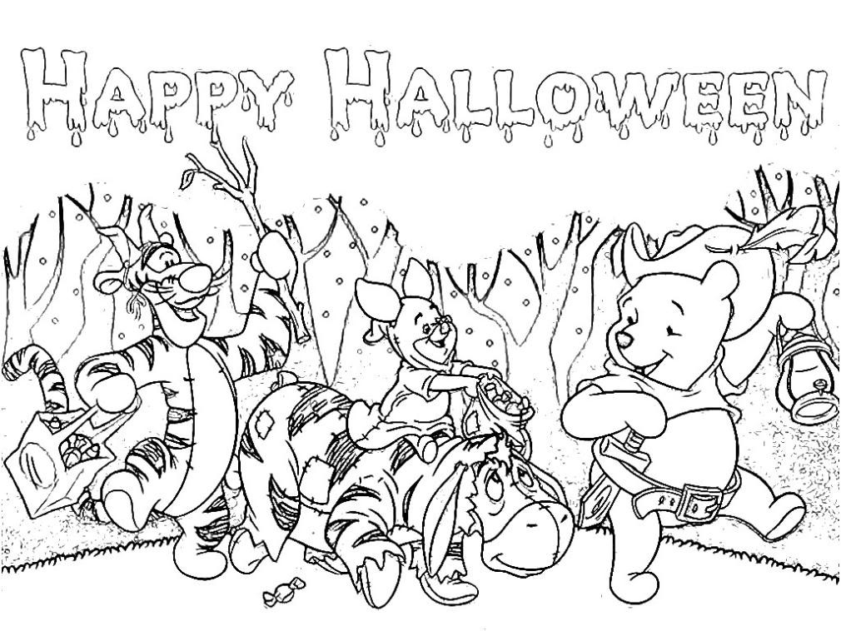
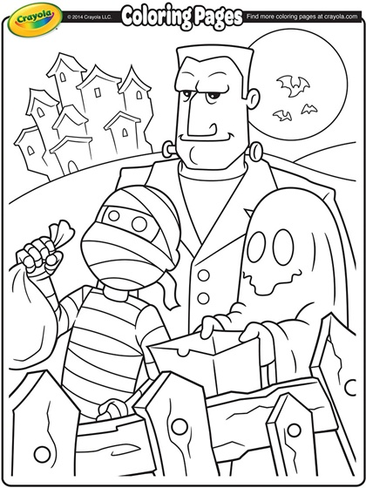
coloring prints

