Background Information Sheet – Complete all sections accurately.
Name & Class |  | Date & Place | Lesson Type |  |  | Plan |  | Topic |  |  | Length | Level
Aileen/Listening class |  | 05/10/2016 | Listening |  |  | PPP |  | How to love yourself |  |  | 45min | intermediate
Class profile
Number of students: 12 person Age: adults (20 ~ 35years) Nationality: Korean
Motivations: Select: Social welfare, Personal advancement, Cognitive interest.
Individual or class hobbies and interests: current affairs and discussing world news.
Special considerations: most of them are female, 2person are male. Ss are mature.
Main aim (listening skills)
- Students practice listening comprehension, using a combination of top-down bottom-up models.
Subsidiary aims (speaking skills)
- Students practice listening and speaking during a listening and answering, discussion to find the answer with their classmates.
- Students learn keywords and lexis related main topic.
Description of language skills specifically used/practiced:  - Speaking – Ss pair discussion – small talk about text.  - Listening – Ss listen the text (video clip) |  |  |  |  |  |  | Description of language systems specifically used/practiced:  - Lexis – primary,achievable, accomplishments.  - Discourse – small talk, informal, opinion sharing.

Anticipated difficulties with lesson activities and classroom management:
- Audio equipment may fail.
2. Students are inclined to be overly cautious so as not to make any mistakes.
How I can deal with these difficulties:
- Use the backup recording, laptop and portable speakers.
2. Let them know that it is okay to make any mistakes.
Assumptions: (What students must already be able to do and what concepts must already be mastered before the lesson in order to achieve the aims of the lesson.)
Students are practived at these type of question-answer exercises and do not rely on writing their ideas down before being able to share them.
Material(s) needed: ppt, computer, whiteboard, eraser and pens, 12 copies of handouts.

Checklist. Mark down those included in this lesson plan ( or N/A)
n/a | model sentences for target language |  |  | v | concept questions for target language |  |  |  | v | analysis sheet for target language
v | stages clearly titled and separated |  |  | v | purpose of each stage indicated |  |  |  | v | anticipated timing included
v | interaction pattern marked |  |  | n/a | a board plan (if relevant) |  |  |  | n/a | examples of all tasks used
v | answer sheet to all exercises |  |  | v | Tape or text script |  |  |  | v | all materials labelled and numbered
Personal aim : What I most hope to demonstrate in this lesson is the ability to give clear instructions to try and reduce my T.T.T

Stage 1:_Lead-in  The purpose of this stage is to ease into the topic, relaxing both teacher and students by focusing their attention on an interesting subject and encouraging the class to share their opinions freely, thus increasing STT and participation. This stage may be used to create a basis from which to elicit ideas and lexis relating to the text. | Inter  action | Time | Instructor’s comments
Procedure: (Separated into titled stages with inclusion of target language, instructions, concept questions, answers to tasks etc., where appropriate)  Arrange seating so everyone has a partner.  Show PPT 1 (Picture of SNS)  Start showing a picture of ‘Star SNS’ to illustrate the modern time’s illness  “Hello everyone. Today we are going to talk about Some feelings about SNS.  do you use sns like kaokao, facebook, instagram, etc?  Ss respond spontaneously - “yes; I use instragram; facebook; I don’t use them at all”  Instructions - “How do you feel when you use it?  when you see other people living happy or luxury life in SNS, Are you okay?  Does SNS made people feel frustrated about theirselves, comparing others?“  Ss share their experiences, feelings of using that for about a minute in paris. Monitor.  Feedback orally – nominate and invite comments from 2 or 3 pairs.  “Nate, How do feel about using SNS? ”  be seated during the feedback. | T  S-S  T  S-S  T-S | 1min  30sec  1min  2min  1min

Stage 2: Presentation  The purpose of this stage is to make the listening less challenging to the students by making use of guiding questions which help predict expected content; answers to these questions may be guessed during this stage and checked later in the lesson; pre-teaching keywords and phrases from the text. Knowledge of the purpose of the text, form and style could be highlighted to further aid comprehension. Thus, schema is activated. | Inter  action | Time | Instructor’s comments
Pre-teach vocabulary : primary, achievable, accomplishments  Briefly elicit/ccq the keywords that students had difficulty with, using the ppt(refer to the analysis sheet).  Eliciting questions for primary:  1) Does your family is what for you? (precious, treasure, gift, etc.)  2) Do people think  Board their answers. Speak ‘primary’ and let them drill the word.  CCQ) Does your love-affairs are primary for you? (Yes)  CCQ) Is it similar with the word ‘important’?(Yes)  Eliciting questions for achievable:  1) Do you have dreams? (Yes)  2) Do your goals can be done really? (Yes)  Board their answers. Speak ‘achievable’ and let them drill the word.  CCQ) Do people want achievable dreams? (Yes)  CCQ) Dreaming being a bird is achievable?(No)  Eliciting questions for accomplishments:  1) Do you have experienced to get a prize? (Yes)  Speak ‘accomplishment’ and let them drill the word.  CCQ) Does your diploma is accomplishments? (Yes)  CCQ) Accomplishments is good?(Yes)  Instructions: “Talk to your parner about the answer to these questions.”  Show PPT1 of books with the questions and read each question aloud.  Guiding Questions:  1. what kind of books are they? (self-development book, psychology, mind-control, etc.)  2. Why do you think people find this kind of book related curing their self-esteem? (fear, tired, etc.)  Ss share their ideas about the answer to the questions with their partner for about a minute.  Feedback – nominate a student who was observed to have a good answer for each question. | T-S  T-S  T-S  T  S-S  T-S | 1min  1min  1min  30sec  1min  30sec

Stage 3: Practice - Listening for gist comprehension  The purpose of this stage is to allow the students to practice gist skills to identify the main idea and key points of interest. Specific and authentic exercises designed to encourage this skill should be used in a natural way. Students draw on their world-knowledge (top-down) to make an initial impression and general sense of the text and perhaps comparing the accuracy of their guesses to the guiding questions used for the text. | Inter  action | Time | Instructor’s comments
Show students picture  - use ppt 3 picture.  Instructions:  “Look at these pictures and question, write your answers briefly to these question.”  “Explain your answer to your partner after you have finished.”  Guiding Questions:  1. Do you have any idea of how to love yourself ? Talk about your skills to love yourself.  Ss share their ideas about the answer to the questions with their partner for about a minute.  Feedback – nominate a student who was observed to have a good answer for each question. | T  S-S  T-S | 30sec  1min  30sec

Stage 4: Practice - Literal comprehension  The purpose of this stage is for students to focus on literal meaning, e.g. of vocabulary, phrases, details, ideas etc. A variety of exercises may be used and should be constructed for short responses e.g. objective questions. The information highlighted should, ideally, be of significance to the next stage. | Inter  action | Time | Instructor’s comments
Instructions:  1. “Look at these questions.” show the questions and read the questions.  2. “Listen carefully this passage. Write your answers briefly to these questions.”  Literal questions  1. Does the speaker said “setting goals” is good to love ourselves? (Yes)  2. How can we “treat ourself well”?  (Eat healthy, exercise, get enough sleep, and learn to relax.)  Play the audio and video for 1:47 minutes, then pause. Ss listen.  Ss work individually. Monitor, pointing out relevant paragraphs if the student is stuck.  Announce stop and pair-check.  “stop. compare your answers with your partners”  ss Pair check their answers.  Feedback. Verbal. Nominate 2 students for each questions if possible.  Ask follow-up questions to check what they heard. | T  S  S-S  T-S | 1min  1:47  1min  2min

Stage 5: Practice - Interpretive comprehension  The purpose of this stage is to allow student to listen intensively for inference. Discriminating between fact and opinion and understanding the writer’s true thinking are possible considerations during this stage. Contrasting ideas may be highlighted, and use of certain language which affects meaning can be analysed in context. | Inter  action | Time | Instructor’s comments
Instructions:  “listen one more time, but this time answer these questions.” read the questions aloud.  Interpretive Questions:  1. Why do we have to reward for accomplishments?  (it can helpful to motivate ourself to try to achieve goals, and don’t make us give up while doing things.)  2. Do you think girl’s caring about ‘how they look’ is related with self-love?  (yes, because more than 70persent of girls are feel not good when they have lack of self-esteem)  “After listening, discuss with your partner and why you say so.”  Play the audio and video for 1:47 minutes, then pause. Ss listen.  students work individually. Monitor, pointing out relevant paragraphs if the student is stuck.  Ss- Pair check. their answers.  Feedback. Verbal. Nominate 3 students for each questions if possible. | T  S  S-S  T-S | 1min  1:47  3min  2min

Stage 6:_Production - Applied Comprehension  The purpose of this stage is to complete the final step in reading comprehension by getting students to apply to themselves the information from the text and which was focused on during the practice stages. The task should take into account your students’ background information in order to be suitable as an applied task. Speaking or writing skills may be practiced here. This stage is an important part of language acquisition. | Inter  action | Time | Instructor’s comments
Instructions:  Discuss all of these questions in pairs first and groups.  Applied Comprehension Questions:  1. If you start to do ‘Step2: Write down qualities’, what would you write about yourself?  2. Do you think many people are having difficulty with loving themselves? then why?  (lack of self-esteem, complex etc.)  students discuss in pairs. Monitor for strong student pairs to answer afterwards.  Backup talking point, if there is additional time after talking.  Q. If you are perfect to deal with self-love, How does it good?  Feedback. Verbal. Nominate 3~4 students for each questions if possible. | T  S  S-S  S-S  T-S | 30sec  1min  3min  2min  2min

Stage 7:_Wrap-up  The purpose of this stage is to end the lesson with some positive feedback about the lesson and the students’ participation. Review the ideas from the production stage if possible, and perhaps offer error correction. Classroom management should be considered, such are collecting worksheets, giving homework, stimulate interest in the next class or arranging the desks etc. | Inter  action | Time | Instructor’s comments
Feedback. Ask a discussion question from the task above to nominated students.  offer any error correction after several students have spoken.  then proceed with the next question.  Announcements:  - Please keep your listening text and bring it to class tomorrow. we will use it.  - Arrange the desks and chairs.  class dismissed. | T | 1min

Instructor’s Final Comments
Overall strengths of this lesson (planning and teaching) | Areas to work on

Overall comment

For this stage of the course, your lesson today was

- Above standard

- To standard

- Below Standard

Instructor: …………………………… Date: …………/……………/…………

Script: How to love yourself (1:47 sec)

Focus on one of the most important relationships you will ever have -- your relationship with yourself. Live the happy life you deserve and learn self-love with these tips.

Step 1: Put yourself first
Put yourself first and make being happy a primary goal in your life.
Step 2: Write down qualities
Write down all of your positive qualities and read them to yourself every day. Add new qualities to the list as you discover and acknowledge them.
Step 3: Accept yourself
Accept and love yourself for who you are. Celebrate your positive qualities; acknowledge but don't get hung up with your negative qualities.
Tip
There's no reason to deny that you have negative qualities. Everyone does.

Step 4: Set goals
Set achievable goals for yourself. Then praise and reward yourself for your accomplishments.

Tip
Don't wait until you have achieved a complete goal. Reward yourself for completing steps along the way.
Step 5: Believe in yourself
Believe in yourself and visualize yourself succeeding.
Step 6: Treat yourself well
Treat yourself well. Eat healthy, exercise, get enough sleep, and learn to relax.
Step 7: Treat others well
Treat others well and do not allow anyone to mistreat you.
Step 8: Have fun
Have fun. Engage in activities that you thoroughly enjoy and surround yourself with great friends and family. Be thankful for who you are today and everyday.
Did You Know?
78 percent of girls with low self-esteem admit it is difficult to feel good in school when they do not feel good about how they look.

< 1. Materials for Guiding questions - SNS Star’s picture>

< 2. Materials for Guiding questions – book related with growing self esteem>

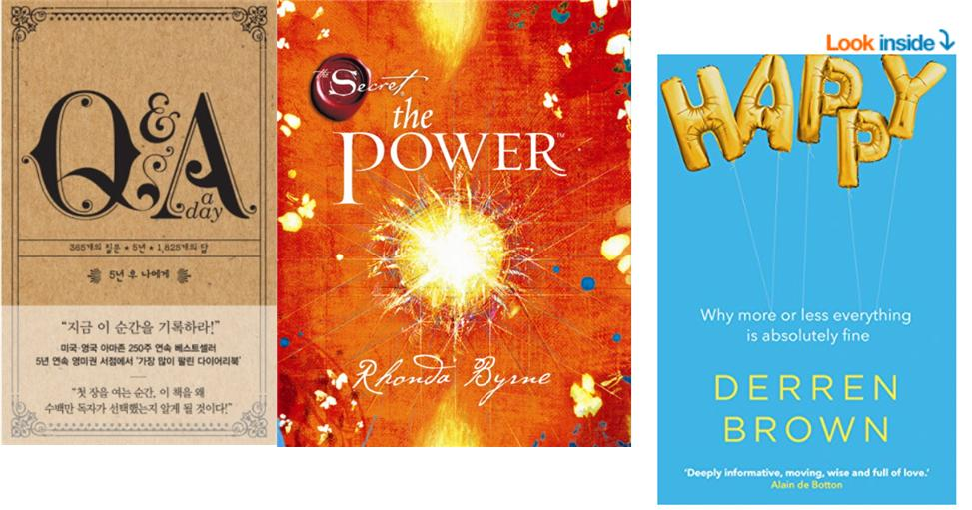

<3. Materials for gist listening question – how to love yourself>

