Background Information Sheet – Complete all sections accurately.

|  |  |  |  |  |  |  |  |  |  |  |  |  |
| --- | --- | --- | --- | --- | --- | --- | --- | --- | --- | --- | --- | --- |
| **Name & Class** | | **Date & Place** | **Lesson Type** | | | **Plan** | | **Topic** | | | **Length** | **Level** |
| Lisa Tesol | | 10/6 | Listening | | | PPP | | High-tech clothes | | | 45 min | inter |
| **Class profile**  **Number of students:**  **12 Age**: Adults ( age above 20 )  **Nationality:**  Korean  **Motivations**:Building listening skills:  **Individual or class hobbies and interests: discussing special clothes**  **Special considerations:** SS are mature, and rule-formers | | | | | | | | | | | | |
| **Main aim (Select: language focus / skills)**   1. Students practice to identify the main idea of the script.   **Subsidiary aims (Select: language focus / skills)**   1. Students practice to pick up details of the listening script. 2. Students practice…to use vocabulary and expressions about clothes. | | | | | | | | | | | | |
| Description of language skills specifically used/practiced:  * Reading * Speaking-students discuss in pairs * Listening-listening to the recording * writing | | | | | | | Description of language systems specifically used/practiced:  * Lexis-benefit,transform,support the words related to the clothes | | | | | |
| Anticipated difficulties with lesson activities and classroom management: Students may not be able to follow the passage easily | | | | | | | | | | | | |
| **How I can deal with these difficulties:** Let them listen to the track again | | | | | | | | | | | | |
| **Assumptions**: (What students must already be able to do and what concepts must already be mastered before the lesson in order to achieve the aims of the lesson.)  All the students are willing to participate | | | | | | | | | | | | |
| **Material(s) needed: -worksheets -audio file**  **-white board -picture** | | | | | | | | | | | | |
| Checklist. Mark down those included in this lesson plan ( or N/A) | | | | | | | | | | | | |
| v | model sentences for target language | | | v | concept questions for target language | | | | v | analysis sheet for target language | | |
| v | stages clearly titled and separated | | | v | purpose of each stage indicated | | | | v | anticipated timing included | | |
| v | interaction pattern marked | | | v | a board plan (if relevant) | | | | v | examples of all tasks used | | |
| v | answer sheet to all exercises | | | v | Tape or text script | | | | v | all materials labelled and numbered | | |
| **Personal aim :** What I most hope to demonstrate in this lesson is the ability to give clear instruction and make friendly environment | | | | | | | | | | | | |

|  |  |  |  |
| --- | --- | --- | --- |
| **Stage 1:_Lead-in**  **The purpose of this stage is to ease into the topic, relaxing both teacher and students by focusing their attention on an interesting subject and encouraging the class to share their opinions freely, thus increasing STT and participation. This stage may be used to create a basis from which to elicit ideas and lexis relating to the text.** | **Inter**  **action** | **Time** | **Instructor’s comments** |
| Greetings) Hello ,everyone. Have you ever imagine we don’t wear clothes?  Why do we wear clothes?  SS respond – “ to protect our body” “to be fashionable” “Be nice”  Instructions)  I will show you three pictures. <picture 1>  What do they wear in the picture?( spacesuit, gym clothes,bulletproof vest)  Do you wear these clothes? (no)  Why do people wear these clothes in the picture? Is there any special clothes that you know? Talk with your partner. Monitor.  Ss share their ideas for a minute in pairs. (to exercise without wetting. Protect body from the bullet. Survive in the space and keep temperature)  Feedback-nominate and listen their answers one by one.  “Sally, What did you talk about?” | T  T-S  S-S  T-S | 1 min  1min  1 min  2min |  |

|  |  |  |  |
| --- | --- | --- | --- |
| **Stage 2: Presentation**  **The purpose of this stage is to make the listening less challenging to the students by making use of guiding questions which help predict expected content; answers to these questions may be guessed during this stage and checked later in the lesson; pre-teaching keywords and phrases from the text. Knowledge of the purpose of the text, form and style could be highlighted to further aid comprehension. Thus, schema is activated.0** | **Inter**  **action** | **Time** | **Instructor’s comments** |
| **Are there any fabric words you know?** Is nylon a fabric? (Yes) Is monitor a fabric? (No)  Nominate each student for an answer. What words do you know?.( Polyester.acrylic .spandex. .. cotton etc)  Teacher will write the words what they said on the board. (Brainstorm pattern)  Pre-teach vocabulary. – benefit . fire-resistant  Eliciting questions for benefit.  1)Point out the words that we brainstorm and ask students “Are these materials same or different?” (different)  2)Why do people wear cotton clothes? (They’re light and comfortable)  3)If we wear nylon clothes, is it same like cotton? (no) Is the cotton ichy?(no)  4)The cotton is light and comfortable and absorb sweat well. They’re good things of cotton. The synonym word is benefit.  CCQ1) When the river floods, is it benefit to us? (no)  CCQ2) The insurance plan provides money when your husband is sick. Is it benefit? (Yes)  Eliciting questions for fire-resistant  1)Look at the picture 2. There are two small model houses. The right house is burned. But the left house is still maintains the forms. What is the difference of left house? (not burn)  2)Yes , Not burn fast. It burns slowly. We call it fire-resistant.  CCQ1)Is this paper fire-resistant? (No)  CCQ2)Is the ice fire-resistant?(Yes)  Instruction: Talk to your partner about the answer to these questions.  Guiding questions>  1)Do you know any special clothes with technology? For example, I wear Yoga clothes when I exercise. It’s comfortable and airy.( fire fighter clothes. Swimsuit. Clothes can check the pulse rate.)  2)Do any of your clothes have special features? (fashionable, colorful, light and comfortable. Warm…)  Feedback orally. Nominate students and listen their answers. | T-S  T-S  T-S  S-S  T-S | 1 min  1 min  1 min  1 min  1 min |  |

|  |  |  |  |
| --- | --- | --- | --- |
| **Stage 3: Practice - Listening for gist comprehension**  **The purpose of this stage is to allow the students to practice gist skills to identify the main idea and key points of interest. Specific and authentic exercises designed to encourage this skill should be used in a natural way. Students draw on their world-knowledge (top-down) to make an initial impression and general sense of the text and perhaps comparing the accuracy of their guesses to the guiding questions used for the text.** | **Inter**  **action** | **Time** | **Instructor’s comments** |
| **\**  Instruction)  1.We will listen to the text .this time. Show picture 3 to students.  2.Which picture is related to the text, A or B?  3.You have to choose one picture after listening. Listen carefully.  Play the audio. Pause after 1 minute 20 seconds.  Ss listen and decide an answer individually.  Which is correct, a or b? (A)  Feedback>  Did you find out more technological clothing ? (Yes)  How many High-tech clothes did you listen? (2.~5)  Good! | T  S  T-S | 1 min  1.30sec  1 min |  |

|  |  |  |  |  |
| --- | --- | --- | --- | --- |
| **Stage 4: Practice - Literal comprehension**  **The purpose of this stage is for students to focus on literal meaning, e.g. of vocabulary, phrases, details, ideas etc. A variety of exercises may be used and should be constructed for short responses e.g. objective questions. The information highlighted should, ideally, be of significance to the next stage.** | **Inter**  **action** | **Time** | **Instructor’s comments** | |
| **Instruction**:> Individually , we are going to check and write answer in **worksheet 4**  This time we will listen one more time .Choose correct answers and we’ll compare answers with your partner.  <4>worksheet  # Choose the best answer  1.What is the material used in spacesuits? d   1. Compression fabric b. flame-resistant fabric 2. cotton d. Aerogel   2.What is not mentioned as new technological clothing? d  a. clothing that plays music  b. clothing that can answer the phone  c. clothing that monitors the heartbeat  d. clothing that helps people lose weight  3. Why do athletes wear compression clothing? d  a. It can reduce the risk of injury  b. increase performance  c.speed uprecovery time  d.water- resistant  > Compare answers with your partner    Check answers :Let ss take turns to answers.  **Replay the relevant section if most students are unsure.** | T  S  S-S  T-S | 30 sec  3min  1min  2min | |  |
| **Stage 5: Practice - Interpretive comprehension**  **The purpose of this stage is to allow student to listen intensively for inference. Discriminating between fact and opinion and understanding the writer’s true thinking are possible considerations during this stage. Contrasting ideas may be highlighted, and use of certain language which affects meaning can be analysed in context.** | Inter  action | Time | Instructor’s comments | |
| **Listen one more time, and this time answer these questions.**  **Questions)**  **1.Is it always better to make high-tech clothes?If so, why?**  **2.What will clothes be like in the future?**  **Listen to the audio to the end.(2:10)**  **After listening, talk with your partner and compare answers.**  **Monitor and assist students to speak.**  **Feed back-What did you talk about question 1?**  **Why do you say so?**  **What did you talk about question 2?** | T  S  S-S  T-S | 1min  3min  1min  2min |  | |

|  |  |  |  |  |
| --- | --- | --- | --- | --- |
| **Stage 6:_Production - Applied Comprehension**  **The purpose of this stage is to complete the final step in reading comprehension by getting students to apply to themselves the information from the text and which was focused on during the practice stages. The task should take into account your students’ background information in order to be suitable as an applied task. Speaking or writing skills may be practiced here. This stage is an important part of language acquisition.** | **Inter**  **action** | **Time** | **Instructor’s comments** | |
| **We are going to make a poster about this topic in groups. 4 students will be 1 group. You are group 2 and the rests are group 3.**  **Topic->If you could invent some special clothing, what would you invent?**  **For example, I want to invent clothes that fly. If I have it, I can control the height and speed.**  **Think about your high-tech clothes. Write simple features of your clothes, price of the clothes, and draw pictures freely.**  **We are going to present in front of students.**  **I will give you 10 minutes.**    **Monitor the students.**  **Remind students about time limit. 3 min left. 1 min left. Please hurry up!!**  **One student from each group will present about their poster.**  **Encourage them to do confidently and praise students.(feedback)** | T  S-S  S  T-S | 2min  10min  3min  1min | |  |

|  |  |  |  |
| --- | --- | --- | --- |
| **Stage 7:_Wrap-up**  **The purpose of this stage is to end the lesson with some positive feedback about the lesson and the students’ participation. Review the ideas from the production stage if possible, and perhaps offer error correction. Classroom management should be considered, such are collecting worksheets, giving homework, stimulate interest in the next class or arranging the desks etc.** | **Inter**  **action** | **Time** | **Instructor’s comments** |
| **What did we learn today?**  **What vocabulary have we learned?**  **Feed back after ss have spoken.**  **Homework is to write an essay about the topic**  **“ Even if high-tech clothes are expensive, do you want to wear it,or not? and why?”**  **Arrange desks and chairs.** | T | 2min |  |

**Instructor’s Final Comments**

|  |  |
| --- | --- |
| Overall strengths of this lesson (planning and teaching) | Areas to work on |
| **Overall comment** For this stage of the course, your lesson today was   * Above standard * To standard * Below Standard | |
| **Instructor: …………………………… Date: …………/……………/…………** | |

**High Tech Clothes**

**How They Benefit Us**

What comes to mind when you think of modern technological innovations? You may think of computers or cell phones. However, clothing has greatly **benefited** from technology, too. New technology has brought new fabrics with special **qualities**. These fabrics help people who have certain jobs.

One of these new inventions is **compression** clothing. Compression clothing is designed to provide **support** to the muscles. Athletes use compression clothing because it can reduce the risk of injury, increase performance, and speed up **recovery** time. Many athletes, such as runners and basketball players, wear them when they are training.

Another invention is flame-**resistant** clothing. This clothing is worn by firefighters and people who work around flames. It keeps people safe from heat stroke and steam burns by taking sweat and moisture off the body. It does not burn in extreme heat, and it protects the skin from fire.

New clothing technology has **contributed** to the aerospace industry, too. Aerogel, for example, is the lightest solid material in the world, and it helps keep things warm. So, NASA uses it to make space suits for astronauts and to protect rovers from changes in climate.

Technology is not only being used to create new fabrics, though. It is also helping to make clothes with special functions. Some companies are making clothing that can play music, answer phone calls, and even **monitor** the heartbeat of the person who is wearing it. As technology develops, it will continue to **transform** our clothing.

Pictures 1<Lead in>



Picture 2>Elicit word –fire resistant

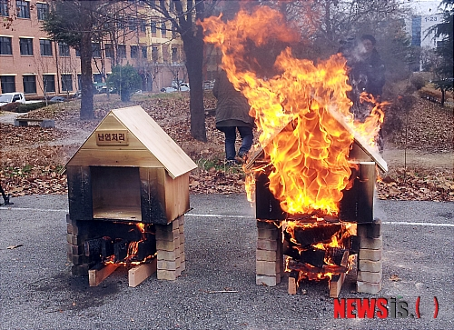

Picture 3

A B

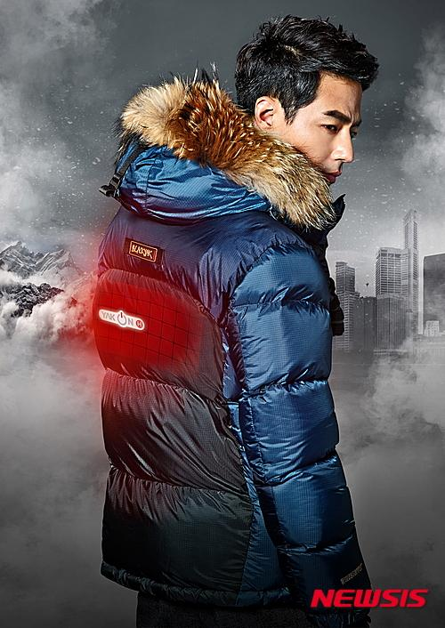

<4>worksheet

# Choose the best answer

1.What is the material used in spacesuits? d

1. Compression fabric b. flame-resistant fabric
2. cotton d. Aerogel

2.What is not mentioned as new technological clothing? d

a. clothing that plays music

b. clothing that can answer the phone

c. clothing that monitors the heartbeat

d. clothing that helps people lose weight

3. Why do athletes wear compression clothing? d

a. It can reduce the risk of injury

b. increase performance

c.speed uprecovery time

d.water- resistant