Name & Class | Date & Place |  | Lesson Type |  | Plan |  | Topic |  |  | Length | Level
Ahra & Rory  TESOL 141st | 10/12/2016  Room 602 |  | Speaking |  | TBL |  | Planning Holiday |  |  | 40 min | Advanced
Class profile
Number of students: 10 Age: Adults Nationality: Koreans / Filipino
Motivations: Building research skills, preparing for professional practice, personal advancement, social relationships, and stimulation.
Individual or class hobbies and interests: Interests in travel all around world
Special considerations: Most of the students are reserved. Students are mature and rule-formers. Be aware of controversial regarding to nationalities.
Main Lesson aim (Skills)
- Students practice and develop speaking fluency by role-play.
Subsidiary aims (Skills)
- Students practice to cooperate with other students in a group, share information, and research proper information.
Description of language skills specifically used/practiced:  - Speaking: Discussing and share information, role-play  - Writing: Write script on worksheet |  |  |  |  |  | Description of language systems specifically used/practiced:  - Function: Asking travel related questions  - Discourse: Turn taking

Anticipated difficulties with lesson activities and classroom management:
- Some of the students may feel shy acting out in front of the class and therefore not participating
- Students may work over the time
- A/V equipment may fail
How I can deal with these difficulties:

Group shy and weak students with active and strong students
- Monitor students while they work and manage there time by saying how long has been passed
- Prepare back-up plan (use laptop and printed hand out)
Assumptions:
Students have been used travel agency.
Students are willing to participate and interested in improving speaking spontaneously.
Material(s) needed: 3 copies of worksheet, 10 copies of self-analysis hand-out, white board, markers, PPT, computer, beam projector

Checklist. Tick those included in this lesson plan (or N/A)
model sentences for target language |  |  |  | concept questions for target language |  |  |  |  | analysis sheet for target language
stages clearly titled and separated |  |  |  | purpose of each stage indicated |  |  |  |  | anticipated timing included
interaction pattern marked |  |  |  | a board plan (if relevant) |  |  |  |  | examples of all tasks used
answer sheet to all exercises |  |  |  | tape script |  |  |  |  | all materials labelled and numbered
Personal aim : What we (Ahra & Rory) most hope to demonstrate in this lesson is the ability to deliver instructions clearly and try to reduce T.T.T while enhancing S.T.T.

Stage 1:_Pre-task  The purpose of this stage is to focus students’ attention and involve them in an interesting task (e.g. brainstorming to the board; help complete a chart etc.) that encourages the class to share their ideas freely, thus increasing STT and participation. Visuals may be used to introduce this task; be specific and focus on what is needed for students to complete the task. Provide the class with the basic inspiration and language they need before going to the next stage (e.g. topic, context, useful grammar/lexis, and an example/demonstration). | Inter  action | Time | Instructor’s comments
R: Rory, A: Ahra  R & A: Hello, everyone.  R: My name is Rory  A: My name is Ahra.  Instructions: Rory (speak)  A write down ‘Travel’ on the white board  “What comes up in your mind when you think of travel?”  Students say words related to travel. (Passport, airplane, hotel, train, France, Italy, food, cost, America, etc.)  Nominate 2-3 students to answer if there is silence  A picks some words and writes on the board while R slightly nods head to students.  “Right! So, when you plan to travel, do you plan yourself? Or do you go to the travel agency for helping?”  (Students answer either myself or go to travel agency)  Nominate 2-3 students to answer if there is silence  ”Yes, you can plan yourself, but also you can use travel agency. We will watch a video together now.”  Play video (from 5 sec to 2min 15 sec)  Students watch the video  No feedback needed. | T  T-S  S | 1 min  30 sec  2 min 30 sec

Stage 2: Task Preparation  The purpose of this stage is for students to work communicatively in pairs or groups to prepare a communicative task (e.g. roleplay, discussion, debate etc.) which they will deliver to the class/teacher. Student’s may research the task, use dictionaries and ask the teacher for guidance. Instructions, groupings handouts/worksheets and resources, should be given at the start of this stage. Students should know exactly what is expected of them, and have enough time to prepare and practice well. Any or all of the skills may be integrated. | Inter  action | Time | Instructor’s comments
<Role play>  Instructions: Ahra (speak)  “Now I will distribute a worksheet for a role-play. First, discuss with your group to pick up 1 place to travel. And there are 3 considerations such as accommodations, activities and cost to fill out. Research those considerations with your group and make a script to do role-play for 3 minutes.”  “I’ll make 3 groups. You 3 are in a group, yon 3 are in a group and you 4 in a group.” (Shy and weak students group with active and strong students)  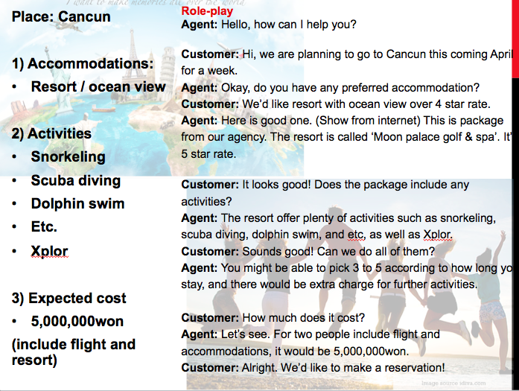  “One of your group members will be an agent and the rest of are friends to go to travel with. You can decide who is going to be agent. I will give you 20 minutes to organize ideas and prepare your draft. Here is an example of role-play script you can make reference to.”  (R Show PPT) “The example is about min & half long. You can add up following  the example or free to make up another format.”  “Do you have any questions?”  (if yes – answer the questions / if no – move to ICQ)  ICQ  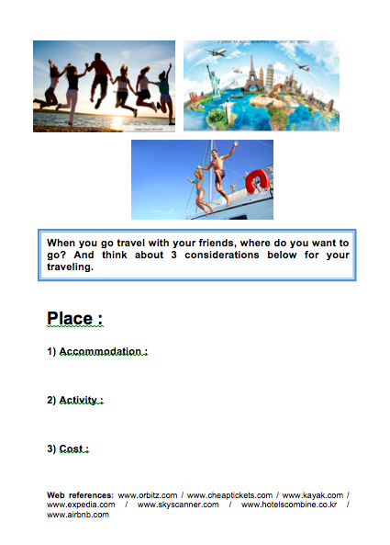  1) “How much time do you have?” (20 minutes)  “Have a seat with your groups”  Students move desks and chairs to seat in group  Hand out role-play worksheet and monitor students.  - Teachers go aground and monitor students.  - Answering the questions to the students.  - If there is silence or no participation, assist students carefully.  - Managing working time and tell student how long they left.  (let students know 10 min, 5 min, and couple of min left)  - Check whether students finished or not.  Students work in groups | T  T-S  S-S | 2 min  1 min  20 min

Stage 3: Task Realisation  The purpose of this stage is for the students to perform/deliver the task they prepared in the previous stage, focusing on their speaking skills such as fluency and pronunciation. Briefly set the students up so they may begin. The teacher should monitor from a distance, i.e. not interrupting this student-centred stage. | Inter  action | Time | Instructor’s comments
Instructions: Ahra (speak)  “Ok, times up. I think you are all finished!”  Arrange stage with desk and chairs  “Now, I want you to come out and act the role-play. Each group has 3 minutes maximum.”  “Does anyone want to volunteer first?”  (if no one, nominate any group to go first) “Your group is first to present so come out now.”  Teachers seat on the back and observe students.  Students  First group comes out  A student who is going to play agent seats one side with nametag ‘agency’, the other students seat on the opposite side.  First group acts role-play  Teachers monitor students  When the group finished, give a big applause and invite next group “Good job, next group on the stage please”  Second group acts role-play  Teachers monitor students  When the group finished, give a big applause and invite next group “Great, last group?”  Last group acts  Teachers monitor students  Teachers take note of interesting language and any errors students make (include grammar, expression, and functions) while students do role-play. | T  S-S | 1 min  9 min

Stage 4 : Post Task  The purpose of this stage is to provide meaningful feedback, error correction and suggestions for further study or homework. Another brief communicative task could be done which is designed to summarise the lesson e.g. write a report; groups vote for a winner; correct their scripts for grammar and practice saying it. | Inter  action | Time | Instructor’s comments
Feedback: Rory (speak)  “Well done everyone”  Correct any significant errors if needed (verbal)  Self-analysis  “I will give you a piece of paper for self-analysis. Let’s write one good point you made today, for example, I participate a lot, I socialized in group very well kind of things, anything. One improving point like I’ll participate more next time. And One suggest topic for next class.”  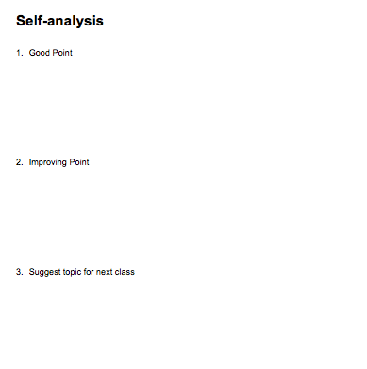  Give hand-out  Students write down.  Monitor and wait a minute for everyone is finished  A collect self-analysis papers  “Did you have fun today? I hope you enjoyed the class. Thank you.”  Class dismissed | T  S  T | 1 min  30 sec  1 min 30 sec

Instructor’s Final Comments
Overall strengths of this lesson (planning and teaching) | Areas to work on

Overall comment

For this stage of the course, your lesson today was

- Above standard

- To standard

- Below Standard

Instructor: …………………………………….… Date: …………/……………/..……….

