Name & Class |  | Date & Place | Lesson Type |  |  | Plan |  | Topic |  |  | Length | Level
Yena Kang 141WD |  | 10/25/2016  Room 602 | Reading |  |  | PPP |  | College |  |  | 30 | Intermediate
Class profile
Number of students: 12 Age: 20-40 Nationality: Korean and Filipino
Motivations: Demonstrating knowledge and understanding
Individual or class hobbies and interests: interested in improving English and current issues
Special considerations: SS are mature, reserved, and inclined to be rule- formers. Students are all male. L1 is Korean.
Main aim (skills)
- Students practice / learn … reading comprehension, using a combination of top- down and bottom-up models.
Subsidiary aims ( skills)
- Students practice… Speaking fluency during an informal discussion
- Students practice… learn the key vocabulary and lexis from a new article
Description of language skills specifically used/practiced:  - Reading- reading the passage  - Speaking – discussion about expressing one’s opinion  - Listening- to their partner, and other pairs if possible  - Writing- long answers |  |  |  |  |  |  | Description of language systems specifically used/practiced:  - Lexis – applicants, qualified, forced, burden, commitment  - Discourse- small talk, Informal, opinion sharing.

Anticipated difficulties with lesson activities and classroom management:
1. One may not be interested in the topic
2. One students are inclined to be overly cautious as not to make any mistakes.
How I can deal with these difficulties:

Do a interesting lead in to grab students attention
- Make relaxed classroom atmosphere to reduce the anxiety and increate self- esteem and motivation
Assumptions: (What students must already be able to do and what concepts must already be mastered before the lesson in order to achieve the aims of the lesson.)
All students have expressed interest in improving informal and unprepared speaking, and are willing to enjoy the class.

Material(s) needed: Ppt, Computer, Whitboard, erasers and pens. 10 copies handout for all the worksheet

Checklist. Mark down those included in this lesson plan ( or N/A)
 | model sentences for target language |  |  |  | concept questions for target language |  |  |  |  | analysis sheet for target language
 | stages clearly titled and separated |  |  |  | purpose of each stage indicated |  |  |  |  | anticipated timing included
 | interaction pattern marked |  |  |  | a board plan (if relevant) |  |  |  |  | examples of all tasks used
 | answer sheet to all exercises |  |  |  | Tape or text script |  |  |  |  | all materials labelled and numbered
Personal aim : What I most hope to demonstrate in this lesson is the ability to maximize student interaction by motivating them in each task, pair work, and class discussion.

Stage 1:_Lead-in  The purpose of this stage is to ease into the topic, relaxing both teacher and students by focusing their attention on an interesting subject and encouraging the class to share their opinions freely, thus increasing STT and participation. This stage may be used to create a basis from which to elicit ideas and lexis relating to the text. | Inter  action | Time | Instructor’s comments
Introduction (Greeting)  Hi, Everyone! How’s everyone today? Did you guys sleep well last night?  What do you guys think are the most important factors to live a successful life?  Instruction  Show ppt 1 (picture of money, love, office worker)  “Tell me some of the important factors in living a successful life.”  (students may answer : Money, Work, Family, Love etc……)  How about college? Do you think college is necessary in order to succeed in life?  Please talk to your partner about “Do you think college is important in our life?” | T  T-S  S-S | 10 secs  30 secs  1 mins

Stage 2: Presentation  The purpose of this stage is to make the listening less challenging to the students by making use of guiding questions which help predict expected content; answers to these questions may be guessed during this stage and checked later in the lesson; pre-teaching keywords and phrases from the text. Knowledge of the purpose of the text, form and style could be highlighted to further aid comprehension. Thus, schema is activated. | Inter  action | Time | Instructor’s comments
Introduction  Okay, Today we are going to read an article about college.  Before we start reading our article, let me tell you some vocabulary before hand to help you understand better with the passage.  Instruction  Show ppt 2  1. Elicit “burden”  What do you guys think about this picture? Look at this men’s face  This is called “burden” Too many things on your shoulder  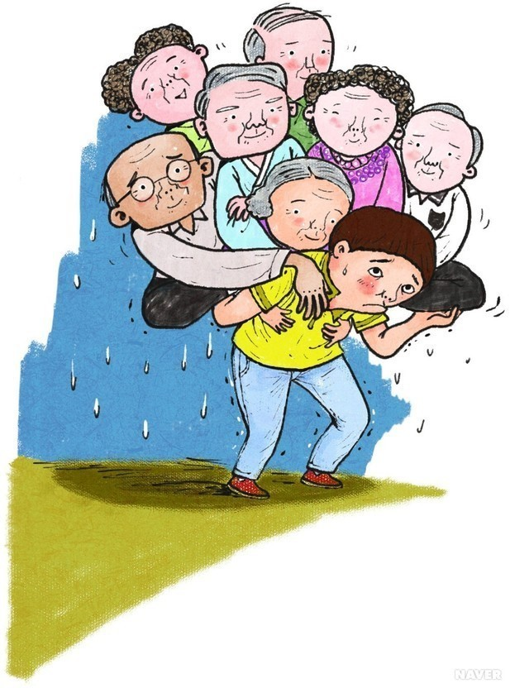  2. Elicit “Forced”  Let’s look at this picture. What do you see?  Do you see a hand that is telling the men what to do?  This is called “ Forced”  - Elicit “applicants”  What do you see in this picture? What do you think they are waiting for?  People who come to do a job interview are called “Applicants”  5.Elicit “commitment”  What do you see in the picture? It is a big promise!  CCQ questions to check for understanding  - If you are going for a job interview, are you applicants?  - If you have lot of money borrowed from a friend, is that a burden?  - If you promise to work in a company is that a commitment?  - If I ask your opinion if you want to do something or not, is that forced?  Now, I am going to hand out an article about college. Please take 3 minutes to read the article and understand the main sentences.  Give out the article to read. Give 3 minutes to read. | T  T-S  T-S  T-S  T-S  T-S  T-S  S | 10 secs  1 mins  1 mins  1 mins  30 secs  30 secs  2 mins  3 mins

Stage 3: Practice – Reading for gist comprehension  The purpose of this stage is to allow the students to practice gist skills to identify the main idea and key points of interest. Specific and authentic exercises designed to encourage this skill should be used in a natural way. Students draw on their world-knowledge (top-down) to make an initial impression and general sense of the text and perhaps comparing the accuracy of their guesses to the guiding questions used for the text. | Inter  action | Time | Instructor’s comments
Introduction:  Okay. Now let me give out the worksheet (Give out comprehension Questions )  - How many years do most people spend studying in college?  - What kind of help can you get from college professors?  - What is the problem with student loan?  - Why do people pay to get a college education?  - Why would a college education separate you from others when applying for a job or program?  After, Show answer sheet on the ppt 3 and share answers together as a whole class. | S  T-S | 3 mins  1 min

Stage 4: Practice - Literal comprehension  The purpose of this stage is for students to focus on literal meaning, e.g. of vocabulary, phrases, details, ideas etc. A variety of exercises may be used and should be constructed for short responses e.g. objective questions. The information highlighted should, ideally, be of significance to the next stage. | Inter  action | Time | Instructor’s comments
Introduction: Now, I am going to hand out a vocabulary worksheet. There are 5 questions on the worksheet for vocabulary check.  There are word bank in the worksheet so match the vocabulary to the suitable sentences.  Worksheet:  Vocabulary Check  - I didn’t want to go to practice, but my friends __________ me to go.  - Many people wanted the new job, so I had to interview many _________.  - Signing a 5 year contract to play baseball is a big _______________.  - Please don’t ____________ me with your problems. I have work to do.  Instruction: Hand out the worksheet  Give them 3 minutes to do read and answer. After make them compare answers with a partner. Then nominate 5 students to read each questions and share answers as a class. | T  S | 30 secs  3 mins

Stage 5: Practice - Interpretive comprehension  The purpose of this stage is to allow student to listen intensively for inference. Discriminating between fact and opinion and understanding the writer’s true thinking are possible considerations during this stage. Contrasting ideas may be highlighted, and use of certain language which affects meaning can be analysed in context. | Inter  action | Time | Instructor’s comments
Instruction:  Hand out opinion practice worksheet  Demonstrate  the worksheet for supporting Opinions and Refuting Opinions  “Okay, everyone. Let’s look at number 1 for supporting Opinions. It is good to travel after high school……. What kind of answer would support this idea? Let’s look at the box underneath.  Okay. The answer is a. Because it can be difficult to travel when you have a family and a full time job”  “Okay, let’s take a look at Refuting Opinion number 1 now. Ahra, can you read number 1 for refuting opinion? (Ahra reads….)  Now, for refuting opinion, we find the opposite opinion for this statement. The answer is b. No, you should have a job which makes you happy. Go to college only if it helps you to be happy.  Okay Now I will give you 3 minutes to answer these questions with your partner. | T  T-S  S | 10 secs  2 mins  3 mins

Stage 6:_Production - Applied Comprehension  The purpose of this stage is to complete the final step in reading comprehension by getting students to apply to themselves the information from the text and which was focused on during the practice stages. The task should take into account your students’ background information in order to be suitable as an applied task. Speaking or writing skills may be practiced here. This stage is an important part of language acquisition. | Inter  action | Time | Instructor’s comments
Introduction  Okay Everyone, Let’s look at the board. Ppt 4  The question to talk about are:  1. Do you think there are better ways to learn than going to college?  2. Many people let their friends, family and teachers influence on their decisions. Do you think this is a good idea when it comes to going to college?”  Please talk to your partner for three minutes | S-S | 3 mins

Stage 7:_Wrap-up  The purpose of this stage is to end the lesson with some positive feedback about the lesson and the students’ participation. Review the ideas from the production stage if possible, and perhaps offer error correction. Classroom management should be considered, such are collecting worksheets, giving homework, stimulate interest in the next class or arranging the desks etc. | Inter  action | Time | Instructor’s comments
Wrap-up  “Okay. Class. Did you enjoy today’s class?” “Did you thoughts change after talking to your partner about college and what is important in life?”  I am not going to give you guys any homework today but please take some time to think about what really makes you happy in life”  Thank you! | T | 1 mins
Instructor’s Final Comments
Overall strengths of this lesson (planning and teaching) | Areas to work on

Overall comment

For this stage of the course, your lesson today was

- Above standard

- To standard

- Below Standard

Instructor: …………………………… Date: …………/……………/…………

