Name & Class |  | Date & Place | Lesson Type |  |  | Plan |  | Topic |  |  | Length | Level
Rory  TESOL 141 |  | 10/26/2016  Room 601 | Reading |  |  | PPP |  | To Tip or Not to Tip? |  |  | 30min | Intermediate
Class profile
Number of students: 11 Age: Adults Nationality: Korean / Filipinos
Motivations: Demonstrating knowledge and understanding and personal advancement
Individual or class hobbies and interests: experience about country where is tipping customary
Special considerations: one student is Filipinos and rest of students are Koreans.
Main aim (language focus / skills)
- Students learn new vocabulary and reading skills (skimming and scanning).
Subsidiary aims (skills)
- Students identify the main idea of the reading article and doing worksheet and answering questions.
- Students practice speaking by discussing with pairs.
Description of language skills specifically used/practiced:  - Reading – Article  - Speaking – Ss pair discussion |  |  |  |  |  |  | Description of language systems specifically used/practiced:  Lexis - wages, treat

Anticipated difficulties with lesson activities and classroom management:
1) Students have never visited country where tipping is customary.
How I can deal with these difficulties:

1) Students can listen to other students who have visited country where tipping is customary.
Assumptions: (What students must already be able to do and what concepts must already be mastered before the lesson in order to achieve the aims of the lesson.)
Students are able to express their opinions in English.
Material(s) needed: PPT, pen, paper, 11 copies of handouts

Checklist. Mark down those included in this lesson plan ( or N/A)
N/A | model sentences for target language |  |  | √ | concept questions for target language |  |  |  | √ | analysis sheet for target language
√ | stages clearly titled and separated |  |  | √ | purpose of each stage indicated |  |  |  | √ | anticipated timing included
√ | interaction pattern marked |  |  | N/A | a board plan (if relevant) |  |  |  | √ | examples of all tasks used
√ | answer sheet to all exercises |  |  | √ | Tape or text script |  |  |  | √ | all materials labelled and numbered
Personal aim : What I most hope to demonstrate in this lesson is the ability to give clear instruction and increase students’ reading comprehension skills.

Stage 1:_Lead-in  The purpose of this stage is to ease into the topic, relaxing both teacher and students by focusing their attention on an interesting subject and encouraging the class to share their opinions freely, thus increasing STT and participation. This stage may be used to create a basis from which to elicit ideas and lexis relating to the text. | Inter  action | Time | Instructor’s comments
Procedure: (Separated into titled stages with inclusion of target language, instructions, concept questions, answers to tasks etc., where appropriate)  Greetings  “Hello everyone! I am Rory. How’s feeling today?”  “So, Have you ever visited restaurant in another country?” (Yes/No)  “Then, Have you ever visited restaurant in Korea?” (Yes)  “Discuss what the differences with your partner”  Feedback  “Tell me what the differences.” (Nominate 2 students) | T  T-S  S-S  T-S | 10sec  30sec  1min  1min

Stage 2: Presentation  The purpose of this stage is to make the reading less challenging to the students by making use of guiding questions which help predict expected content; answers to these questions may be guessed during this stage and checked later in the lesson; pre-teaching keywords and phrases from the text. Knowledge of the purpose of the text, form and style could be highlighted to further aid comprehension. Thus, schema is activated. | Inter  action | Time | Instructor’s comments
Materials – PPT1 and PPT2  Pre-teach vocabulary (wages, treat)  “Let’s learn vocabulary that will help you to read the text.”  - wages  (Show PPT1)  “What is her job?” (cashier)  “What is she doing?” (serving)  “Where she working at?” (Mcdonalds)  “What is he doing?” (carry bags)  “Why do they work?” (money/earn money)  “Every employee receives money for work or services. Usually on an hourly, daily or weekly basis. So, what is that money called?” (wages, salary)  C.C.Q.  “Do higher wages make you work harder?” (Yes)  - treat  (Show PPT2)  “Do you know what day is it?” (Halloween day)  “Why children are going door to door while wearing costumes?” (candies and chocolates)  “What are they going to say?” (Treat or trick)  “What if they don’t get sweets, what are they going to do?” (they threaten to do some harm to the inhabitants of the house)  “So, ‘I want you to show kindness to me such as sweets or snacks’ means Treat or trick?” (Treat)  C.C.Q.  “Do you treat with your parents with respect?” (Yes)  “Do your parents still treat you like a child?” (Yes/No)  “ | T  T-S  T  T-S  T-S | 10sec  1min  10sec  1min  20sec

Stage 3: Practice – Skimming and scanning for gist comprehension  The purpose of this stage is to allow the students to practice rapid reading skills to identify the main idea and key points of interest. Specific and authentic exercises designed to encourage these reading skills should be used in a natural way. Students draw on their world-knowledge (top-down) to make an initial impression and general sense of the text and perhaps comparing the accuracy of their guesses to the guiding questions used for the text. | Inter  action | Time | Instructor’s comments
Materials PPT3, hand out(article)  “Before you read, look at this screen. There are 7 service providers.”  “And talk about your experience when did you tip and how much.”  “Talk with your partners. I’ll give you 2 minutes.”  Feedback  Nominate 2-3 students and show ppt3 for the answers.  Instruction  “I’ll give out this article. Read the article comparing your answers.  “You have 3 minutes.”  Students work individually, skimming and scanning the text. | T  S-S  T-S  T  S | 30sec  2min  1min  10sec  3min

Stage 4: Practice - Detailed comprehension  The purpose of this stage is for students to focus on literal meaning, e.g. of vocabulary, phrases, topic points etc. A variety of exercises may be used and should be constructed to be simple yet somewhat challenging. The information highlighted should, ideally, be of significance to the next stage. | Inter  action | Time | Instructor’s comments
Materials worksheet 1 and worksheet 2  Instruction  1) “I will give out a worksheet. Look at the worksheet1.”  2) “You can read the text again and put T or F next to each questions.”  3) “Work individually and check answers with your partner.”  4) “I will give you 1 minute.”  Feedback  Nominate Students and ask each answer. (Verbal)  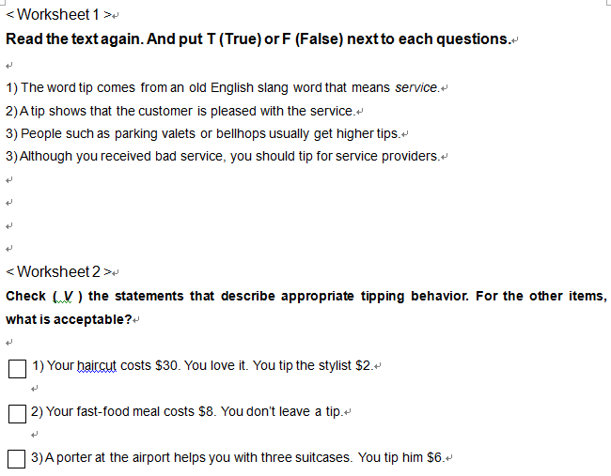  Instruction  1) “Look at the worksheet2.”  2) “Check ( V ) the statements that describe appropriate tipping behavior. For the other items, what is acceptable?”  3) “Work individually and check answers with your partner.”  4) “I will give you 1 minute.”  Feedback  Nominate Students and ask each answer. (Verbal) | T  S  S-S  T-S  T  S  S-S  T-S | 30sec  1min  30sec  30sec  1min  30sec

Stage 5: Practice – More detailed comprehension  The purpose of this stage is to allow student to read intensively for inference. Discriminating between fact and opinion and understanding the writer’s true thinking are possible considerations during this stage. Contrasting ideas may be highlighted, and use of certain language which affects meaning can be analysed in context. | Inter  action | Time | Instructor’s comments
Materials PPT4, pen, paper  Instruction  (show ppt4)  “Look at these questions.”  “Write your answers individually to these questions by referring to the text. “  “I will give you 3 minutes.”  “And then compare your answers with your partners.”  Teacher  Give papers if students who need a paper.  Interpretive questions  1) Why Americans tip people in places like restaurant, airports, hotels, and hair salons?  2) Why do you think people such as taxi drivers and waitress get larger tips than people such as parking valets or bellhops?  Students work individually and compare answers with partners.  Feedback  Nominate 2~4 students and ask questions. | T  S  S-S  T-S | 20sec  3min  3min

Stage 6:_Production - Applied Comprehension  The purpose of this stage is to complete the final step in reading comprehension by getting students to apply to themselves the information from the text and which was focused on during the practice stages. The task should take into account your students’ background information in order to be suitable as an applied task. Speaking or writing skills may be practiced here. This stage is an important part of language acquisition. | Inter  action | Time | Instructor’s comments
Materials PPT5  Instruction  (show ppt5)  “We have two questions. First one is ‘Do you like the idea of tipping? Why or why not?’ and second one is ‘Do you think the tip is mandatory?’  “Discuss with your partner. You don’t need to write down the answers”  “You have 3minutes”  I.C.Q.  “Do you work alone?” (No)  “Do you discuss with your partner? (Yes)  Students  Discuss with partners about those two questions.  Applied questions  1) Do you like the idea of tipping? Why or why not?  2) Do you think the tip is mandatory?  Feedback  Nominate 2~4 students and ask questions. | T  T  S-S  T-S | 20sec  10sec  3min  3min

Stage 7:_Wrap-up  The purpose of this stage is to end the lesson with some positive feedback about the lesson and the students’ participation. Review the ideas from the production stage if possible, and perhaps offer error correction. Classroom management should be considered, such are collecting worksheets, giving homework, stimulate interest in the next class or arranging the desks etc. | Inter  action | Time | Instructor’s comments
“We are finished today. Did you enjoy the class?”  “For homework, find 3 countries where tipping is customary and required.”  “Tomorrow we will talk about it in class.”  “Thank you everyone.”  - Class dismissed - | T-S | 1min
Instructor’s Final Comments
Overall strengths of this lesson (planning and teaching) | Areas to work on

Overall comment

For this stage of the course, your lesson today was

- Above standard

- To standard

- Below Standard

Instructor: …………………………… Date: …………/……………/…………

