Background Information Sheet – Complete all sections accurately.
Name & Class |  | Date & Place | Lesson Type |  |  | Plan |  | Topic |  |  | Length | Level
Joshua / Times TESOL 141 st |  | 10/27/2016  Room 602 | Reading |  |  | PPP |  | The secrets of efficient learning |  |  | 30min | Intermediate
Class profile
Number of students: 11 Age: Adults(+30 years) Nationality: Korean
Motivations: Select: 1. Preparing for professional practice 2. Social relationships
Individual or class hobbies and interests: Current affairs and interesting news reports.
Special considerations: SS are mature. Students are mostly female. L1 is Korean.
Main aim (Select: language focus / skills)
- Students learn and practice reading skills, using a combination of top-down and bottom-up models
Subsidiary aims (Select: language focus / skills)
- Students practice reading while reading gist and specific detail.
- Students practice speaking by sharing their ideas with partners.
Description of language skills specifically used/practiced:  - Reading – Ss reading materials.  - Speaking – Ss carry out pair discussion and presentation. |  |  |  |  |  |  | Description of language systems specifically used/practiced:  - Lexis – Chronic, adrenaline…etc  - Discourse – Small talk, Informal, Opinion, Sharing  - Phonology – Practice speaking lexis.

Anticipated difficulties with lesson activities and classroom management:
- Students are inclined to be overly cautious so as not to make any mistakes
- Some of SS are very passive and not participate and share the opinion
How I can deal with these difficulties:
1. Lead-in to encourage warm, relaxed classroom atmosphere, reducing anxiety and increasing self-esteem and motivation
Assumptions: (What students must already be able to do and what concepts must already be mastered before the lesson in order to achieve the aims of the lesson.)
1. Most Ss are interested in learning materials I prepared

Material(s) needed: white board, eraser and pens ; 11 copies of hand out

Checklist. Mark down those included in this lesson plan ( or N/A)
 | model sentences for target language |  |  |  | concept questions for target language |  |  |  |  | analysis sheet for target language
 | stages clearly titled and separated |  |  |  | purpose of each stage indicated |  |  |  |  | anticipated timing included
 | interaction pattern marked |  |  |  | a board plan (if relevant) |  |  |  |  | examples of all tasks used
 | answer sheet to all exercises |  |  |  | Tape or text script |  |  |  |  | all materials labelled and numbered
Personal aim : What I most hope to demonstrate in this lesson is the ability to
- Identify the main idea of the listening script by repeated listening and answering guiding questions.
- Express their opinions about the topic through discussion and presentation.

Stage 1:_Lead-in  The purpose of this stage is to ease into the topic, relaxing both teacher and students by focusing their attention on an interesting subject and encouraging the class to share their opinions freely, thus increasing STT and participation. This stage may be used to create a basis from which to elicit ideas and lexis relating to the text. | Inter  action | Time | Instructor’s comments
Procedure: (Separated into titled stages with inclusion of target language, instructions, concept questions, answers to tasks etc., where appropriate)  Greetings  Hi everyone. How are you today?  Hi, I’m fine or good.  Today I’m going to introduce the secrets of efficient learning. Does anyone have your own secrets of efficient learning?  Instructions  1. First, match these words to their definitions, For example, ‘chronic’ matches with ‘of long duration’  2. I’m going to hand out worksheet, match every word to the definitions  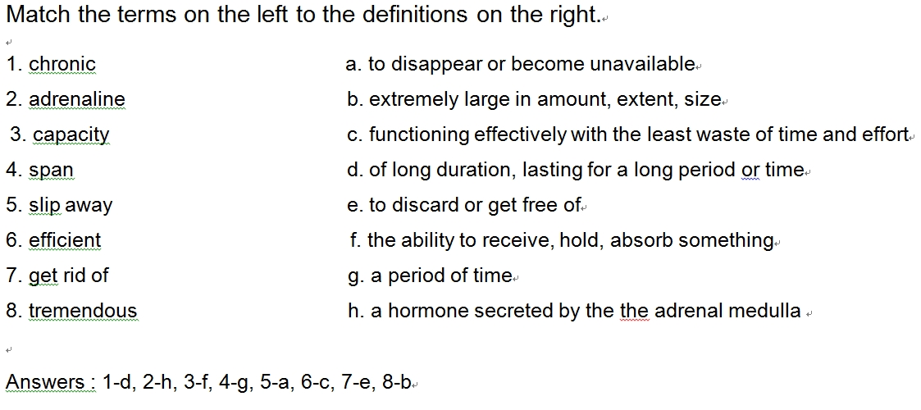  Feedback  - Thanks for matching the words  - We have the same match to the definitions | T-S  S-S  T-S  T | 30sec  1min  1min  30sec

Stage 2: Presentation  The purpose of this stage is to make the reading less challenging to the students by making use of guiding questions which help predict expected content; answers to these questions may be guessed during this stage and checked later in the lesson; pre-teaching keywords and phrases from the text. Knowledge of the purpose of the text, form and style could be highlighted to further aid comprehension. Thus, schema is activated. | Inter  action | Time | Instructor’s comments
Pre-teach vocabulary - use ppt1 and 2  Feedback with projector – Briefly elicit/ccq the keyworks that students had difficulty with, using the ppt  Answers : 1-d, 2-h, 3-f, 4-g, 5-a, 6-c, 7-e, 8-b  Guiding questions – Show workwheet 2.  Instructions :  - Circle the answer you think is correct. Discuss each question with your partner  - Demonstrate guessing the answer  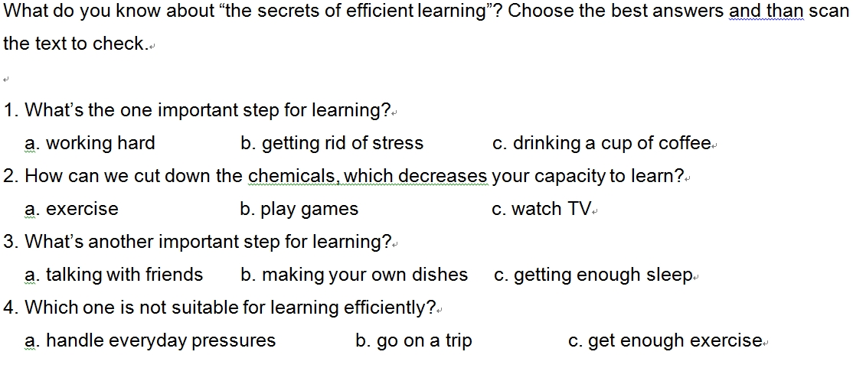  Students work individually  Pair-work. Ss compare their answers.  Monitor for completion | T-S  T-S  T | 30sec  1min  30sec

Stage 3: Practice – Skimming aand scanning for gist comprehension  The purpose of this stage is to allow the students to practice rapid reading skills to identify the main idea and key points of interest. Specific and authentic exercises designed to encourage these reading skills should be used in a natural way. Students draw on their world-knowledge (top-down) to make an initial impression and general sense of the text and perhaps comparing the accuracy of their guesses to the guiding questions used for the text. | Inter  action | Time | Instructor’s comments
This is an article about learning  Instructions  - Scan the text to check if you guessed correctly  - You have 3minutes, so work quickly  - You must stop after 3minutes and compare your answers with your partner  ICQ :  - Should you read all the words in the whole article? (No)  - Must you quickly check your answers?(Yes)  - How much time do you have? (3minutes)  Ss work individually, skimming and scanning the text.  Announce stop and pair-check, even if ss have not finished.  “Stop, Turn over the text now. Compare your answers with your partner.”  Feedback  - Nominate students for an answer  - Ask students to compare with their partners  - Tell the students each answer  Answers : 1-b, 2-a, 3-c, 4-b | T-S  T  S  S-S  T-S  T | 1min  30sec  1mins  3mins  1min  30sec

Stage 4: Practice - Detailed comprehension  The purpose of this stage is for students to focus on literal meaning, e.g. of vocabulary, phrases, topic points etc. A variety of exercises may be used and should be constructed to be simple yet somewhat challenging. The information highlighted should, ideally, be of significance to the next stage. | Inter  action | Time | Instructor’s comments
Instructions :  - Individually, read the text again and put T or F next to each statement below.  - Check with your partner. Explain to your partner why the false answers are false.  - For example, number 1….(refer to the text indicating the statement is false)  - You have 3 minutes.  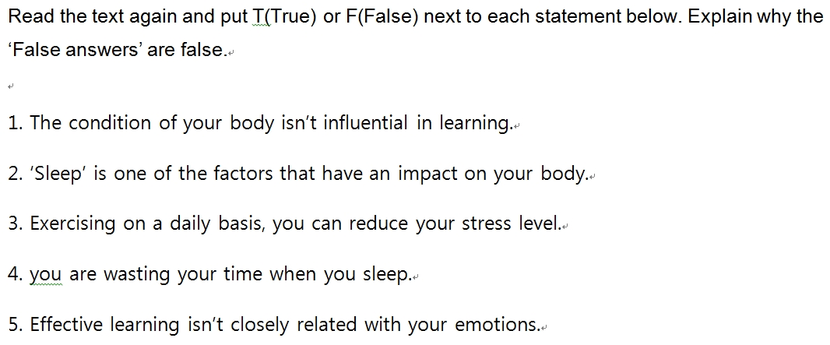  Students work individually for 5minutes  Pair check answers, explaning reasons for false statements. | T  S  S-S  T-S | 1mins  2mins  1min  3mins  30sec

Stage 5: Practice – More detailed comprehension  The purpose of this stage is to allow student to read intensively for inference. Discriminating between fact and opinion and understanding the writer’s true thinking are possible considerations during this stage. Contrasting ideas may be highlighted, and use of certain language which affects meaning can be analysed in context. | Inter  action | Time | Instructor’s comments
Instructions :  - For exercise 4, write your answers briefly to these questions by referring to the text.  - Explain your answer to your partner after you have finished.  ICQ :  - Are you writing your answers first?(Yes)  - When you have finished writing all the answers, must you talk to your partner? (Yes)  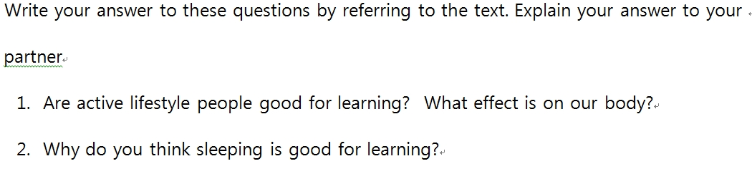  Students work individually, Monitor, pointing out relevant paragraphs if the student is stuck.  Pair check  Feedback  Nominate 2 students for each question if possible. | T  S  S-S  T | 2mins  2mins  2mins  30sec

Stage 6:_Production - Applied Comprehension  The purpose of this stage is to complete the final step in reading comprehension by getting students to apply to themselves the information from the text and which was focused on during the practice stages. The task should take into account your students’ background information in order to be suitable as an applied task. Speaking or writing skills may be practiced here. This stage is an important part of language acquisition. | Inter  action | Time | Instructor’s comments
Instructions  Discuss any of these questions in pairs or groups  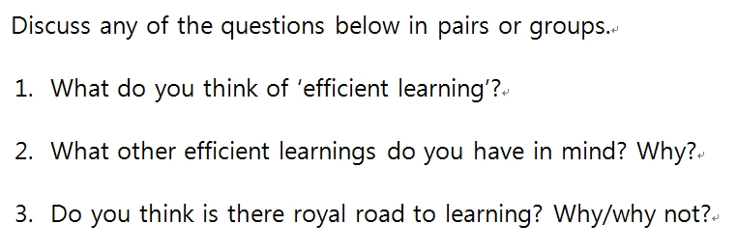  Students discuss in pairs. Monitor for strong student pairs to answer afterwards.  How would you like to use the secrets of efficient learning in your real life?  Feedback  Ask a discussion question from the task and nominate 2-3students | T-S  S-S  T | 30sec  4mins  30sec

Stage 7:_Wrap-up  The purpose of this stage is to end the lesson with some positive feedback about the lesson and the students’ participation. Review the ideas from the production stage if possible, and perhaps offer error correction. Classroom management should be considered, such are collecting worksheets, giving homework, stimulate interest in the next class or arranging the desks etc. | Inter  action | Time | Instructor’s comments
Homework  I’ll give you homework.  I want you to find some methods that are interesting, efficient and a new way.  “See you tomorrow, and don’t be late”  Class dismissed. | T-S | 30sec
Instructor’s Final Comments
Overall strengths of this lesson (planning and teaching) | Areas to work on

Overall comment

For this stage of the course, your lesson today was

- Above standard

- To standard

- Below Standard

Instructor: …………………………… Date: …………/……………/…………

The secrets of effcient learning
Prepare Your Body for Learning
The condition of your body is influential in learning. There are numerous factors that have and impact on your body such as stress, exercise, and sleep. Chronic stress is one of the core elements that hinder you from learning efficiently. So one important step in preparing your body for learning is getting rid of stress. Unless you react properly to everyday pressures, your body will release too much adrenaline and cortisol, which decreases your capacity to learn. The chemicals your body produces under stress can be cut down or eliminated through exercise. So if you exercise on a daily basis, you can learn more efficiently by reducing your stress level. Furthermore, research shows that people who have an active lifestyle have better attention spans, memories, and motor skills. It is also important to get enough sleep if you want to boost your ability to learn. You may think (that) you're wasting time when you sleep, but actually your brain is busy processing, organizing, and storing the information you've been trying to learn while you were awake. So to prepare yourself to learn, you should first be able to handle everyday pressures, and get enough exercise and sleep.
Stay Motivated.
Effective learning is closely related with your emotions. When you feel excited about what you're learning and happy about the progress that you have made, you give a tremendous boost to your ability to learn. So try to find what truly interests you and enjoy the journey of learning. Another way to boost learning is to put what you learned into action. For example, when you memorize words in a foreign language, you may find that they keep slipping away unless you review them often. On the other hand, when you get a chance to actually use a word (that) you've memorized, you'll find that it's much easier to recall the next time you need it. When you study something, experiment with it and find fun ways to learn it. You'll realize that you can master it with much less effort than you would (master) if you just memorized it off the page of a textbook.

Match the terms on the left to the definitions on the right.

1. chronic a. to disappear or become unavailable
2. adrenaline b. extremely large in amount, extent, size
3. capacity c. functioning effectively with the least waste of time and effort
4. span d. of long duration, lasting for a long period or time
5. slip away e. to discard or get free of
6. efficient f. the ability to receive, hold, absorb something
7. get rid of g. a period of time
8. tremendous h. a hormone secreted by the the adrenal medulla

What do you know about “the secrets of efficient learning”? Choose the best answers and than scan the text to check.

1. What’s the one important step for learning?
a. working hard b. getting rid of stress c. drinking a cup of coffee
2. How can we cut down the chemicals, which decreases your capacity to learn?
a. exercise b. play games c. watch TV
3. What’s another important step for learning?
a. talking with friends b. making your own dishes c. getting enough sleep
4. Which one is not suitable for learning efficiently?
a. handle everyday pressures b. go on a trip c. get enough exercise

Read the text again and put T(True) or F(False) next to each statement below. Explain why the ‘False answers’ are false.

1. The condition of your body isn’t influential in learning.
2. ‘Sleep’ is one of the factors that have an impact on your body.
3. Exercising on a daily basis, you can reduce your stress level.
4. you are wasting your time when you sleep.
5. Effective learning isn’t closely related with your emotions.
.

Write your answer to these questions by referring to the text. Explain your answer to your
partner
- Are active lifestyle people good for learning? What effect is on our body?
- Why do you think sleeping is good for learning?

Discuss any of the questions below in pairs or groups.
- What do you think of ‘efficient learning’?
- What other efficient learnings do you have in mind? Why?
- Do you think is there royal road to learning? Why/why not?

#1 - Answers : 1-d, 2-h, 3-f, 4-g, 5-a, 6-c, 7-e, 8-b
#2- Answers : 1-b, 2-a, 3-c, 4-b
#3- Answers : 1-F, 2-T, 3-T, 4-F, 5-F

