Name & Class | Date & Place |  | Lesson Type |  | Plan |  | Topic |  |  | Length | Level
Yena/Joshua  Tesol 141 | 10/11/16  602 |  | Speaking |  | TBL |  | A new menu competition |  |  | 40mins | Intermediate
Class profile
Number of students: 12 Age: Adults(+30years) Nationality: Korean / Filipino
Motivations: 1. Task completion 2. Express opinions in groups 3. Social relationships 4.learning to present
Individual or class hobbies and interests: Food
Special considerations: Ss are mature, rserved students. Gender may vary. First language is Korean.
Main Lesson aim ( skills)
- Students practice speaking to present the topic clearly in front of the class.
Subsidiary aims (skills)
- Students learn to participate in a discussion.
- Students will be able to become confident by explaining their menu
Description of language skills specifically used/practiced:  - Speaking: group discussion/ presentation  - Listening: Instruction / presentation |  |  |  |  |  | Description of language systems specifically used/practiced:  - Discourse: Having conversation about their own menu.  - Function: Expressing their opinion.  - Grammar: Complete the answers using the correct grammar.

Anticipated difficulties with lesson activities and classroom management:
Ss might need more time in completing the worksheets and poster.
Ss might have hard time understanding the instruction.
How I can deal with these difficulties:

Help students to manage time by alerting them with time beforehand.
Give students clear/explicit explanation
Assumptions: (That which may provide insight about your methodology, choice of material, management decisions, selection of target language etc.)
Ss may enjoy making their own food
Ss may have thought of their ideal food
Material(s) needed: Picture (competition, food), 3 pieces of worksheet, colored papers, coloring materials
White board, marker and prize for the winning group.

Checklist. Tick those included in this lesson plan (or N/A)
model sentences for target language |  |  |  | concept questions for target language |  |  |  |  | analysis sheet for target language
stages clearly titled and separated |  |  |  | purpose of each stage indicated |  |  |  |  | anticipated timing included
interaction pattern marked |  |  |  | a board plan (if relevant) |  |  |  |  | examples of all tasks used
answer sheet to all exercises |  |  |  | tape script |  |  |  |  | all materials labelled and numbered
Personal aim : What I most hope to demonstrate in this lesson is the ability to be an enabler.

Stage 1:_Pre-task  The purpose of this stage is to focus students’ attention and involve them in an interesting task (e.g. brainstorming to the board; help complete a chart etc.) that encourages the class to share their ideas freely, thus increasing STT and participation. Visuals may be used to introduce this task; be specific and focus on what is needed for students to complete the task. Provide the class with the basic inspiration and language they need before going to the next stage (e.g. topic, context, useful grammar/lexis, and an example/demonstration). | Inter  action | Time | Instructor’s comments
Introduction  Hello, everyone! How is everyone today? Let’s look at the pictures in the front.  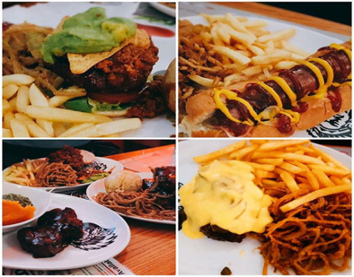  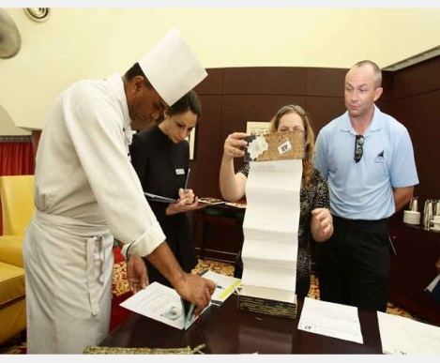  Instruction  - Show picture #1 (food)  What can you say from looking at this picture?  - Show picture #2 (competition)  What does this picture look like? What do you think they are doing?  - Now, In groups we are going to work on creating a new menu. (divide them in to group of 3, and  - In groups, you are all going to compete in a menu competition. You are going to create a new menu. Discuss in your groups and only include the four things in menu poster. (name , picture, ingredients, price) *Show example poster of lemon pizza*. the three questions in your worksheet do not have to be in your poster. Write the answers for the questions in your worksheet and be ready to speak in front of the class. Remember, everyone in the group has to speak when presenting.  - Demonstrate  - Show the example menu –Joshua  - Questions 1,2,3 -Yena | T  T-S  T | 5 secs  30 secs  1 mins  1 mins

Stage 2: Task Preparation  The purpose of this stage is for students to work communicatively in pairs or groups to prepare a communicative task (e.g. roleplay, discussion, debate etc.) which they will deliver to the class/teacher. Student’s may research the task, use dictionaries and ask the teacher for guidance. Instructions, groupings handouts/worksheets and resources, should be given at the start of this stage. Students should know exactly what is expected of them, and have enough time to prepare and practice well. Any or all of the skills may be integrated. | Inter  action | Time | Instructor’s comments
I will hand out the worksheet and give you papers and coloring pencils to use. If you need more, please help yourselves from the front. The example is going to be in the front also.  Instruction  - Hand out the worksheet, papers, and coloring materials  - Now, let’s start making a new menu for the competition. Remember to be creative as possible!  - Give them time to work on, monitor by walking around  - (After 8~10 mins of discussion) Mention questions to answer on the bottom of the worksheet.  - Before 3 minutes, tell the students to wrap up and be ready to present.  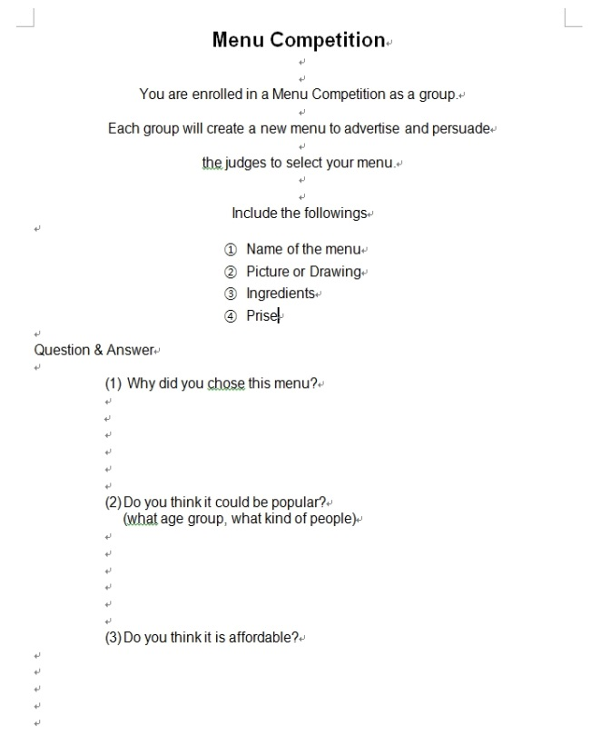 | T  S-S | 30sec  18mins

Stage 3: Task Realisation  The purpose of this stage is for the students to perform/deliver the task they prepared in the previous stage, focusing on their speaking skills such as fluency and pronunciation. Briefly set the students up so they may begin. The teacher should monitor from a distance, i.e. not interrupting this student-centred stage. | Inter  action | Time | Instructor’s comments
Instruction  - Ok, time is up.  - Now, we are going to start presenting our new menu.  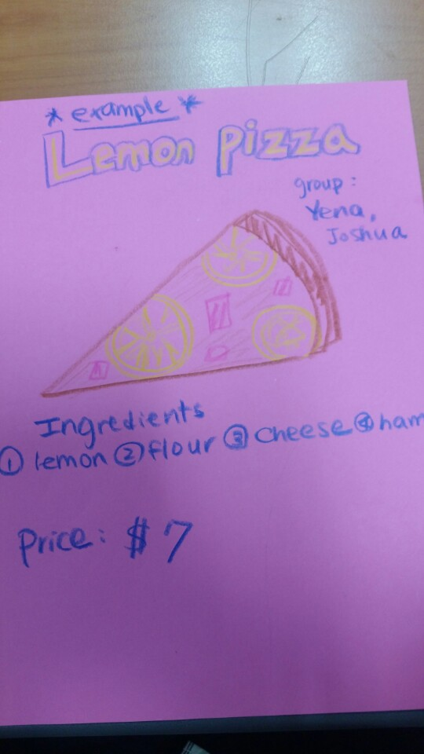  - Who wants to volunteer?  - If nobody volunteers, nominate first group.  - Make students present the menu  - After three groups present, make everyone sit down.  - Teachers stand back and listen to the students carefully | T  S-S  S-S  S-S | 30 secs  5 mins  5 mins  5 mins

Stage 4 : Post Task  The purpose of this stage is to provide meaningful feedback, error correction and suggestions for further study or homework. Another brief communicative task could be done which is designed to summarise the lesson e.g. write a report; groups vote for a winner; correct their scripts for grammar and practice saying it. | Inter  action | Time | Instructor’s comments
Okay. Good job everyone. Everyone has good menu. (be specific on positive feedback) (what was good and what you liked)  Instructions  - Ask group 1 about group 2’s menu. “Do you think ‘Menu name’ is affordable? Would you buy this?”  - Show the posters from each group, and vote for the best menu.  - “Before we vote, does anyone have questions about other team’s menu?”  - “ Now, we are going to vote for the best menu. Let’s look at the menu again. Who wants to vote for menu 1? , Menu 2? , Menu 3?”  - Write down the numbers for the vote on the board.  - Give the group with the best menu a prize.  Wrap up: Okay. Did everyone enjoy creating a new menu? Did you have fun?  (Students answer )  Okay! Good! Let’s pack up and finish class. See you all tomorrow! | T  T-S  T | 30 secs  2 mins  1 mins

Instructor’s Final Comments
Overall strengths of this lesson (planning and teaching) | Areas to work on

Overall comment

For this stage of the course, your lesson today was

- Above standard

- To standard

- Below Standard

Instructor: …………………………………….… Date: …………/……………/..……….

Menu Competition

You are enrolled in a Menu Competition as a group.

Each group will create a new menu to advertise and persuade

the judges to select your menu.

Everyone in the group should be part of the presentation
(divide which part you are going to present)

Include the followings

- Name of the menu
- Picture or Drawing
- Ingredients
- Price

Question & Answer
- Why did you chose this menu?

- Do you think it could be popular?
(what age group, what kind of people)

- Do you think it is affordable?

