☐ Listening ☐ Speaking ☐ Reading ☐ Grammar ☐ Writing

Topic: Tips for flying comfortably

Instructor:  Seo-Yeong Byun  (Ellen) | Level:  Upper Intermediate (Adult) | Students:  12 | Length:  50 Minutes

Materials:
- Pre-Activity : Realia - Two pictures(Flight meals, Flight seats), Video
Vocabulary & Idiom worksheet(12 copies)
- Main Activity : worksheet - True/False questions (12 copies)
- Post Activity : worksheet - Discussion topic, Listening audio script(12 copies)
- Computer for audio file
- White board and board markers

Aims:
- Main aim : Ss will be able to develop the awareness of the listening process and listening strategies by asking(talking), thinking and writing about the topic.
- Secondary aim : Ss will be better able to plan more pleasant and enjoyable flight experience by using authentic listening tasks.
- Personal aim : I want them to improve both the ability and the confidence to handle communication situations they may encounter beyond the classroom.

Language Skills:
- Speaking : Ss will repeating sentences, give a prepared speech, describe a
picture and discus the topic
- Listening : Ss will listen the sound(words, sentences, the whole script) from the
video, audio about the topic. And teacher’s talk
- Reading : Ss will read aloud from scripts, worksheets of the topic
- Writing : Ss will write sentences, vocabularies, Ss opinions, dictation based on
the topic.

Language Systems:
- Phonology : /f/, /v/, /θ/
- Lexis : New vocabularies (Long-haul, luggage, wet wipes, boredom, dietary,
mop up, personalize
- Function : Request
- Grammar : Present progressive, Subjunctive Future
- Discourse : Article
Assumptions:
Ss already know
- How the class is set up and run(there will be 4 Ss at each table)
- Four language skills and language systems
- The procedure and condition of a long-haul flight

Anticipated Errors and Solutions:

- If Ss need linguistic help during the discussion, explain and give them linguistic
support by providing definitions and examples
- If some Ss keep quiet for fear of upsetting other people during discussion,
encourage them to speak and advise them to be slowly and be clear about their
opinions.
- If some Ss dominate the discussion, ask them to give other Ss a chance to speak

References:
- Vocabularies & Idiom definitions : http://www.merriam-webster.com/
- Visual aid : Google images
https://problemsolvingfire2011.wordpress.com, https://raggamuslims.wordpress.com, http://www.egyptindependent.com/news/why-your-kid-s-inflight-meal-might-be-tastier-yours
http://www.usatoday.com/story/dispatches/2013/02/01/worst-airplane-seat
http://www.dailymail.co.uk/travel/travel_news/article-2959819
- Video : https://youtu.be/6xcXojRVY4g
- Audio script
http://www.ageuk.org.uk/travel-lifestyle/travel-tips/top-10-tips-for-flying-comfortably/

Lead-In
Materials:
Time | Set Up | Student Activity | Teacher Talk
2min | Whole  class | Answering Ts’s questions | Hi, everyone! It's coming soon Christmas holiday.  - You may plan to fly to your holiday destination.  - Are you looking forward to it?  - Have you ever been a long plane ride?  - Please raise your hand, anyone who has those experiences?  - Was it an enjoyable flight?

Pre-Activity
Materials: Two pictures(Flight meals, Flight seats), Video(How to prepare for a long plane ride)
Vocabulary & Idiom worksheet #1(12 copies)
Time | Set Up | Student Activity | Teacher Talk
5min  3min  5min  2min  2min | Whole  Class  Pairs  Whole  class | Answering Ts’s questions  Watching the video  Answering Ts’s questions  Ss start discussing & writing the words  Ss check the words &  Pair working  Ss check the answers | 1 Brainstorming  Elicit  (Present picture#1, #2 on the board)  “Here are three types of dietary and two types of flight seats.”  - What are the differences of dietary on the picture #2?  - Which seats look like comfortable on #2-A ?  - How could the woman occupy the whole row of seats?  (Present the video – “How to prepare for a long plane ride?”)  -What is the first thing that comes to mind when flying long distances?  (Write the key words which Ss are talking on the board)  - Then, What were the uncomfortable experiences?  Subject  (Write the subject “Tips for flying comfortably”  On the board)  CCQ  - Which seat is more comfortable for a long plane ride? And why?  - Is the idea of trying to stay awake during flights to prevent the effects of jet lag good or bad?  - How and when can you ask for dietary requirements?  2 New Vocabulary and Idiom  Instruction  - We are going to learn the new vocabulary and Idiom before listening.  I’ll hand out you a worksheet  First, read the definitions of words and then fill in the blank the correct word from the list below.  - Work together with your partners.  - I’ll give you 4 mins to finish.  (Distribute the worksheet #1)  “ Look at the paper and we solve #1 together.”  Demonstration  - Look at #1 (read and then)  - What is the answer for an example?  Yes, right. Good job.  ICQ  - Who will you talk to?  - Are you working in pairs?  - Are you writing?  - How much time do you have?  “Let’s get it started”  Monitoring  Monitor walk around unobtrusively.  Check if they are following the instructions correctly. Answer students if they ask questions  - Give time warning : 1 minute left…  - Keep an eye on as they finish.  - If they need more time, give 1 more minute.  “ Time’s up”  Check answers  “ Let’s check the answers together!  Okay, everyone did a good job!”  Additional explanation  “Now, we are going to talk about difference between ‘luggage’ and ‘baggage’.  What’s the difference between ‘luggage’ and ‘baggage’?  These words have a lot in common, such as meaning of suitcases, trunks, personal belongings when traveling.  You may see the signs for ‘baggage claim’, ‘luggage claim’ at the airports.  ‘Baggage’ is more usual in American English.  The major difference is ‘baggage’ has several additional meanings which ‘luggage’ does not share as feelings, circumstances, or beliefs.  For example, emotional baggage, political baggage.  Another meaning is prostitute, or contemptible woman.

Main Activity
Materials: worksheet #2(12 copies)
Time | Set Up | Student Activity | Teacher Talk
4min  4min  4min | Pairs &  Group  Individu-ally | Ss read, guess and discuss the topic  Ss check the answer  Ss listen the audio sound of the article | 1 Prediction  “As you see, today’s topic is ‘Tips for flying comfortably’.  Instruction  “ I’ll hand out another worksheet before listening.  With your partners, guess which scenes are proper in the blanks. Then share your ideas with your next group.  I’ll give you 3 mins to finish.  (Distribute the worksheet)  ICQ  - Are you working in pairs?  - Do you guess in the order of each scene?  Give time warning : 1 minute left.  “Okay guys, time’s up”  Then let’s listen to the article and check the answers.  See if your prediction is right or wrong.  2 Listening for the main idea  Instruction  “Listen it carefully without taking a note.  After listening, we will look at the worksheet again to find out correct answer.  ICQ  - Do you need to take a note while listening?  - How many tips are there?  (Play the listening audio sound)  Check answers  “Now, check your True/False worksheet #2 by yourself”  Check answers with teacher.

Post Activity
Materials: Worksheet #3 (Discussion topic), Listening audio script / 12 copies
Time | Set Up | Student Activity | Teacher Talk
5min  5min  5min  4min | Group  Group  Whole  Class | Ss discuss about the topic  Ss discuss about the topic  Ss prepare the speech  Ss answer elicited questions of today’s lesson | 1 Activity #1  Instruction  “Okay, now, I’ll hand out a worksheet #3 about the topic.  And you are making groups in three.  Each group will talk to the flight items related to worksheet #3 and write down on it.”  ICQ  - Are you working in groups?  - How many people will you talk to?  - What will you talk about?  “ Let’s begin”  Monitoring  Monitor if all members are participating on the discussion.  Answer Ss if they ask questions.  2 Activity #2  (Distribute the listening script)  Instruction  - “Now, we will discuss in three groups.  Each group will discuss about “Top 10 tips for flying comfortably.  - And then, each group choose the best tip. And tell us about why you choose them and what else tips you discussed.  - Each group needs a writer and a reporter to present your opinions.  - I’ll give you 5 mins to discuss.”  ICQ  - How many questions are there?  - What do you need to discuss?  - What will you do after discussion?  - Do you need an writer and a reporter to present?  Monitoring  Monitor if all members are participating on the discussion.  Answer Ss if they ask questions.  Feedback  “It’ time to listen to each group’s reporter about their discussions.  Please stand up and report your opinions.  Speak loudly and clearly.  Other Ss have to pay attention to the reporter.”  3 Conclude Lesson  - Summarize today’s lesson by checking new vocabulary, idiom and the contents in the text.  Then do error correction about grammar and pronunciation during discussion and speech.  “Okay, everyone did a great job.!  Please remember what we learned today so that you can plan your enjoyable flight.  I’ll give you’re an assignment.  Make an enjoyable plan for a long-haul flight by using your own tips. And you can research useful ideas on internet.  Thank you for participating in class and see you next time! “
SOS Activity
Materials:
Time | Set Up | Student Activity | Teacher Talk
5min | Whole  class | Ss answer Ts’s questions | 1 Fill in the blanks  Instruction  “We are going to talk about job titles.”  (Write these words on the board)  “These words imply the gender of the person performing that job. Nowadays, as you know, both of gender has those same jobs.  So, these job titles are neutralized.  Now, tell me your answer.  (Write the correct words on the board)  CCQ  - Is the right answer ‘person’ instead of man, -ess, -er?  - What would children think when they are told ‘Fireman’ instead of ‘Firefighter’ as a job?  ICQ  - Do you remember you can use dictionary?
  Stewardess Policeman Fireman
  Salesman Chairman Waiter
  Spokesman
  Flight attendant Police officer Firefighter
  Salesperson Chairperson Wait staff
  Spokesperson

- Picture #1
1 
2 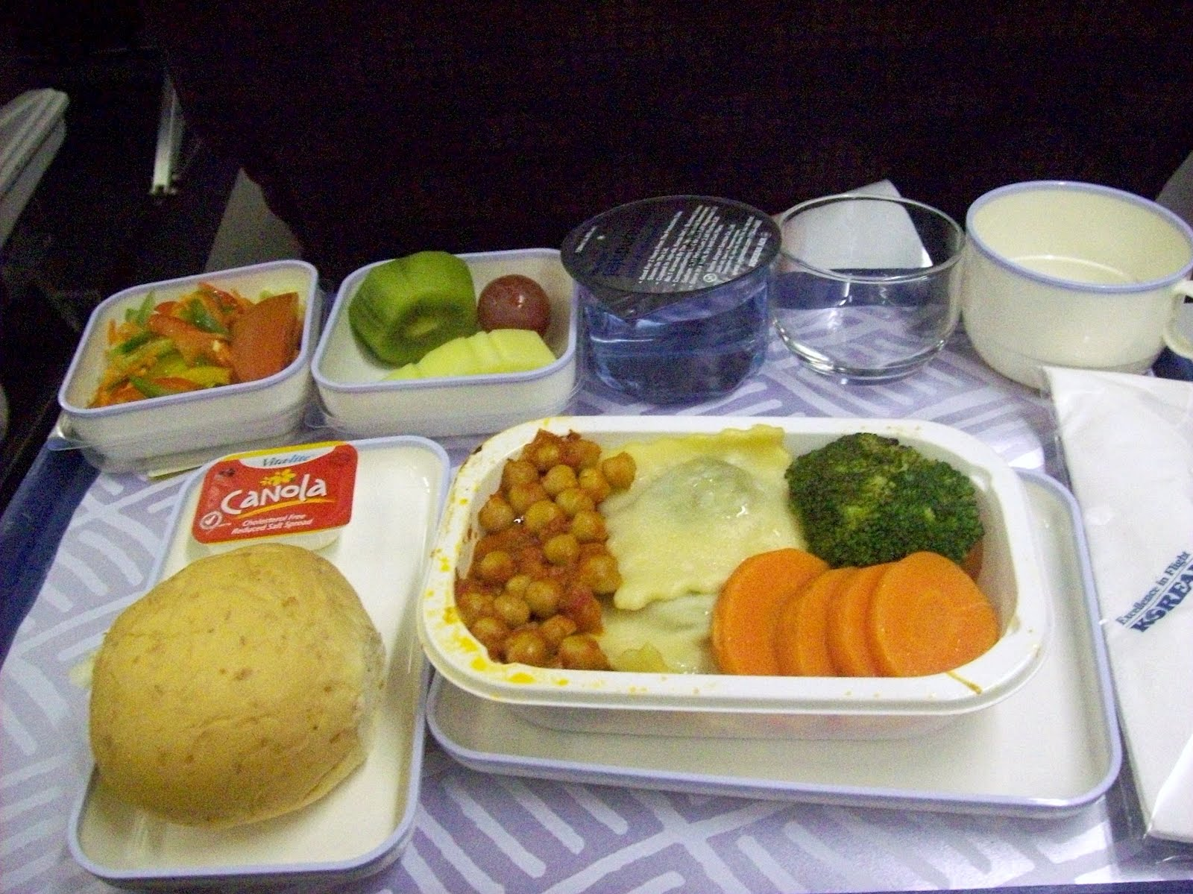
3 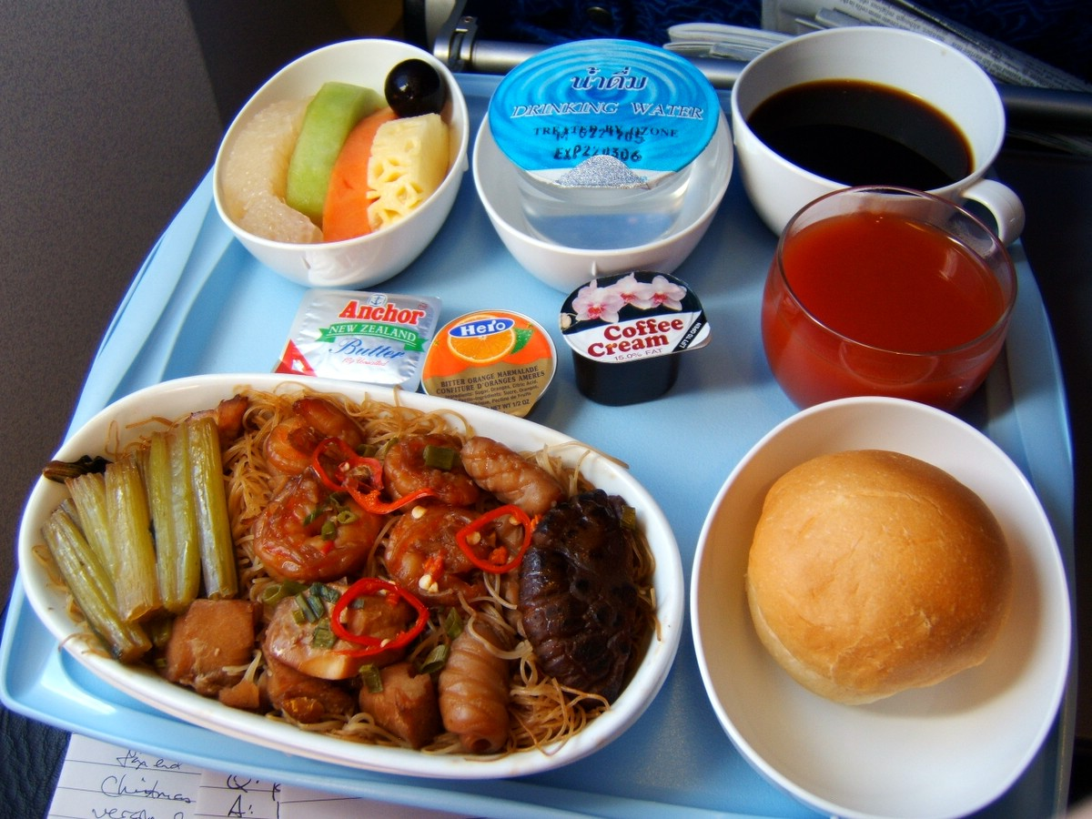
- Picture #2
- A -
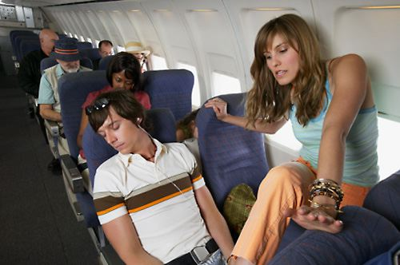

- B -
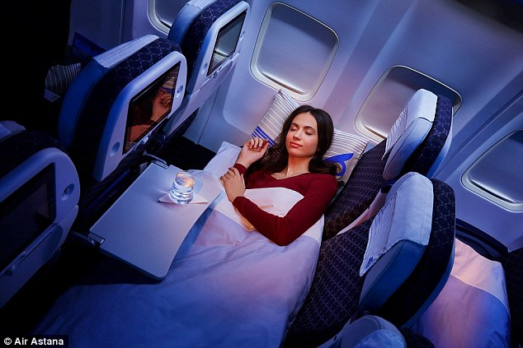
- Video #1

How to Prepare for a Long Plane Ride
(https://youtu.be/6xcXojRVY4g)

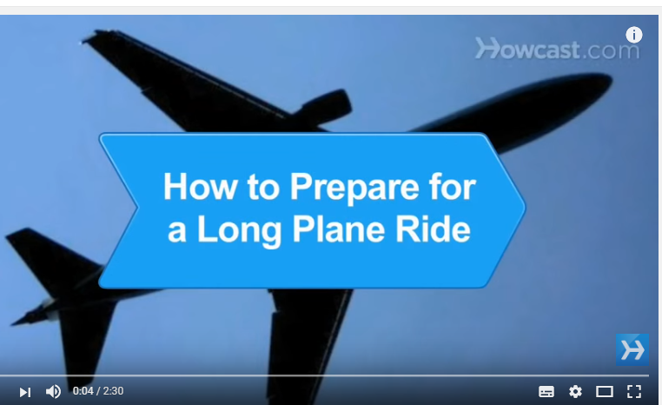

- Worksheet #1 (Vocabulary & Idiom)

Ex) the bags and suitcases that a person carries when traveling luggage
1. the kinds and amounts of food available to or eaten by an individual, group, or population --------------------
2. known as a wet towl, or a moist towelette, is a small moistened piece of
Paper or cloth that often comes folded and individually wrapped for convenience. --------------------
3. a long journey or distance / a long period of time --------------------
4. to gather as if by absorbing -----------------------
5. to mark (something) in a way that shows it belongs to a particular person
6. the state of being bored -----------------------
7. to control something and prevent it from causing you problems :

Long-haul luggage wet wipes boredom dietary mop up personalize keep ..( something/somebody) at bay

- Worksheet #2
* Answer True of False from the following sentences.
1. It is banned to distinguish your luggage with a sticker, strap or etc. (T/F)
2. To stretch your legs will help loosen any stiffness you experience from the
cramped conditions. (T/F)
3. You can have any dietary requirements you have without booking in advance.
(T/F)

- Worksheet #3
* Discuss items or ideas about each following section.
Pack a few extras | Dress comfortably | Don’t be afraid to ask | Plan ahead
↓ ↓ ↓ ↓
1 ---------------------- ---------------------- ---------------------------- ---------------------
2 ---------------------- ---------------------- ---------------------------- ---------------------
3 --------------------- ---------------------- --------------------------- ---------------------
4 --------------------- ---------------------- --------------------------- ---------------------

- Listening audio Script

Top 10 tips for flying comfortably
You may plan to fly to your next holiday destination, but are you looking forward to it? Try following these simple steps for a more pleasant and enjoyable flight experience.

1. Plan ahead
Choose your seating preference in advance and tell the airline or booking agent about any dietary requirements you have. You don’t necessarily have to settle for the same food that everyone else will be having on the plane.

2. Bring entertainment
A selection of light paperback books, magazines and newspapers should pass the time nicely. You could also bring a portable music player (fully charged or with batteries) and a deck of cards.

3. Pack a few extras
Wet wipes can come in very handy to mop up any spills or to freshen up. For the best chance of a good sleep on a long-haul flight, you may also want to buy a neck rest. There are usually restrictions on what you can carry through the security gate but you can usually buy a bottle of water and snacks on the other side before boarding the plane.

4. Personalise your luggage
With a sticker, strap, or sewn-on patch you will easily distinguish your luggage from everyone else’s when you collect your cases which could make your journey a lot less stressful.

5. Dress comfortably
Light, loose clothing is best and don’t forget to bring a jumper or something to keep you warm if the air conditioning gets too cold for you.

6. Arrive on time
For a smooth journey you should arrive at the airport well before your flight, so check your booking details for the exact time. You may end up waiting but at least you will have time to deal with any disruptions such as adjusting the weight of your baggage.

7. Stretch your legs
Every so often try walking up and down the aisle of the plane. This will help to protect you from Deep Vein Thrombosis by boosting your circulation and will help loosen any stiffness you experience from the cramped conditions.

8. Don’t be afraid to ask
If you see an empty seat that looks more comfortable than your own, it may be worth asking if you can swap. Or if you suffer any kind of discomfort just tell an air steward and they might be able to help.

9. Talk to your neighbour
If they are willing, you can have a very interesting chat to the person next to you. To exchange travel stories, or even life stories will keep boredom at bay.

10. Allow yourself to sleep
Some people try to stay awake during flights to prevent the effects of jet lag. But this could be a struggle and a good sleep could leave you feeling refreshed and prepared for the rest of your journey.

