☐ Listening ☐ Speaking ☐ Reading ☐ Grammar ☐ Writing

Topic: “I’m Sick!” – At doctor’s office.

Instructor:  Celine Bae | Level:  Intermediate (Adult) | Students:  16 | Length:  30 Minutes

Materials:
Captured animation picture of audio file – Doctor & Patient
Audio File ( 33’’)
Health problem symptom matching sheet (Worksheet #1)
T/F Question worksheet (Worksheet #2)
Sequence Making (Worksheet #3)
“My doctor’s office visiting” writing for Post Activity ( Worksheet #4)
Audio/Visual files “Listen & Repeat” (1 min. & 18 sec.)

Aims: (3)
Main Aim: Students will improve understanding of expressions at doctor’s office by audio listening and be able to learn health related vocabularies.
Secondary Aim: Students will practice to express various symptoms by pair work in order to improve the speaking for their own emergency situation.

Language Skills: (4- Integrated)

Speaking: Students will practice speaking with their own stories of visiting doctor’s office with partners.
Listening: Students will listen audio about doctor & patient talk and understand details vial T/F questions
Reading: Students will read lines of dialogues and understand context via sequence making activity.
Writing: Students will write their own situation of visiting doctor with symptoms.

Language Systems: (3-5)
- Lexis: New vocabularies in symptom matching sheet
- Grammar: Present perfect
- Discourse: Role plays on dialog and their stories.

Assumptions:
- Students already know some vocabularies of expression at doctor’s office.
- Students already know language systems & skills
- Students already know class set up and how they run. ( there will be 5-6 students at each table)

Anticipated Errors and Solutions:
- If students have hard time to understand details
Play audio line by line and help them to understand.
- If students have hard to write their own stories of visiting doctors
Instruct them to use symptom vocabularies from worksheet #1 and provide them some vocabularies regarding symptoms and prescription.

References:
https://www.google.co.kr/search?q=health+problems+lesson&biw=834&bih=460&source=lnms&tbm=isch&sa=X&ved=0ahUKEwiGqaPKuazQAhVDkpQKHTvtBR4Q_AUIBigB#imgrc=dbrWGrB-qji45M%3A

https://www.youtube.com/watch?v=t87VGQ-NlwQ&feature=youtu.be

Lead-In
Materials: Verbal Questioning
Time | Set Up | Student Activity | Teacher Talk
1 | Whole class | Answering to Teacher’s Question | Hello Everyone! How everyone’s feeling today? Good? Is anyone feeling not good? Hope not. But everyone get sick sometimes right? Have you all been sick before? If you are not feeling well or sick what do you have to do? Where would you go to?

Pre-Activity
Materials:
Animated Picture of doctor’s office ( No dialog, just sitting face to face)
Matching health problem worksheet ( Worksheet #1)

Time | Set Up | Student Activity | Teacher Talk
6 min | W/class  Individually | Seeing picture on the board and answering teacher’s questions.  Working on health problem matching worksheet. ( Worksheet #1)  Whole class  Paris | Procedure:  - Vocabulary  (Show picture of doctor’s office) ‘  Elicit  Where this place might be?  Who is working there?  Why do you go there?  What words are in your mind when you see this picture?  (Writing Voc. From students on the board)  Predictions  Look at the picture, what can it be wrong with her?  (share the answers with whole class)  Move on to worksheet #1  Instruction  Now I’m going to hand out worksheet. On this worksheet, there are pictures of each symptoms and list of symptom vocabularies below. You see each picture and write down vocabularies matches with pictures.  ICQ  What do you have write down under the pictures?  Check answers  “Now let’s check the answers together? Which vocabulary goes to 1st picture?  Speaking Exercise  Practice expressions with your partners on each symptom.  Demonstration  I have headache. I have toothache…etc.

Main Activity
Materials: Audio File (33”)
T/F Questions (Worksheet #2)
Sequence Worksheet (Worksheet #3)
Time | Set Up | Student Activity | Teacher Talk
10min | Whole Class  Individually  Whole class  Individually  Whole class | Listening the Audio for 1st time  Listen audio and answering on worksheet #2  Share their answers with classroom  Answering the questions on worksheet  Share their answers with classroom. | Procedure:  - Listening for the main idea  Instruction  Now, I’m going to play the audio. Please don’t write anything. Just listen carefully for dialog and try to listen for reason of visiting.  ICQ  Can you write while you are listening?  What do you have to try to listen?  ( Play audio file without stopping)  Checking the main idea  Why this person is visiting?  - T.F questions  Instruction  Now, I will hand out worksheet. There are T/F questions. I will play the audio again and answer the questions on worksheet as you listen.  ICQ  What do you have to do while you are listening?  (Distribute worksheet and play audio)  ( Monitoring while students are listening and answering the questions on worksheet)  ( Ask if they need to listen one more time)  Checking the answers with class  Okay, let go over the answers one by one.  Is 1st sentence true or false?  - Sequence making activity  Instruction  I’ll give you another hand out. This is sequence worksheet. There is each line of dialogues of what you just heard. Please order them correctly by writing numbers on blank on left.  ICQ  What do you have to do with lines of dialogue?  (Distributing worksheet)  ( Monitoring the classroom while they are working on worksheet)  Checking the answer with class  Who can tell us the right order of this dialogue?

Post Activity
Materials: “My doctor’s office visiting Story” ( Worksheet #4)

Time | Set Up | Student Activity | Teacher Talk
13 | Pair work | Write their own story of visiting a doctor’s office  Role play after finish writing. | Procedure:  - Free production  Instruction  Making own story of visiting doctors. Choose your own symptoms and prescriptions. Use the worksheet that I will hand out to you and try to fill out the lines there. You don’t have to fill out the all the lines however, try to write at least of 6~7 lines and please work with person sitting next you as pairs.  ICQ  What do you have to write on?  How many lines do you have write minimum?  (Monitoring around the classroom)  - Role play  Instruction.  If you are finish with your writing, please do role play with your partners. Please rotate the roles as well. You can see your papers when you play first 2 rounds for each part. But after you played both roles, please turn your papers down and do role play again without reading the worksheet. And change the role after finish one part.  ICQ  Can you read your paper when you do the role play for 3rd time?

SOS Activity
Materials:
Audio file “Listen & Repeat” (1min 18 sec.)
Time | Set Up | Student Activity | Teacher Talk
2 | Whole Class | Watch the file with line by line and repeat after the line. | - Listen and repeat  Instruction  I am going to play the file that you listened for this class. This time the dialogue will be presented line by line on the board. Listen each line and repeat after the each line.  ICQ  After you watch/listen each dialogue line, what do you have to do?

****Plus include all worksheets, PPTs, scripts, photos of realia… EVERYTHING you use

<Captured Picture-Doctor & Patient>

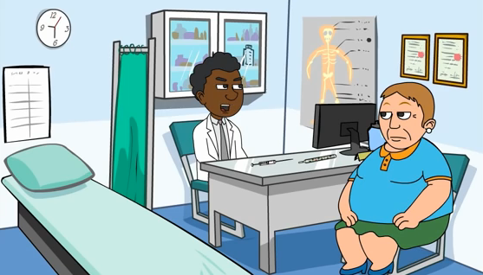

<Worksheet #1>
Matching the symptoms

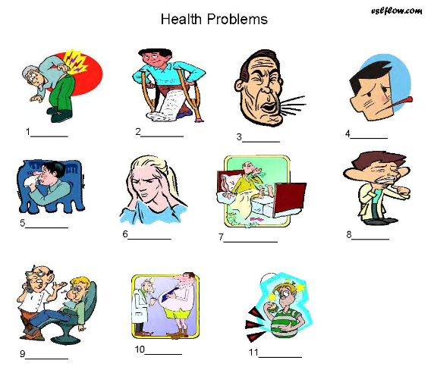

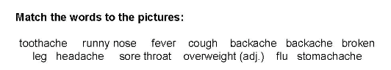

<Worksheet #2>

T/F Questions: Please circle the answer

- Her throat is hurting. T/F
- She has fever. T/F
- She is been sick for 4 days. T/F
- Doctor thinks that she has food poison. T/F
- She has to take 2 aspirins every 5 hours. T/F
- Doctor suggests her to exercise little. T/F
- She has to drink lots of fluids. T/F
- If she is not feeling better in couple days, she has to give a doctor call. T/F

<Worksheet #3>
Sequence Making
____How long have you had these symptoms?
____What seems to be the problem?
____I’ve got a sore throat and a bad cough. I’ve also got a headache.
____It sounds like you’ve got the flu. Take two aspirin every four hours.
____And if you don’t feel better in a couple of days, give me a call.
____About four days now.
____You should also get lots of rest and drink plenty of fluids.

<Worksheet #4>
My visiting to doctor’s office.
Doctor: ________________________________________________
Me:___________________________________________________
Doctor: ________________________________________________
Me: ___________________________________________________
Doctor: ________________________________________________
Me: ___________________________________________________
Doctor: ________________________________________________
Me: ___________________________________________________
Doctor: ________________________________________________
Me: ___________________________________________________

<Transcript>
Doctor: Good morning, Mrs. Jones. What seems to be the problem?
Jones: Well doctor, I’ve got a sore throat and a bad cough. I’ve also got a headache.
Doctor: How long have you had these symptoms?
Jones: About four days now. And I’m feeling really tired too.
Doctor: It sounds like you’ve got the flu. Take two aspirin every four hours. You should also get lots of rest and drink plenty of fluids. And if you don’t feel better in a couple of days, give me a call.
Jones: Thank you doctor.

