■ Listening □ Speaking □ Reading □ Grammar □ Writing
***Mainly Listening but integrated of all skills.
Topic: How to Eat Healthy

Instructor:  Yuna Lee | Level:  Upper Intermediate(Adult) | Students:  12 | Length:  30 Minutes

Materials:
- White board & Color markers
- Realia : Food Flashcard (Appendix 1)
- 12 Empty Pieces of paper for mind map (Appendix 2)
- YouTube Video clip “How To Trick Your Brain and Stomach to Eat Less and Lose Weight Fast”
- 12 pieces of paper with Color Pencils & Crayons (Appendix 3)

Aims:
- Main : Ss improve their listening skills by Listening and understating the topic
- Secondary : Ss can have better knowledge about healthy diet and being creative by drawing
- Personal : I want Ss to think it is interesting topic to learn and elicitate Ss

Language Skills:
- Listening : Ss will listen to ‘How To Train Your Brain To Eat Healthier!’ Video
- Speaking : Ss will discuss about the food like to eat
- Reading : Ss can read the short script about the topic
- Writing : Ss will lists healthy and unhealthy foods

Language Systems:
- Grammar : Singular and Plural (Food vs Foods, French Fry vs French Fries. )
- Lexis : Learn New Vocab (Atumn Squash, Cauliflower, Zucchini etc)
- Phonology : Sounds. Vegetable, Avocado, Broccoli, Celery etc
- Discourse : “Do you think eating French fries for your meal is healthy?” “No It’s NOT.”
- Function : Purpose “What do you think eating healthy is important?”

Assumptions:
Students already know
- How the class is set up and run (3 Group - 4 Student at each table)
- Experienced teacher’s style of teaching
- Familiar with each other and Classroom Environment and setting
- Basic vocabulary of food ingredients

Anticipated Errors and Solutions:
- If some student don’t know much about name of the food ingredients
  - Give them examples of Food Flashcard
- If some student have different opinions about the good food or taste of the food
  - Explain to Ss that it is important to respect other people’s culture & preference.
- If there are some time left
  - SOS activity: Make them to draw “Ideal diet meal” with color pencil

References:
- YouTube
“How To Trick Your Brain and Stomach to Eat Less and Lose Weight Fast”
https://www.youtube.com/watch?v=0doFbF3zK-g

- Google Image “ Healthy Meal”
https://www.google.co.kr/search?q=healthy+meal&biw=1280&bih=928&source=lnms&tbm=isch&sa=X&ved=0ahUKEwjO9s328K_QAhWCvLwKHaByAtUQ_AUIBigB

Lead-in
Materials: None
Time | Set Up | Student Activity | Teacher Talk
1min | Whole  Class | Greeting to each other  Having Conversation Ss<-> T | “Hi, everyone! How are you?  Did all you guys had a good weekend?”

Pre-Activity
Materials: Realia, White board & Color markers
Time | Set Up | Student Activity | Teacher Talk
3min | Whole Class | - Showing their interest to the Visual Aid  - Answering to teacher’s questions | Elicitating  student to speak by asking & using Realia, “Food Flash Card”  - “What do you think we are going to talk about today?”  - “What are the food ingredients that you know?”  - “Can you tell what names of these vegetables are?”  New Vocabulary  Write down some of the difficult words on the board in alternative position.

Main Activity
Materials:
- 12 Empty Pieces of paper for mind map
- Youtube listeining Material (2min),
- 12 pieces of paper with Color Pencils & Crayons
Time | Set Up | Student Activity | Teacher Talk
3min | Pairs | Writing &  Discussing with Partner | Prediction  Hand out the work sheet for Mind Map Exercise  Instruction  “As you guys guessed, our topic today is about food. Then what are some other related words that come up in your head? I want you guys to be in pairs and write down as many as related keywords you can think of with your partner. I will give you 3min.”  ICQ  “Are ‘healthy ‘and ‘Diet’ related word of food?”  “Is ‘shower’ related word of food?”  (Give time Ss working on Worksheet)  Monitoring  Are they working in pairs?  “You have 1more min to share ideas with your partner.”  “Okay time is up. I think all of you seemed really brain stormed and expended your ideas with you partner. Good Job.”
1min | Whole Class | Sharing answers to the whole class by speaking | Elicitate  “Can each team share some words that you wrote with class?”  Encourge  “That was very good. Thanks for sharing.”
10min | Whole Class | Listening | Instruction  “Now you are going to listen to this 2min audio file, “How To Trick Your Brain and Stomach to Eat Less and Lose Weight Fast.”  Just focus on listening, do not bother taking note. I will play several times. Don’t worry.”  CCQ  “Do you have to take note?”  “How many times you get to listen?”  Instruction  “I am going to play again and this time with Youtube visual”  Checking  “Okay. What were her recommendations about eating healthy food? Do you want to listen more?”
3min | Whole Class | Answering & Speaking | Elicitate  “There were 5 recommendations about healthy eating habits. What were they?”  “What was her recommended percentage of good and bad food portion?  *Wait for Students’ Response & Give Feedback
5min | Single | Drawing | Instruction  “Now I want you to guys draw your own healthy meal. As the recommendation, 75% portion of healthy food and 25% portion of food that you like. Please make it colorful and creative. I will give you 5 min. Let’s begin!”  CCQ  “How many color pencils are you allow to use it?”  “Can you add junk food in your meal?”  Monitoring  Make sure all Ss understood and have the materials. Monitor discreetly. Answer students if they ask.

Post Activity
Materials: 12 pieces of paper with Color Pencils & Crayons
Time | Set Up | Student Activity | Teacher Talk
3min | Whole Class | Walking around the Classroom  & Speaking | Free Production  “Let’s take a look at other Ss work and share the opinion”  1~2 students thoughts sharing  Conclude Lesson  Summarize today’s lesson and wrap up

SOS Activity
Materials: Realia ‘ Food Flashcard’
Time | Set Up | Student Activity | Teacher Talk
3min~  until class is  over | Whole  Class | Speaking, Listening,  Being Active | “We have some time left so I want to play the game using the food flashcard. I want one student to come in front and answering to yes or no question that all students ask. Who guess the first will be the winner.”  ICQ  “Are we allow to ask Is red?”  Are we allow to ask Is it Banana?”  “Okay let’s start.”  Monitor  Monitor discreetly.  “Okay time is up. Hope you guys enjoy the class. I will see you next time. Thank you.”

Material

- Realia : Food Flashcard (Appendix 1)
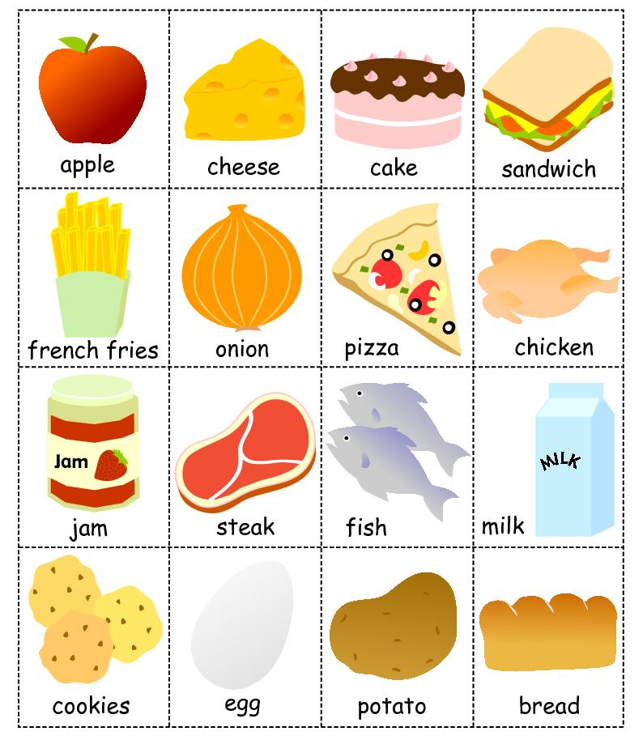
Material

- 12 Empty Pieces of paper for mind map (Appendix 2)

Material

- 4 12 pieces of paper with Color Pencils / Crayons (Appendix 3)
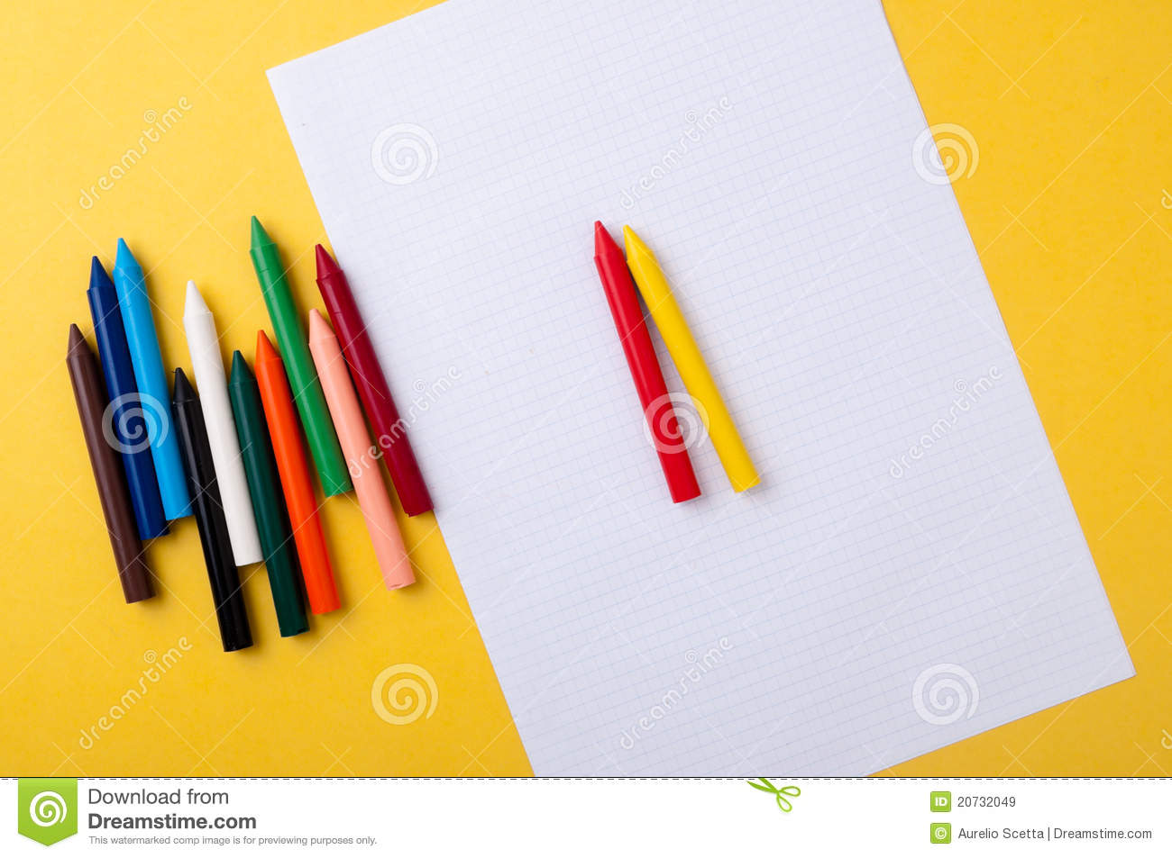

Material

- YouTube Video Clip
“How To Trick Your Brain and Stomach to Eat Less and Lose Weight Fast”
https://www.youtube.com/watch?v=0doFbF3zK-g

