☐ Listening ☐ Speaking ☐ Reading ☐ Writing

Topic: Favorable First Impression and Manners

Instructor:  Eun Young Kim | Level:  Upper Intermediate (Adult) | Students:  17 | Length:  50 Minutes

Materials:
- Realia: Pictures of famous people with favorable first impressions and unfavorable first impressions.
- White Board and board markers
- Vocabulary worksheet (17 copies)
- Fill in the blanks worksheet (17 copies)
- Computer for audio file.

Aims: (3)
- Main Aim: Ss will be able to improve their first impression skills
- Secondary Aim: Ss will be able to talk and share opinions of good impressions.
- Personal Aim: I want them to be able to have a more positive interaction with others starting with a good first impression and gain many successes in life.

Language Skills: (4- Integrated)

Speaking – Ss will discuss “What makes a good first impression and what is a bad first impression?”
Listening/Visual – Ss will look at pictures of different impressions to discuss good and bad.
Reading - Ss will read scripts of topic.
Writing – Ss will take casual opinion notes on the topic of good and bad impressions.

Language Systems:
- Phonology
- Lexis: New vocabularies in the articles
- Grammar: present participle and past participle
- Discourse: news article

Assumptions:
Students already know
- How the class is set up and run (there will be 5-6 students at each table)
- Four language skills and language systems
- A good first impression leads to success in interactions with others

Anticipated Errors and Solutions:
- If students do not participate.
>> Show pictures and ask questions to start discussions
- If students are nervous to answer.
>> I will, as teacher, will lead them with specific questions
- If students get excited from the topic and the conversations get loud
>> I would pick the loudest student and ask their opinions more seriously to take control of the course.

References:

- English definitions
http://www.google.com/
- Visual pictures
http://www.google.com/
- Listening File & Script
- http://www.google.com/
http://www.naver.com

- Visual Worksheet
Custom created

Lead-In
Materials: None

Time | Set Up | Student Activity | Teacher Talk
3 min | Whole  Class | Answering teacher’s questions | (Excited tone) Good morning! How are you today? Did I just make a good impression? How about this- (Sad Tone) Good morning. How are you today? What do you think our topic is today? Who wants to answer?

Pre-Activity
Materials: Board, Board markers, Visual Photos

Time | Set Up | Student Activity | Teacher Talk
10 min  7mins  5mins | Whole Class  Pairs  Whole Class | Observation and answering teacher’s questions | - Observation  Elicit  (Show the students visual photos)  There are many different people in these pictures.  - What do you notice first?  - What emotion do you see?  - Sad? Angry? Happy? Calm? Worried?  - If you met this person do you think you will have a good or bad conversation?  - Why?  - How long do you think it takes to make a first impression?  Additional Explanation  (Speak about How many seconds it takes to make a first impression)  This study shows  “… that all it takes is a tenth of a second to form an impression of a stranger from their face, and that longer exposures don’t significantly alter those impressions…”  Model  Write the subject “Favorable First Impression and Manners” on board.  CCQ  What makes a good first impression?  - New Vocabulary  “Let’s take a look at worksheet #1 and fill in the blanks using the words in the box below. I will give you 5 minutes to complete it.”  (Pass out worksheet #1)  “Let’s look at the paper and do the first one together.”  Watch and see if anybody needs help.  (Keep track of time and give more time if they need)  “Time finished. Let’s review.”  Check Answers.  “Who got the answer to #2?”  Make student read out loud.  Complete review

Main Activity
Materials: Board, Board markers, visual photos, Blank paper

Time | Set Up | Student Activity | Teacher Talk
15Min | Whole Class | Thinking and Writing | “Now we are going to review and look at the pictures again. We are going to write each facial feature and write down the positive good type of the eyes, nose, mouth and the bad type impression form. For example: Forehead – positive good type is relaxed. And the bad type is frowning. You have 10 minutes to write as many features as possible with good and bad style.”  Show picture of forehead with and without frown.

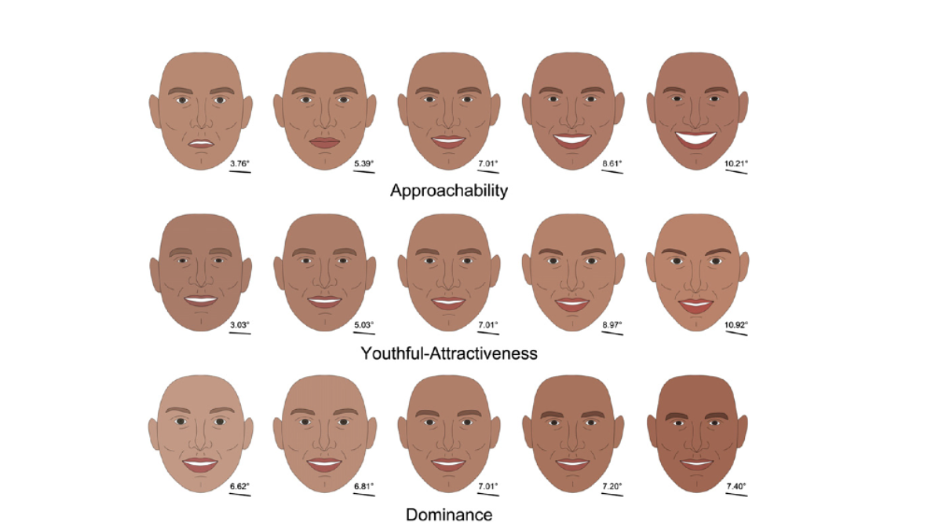

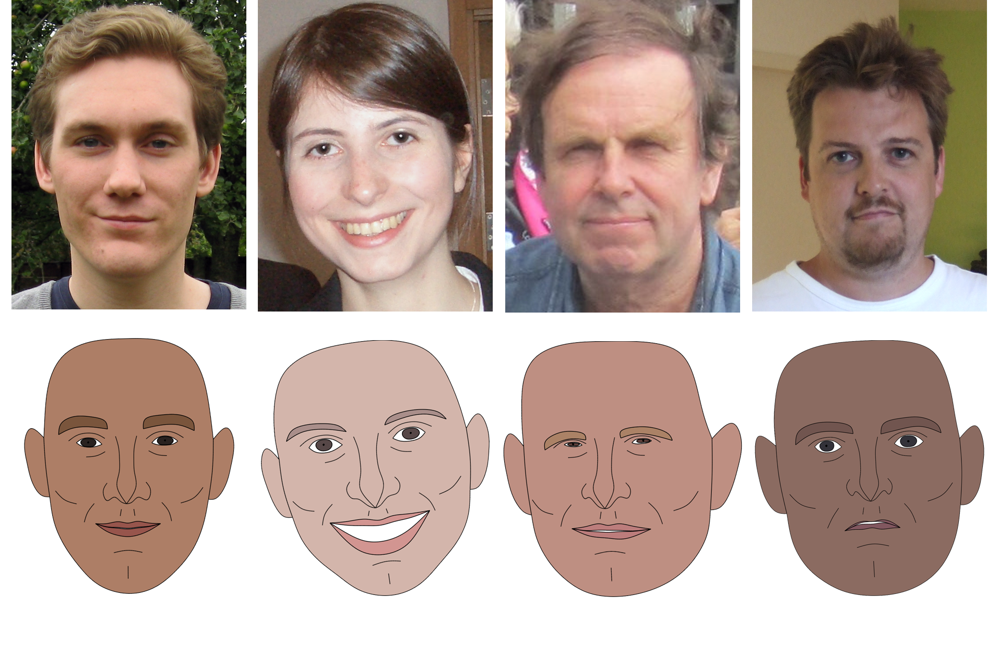

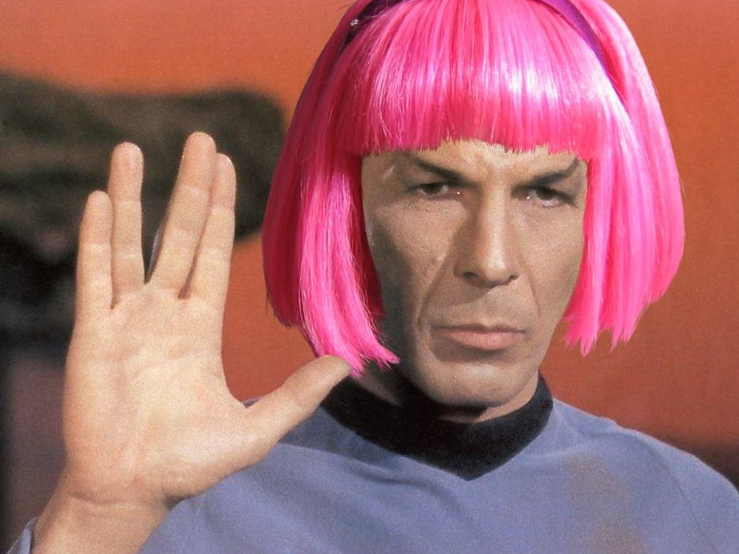

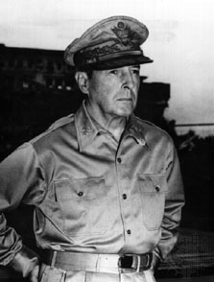

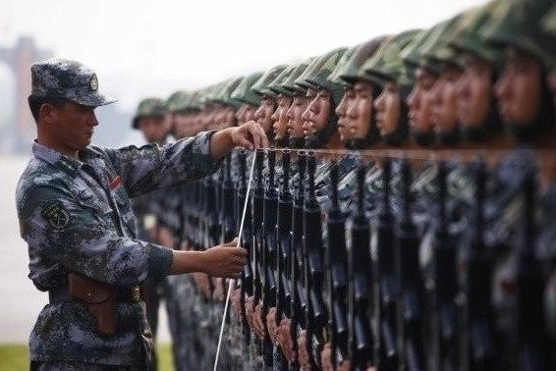

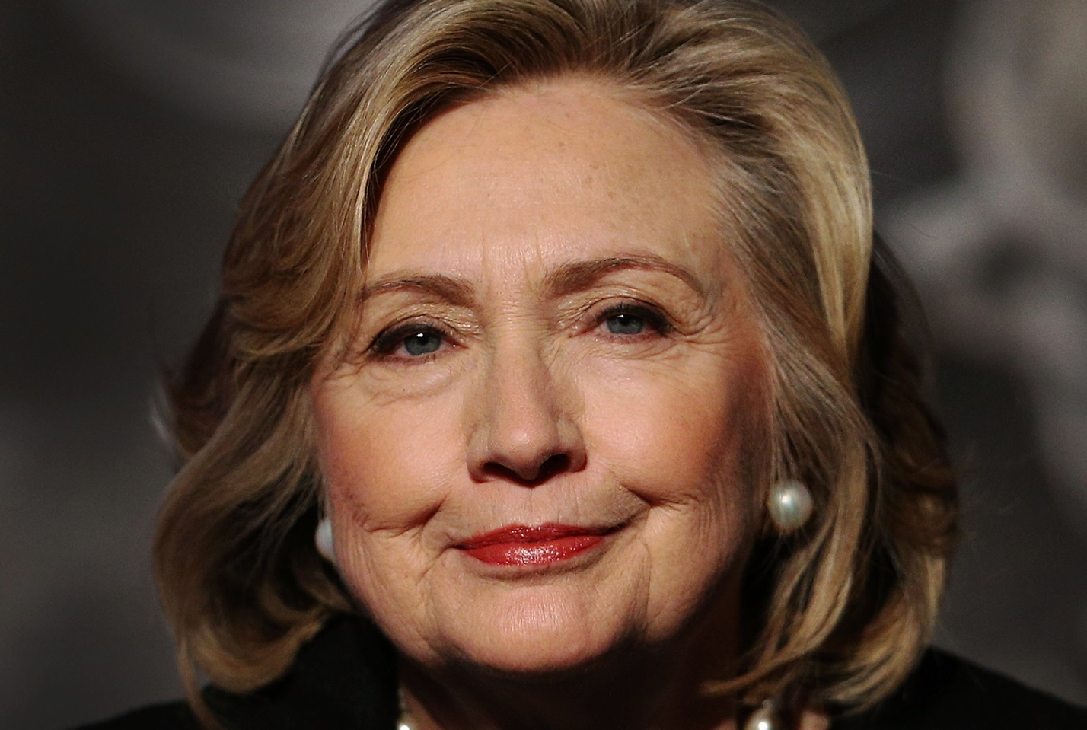

Post Activity
Materials: Board, Board markers, visual photos, Computer for audio file.

Time | Set Up | Student Activity | Teacher Talk
10Min | Whole Class | Listening and Speaking | “Let’s speak about tone. Tone makes a good first impression. Let’s listen to some recordings and discuss.”

SOS Activity
Materials: Volunteers

Time | Set Up | Student Activity | Teacher Talk
5min | Whole Class | Acting | “Let’s introduce ourselves with good impressions.”

****Plus include all worksheets, PPTs, scripts, photos of realia… EVERYTHING you use

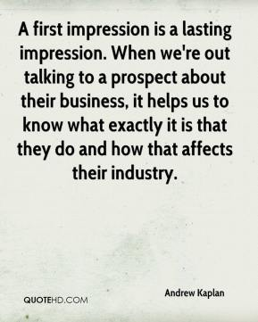

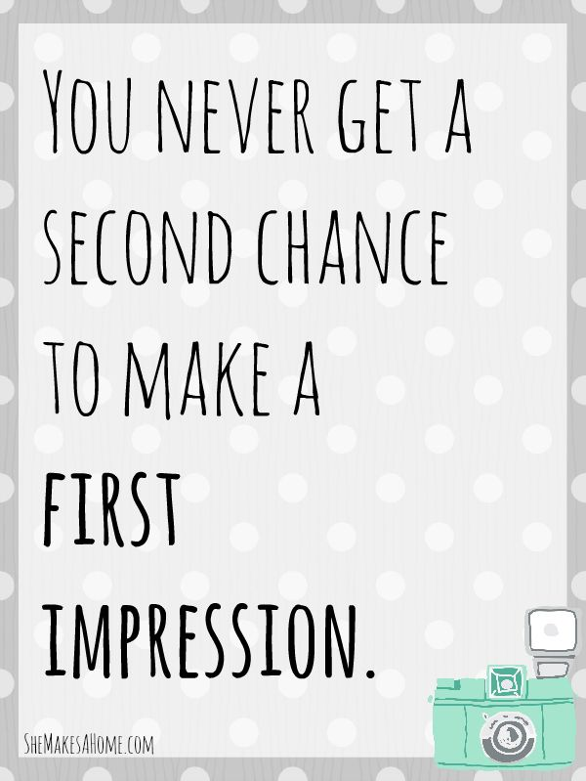

-end-

