☐ Listening $∎$Speaking ☐ Reading ☐ Grammar ☐ Writing

Topic: Blind dating role-play

Instructor:  Sylvia , Candy , Zoo | Level:  Intermediate | Students:  16 | Length:  30 Minutes

Materials:
- Marks and board
- Realia (CCQ pictures)
- Vocabulary work sheet
- Instruction PPT
- Role –Cards, ID-Cards
- 16 copies of blind date questions

Aims:

To improve speaking skills while having acting with students.
They can ask the questions using WH(where,when,what,why….)sentence and also learn the vocabularies.

Language Skills:

- Listening : Ss are following the instruction and they can listen the other student’s role-play acting.
- Speaking : Ss are acting role-play and they communicate with other students.
- Reading : Ss read the role-play cards and vocabulary worksheets.
- Writing : Ss check the vocabularies on the worksheet and can fill the matched words

Language Systems:

- Grammar : WH-information questions ( what is your hobby?, where do you come from?)
- Lexis : vocabulary worksheet, CCQs
- Fuction : asking and answering the questions
- Discourse : role-cards, role-play questions.

Assumptions:

- All students are adults ( above age 20)
- All students can understand basic grammar
- All students can express their thinking in English
- All students can know the background of blind dating.

Anticipated Errors and Solutions:

- If the students have difficulties with words and fail to fill the blank.
- Give the CCQs for better understanding

- If the students can’t understand the rule of role-play
- Give the ICQs for better understanding
- Show the demo.

References:

- Realia (role cards picture, CCQ pictures)
- Blind date reference
- . https://www.youtube.com/watch?v=QAkdYfSC97I&feature=youtu.be

Pre-task
Materials: Vocabulary worksheets, CCQ questions, board and mark

Time | Set Up | Student Activity | Teacher Talk
5 min | Whole |  | <Procedure>  Geeting and instruction  Good morning guys, how was your weekend? Did you have a great time?  Today, we will do “blind dating role –play” sound like exiting? Right?  Before we get in the role-play, i’d like to check some words which might be difficult or unfamiliar with you.  -. Distribute the vocabulary worksheet  Instruction  Please look at the words in your worksheet and try to fill in the all blanks <2min>  Time warning 20 sec  CCQ  - Bald  -Does he have a black hair?  -Does he look like young man?  - . Vegetarian  -What can you see?  -Do they like eating meat?  - Nostril  -Does he have big nose?  -Which animals have big nostrils  - Nursing home  - Are there young people stay in this house?  -Do they feel happy?

Task Preparation
Materials: instruction PPT
Time | Set Up | Student Activity | Teacher Talk
3 min | 2 groups |  | <Procedure>  Okay please make the 2group for blind dating . there will be 2mans and 3-4 women in each groups.  - SET UP 2 groups  I will give you rules for this role-play please listen carefully  -. Show the instruction PPT  instruction  - The men in each group want to find their partner in this dating. They have to select a partner In the final.  - There is a wall between men and women. They can’t see each other  - The men have to choose the partner only base on the answer of questions  - When the men ask the questions to women, all women have to answer one by one  - The men have to ask the 1-2 following questions to woman  ICQ  - How many women in your group?  - How many times do you have?  - How many questions do you have to answer?

Task Realization
Materials: Role cards, ID-cards, blind –dating questions,

Time | Set Up | Student Activity | Teacher Talk
20 | 2 Groups |  | <Procedure>  Okay. Do you finish the group set?  Then please pick-up the one slip of paper in the pocket, this paper let you know the role and profile.  -. Pick up the slip of paper  Please aware the profiles of your role and show your best acting!  Run the role-play  Monitoring  -. Allocating 10min for each group  -. Help the students to run the role-play and choose partner in the end.  -. Time warning left 2Min  Okay! Guys! Did you enjoy the blind date?  Did you success to be a couple?

Post Activity
Materials: board and mark

Time | Set Up | Student Activity | Teacher Talk
2min | Whole |  | < Instruction>  Do you remember the questions when you are in blind date?  Let’s check the WH-questions  CCQ  - When is your birthday?  - Where are you from?  - What’s your favorite season?  - Why do you think so?  These WH questions are very helpful to make asking sentences. So please keep these WH in your head!  Give homework  Good job guys  Remember the WH questions and make your 5sentens of WH questions for next time  Thank you for your attending!

SOS Activity
Materials: N/A

Time | Set Up | Student Activity | Teacher Talk
3 | Whole |  | <Instruction >  Men! Could you share your opinions why do you choose your partner?  - Sharing ideas of two man

<Vocabulary worksheet>

- [ADJ] Someone who is ( ) has little or no hair on the top of their head.
Ex : The man's ( ) head was beaded with sweat

- [NOUN] A ( )is a private hospital, especially one for old people.
Ex : He died in a ( ) at the age of 87

- [ADJ] Someone who is ( ) never eats meat or fish.
Ex : Yasmin sticks to a ( ) diet

- [NOUN] Your ( ) are the two openings at the end of your nose.

bald , Vegetarian, nostril, nursing home.

<REALIA>
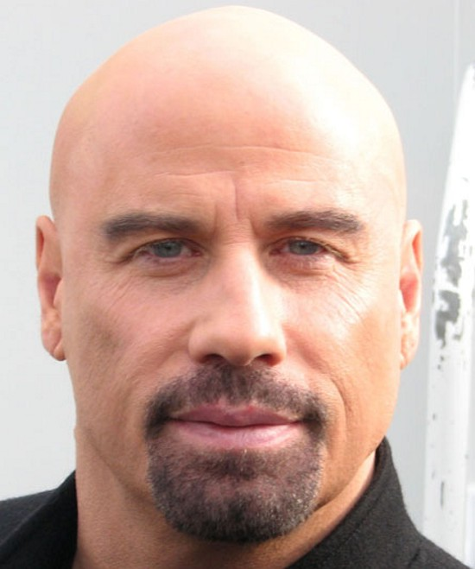
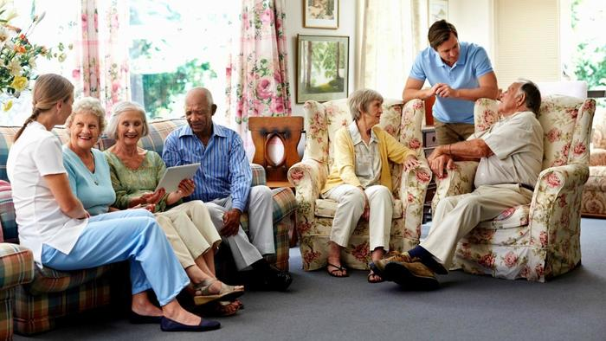

<Role Card>
Man 1(Name : Brian Seo - age 34)
1. Appearance : My height is 180 and I bald and skinny body.
2. Job : I am working in on a Samsung company as a fund manager.
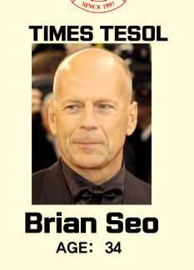
3. Characteristic : I really love vegetables and never eat meats. Many people said that I’m understanding and considerate person. I have a daughter who is 3years old. So I am looking for a woman who really like kids and can love my baby like a real mother. My attraction is sweet, kind and delight personalities
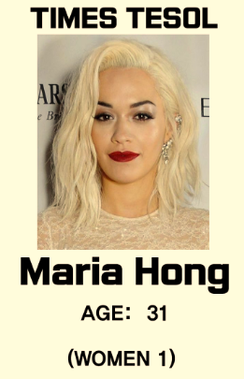
Women 1 (Name : Maria Hong - age 31)
1. Appearance : I have good looking with blond hair and tall height, so I have got offer from the entertainment company.
2. Job : No job.
3. Characteristic : I am really active and bright person. That's why I hate a serious person and vegetarian. My hobby is having a manicures in nail shop. I like to read a beauty magazine. Every night I go to party because I love drinking alcohol at the party.
Women 2 (Name : Cinderella Chae - age 40)
1. Appearance : I have brown curly hair, I am not tall. I am a little bit chubby these days. My sight is not good, so I wear glasses.
2. Job : I am working in the kindergarten as a teacher. I really love children.
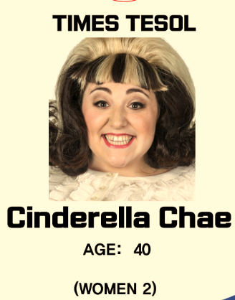
3. Characteristic : I am depressed because there are so many poor people. I sometimes go to nursing home as a volunteer. I am raising four dogs and three cats. I love romantic man.
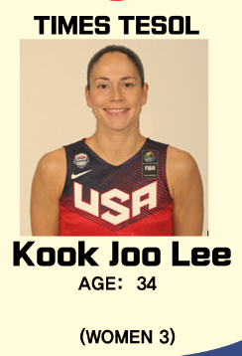
Women 3 (Name : Kook Joo Lee - age 34)
1. Appearance : I have short black hair, and tall height, 190 centimeters.
2. Job : I run two gyms as an owner. I was a boxer, but I broke my leg. That's why I had to quit the boxer.
3. Characteristic : I have strong mind. People say that I am boyish and tough. I love jewelry, especially ear rings. Actually, I hate someone who lies. If someone lies to me, I can kill him.

Man2 (Name : Jun ha Jang – age 36)
1. Appearance : My height is 180 and I have black hair and fat body.
2. Job : I am working in JYP company as a gag man.
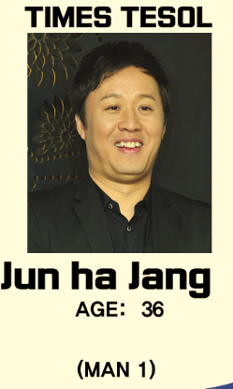
3. Characteristic : I love food, so I need the women who cooks very well. I would like my wife to make me stop eating. I like children. That’s why I am doing volunteer at an orphanage. I am really close to my mother. She really loves me, so I visit her 4 times a week, and I call to my mom every day.
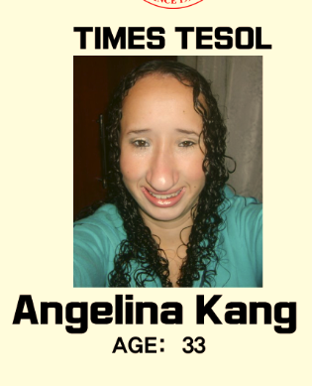
Woman 4 (Name : Angelina Kang - age 33)
1. Appearance : In my face, I have big nostril, small eyes. My body is really gorgeous because I exercise every day, but I am too short.
2. Job : I am a musician of guitar, so I have concert twice a week.
3. Characteristic : I am crazy about listening to Jazz. I always turn on the music. I don’t like to have a conversation with people. I like being alone, so I like traveling alone. If I am married, I want to marry someone who leaves me alone.

Woman 5(Name : Teddy Kim - age 40)
1. Appearance : I am wearing glasses because I like to look like a smart woman. I fought with a co-worker because he said that my head is big. I know that, but I don’t want to hear that sound. It makes me hurt.
2. Job : I am a professor in Seoul National University. My major is linguistics, so I like analyzing the sentences.
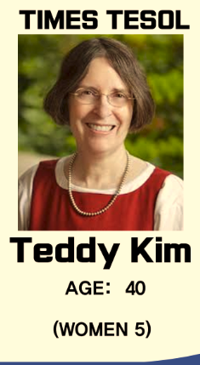
3. Characteristic : I love reading and discussing. I can’t stand if someone says understandable words. I like students, but when they can’t understand my teaching well, I become very angry. I think young people have to respect and make a concession to old people. That’s why I am doing volunteer at the nursing home.
Woman 6 (Name : Princess Na - age 22)
1. Appearance : I love wearing short skirts, so I have never worn pants. I have black long hair, but I am too fat, 120 kilograms.
2. Job : I am a student in college. Now, I am studying about clothes, so every day I go shop for comparing the clothes.
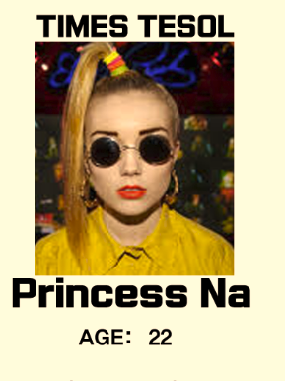
3. Characteristic : I want to a rich man because I hope to study clothes more. However, my parents can’t give me allowance because they don’t get lots of money. I want to be a fashion designer, so I want to study abroad. If I marry, I want to get husband who can make me study abroad alone and raise our baby alone in Korea.

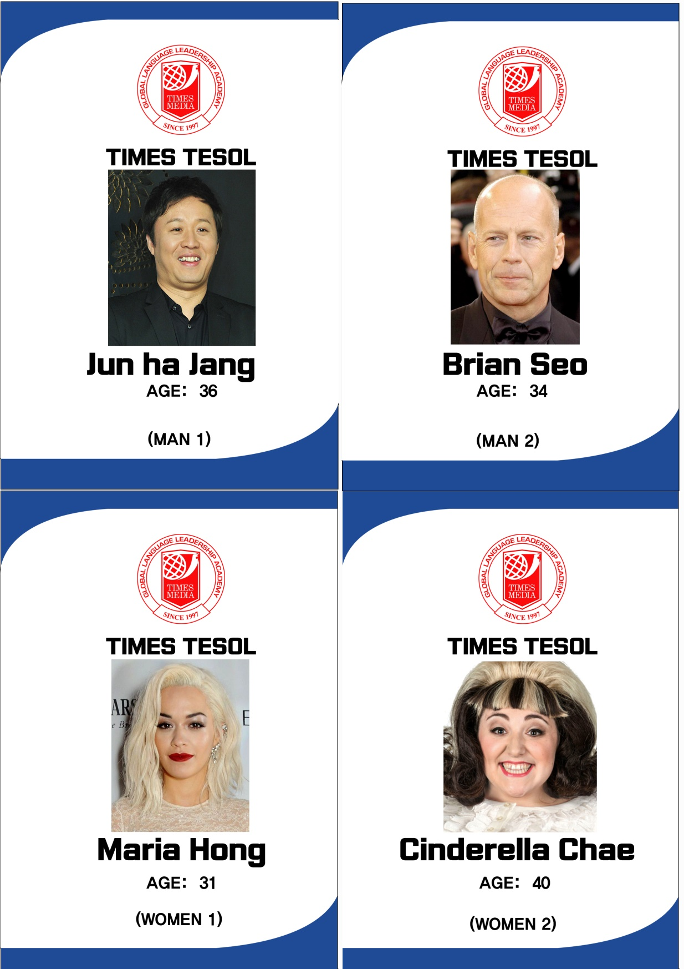
<ID – Cards>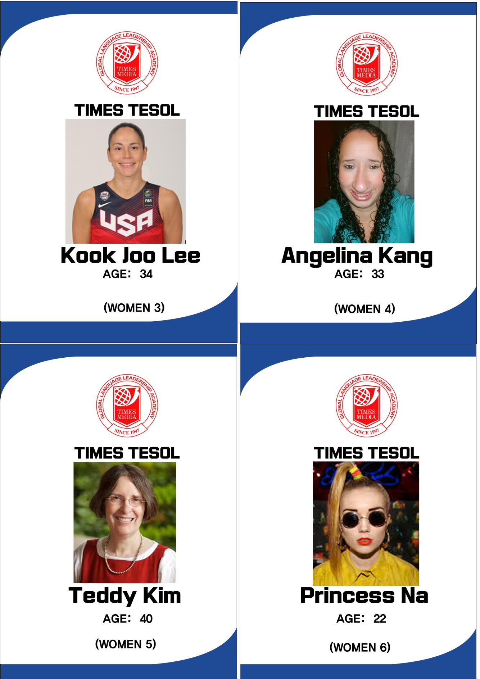

< Instruction PPT>

< Blind date questions>
WH QUESTION
- Describe your appearance!
- What is your job?
- What do you do during the weekend?
- When did your last relationship end?
- Describe your appearance!
- What is your job?
- What is your habit?
- What is your advantage?
- Describe your appearance!
- What do you do during the weekend?
- When do you want to get marriage?
- If you die right away tomorrow, what would you like to do best?
- Describe your appearance!
- What kinds of food do you like?
- What do you think about international marriage?
- What is your job?
- Describe your appearance!
- What kinds of movie do you like?
- What is your top rank among family, dating, and friends?
- What is your habit?
- Describe your appearance!
- What do you do during the weekend?
- What was the happiest moment of your life?
- If you die right away tomorrow, what would you like to do best?
- Describe your appearance!
- What do you think about international marriage?
- What was the hardest part of your life?
- What is your advantage?
- Describe your appearance!
- What is your top rank among family, dating, and friends?
- What is your favorite movie? why?
- What kinds of food do you like?

