2016-11-26

“Speaking Lesson Plan for MT”

TESOL
Teacher: Jasmine
Name: Esther and Christine
Class Number : TESOL Class 143

☐ Listening ☐ Speaking ☐ Reading ☐ Grammar ☐ Writing

Topic: Housing Complaints

Instructor: Esther  Christine | Level: Upper intermediate  (Adult) | Students: 12 | Length:  30 Minutes

Materials:
- Computer with speaker for audio file
- white board, board markers
- pictures : picture#1,picture#2, picture#3, picture#4
- vocabulary worksheet *1(12copies)
- Dialog worksheet *2 ( 12 copies)
-Role play worksheet *3-1,*3-2,*3-3
- Paper and pencils

Aims: -Main aim : Ss can understand this situation and improve their speaking skills
using this audio file and communication.
- secondary aim : Ss can talk share about their thinking and experiences.
- personal aim : I want to discuss others with respectful attitude.

Language Skills:

- Reading : Ss can read the script about housing complaints
- Listening : dialog audio file.
- Speaking : role play/ discussion
- Writing : vocabulary(choose the word and fill in the blanks)

Language Systems:
- Phonology : ‘s’ sound ‘z’, ex)cease/ resume/ zone
- Lexis : new voc. In the text (blaring, walking refrigerator, artillery, zone.)
- Grammar : present perfect, passive : has resumed, be done.
- Discourse : to fully understand, Ss talk about housing complaint
- Function : accepting : Would you mind~ing?
Request : Could you? I’d like to

Assumptions:
Students already know
- How to read and seating arrangement (there will be 6 students at each table)
- Most students know language systems and 4 language skills
- Ss have experience about housing complaints.

Anticipated Errors and Solutions:

- if students don’t know some vocabulary
-> give them some synonyms -> or give some information using the sentences.
- if there is a student who is a shy person
->encourage her/him to speak confidently.
- if there is a student who is a dominant person
->give some opportunity one by one

References:

Picture #1. https://goo.gl/cHvpYl
Picture #2. http://radiantplumbing.com/learningcenter/sewage-smell-in-austin-tx/
Picture #3. http://mkple.com/Odh08
Picture #4. http://socialfbnotes.com/smoking-complaint-social-notes/
Web page: English-Housing complaints audio file:
http://esl-lab.com/complain/complainrd1.htm

Lead-In
Materials: None
Time | Set Up | Student Activity | Teacher Talk
2mim | whole  class | Set up  Answering the questions | Hello? Everybody. How are you?  Where do you live? House or Apartment?  Introduce Topic  Today we are going to learn about Housing complaints

Pre-Activity
Materials: board, board makers, pictures#1~#4, voc.worksheet *1
Time | Set Up | Student Activity | Teacher Talk
3min  2min  3min | Whole class  individually  whole | Answering the questions  Fill in the blanks  Answering the questions | Procedure:  1.Eliciting  Let’s think about these pictures  (showing the pictures)-visual aid  the picture #1  the picture #2  the picture #3  the picture #4  CCQ  -what can you see in this pictures?  -Is she angry or happy?  -where are they?  -Is he happy or not ?  -Do you like dogs?  -What do you want to do?  1.New vocabulary  we go through learning about the new vocabulary at first. Could you fill in the blanks the word as choosing the below words? I’ll give you 2min(distribute the vocabulary worksheet)  Explain the meaning of the following words  (Write the answer on the board)  1.Blaring  Blaring is a very loud sound. For example, I can’t do my homework with the TV blaring next door.  CCQ  Do you often hear a stereo blaring in the next door apartment?  2.Walking refrigerator  It means a very big person. That is, a really big man, and nobody doesn’t want to make the man angry such as a building’s owner or their family.  CCQ  Have you met a walking refrigerator person?  Do you think a security guard is a walking refrigerator or not?  3.Zone  zone is a locally circumscribed place. For example, this area is zoned for commercial use only, and the city is planning to build several shops here.  CCQ  Do you want to live a comfort zone?  4. Artillery  artillery is a large guns, often on wheels, used by armies. For example, the army has removed its artillery in anticipation of the peace treaty.  CCQ  Have you heard about that artillery sound?

Main Activity
Materials: Computer with Speaker for listening, Screen, Dialog worksheet *2
Time | Set Up | Student Activity | Teacher Talk
4min  3min  8min | Whole class  pairs | Ss are listening dialogue.(man –man)  Ss are talking to their partner  Pairs | Procedure:  1.Dialogue Drilling(controlled practice)  (distribute the dialogue)  It is a conversation between apartment manager and tenant at the apartment.  -at first play the audio file for 1.40sec  -and then the teacher reads and students repeat-drill the text for 2min.  ICQ  How much time do you have?  Now we are going to do conversation with your partner in pair for 2min.  (Less-controlled practice)-monitoring and check their pronunciation.  ICQ  Who do you work with?  2.role play(free production)  we are going to start real practice. We have 3 situation each table and take one role card each.(demonstration)  now I will give you 7min for sharing conversation with your partner.  -monitoring.  (run the task , monitoring)

Post Activity
Materials: board and board markers.
Time | Set Up | Student Activity | Teacher Talk
3min | whole |  | Procedure: 1. Error correction  (write the sentences on the board and facilitate peer correction.)  - feedback.  Teacher correction.

SOS Activity
Materials: Paper, Color pencils
Time | Set Up | Student Activity | Teacher Talk
2min | pairs | Discussion | Procedure:  Instruction  We are going to discuss about housing complaints your own experiences for 2min in pair.  Okay!~ time’s up  Check each other.

Picture #1

picture #2

picture #3

Picture #4

vocabulary work sheet *1

1. - I can't do my homework with the TV next door

2.–We called a very big person as a -------------.
3.-This area is for commercial use only, and the city is planning
to build several shops here
4.- The army has removed its in anticipation of the peace
treaty.

*below
1. artillery
2. zoned
3. walking refrigerator
4. blaring

Work sheet * 2.
Housing complaints
Apartment Manager: Well, hi Mr. Brown. How's your apartment working out for you?

Tenant: Well… Mr. Nelson. That's what I would like to talk to you about. (What?) Well, I want to talk to you about that noise! (Oh) You see. Would you mind talking to the tenant in 4B and ask him to keep his music down, especially after 10:00 o'clock at night?

Apartment Manager: Ohhh. Who me?

Tenant: Why yes. The music is blaring almost every night, and it should be your job as manager to take care of these things.

Apartment Manager: Hey, I just collect the rent. Besides, the man living there is the owner's son, and he's a walking refrigerator. (Well . . .) Hey, I'll see what I can do. Anything else?

Tenant: Well, yes. Could you talk to the owners of the property next door about the pungent odor drifting this way.

Apartment Manager: Well, the area is zoned for agricultural and livestock use, so there's nothing much I can do about that.

Tenant: Well, what about the . . . . That, that noise.

Apartment Manager: What noise?
I don't hear anything.

Tenant: There, there it is again.

Apartment Manager: What noise?

Tenant: That noise.

Apartment Manager: Oh, that noise. I guess the military has resumed its exercises on the artillery range.

Tenant: You have to be kidding. Can't anything be done about it?

Apartment Manager: Why certainly. I've protested this activity, and these weekly (Weekly!) activities should cease . . . within the next three to five years.

Tenant: Hey, you never told me about these problems before I signed the rental agreement.

Work sheet * 3-1. <Role cards for role play>
Noise problem
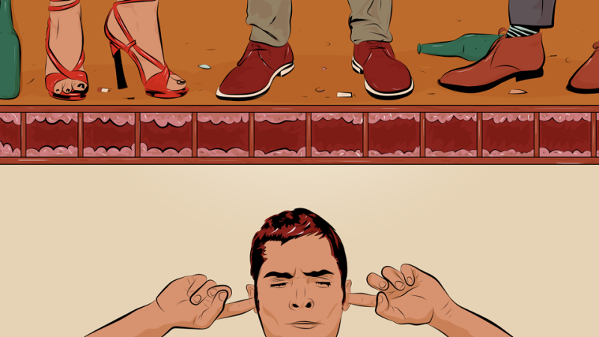

Resident A  You are a resident who lives in apartment. You are suffering stress for noise upstair resident's kids are making.  You have a daughter who is studying everyday for Korean SAT.  You kept trying to hold back her anger. But she can't bear anymore. Her daughter is very sensitive these days because of SAT. So she decide to tell the upstair about it.  Meet upstair's resident and tell your situation and ask.  1) Explain your situation frist, kindly. (Noise cause your family to be stressful especially your daughter who is a student studying for SAT)  2) Ask upstair to refrain from running around and shouting.  3) After the talking, speak to the upstair that you understand because you’re a mom too. | Resident B  You are a resident who lives in apartment. you have 2 kids. Both are boys and they are too energetic to control them. Everyday, they run around in the home and shout all day and night. So you're really tired to stop kids' too energetic act and sorry they are bothering the downstair's resident.  You always think you should apologize to downstair.  Meet downstair’s resident and apologize.  1) Apologize for the noise.  2) Thank downstair for understanding until now.  3) Tell downstair that you will warn your kids against running and shouting.

Work sheet * 3-2. <Role cards for role play>
Pet problem
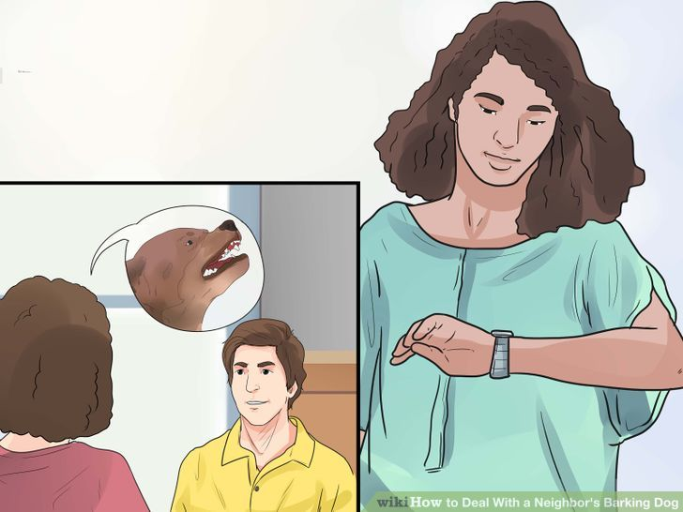

Resident A  You are a resident who lives in apartment. Your neighbor who lives next to you raise a pet, a dog. The dog is very small and cute. But noise, barking of pet and pet's poop cause her to be stressful. Recently, she couldn't sleep at all because of barking of pet all night. So she couldn't concentrate on her working,  She wants to talk to the neighbor.  Visit your neighbor's home.  1) Explain your situation.  2) Ask her to take care of her dog more carefully.  3) Ask her to put yourself in your shoes. | Resident B  You are a resident who lives in apartment. You raise a dog at your home. the dog is very small and cute. You think it is not big problem to raise a pet at your home. So when your neighbor who lives next to your apartment visited your home. You're really slightly surprised.  You have to answer.  1) You can't understand why your neighbor visit and complain to you about your pet.  2) You say you don't know how big your pet's barking and promise to train your pet not to bark.  3) Apologize for not thinking deeply about other neighbor's stress.

Work sheet * 3-3. <Role cards for role play>
Smoking problem
Residents  You are a residents who live in apartment. You are very stressful because of smokers who smoke everywhere in apartment. it is very dangerous for children and pregnant. Also, it cause a an unpleasant smell through the apartment.  Smokers throw their cigarette butts out anywhere. Cigarette butts are found anywhere. It is bad for your apartment's living environment. So you want to talk your apartment manager and solve this problem.  Go to apartment management office and meet a manager.  1) Explain the problem many residents are suffering these days.  2) Ask the manager to seek solution to the smoking problem.  3) show your appreciation of the kindness. | Apartment's manager  You are an apartment's manager. These days, many residents are suffering from smokers who smoke anywhere in apartment. You can hear about complaint of smoking problem around the apartment. So you think you need to consider the solutions.  You have to answer.  1) Sympathy their problem and apologize as a manager.  2) Tell them you are seeking a solutions and going to announce for everyone ASAP.  3) request everyone to cooperate.

