☐ Listening ■Speaking ☐ Reading ☐ Grammar ☐ Writing
■ Title : Where would you like to travel?

Instructor:  Yuna (Yuna Lee)  Kristine (Hyunwoo Kim) | Level:  Intermediate | Students:  12 | Length:  30 Minutes

Materials:
- White board & Color markers
- Realia : Passport, 6 Name Tag , Question Box (Appendix 1)
- Visual Aids : Photos of Companion, Accommodation, Sight-seeing (Appendix 2)
- Work Sheet for Main Activity : Role-play “Travel Agency”
- Work Sheet for SOS Activity : “Personal Travel Experience”

Aims (Objectives)
- Ss will be able to speak fluently by sharing their opinions by doing traveling agency role-playing (Communication)
- Ss will work cooperatively in pairs and group by sharing information that is unique to each student (Group Dynamics)
- Teacher’s Personal Aim : Encourage the Ss to speak focusing on fluency > Accuracy

Language Skills:
- Listening : Teacher’s elicitation, Teacher’s explanation of realia, Other Ss’s responses to interview, Other Ss personal experience
- Speaking : Asking and answering during interview, Discussing
- Reading : Worksheet
- Writing: Filling partner(Customer)’s information during interview

Language Systems:
- Grammar: Where would you like to go? What would you like to do?
- Lexis : Companion, Accommodation, Sight-seeing
- Phonology : Correcting Pronunciation (V vs B : Travel)
- Discourse : Discussing setting travel plan as their role-play
- Function: Asking for information, Giving Information, planning the trip
Assumptions:

- How the class is set up and run : Pair & Group
- Ss are familiar with each other and the classroom setting / environment
- Ss enjoy role-playing, and planning imaginational the trip

Anticipated Errors and Solutions:
- If some student don’t have much experience in traveling
Give them worksheet for the travel agency consultation role
- If some student have different preference about traveling
Explain to Ss that it is important to respect other people’s culture & preference.
- If there are some time left
SOS activity: “IWTK (I want to know)”

References:

- Visual Aids
Picture (accommodation) images.png > Link Download
Picture (Companion) 다운로드.jpg > Link Download
Picture (sightseeing) 다운로드.jpg > Link Download

Pre-task
Materials : Realia (Passport), Visual Aids ( Accommodation, Companion, Sight-seeing ),
Marker, Question Box
Time | Set Up | Student Activity | Procedure / Teacher Talk
30sec | Whole  Class | Listening, answering question | <Greeting & Brief Rapport>  “Hi, everyone! How are you?”  “This is Yuna and Kristine. Today you will have fun speaking class with interesting topic we have prepared for you.”  “Can you guess what our topic is by guessing the object we brought?”
5min | Whole  class | - Guessing the Realia  - Answering to teacher’s questions | <Introducing a topic by guessing>  Make Ss guess the Realia (Not show them yet)  “Can you guess what is in the box?”  (HINT) “I am square and If you are Korean I am green.”  (If Ss don’t get it give second hint.)  “If you haven’t been aboard I am clean.”  Ss anwser “Passport” -> Show them Passport (Realia)  <Ecilitating>  “Great! Can you guess what is our topic is?.”  “Okay before we get into our topic we are going to learn few vocabularies that are related to travel.”  “Yes that’s right! If you think about traveling what are the words that pops up into your head?  “Okay that’s very good and also what are things are important when you travel?”  Ss answer  <Learn Vocabulary>  : Accommodation, Companion, Sight-seeing  Show Visual Aids & Write on board  <ICQ>  “What are the examples of an accommodation?”  “Can your friends house can be an accommodation?  ”Why do need companion when you travel?”  “Can animal be your travel companion?”  “Which country has pyramid for sightseeing?”  “Which country has tallest building for sightseeing?”  “Where are some good sightseeing places in Seoul?”

Task Preparation
Materials : Passport Realia, Visual Aids ( Accommodation, Companion, Sight-seeing )
Time | Set Up | Student Activity | Procedure / Teacher Talk
5min | Whole  class | - Understanding the activity by see the worksheet and listening to the teacher’s explanation.  - Answering | 1: Role Play Work Sheet  <Instruction>  “That was very good. Now we are going to do the role playing activity. Situation of role playing is travel agency office. One of you came to plan the vacation and the other person will recommend the destination.  *Handout the worksheet & name tag.  <Demonstration 30sec>  “It was simple version but for your activity we would like you to use all of the words that are listed on the worksheet.”  “You can freely decide with your partner which one you will be acting, and as a customer role you may also use the words on this work sheet.”  <CCQ>  “Can customer use these words also?”  “Can you act like you have or haven’t been the place?”  “Do you have to use how many words on this work sheet?”
10min | Pair | - Role-playing acting, Speaking | ”We want you guys make a pair for the main activity but this class I want you to sit with someone in your table but not the partner who is sitting next to you so that we would get to know each other more.”  “Okay you may begin”  (Discretely monitor Ss making sure they are following the rules and actively communicating)  “2 more minutes to discuss”  “Alright now I want you to finish the conversation.”

Task Realization
Materials: Role-play work sheet, Name Tag
Time | Set Up | Student Activity | Teacher Talk
5min | Whole  class | - Discussing  - Few Ss Demonstrating in front of the class  - Ss Exchanging Feedback | 3. Discuss  “Okay Did everyone like their recommended destination for a vacation? Was there any surprise?”  “Is there anyone who would really like to demonstrate in front of the class??”  <Get volunteer pair to demonstrate.>  “Wow, Thank you. You can go back to your seat now.”  <Ask for Ss<->Ss Feedback instead of giving it away>  “What do you think about their performance?”  “Were they smooth like as if there in a real situation?”  “What do you think?”  “They have used all the terms and nice recommendation.” (Feedback)  *Get 1 more demonstration if time is enough

Post Activity
Materials: None
Time | Set Up | Student Activity | Teacher Talk
2min | Whole Class | - Ss Exchanging Feedback | <Feedback>  “What was most difficult and fun thing about this activity?”  (Expected Answers : Not having enough experience in traveling, Using all the worksheet vocabulary, Acting for not related field…etc)  Listen to students Feedback on the activity  Give Feedback  <Language Focus>  Error Correction of Grammar  “Did you enjoy today’s activity? We hope you had fun trying to engage with the role of the travel agent company.”  “Good job everyone.”

SOS Activity
Materials: ???
Time | Set Up | Student Activity | Teacher Talk
3min | Whole group | - Reading  - Present Public Speaking | <instruction>  “Since we have some time left, we will play some more fun activity called ‘IWNT : I want to know’”  “Here, we want you to pick one folded piece of paper for each and read what’s written.”  Let Ss pick one paper for each.  “After you are done reading the sentence then fold the paper back to how it was and write down your classmate’s name that you want to ask that question.”  “Don’t wirte your name it will be anonymous.”  Collect the paper back to the box.  “Can someone pick one paper and the sentence for us?”  “Everyone understood the question?”  “Who’s name is written on the back?”  “000, Can you share your experience with the class?”  Play the activity until class is over.  “Thank you everyone. Hope to see you next time!”

- Visual Aids (Appendix 2)

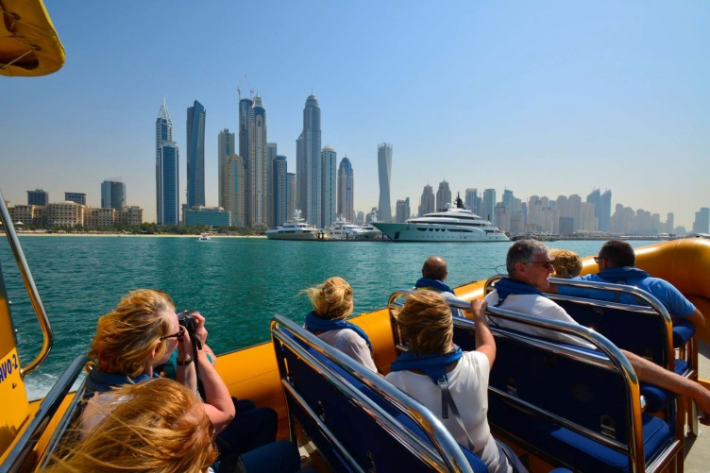

Main Activity Worksheet
English Terms Related to Travel!
143th WK Speaking Lesson

Travel
Date
to book / booking
Arrive / Arrival
Souvenir
Leave
Depart
Return
Brochure
Sight seeing
Local Food
Swimming Pool
Water Sports
Winter Sports
Activity
Price
One-way
Ticket
Map
Single
Ticket
Travel Agency
Reservation
Holiday
Business Trip
Delay
Cancellation Policy
Accommodation
Cancel a booking
Companion
Pick-up Service
Rent a car
Relaxation
Spa Massage
Journey
Enjoy

SOS Activity – IWTK (I want to Know)
143th WK Speaking MT – Yuna & Kristine

- In your past traveling experience, what was the most embarrassing moment that you ever had?
- In your past traveling experience, what was one of the funniest moments that you ever had?
- In your past traveling experience, what was most tasty food you've ever had?
- In your past traveling experience, where was the most memorable place you've ever visited?
- In your past traveling experience, who was your best traveling partner? Why?
- In your past traveling experience, who was your worst travel partner? Why?
- Where would like to travel in the future? Why?
- If you have to convince us that you are the best companion to travel with, why is that? Give us 3 reasons.

