☐ Listening ☐ Speaking ☐ Reading ■ Grammar ☐ Writing
Topic: “If I were……”

Instructor:  Diana(Eunyoung Kim)  James(JooHyun Cho) | Level:  Upper Intermediate(Adult) | Students:  15 | Length:  30 Minutes

Materials:
▶ White board and marker
▶Flash Cards (20cards)
▶Fabric (board)
▶Method to stick card on board

Aims:
▶Main aim: Students will be able to understand when to use “I were”in the subjunctive mood which would begin with “If” – If I were….
▶Personal aim: I want to encourage students to actively participate in speaking during class especially during activities to fully understand when to use “If I were…”

Language Skills:
▶Speaking: Students will practice using “If I were…”
▶Writing:Students will know when to use “If I were…” in written sentences.
▶Listening:Students will listen to other students’ opinions.
▶Reading: Students will read one students opinions.
▶Grammar: Students will properly understand and use “If I were…”

Language Systems:
▶Phonology: Correct pronunciation of “would” /wʊd/,“were” /wə(r)/
▶Lexis:If I were, I would
▶Grammar: Subjunctive
▶Function:Giving information of how and when to use “If I were…”
▶Discourse: Asking questions and answering

Assumptions:
▶Ss enjoy physical activities
▶Ss are confused with simple past and subjunctive

Anticipated Errors and Solutions:
▶If students are nervous to answer,
>> We will, as teachers, will lead them with specific questions.
▶If students get excited from the topic and the conversations get loud
>> We would pick the loudest student and ask their opinions more seriously to take control of the course.

References:
▶Materials from the stationery: Fabric, colored balls, flash cards, glue gun

Pre-task
Materials:

White board and marker,
Flash Cards (20cards)

Time | Set Up | Student Activity | Teacher Talk
5min | Whole  class | Answering teacher’s question. | Greeting  -Good afternoon, everyone! How was your week? (Wait for Ss response)  Okay, good. I’m glad to hear that.  Eliciting  (Write down “If I were...”)  -If you were a man, what would you do?  (Ask 1 or 2 students)  -Can I say “If I was a man” instead of saying “If I were a man?  (Get to see how many Ss are aware of using simple past and subjunctive)  -We use “was” when there is a real possibility, and “were”for just imagination, which isn’t real.  Give Examples:  If I was at the party last night.  If I were at the moon last night.  -Please note that you can use “was” all the time because it became so popular but the proper/traditional way is to use “were” in the subjunctive mood.  CCQ  When do you use “was”?  And when do you use “were”?

Task Preparation
Materials:

White board & Marker
Work sheet
Time | Set Up | Student Activity | Teacher Talk
5min | Whole class | Answering teacher’s question.  Writing their own creative sentence. | <Hand out work sheets>  Instruction  -We are going to write down a sentence, by using “If I were”. Try to come up with the phrase “I would” after using “If I were”.  -I will give you 2mins.  ICQ  -Are we going to write sentences, by using “If I was”?  -What would you write after “If I were”?  -How much time do you have?  Instruction  -Now let’s share few sentences from which you have made.  (Ask 2 or 3 Ss)  -Who wants to share?  (If no one is willing to participate, first ask a Ss who seems to do it.)

Task Realization
Materials:

White board & Marker
Fabric material board
Flash cards (20cards)
Time | Set Up | Student Activity | Teacher Talk
15min | Whole class | Ss will be asking and answering in a pair. | Instruction  -Now we are going to physically do a fun activity.  - First, you will put your hand in the box (any container can be used) and take 1 card out.  (Let all students pick out a word from the box)  -Look at the word on your card, and think about a sentence, using “If I were …”, followed by“I would…” after that.  -I will give you 1min to think about it, and then we will share it.  (Give them a min to think about it)  ICQ  -Which phrases are you using, to make the sentence?  Instruction  -I want you to come out in a pair and stick your flash card on the Fabric board.  (Call 1 pair of Ss, and let them stick the cards on the Fabric board)  -Could you tell me your sentence?  -Please answer it by saying “If I were___, I would ____.  -Thank you.  (Ask or pick another student for their card and sentence.)

Post-task
Materials:
White board& marker

Time | Set Up | Student Activity | Teacher Talk
5min | Whole class | Listening teacher’s talk and answering the question. | Feedback  -Did you enjoy today’s activity? (Listen to students’ feedback on the activity)  Language focus  -Now, we’re going to do some error correction  Error correction  Write student’s errors you noticed during the activity and write them on the board.  Conclusion  “Do you have any questions?”  Hope you all have a beautiful day.  Good bye.
SOS Activity
Materials: Worksheet #2 Group discussion crossword (15 copies) (with answer sheet)

Time | Set Up | Student Activity | Teacher Talk
5min | Whole class | Listening Teacher’s direction and fill in the crossword | Instruction  “Here is a crossword puzzle. You can fill the crossword with given words.  Work with group. I will give you 4 minutes.”  ICQ  “How much time do you have?  “Are you in the group?”  Monitoring  Assist students if they need any help. Give a time warning “1 minute left”

Worksheet #2Group discussion crossword
“IF I WERE… ”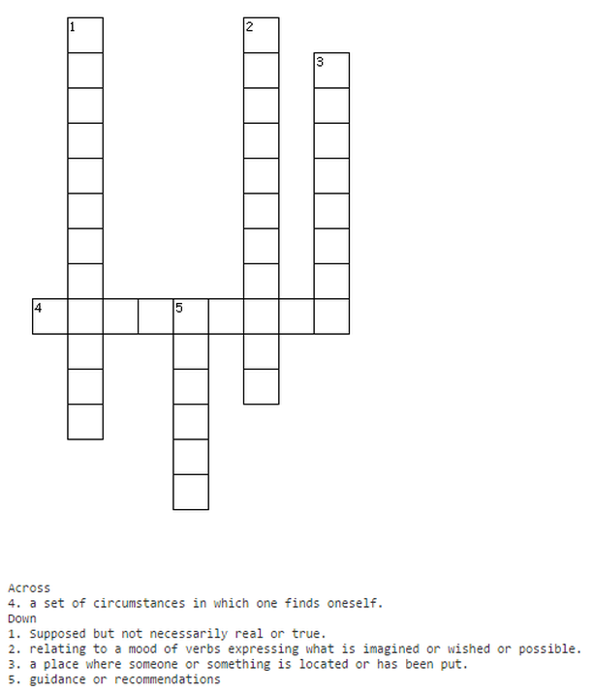
- Situation - Position - Hypothetical
- Subjunctive - Advice

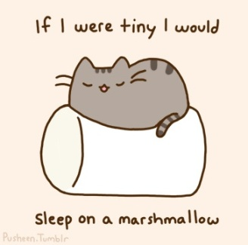
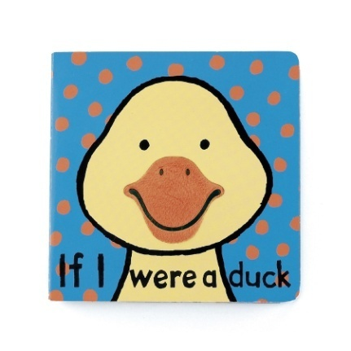
If I were…

Think of a word, to make a sentence by using “If I were”.
Come up with the phrase “I would” to finish the sentence.

Example: If I were a book, I would highlight the words for the people who are reading me.

1.

2.

