☐ Listening ☐ Speaking ☐ Reading ☐ Grammar ☐ Writing
Topic: Collocations (Christmas)

Instructor:  Christine ( Sinhee Lee)  Jasmin ( Hohyun Lee ) | Level:  Upper Intermediate (Adult) | Students:  15 | Length:  30 Minutes

Materials:
▶ Computer and beam projector
▶ White board and marker
▶ Video file (2’12”) (lead-in)
▶ PPT file (pre-activity)
▶ Visual aid #1, #2, #3, #4 – pictures (pre-activity)
▶ Visual aid #5, #6 – pictures (main-activity)
▶Worksheet #1 Collocations Christmas worksheet (15 copies) (main-activity)
▶ Realia - Christmas decorations (main-activity)
▶ Worksheet #2 Match the words (15 copies) (SOS activity)

Aims:
▶Main aim: Students will be able to use their speaking skills with more grammatical accuracy when describing any situation.
▶Second aim: Students will be able to speak more fluently through learning Collocations exercises.
▶Personal aim: I want the students to apply Collocations to their daily life when they’re speaking.

Language Skills: (4- Integrated)
▶Speaking: Students will discuss their partners and groups with worksheet #1 and answer teacher’s questions.
▶Listening: Students will listen to other students’ opinions and video file.
▶Reading: Students will read worksheets.
▶Writing: Students will write short sentences with Collocations they learned.

Language Systems:
▶Phonology: Shovel /ʌ/ Vs. Eggnog /ɑ:/
▶Lexis: Meaning of ‘eggnog’, ‘put up’, ‘shop for’
▶Grammar: Collocations ex) Strong coffee, Heavy rain, Shovel snow etc.
▶Function: Knowing about various expressions of Christmas Collocations
▶Discourse: Discussion
Assumptions:
Students already know
▶How the class is set up and run
▶Four language skills and language systems
▶Vocabulary about Christmas

Anticipated Errors and Solutions:
▶ If there is more time than planned,
>>give students extra time for discussion.
▶ If students are nervous to answer,
>> We will, as teachers, will lead them by eliciting with specific questions.

References:
▶Web page : Worksheet #1 Collocations Christmas worksheet
https://goo.gl/m4yYb1
▶Video : You tube – Learn Collocations
https://goo.gl/nf6OE9
▶ Web page : Vocabulary
www.naver.com
▶Web page : picture
https://goo.gl/MxmDrC,

Lead-In
Materials: White board and marker,
Computer and beam projector
Video file (You tube – Learn Collocations)(2’12”)
Time | Set Up | Student Activity | Teacher Talk
1min  3min | Whole class  Whole  class | Answering T’s questions  Watching a video briefly | (Have the PPT ready before class starts)  Greeting  “Good evening, everyone! How do you feel today?( …….) Great. Actually, A minute ago, I was little bit annoyed. Can you guess why? (…….) Because of a traffic jam (Chalk on a white board). When I came to Times Tesol in the afternoon, I was almost late! As you know, Kang-Nam is famous for heavy traffic (Chalk on a white board). Anyway… so..Can you guess what we are going to learn about today?  Yes, Exactly! ‘Collocations’”.  “I will show you a video connected with Collocations of verb ‘Look’.  Let’s see a short video!”

Pre-activity
Materials: White board and marker
Computer and beam projector
PPT file
Visual aid #1, #2, #3, #4 – pictures
Time | Set Up | Student Activity | Teacher Talk
4min | Whole  class | Answering T’s questions  Students answer the question | <Brainstorming>  ◆Collocate Vs. Don’t collocate  (Write vocabularies collocational or not collocational on a white board and ask Ss what is a correct Collocations with pictures.)  - Strong coffee Vs. Powerful coffee  - Tall tree Vs. High tree  - Heavy rain Vs. Weighty rain  - Big mistake Vs. Large mistake  Eliciting  “-what kind of coffee do you like?  -Is this tree short?  -Is this rain light?  -What happened to her?”  “Now, we are going to learn another Collocations with PPT. I will show you a demonstration. Please look at the PPT.”  Instruction& Demonstration  “I will show you a 4 PPT. Each PPT worksheet has blanks like this. First, I will show you just one word or phrase included a blank. If you can catch an answer, please let me know. If you don’t answer correctly, I will keep showing you 4 more hints.”  ICQ  “What can you see on each PPT sheet?”  “Can you get more hints if you can’t correct the answer?”  (Show the PPT)  “Let’s Start!”  Feedback  “Can you catch Collocations with ‘take’, ’break’ ,’keep’, ’go’?  Sounds good!”

Main- activity
Materials: Worksheet #1 Collocations Christmas worksheet ( 15 copies )
White board and marker
Visual aid #5, #6 – pictures
Realia- Christmas decorations
Time | Set Up | Student Activity | Teacher Talk
4min  5min  2min  2min  3min  3min | Whole class  Pairs  Groups  Whole class  Groups  Whole class | Listening teacher’s talk and answering the question.  Students discuss and start matching worksheet  Students check the answer  Check the answer together  Students make 4 sentences  Students present a sentence | “I will give you a worksheet.”  (Distribute worksheet #1)  “Did you have a worksheet everyone?”  Eliciting  “What kind of images can you see?  What kind of words can you read?  How’s your feel when you see this images and words?  As you know, Christmas is coming. So today we’re going to learn about Christmas Collocations.”  <Vocabulary>  “Before starting, I will introduce 3 terms.”  CCQ  (I will show picture #5)  “What can you see? Yes, there are egg and eggbeater.  What can be made for? Yes….(I will show picture #6) Can you guess what it is? Especially on Christmas, people usually made for eggnog.(Write down ‘eggnog’)  It includes egg, sugar, milk, brandy, rum.  It looks delicious. Isn’t it?”  CCQ  (I will show Christmas decorations)  “What is it? How can I use it? Where can I put them up?  Yes, Usually we are using Collocations with decorations ‘put up’”.(Write down ‘put up’)  CCQ  “What are we prepare on Christmas for family, friends? Yes, We will shop for the gift.”  “From now on, We’re going to do 3 steps with this worksheet.”  Instruction  “First step, as you can see, there are 18 verbs or phrasal verbs in the left column with vocabulary in the right. we’re going to match verb with vocabulary. Work together with your partner. In this step, You don’t need to do make sentences on the worksheet. I will give you 5minutes.”  ICQ  “ How much time do you have?”  “Are you working in the group?”  “Do you have to make sentences now?”  “Let’s start.”  Monitoring  Monitor discreetly and answer students if they have a question.  “1 minute left.”  (Ask if they need more time. If so, give them 1 more minute.)  “Time’s up, everybody. Good job.”  Instruction  “From now on, let’s start 2nd step.  We’re going to correct answers with your groups. I’ll give you 2minutes.”  ICQ  “How much time do you have?”  “Are you working in the groups?”  “Let’s start.”  Monitoring  Monitor discreetly and answer students if they have a question.  “1 minute left.”  “Time’s up, everybody. Good job.”  “Let’s check the answer together. If I said number 1 write to, you can say the correct vocabulary k. Santa Claus. Alright? Okay, let’s start number 2,3,4,5,…18”  “Good job, Everyone.”  Instruction  Finally, you have to make 4 sentences using Christmas Collocations on the worksheet. Work with your groups.  I’ll give you 3minutes.”  ICQ  “How much time do you have?”  “Are you working in the group?”  “Let’s start.”  Monitoring  Monitor discreetly  “1 minute left.”  “Time’s up, everybody. Good job.”  “Now, let’s present 2 sentences each group. Who’s speaking in this group?  (Student name) Please.”  “Thank you everyone.”

Post- activity
Materials: White board and marker
Time | Set Up | Student Activity | Teacher Talk
3min | Whole class | Listening teacher’s talk and answering the question. | < Feedback>  “Did you enjoy today’s activity? (Listen to students feedback on the activity)  <Language focus>  “Today, we learned about Collocations. Especially Christmas Collocations.  To sum up again, Collocations is common ‘going –together patterns’ of words.”  <Conclusion>  “Do you have any questions? If not, let’s finish today’s class. Thank you for your participation.”
SOS Activity
Materials: White board and marker
Worksheet #2 Match the words (15 copies)
Time | Set Up | Student Activity | Teacher Talk
5min | Whole class | Listening teacher’s talk and answering the question  Students fill in the blanks  Students check the answer | “I will give you a worksheet.”  (Distribute worksheet #2)  Instruction  “Now we are going to match the words to the pictures then put the words in the correct column. I will give you 5 minutes. Work with your partners.”  ICQ  “How much time do you have?  “Are you working in group?”  “Let’s start.”  Monitoring  Assist students if they need any help. Give a time warning “1 minute left”.  Answer check

Visual aid #1– pictures

Visual aid #2– pictures

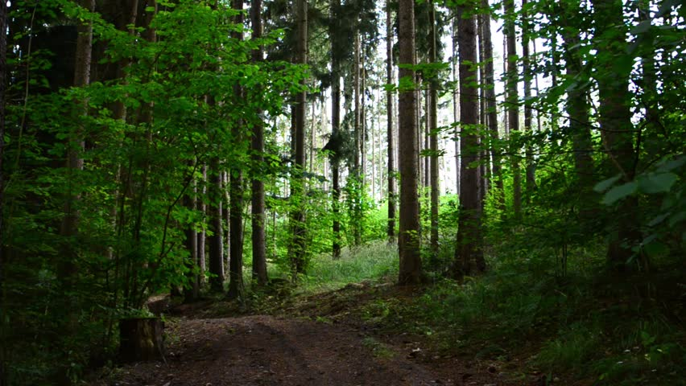

Visual aid #3– pictures

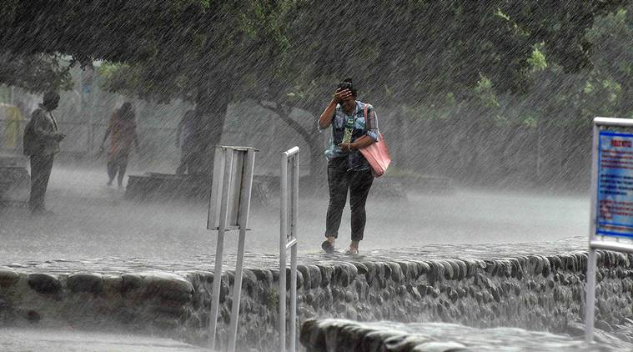

Visual aid #4– pictures

Visual aid #5– pictures

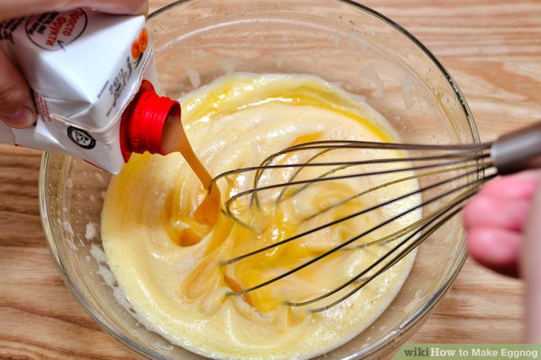

Visual aid #6– pictures

Worksheet #1 Collocations Christmas worksheet Christmas
Collocations
(Phrasal) Verb Vocabulary
- Write to a) A tree
- Wrap b) A Christmas Day
- Whip up c) A Fire
- Stay up d) A Cake
- Sing e) All Night
- Shovel f) Carols
- Shop for g) Cookies and Milk for Santa
- Set up h) Gifts in coloured paper
- Send out i) Invitation
- Put up j) Presents
- Put out k) Santa Claus
- Make l) Some cookies
- Light m) Some Eggnog
- Have n) Stockings
- Give o) The Cristmas Tree
- Fill p) The Decorations
- Cut Down q) The perfect gift
- Bake r) The snow

1. ____________________________________________________
2. ___________________________________________________
3. ___________________________________________________
4. ___________________________________________________
What do you want to do on Christmas?
Using Christmas Collocations from above, make 4 sentences.
Worksheet #2 SOS activity; Match the words.

