☐ Listening ☐ Speaking ☐ Reading ☐ Grammar ☐ Writing

Topic: Compound Words

Instructor:  Annie, Bonnie | Level:  Upper Intermediate(Adult) | Students:  15 | Length:  30 Minutes

Materials:
- White board, markers
- Computer, projector
- Worksheet 1 (Pre-activity: figure out compound word from pictures) / 15 copies
- Worksheet 2 (Post-activity: find compound words in the classroom) / 15 copies
- Flashcards (Main activity: cards for matching game) / 30 cards
- Video file of song ‘For the First Time in Forever’

Aims: (3)
- Main Aim: Ss will be able to learn and recognize various compound words through active and visual activities.
- Secondary Aim: Ss will establish rapport with other classmates by communicating and making decisions together during the team game.
- Personal Aim: Ss will be able to realize that compound words are common and that they are in everyday use, through the main activity and post activity.

Language Skills: (4- Integrated)
- Speaking: Answering T’s questions, sharing answers with partner or class for worksheet activities (pre-activity, post-activity), communicating with team members and making sentences with compound words (main activity)
- Listening: Listening to T’s instructions, interacting with team members (main activity), listening to a song (SOS activity)
- Reading: Reading instructions on worksheets, reading words on flashcards (main activity)
- Writing: Writing compound words on worksheets (pre-activity, post-activity)

Language Systems: (3-5)
- Phonology : N/A
- Lexis : Various compound words (dragonfly, downtown, bulldog, chairman, household, friendship, carpool, daydreaming, brainwash, etc.)
- Grammar : Compound Words
- Function : Matching, memorizing
- Discourse : Partnered and class discussions, agreeing and deciding as a team

Assumptions:
- Ss know how the class is set up and ran (there will be 4~5 students seated in a group)
- Ss are actively participating in class
- Ss have been exposed to compound words in everyday life and previous studies
- Ss know the language skills and systems

Anticipated Errors and Solutions:
- If time is running out, shorten the discussion time
- If there is more time than planned up to the main activity, spend more time on the matching game (manage time accordingly) or do the SOS activity
- If Ss find matching game too difficult, give hints to run the game more efficiently (write several compound word answers on the board)

References:
- List of compound words (learningdifferences.com): goo.gl/gft3xn
- Compound Words Picture Worksheet (Worksheet 1): goo.gl/O7djii
- Compound Words Listing Worksheet (Worksheet 2): goo.gl/qyWllC
- Video file of the song ‘For the First Time in Forever’ (SOS activity): goo.gl/5tkAbZ

Lead-In
Materials: Board, marker
Time | Set Up | Student Activity | Teacher Talk
3 min | Whole class | Listen to teacher & answer questions | T: Hello everyone! How is everyone’s day so far?  Instead of telling you what we will be learning today, I want you to take a guess!  Please look at the board and think about what the answer would be.  (T draw on the board ‘sun’ and ‘flower.’)  *Eliciting  T: What new word do the pictures make?  (sunflower)  (Repeat the process with the word ‘scarecrow’.)  T: Great! So, can anyone guess what we will be learning today?  Yes, we will be doing some activities with ‘compound words.’  (Write ‘compound words’ on the board.)

Pre-Activity
Materials: Worksheet 1 (figure out compound word from pictures)
Time | Set Up | Student Activity | Teacher Talk
1 min  3 min  2 min  1 min | Whole class  Individual  Pairs  Whole class | Listen to teacher’s instructions  Answer teacher’s questions  Complete worksheet  Share answers with a partner  Answer teacher’s question | Procedure:  (Distribute Worksheet 1.)  *Instructions  T: First, you will complete this worksheet. Look at the pictures and write the compound word that is made up of the two pictures. You will work individually for 3 minutes. Then, you will have 2 minutes to share and check answers with a partner. If you don’t know an answer, just skip the problem. You can try finding out the answer later when you’re working with your partner.  *ICQ  - Are you working with a partner for the first 3 minutes? (no)  - What do you do if you don’t know an answer?  T: You may start!  *Monitoring  (Give 1 minute time warning.)  T: Now, please check your answers in pairs.  *Checking Answers  T: Are there any words that you or your partner couldn’t figure out?  (Give answers if needed.)

Main Activity
Materials: 15 pairs of flash cards with compound words (total of 30 cards)
Time | Set Up | Student Activity | Teacher Talk
1 min  13 min  1 min | Whole class  Three teams  Whole class  Whole class | Listen to teacher’s instructions  Play the card matching memory game  Give feedbacks | Procedure:  *Instructions  T: Now we’ll be playing a compound words memory game together. Everyone please push the tables to the sides and come to the center of the classroom.  (Divide Ss into three teams of 4~5. Set up the cards: spread them randomly on the floor, upside down.)  T: Each card has one word on it, and every card has a pair that makes a compound word together. Each team will take turn flipping over two cards. If you find a correct pair, you need to make a correct sentence using the compound word to get a point. If you don’t find the correct pair, you need to turn it back over, and it will be the next team’s turn.  *Demonstrate  (Flip over 2 cards and if it is a correct pair, make a sentence. If it isn’t a correct pair, flip back over.)  *Instructions (continued)  T: The team that has most cards at the end of the game will be the winner. You will play the game for 13 minutes. Are you ready?  (Decide turn by having one person from each team do ‘rock scissors paper’.)  *ICQ  T: -How much time do you have?  -Can you flip over the five cards at a time? (no, 2 cards)  *Monitoring  (Actively monitor and guide those in trouble doing the exercise.)  (Give 1 minute time warning.)  T: Time’s up. How many cards does each team have? (Announce the winning team.)  Please go back to your seats.  *Feedbacks  - Did you enjoy the game?  - What it easy or difficult for you?  *CCQ/ Error Correction  - What are some compound words you found during the game?  - Were there any compound words that you didn’t know before?  (Let Ss freely discuss their errors and opinions.)

Post Activity
Materials: Worksheet 2 (find compound words in the classroom), board, marker
Time | Set Up | Student Activity | Teacher Talk
1 min  3 min  1 min | Whole class  Pairs  Whole class | Listen to teacher’s instructions  Complete worksheet  Share answers with class | Procedure:  (Distribute Worksheet 2.)  *Instruction  T: In partners, you will write as many compound words you can find in this classroom.  *Demonstration  T: Let me give you an example.  Look at your worksheet. What compound word do you see at on the first line? (Cupcake)  Yes, cupcake is a compound word with two words ‘cup’ and ‘cake’ put together. Now, look around this classroom and find as many compound words you can!  You have 3 minutes.  *ICQ  T: -Can you write any compound words?  -Are working individually?  -How much time do you have?  T: You may start now.  *Monitoring  *Checking Answers/ Eliciting  T: -Time’s up.  -One person from each group please share a compound word you found in the classroom.  (Write on board some words elicited by Ss)  *CCQ  T: So after all the activities, can someone think of a definition of ‘compound word’?  (‘two words are joined together to make a new meaning’)  *Feedback  -I hope you had fun and learned some more compound words.  -Did you enjoy the activities?  (Have students freely share their opinions.)  -You guys did a very good job today. See you soon everyone~

SOS Activity
Materials: Video file (for the song ‘For the First Time in Forever’: goo.gl/5tkAbZ), computer, board, marker
Time | Set Up | Student Activity | Teacher Talk
1 min  2 min  1 min  2 min | Whole class  Individual  Whole class | Listen to teacher’s instructions  Listen to the song and find/write compound words  Share compound words.  Listen to the song one more time | Procedure:  *Instruction  T: For this quick game, you’re going to listen to a song. As you listen, try to find as many compound words and write them down. You can write on the back of the worksheet from our previous activity. The person who finds most compound words after listening one time will win this game!  (Play the video until 2:10, without stopping.)  *Checking Answers  T: What are some compound words that you heard? (Write the words down on the board. Announce the winner.)  T: Let’s listen to the song one more time. Listen for the compound words!  (Play the song again.)

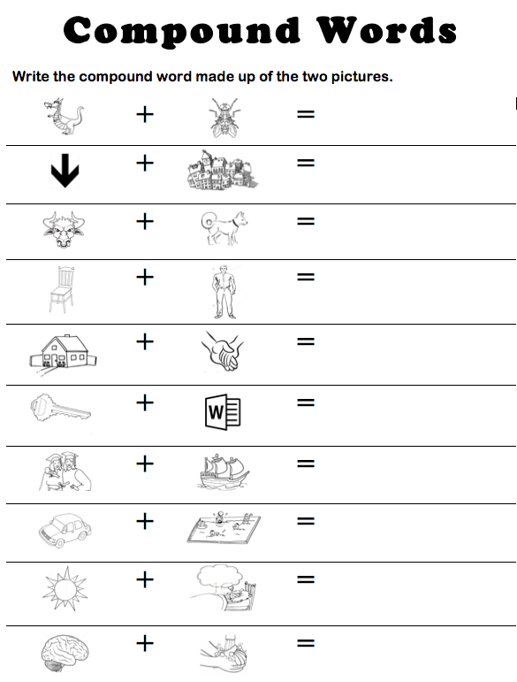
Worksheet 1
Worksheet 2
Compound
Words

List as many compound words you can find in the classroom.
1st Word | 2nd Word | Compound  Word
Cup | Cake | Cupcake

Flashcards

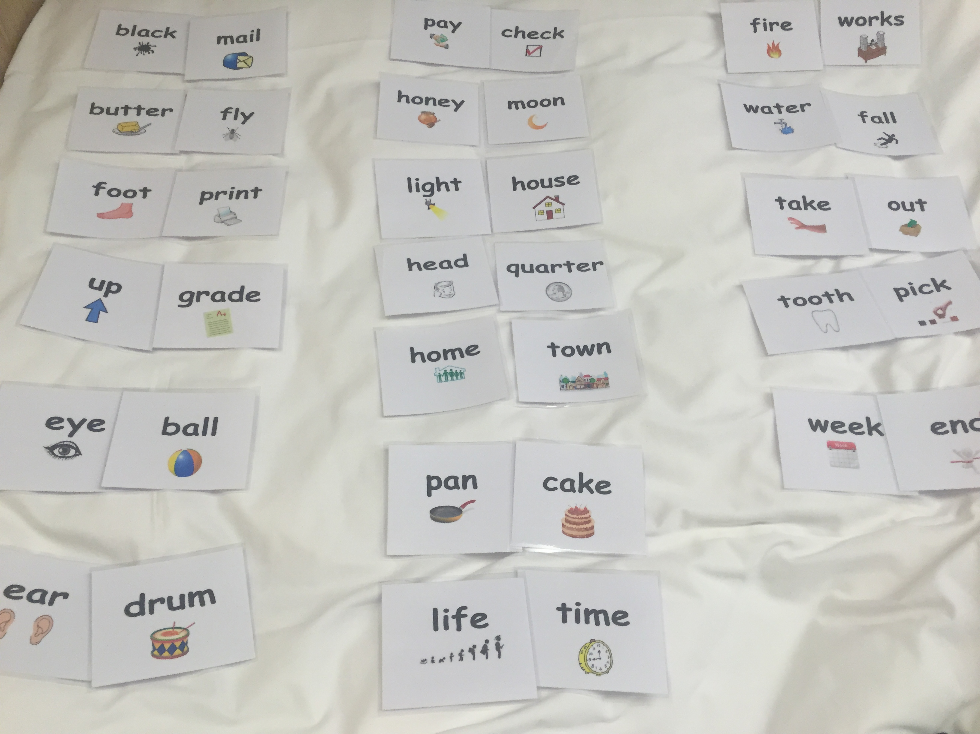

Video File
https://www.youtube.com/watch?v=EgMN0Cfh-aQ
(‘For the First Time in Forever’ from Frozen)

