☐ Listening ☐ Speaking ☐ Reading ■ Grammar ☐ Writing
Topic: “If I were……”

Instructor:  Diana(Eunyoung Kim)  James(JooHyun Cho) | Level:  Upper Intermediate(Adult) | Students:  15 | Length:  30 Minutes

Materials:
▶ White board and marker
▶Flash Cards (20cards)
▶Fabric (board)
▶Method to stick card on board

Aims:
▶Main aim: Students will learn the second conditional by using “If I were” in the subjunctive mood.
▶Personal aim: I want to encourage students to actively participate in speaking during class especially during activities to fully understand when to use “If I were…”

Language Skills:
▶Speaking: Students will practice using “If I were…”
▶Writing:Students will know when to use “If I were…” in written sentences.
▶Listening:Students will listen to other students’ opinions.
▶Reading: Students will read one students opinions.
▶Grammar: Students will properly understand and use “If I were…”

Language Systems:
▶Phonology: Correct pronunciation of “would” /wʊd/,“were” /wə(r)/
▶Lexis:If I were, I would
▶Grammar: Second conditional
▶Function:Giving information of how and when to use “If I were…”
▶Discourse: Asking questions and answering

Assumptions:
▶Ss enjoy physical activities
▶Ss are confused by simple past and subjunctive

Anticipated Errors and Solutions:
▶If students are nervous to answer,
>> We will, as teachers, will lead them with specific questions.
▶If students get excited from the topic and the conversations get loud
>> We would pick the loudest student and ask their opinions more seriously to take control of the course.

References:
▶Materials from the stationery: Fabric, colored balls, flash cards, glue gun
▶Google by Discovery Education Puzzle Maker
http://puzzlemaker.discoveryeducation.com/CrissCrossSetupForm.asp

Lead in
Materials:

White board and marker,
Flash Cards (20cards)

Time | Set Up | Student Activity | Teacher Talk
5min | Whole  class | Answering teacher’s question. | Greeting  T: Good afternoon, everyone! How was your week? (Wait for Ss response)  Okay, good. I’m glad to hear that.  Eliciting  (Write down “If I were...”)  T: If you were a man, what would you do?  (Ask 1 or 2 students)  T: Can I say “If I was a man” instead of saying “If I were a man?  (Get to see how many Ss are aware of using simple past and subjunctive)  (Wrtie down "was" - real possibility  "were"- imagination)  T: We use “was” when there is a real possibility, and “were”for just imagination, which isn’t real.  Give Examples:  (Write down examples)  If I was at the party last night.  If I were at the moon last night.  T: Please note that you can use “was” all the time because it became so popular but the proper/traditional way is to use “were” in the subjunctive mood.  CCQ  T: When do you use “was”?  And when do you use “were”?

Pre Activity
Materials:

White board & Marker
Work sheet
Time | Set Up | Student Activity | Teacher Talk
3min  2min | Whole class  Individually | Answering teacher’s question.  Writing their own creative sentence. | <Hand out work sheets>  (Work Sheet #1 "If I were…")  Instruction  T: We are going to write down a sentence, by using “If I were”. Try to come up with the phrase “I would” after using “If I were”.  T: I will give you 2mins.  ICQ  T: Are we going to write sentences, by using “If I was”?  T: What would you write after “If I were”?  T: How much time do you have?  Instruction  T: Now let’s share few sentences from which you have made.  (Ask 2 or 3 Ss)  T: Who wants to share?  (If no one is willing to participate, first ask a Ss who seems to do it.)

Main Activity
Materials:

White board & Marker
Fabric material board
Flash cards (20cards)
Time | Set Up | Student Activity | Teacher Talk
5min  10min | Whole class  In pairs | Ss will be asking and answering in a pair.  Come out in pairs, ask and answer each other. | Instruction  T: Now we are going to physically do a fun activity.  T: First, you will put your hand in the box (any container can be used) and take 1 card out.  (Let all students pick out a word from the box)  T: Look at the word on your card, and think about a sentence, using “If I were …”, followed by“I would…” after that.  T: I will give you 1min to think about it, and then we will share it.  (Give them a min to think about it)  ICQ  T: Which phrases are you using, to make the sentence?  Instruction  T: I want you to come out in a pair and stick your flash card on the Fabric board.  (Call 1 pair of Ss, and let them stick the cards on the Fabric board)  T: Could you tell me your sentence?  T: Please answer it by saying “If I were___, I would ____.  T: Thank you.  (Ask or pick another student for their card and sentence.)

Post Activity
Materials:
White board& marker

Time | Set Up | Student Activity | Teacher Talk
5min | Whole class | Listening teacher’s talk and answering the question. | Feedback  T: Did you enjoy today’s activity? (Listen to students’ feedback on the activity)  Error correction  Write student’s errors you noticed during the activity and write them on the board.  Example: If I were moon today  Correction: If I were a moon last night  Conclusion  “Do you have any questions?”  Hope you all have a beautiful day.  Good bye.
SOS Activity
Materials: Worksheet #2 Group discussion crossword (15 copies) (with answer sheet)

Time | Set Up | Student Activity | Teacher Talk
5min | Whole class | Listening Teacher’s direction and fill in the crossword | Instruction  “Here is a crossword puzzle. You can fill the crossword with given words.  Work with group. I will give you 4 minutes.”  ICQ  “How much time do you have?  “Are you in the group?”  Monitoring  Assist students if they need any help. Give a time warning “1 minute left”
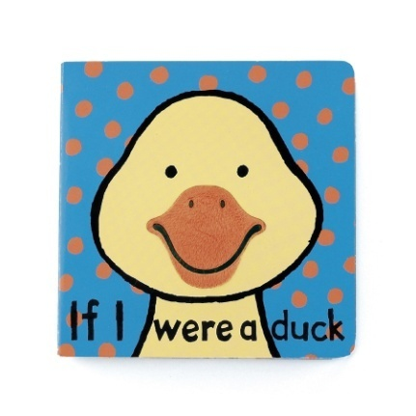
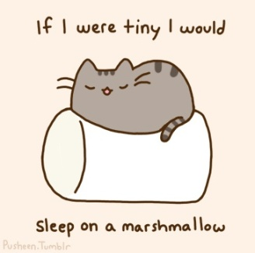
If I were…

★ Example:

1. If I were a duck….
I would quack at the dogs.

2. If I were a princess….
I would get married with a handsome prince.

☞Think of a word, to make a sentence by using “If I were”.
Come up with the phrase “I would” to finish the sentence.

1.
______________________________________________

2.
______________________________________________

3.
______________________________________________

Worksheet #2Group discussion crossword
“IF I WERE… ”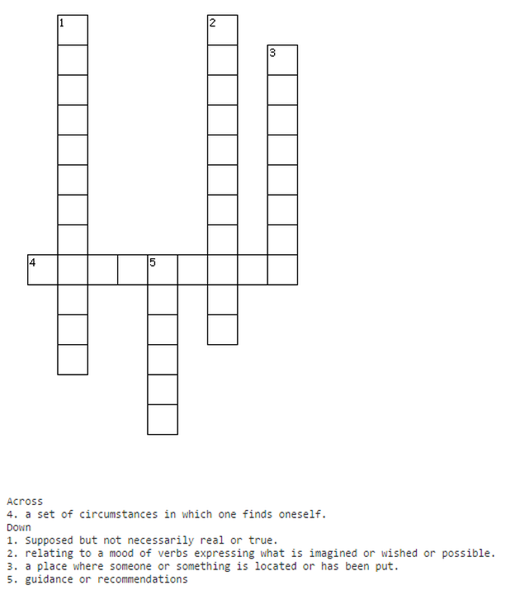
- Situation - Position - Hypothetical
- Subjunctive - Advice

