☐ Listening ☐ Speaking ☐ Reading ☐ Grammar ☐ Writing

Topic: Different Wedding Cultures

Instructor:  Celine, Annie | Level:  Upper Intermediate(Adult) | Students:  15 | Length:  30 Minutes

Materials:
- White board, markers
- Computer, projector
- Video of ‘Weddings in different cultures’
- Vocabulary list
- A4-sized pictures of vocabulary words (toss, embroider, frock, groom, ransom)
- Wedding invitation (realia)
- Article: Wedding in Different Cultures / 15 copies
- Worksheet 1: Comprehension Check / 15 copies
- Worksheet 2: Planning My Wedding / 15 copies

Aims: (3)
- Main Aim: Ss will improve their reading comprehension skills and learn new vocabularies by reading and discussing about the article
- Secondary Aim: Ss will learn about different wedding cultures by reading the article and sharing the information in small groups
- Personal Aim: Ss will have a chance to think about their own wedding preferences by learning about different ceremonies and wedding cultures.

Language Skills: (4- Integrated)
- Reading: reading articles, worksheet
- Listening: listening to information about other Ss’ article, song, T’s instructions
- Speaking: sharing information in small groups, answering T’s questions
- Writing: completing worksheets (comprehension check questions, planning on my wedding)

Language Systems:
- Phonology :‘ss’ sound (‘toss’) and ‘ck’ sound (‘frock’)
- Lexis : Vocabulary words (ransom, toss, groom, embroider, frock)
- Grammar : Present simple tense
- Function : Reading, comprehending
- Discourse : Group discussions

Assumptions:
- Ss know how the class is set up and ran (there will be 4~5 students seated in a group)
- Ss are actively participating in class
- Ss know the language skills and systems
- Ss have a general understanding of at least one wedding culture

Anticipated Errors and Solutions:
- If time is running out, shorten the discussion time or have Ss finish Worksheet 2 (‘Planning My Wedding’) for homework
- If there is more time than planned, give Ss more time for Worksheet 2 (‘Planning My Wedding’) or do the SOS activity

References:
- Video of ‘Weddings in different cultures’ (YouTube): goo.gl/gbiKvF
- Article (livescience.com): goo.gl/iPkE1U
- Pictures : Vocabulary1 (Google image ‘Toss’) : https://goo.gl/Ap7mdr
Vocabulary 2 (Google image ‘Embroider): https://goo.gl/8xKZev
Vocabulary 3 (Google image ‘Groom’): https://goo.gl/yKYM5B
Vocabulary 4 (Google image ‘Frock;): https://goo.gl/Ezv4Pj
Vocabulary 5 (Google Image ‘Ransom’): ‘https://goo.gl/HySi3p
- Worksheet 1 picture 1 (Google image: ‘Peru wedding cake’): goo.gl/DXVscj
- Worksheet 1 picture 2 (Google image: ‘Chinese Wedding’): goo.gl/GGVtnY
- Worksheet 1 picture 3 (Google image, ‘vykyp nevesty’): goo.gl/BR7aGg

Lead-In
Materials: Wedding invitation (realia)
Time | Set Up | Student Activity | Teacher Talk
1 min | Whole class | Listen to & answer T’s questions | Procedure:  <Greeting>  Hello everyone, how are you?  <Eliciting>  -What comes to your mind when you see this? (show a wedding invitation)  -Is anyone married here? What was your most memorable moment about the wedding?  (if no one is married, ask about a wedding Ss have attended before)  <Introduce the topic>  Today, we will talk about ‘Different Wedding Cultures.’

Pre-Activity
Materials: Computer, projector, video (‘Weddings in different cultures’), A4-sized pictures for each vocabulary word (5), board, marker
Time | Set Up | Student Activity | Teacher Talk
1 min  3 min | Whole class  Whole class | Watch video  Learn key vocabularies  Listen to & think about guiding questions | Procedure:  <Introduce the topic (continued)>  First, we will watch a short video clip.  (Play video)  How did you like the video?  <Vocabulary>  Let’s learn some key vocabularies that will help you understand the text.  1. Toss  a) Presentation  -Elicit (show picture):  What is the woman doing with the flower? What is the man doing with the ball?  - Write word on the board & give definition  b) CCQ  -Everyone pretend to toss something to the person next to you.  2. Embroider  a) Presentation  -Elicit (show picture):  What do you see in the picture?  -Write word on the board & give definition  b) CCQ  -What are some things you can embroider?  3. Frock  a) Presentation  -Elicit (show picture):  What do you see in the picture?  - Write word on the board & give definition  b) CCQ  -When do people wear a frock?  -Can men wear a frock?  4. Groom  a) Presentation  -Elicit (show picture):  Who do you see in the picture?  -Write word on the board & give definition  b) CCQ  -How do grooms look on their wedding day?  5. Ransom  a) Presentation  -Elicit (show picture):  What do you see in the picture?  -Write word on the board & give definition  b) CCQ  -When might someone request a ransom?  <Guiding Questions>  While you are reading the articles, I want you to think about these questions:  (Write the questions on board)  -What comes to your mind when you think of ‘wedding’?  -Have you ever been to a foreign wedding? -How are weddings different in different cultures?

Main Activity
Materials: Article: ‘Wedding in Different Cultures’(15 copies), board, marker
Time | Set Up | Student Activity | Teacher Talk
1 min  5 min  1 min  5 min  1 min | Whole class  Individual  Small group  Whole class | Listen to T’s instruction  Read article, circle key words, write a summary sentence  Listen to T’s instruction  Share & write summary sentence for each section  Listen to T’s error correction | Procedure:  <Instruction>  “You will get a handout that has 3 short sections from an article. You will read only 1 section that is highlighted on your paper. Please read individually, and while you are reading, circle any words that you think are important. After reading, you will write one sentence that summarizes your section, on the bottom of your passage. You have 5 minutes.”  (Hand out article sheet)  <ICQ>  Are you reading all 3 sections on the handout?  What are you doing while reading?  What are you doing after reading?  <Monitoring>  (Monitor discreetly. Make sure Ss know what to do. Answer questions if necessary.)  (Give time warning if needed)  <Instruction>  “Now, everyone will discuss what you read in small groups of 3. Tell your group what country you read about, and give a brief summary of the country’s wedding culture. At the end of discussion, everyone should have a summary sentence written down for each of the 3 sections. You will have 5 minutes.”  <ICQ>  What are you doing with your group?  Does everyone need to write down a summary sentence for all 3 sections?  (Group Ss into 3~4 people, making sure that there is a S who read each section.)  <Monitoring>  (Monitor discreetly)  (Take note of incorrect statements/sentences that Ss create)  (Give time warning if needed)  <Error Correction>  (Write on board 1~2 incorrect sentences from previous discussion. Have Ss correct the sentences as a class.)

Post Activity
Materials: Worksheet 1: ‘Comprehension Check-up’, Worksheet 2: ‘Planning My Wedding’ (15 copies)
Time | Set Up | Student Activity | Teacher Talk
1 min  3 min  1 min  1 min  5 min  1 min | Whole class  Individual  Whole class  Whole class  Individual  Whole class | Listen to T’s instruction  Complete worksheet  Share and check answers  Listen to T’s instruction  Work on worksheet 2  Share opinions with class | Procedure:  <Instruction>  “Everyone should now have an understanding of wedding cultures for each of the 3 countries. Now, you will answer some questions to check your understanding. We will hand out a worksheet. Please work individually to write the answers to each question. You don’t have to use complete sentences; you can write key words or short phrases for your answer. You have 3minutes.”  <ICQ>  Do you have to answer in complete sentence?  How much time do you have?  <Monitoring>  (Monitor discreetly)  (Give time warning if needed)  <Sharing answers>  (For each question, have 1 student share answer)  <Instruction>  “Okay we’ll move on to next activity. From your readings and discussion with your partners, you’ve been informed about various wedding traditions. Now, you are going to imagine what you would like your wedding to be like. Think about it and plan for it on the worksheet that we’ll hand out now. There are reference lists on the worksheet to help you to plan on items.  If you are married already, just think back and plan for your ideal wedding.  You will have 5 min.”  (Hand out worksheet 2)  <ICQ>  What do you have to do on your worksheet?  How much time do you have?  <Monitoring>  (Discreetly monitor and add ideas if Ss have  trouble writing.)  (Give time warning if needed)  <Sharing plans and feedback>  Let’s hear some of wedding plans. Can anyone share your plans?  (Listen to 3-4 Ss plans)  We hope today’s activity helped you to learn more about different wedding traditions via reading comprehension. You guys did good job!

SOS Activity
Materials: board, marker
Time | Set Up | Student Activity | Teacher Talk
5 min | Whole class | Answer the quiz | Procedure:  <Instruction>  “Now, we’re going to do a ‘taboo’ game with vocabularies we learned together and some things you read in your articles. Let’s start with ___, please come up here and sit down to face your classmates. Here is the 1st word.”  (Write the 1st word “Groom” on the board. After 1st round, the student answered can pick next student to answer and will write down the 2nd word.)  <ICQ>  What words will we use for game?

Vocabulary List

- Toss: To throw something lightly
- Embroider: To design by stitching a pattern
- Frock: A woman or girl’s dress
- Groom: A man who is getting married
- Ransom: Money to be said to set someone free

Vocabulary Pictures
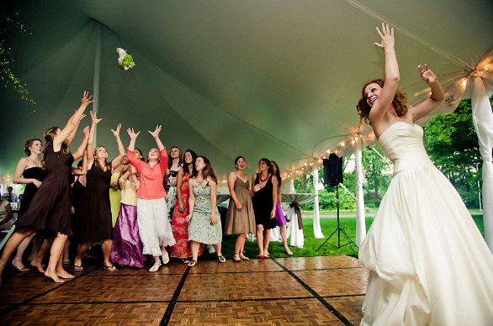
<TOSS>

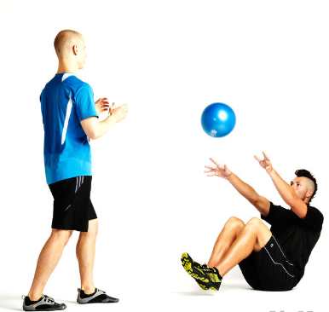
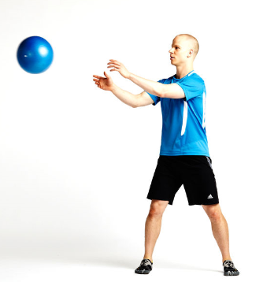

<Embroider>
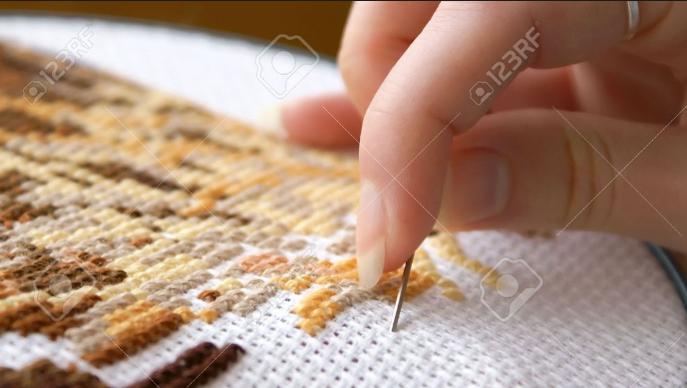

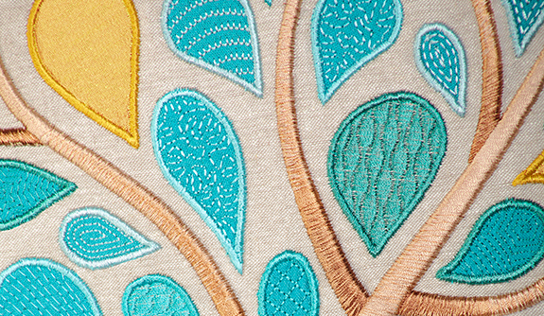

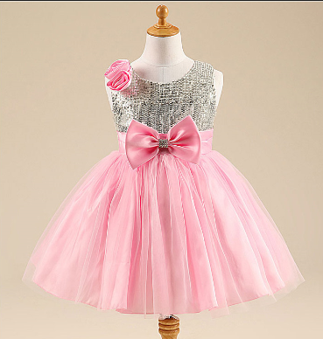
< Frock>

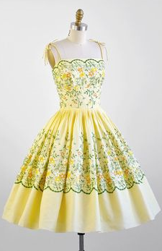
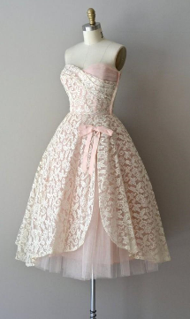

<Groom>

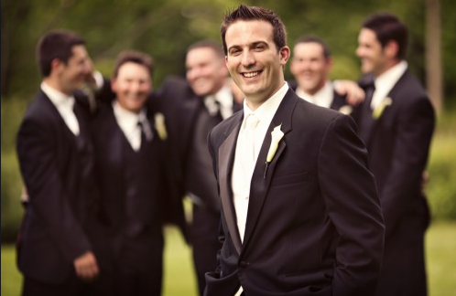

<Ransom>

Article : Wedding in Different Cultures

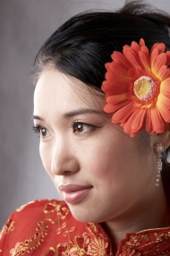
Wardrobe Change
In modern China, brides pick not one wedding dress, but three. First, there's the traditional ‘cheongsam’, an embroidered, slim-fitting frock that's usually made red for weddings, because red is a strong, lucky color in Chinese culture. Next, the bride might swap into a white poufed ball gown that wouldn't look out of place at an American wedding — a bridal nod to the popularity of Western trends. Finally, the bride ducks out of the reception to change into a third dress, this one a gown of her color choice or a cocktail dress.

Summary Sentence: _________________________________________________________________________
_____________________________________________________________________________________________

Peruvian Cake Pull
In Peru, single female guests take part in a tradition a little sweeter than a bouquet toss. Charms attached to ribbons are tucked between the layers of the wedding cake. Before the cake is cut, each woman grabs a ribbon and pulls. At the end of one ribbon is a fake wedding ring. The guest who picks that ribbon is said to be next in line for marriage.
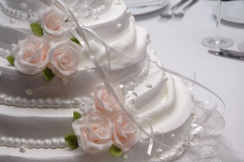

Summary Sentence: _________________________________________________________________________
_____________________________________________________________________________________________

Ransom for the Bride
Russian grooms have to work for their brides. Before the wedding, the groom shows up at the bride's home and asks for his beloved. In jest, her friends and family refuse him until he pays up in gifts, money, jewelry or simple humiliation. Grooms are forced to do silly dances, answer riddles, and perform goofy tests of worthiness like diapering a baby doll. Once the groom impresses friends and family with this bridal ransom, or "vykupnevesty," he's allowed to meet his bride-to-be.
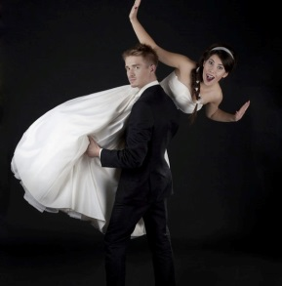

Summary Sentence: _________________________________________________________________________
_____________________________________________________________________________________________
Worksheet 1
<Comprehension Check-Up>

Direction: Answer the following questions.
- Are there any aspects of Korean wedding ceremonies or traditions that are similar to that of China, Peru or Russia?

- Which of the three country’s wedding styles do you prefer? Why?

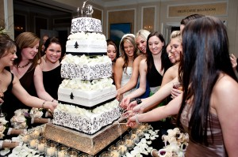
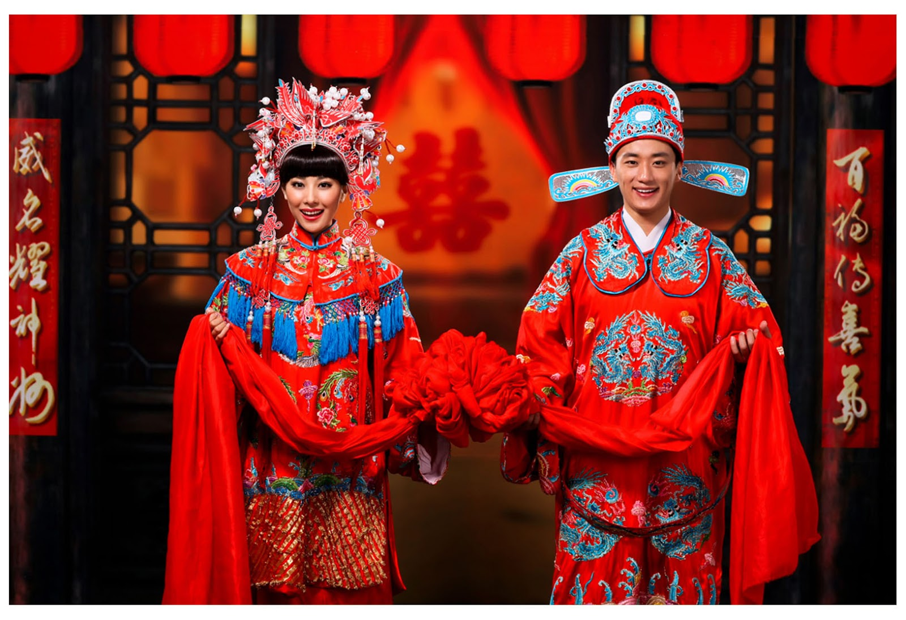
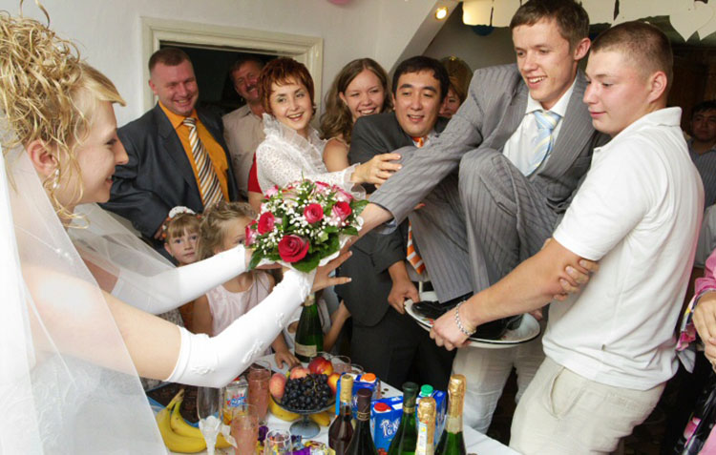
Worksheet 2
<Planning My Wedding>
Direction: Plan your own weddings, choosing the dress, decoration and events!
<Reference List>
- Dress – white pouf dress, red see-through, classic white princess style…etc.
Black Tuxedo with bow tie, Grey suit with regular ties…etc.
- Decoration: Flowers, trees, ribbons, laces…etc.
- Events: Bride & groom singing, dancing with father, limbo game…etc.
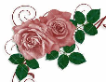
On my wedding…

I will wear__________________________________
I will decorate my wedding with _________________
________________________________________
I also want to have events/ceremonies like
__________________________________________
__________________________________________
____________________________________________________________________________________

