☐ Listening ☐ Speaking ☐ Reading ☐ Grammar ☐ Writing

Topic: Smore cooking class

Instructor:  Bonnie, Candy | Level:  Intermediate | Students:  17 | Length:  30 Minutes

Materials:
- White board
- Markers
- 3 Pictures of the vocabulary
- 17copies of the vocabulary worksheet1
- 17copies of the fill in the blanks worksheet2
- 17copies of the SOS activity worksheet3
- 9copies of the Recipe for cooking
- 9Package of S’more (Chocolate, marshmallow, cracker...)
- Realia – Cracker, Nutella Jam, Marshmallow, Chocolate
- Song for cooking time (post activity ):cookie crumble (mp3 file)

Aims:
- Students will practice reading comprehension skills.
- Students will learn vocabulary related to the recipe by using context clues.
- Students will use to recipe in their daily lives.
- Students will learn English with pleasure and will work cooperatively in a group by post-activity.

Language Skills:
- Listening: Teacher’s elicitation and background information; Teacher’s explanation of vocabulary and reading of article.
- Reading: Cooking along to recipe, worksheet.
- Speaking: Asking and answering questions with CCQ.
- Writing: Fill in the blanks worksheet and vocabulary.

Language Systems:
- Function: Asking for and giving information
- Phonology: Correct of new vocabulary words.
- Lexis: Could explain about the history
- Grammar: N/a
- Discourse: ask and work along to the recipe

Assumptions:
- Ss know how the class is set up and ran
- Ss are know the language skills and systems

Anticipated Errors and Solutions:
- Students will enjoy the activity but It takes much time for cooking.
->Teacher will check the time during of the post-activity.

References:
-S’more’ Background article
https://en.m.wikipedia.org/wiki/S'more

-S’more’ recipe
http://www.foodnetwork.com/recipes/paula-deen/sure-fire-no-fire-smores-recipe.html

-vocabulary pictures
https://goo.gl/WPtrmg
https://goo.gl/3Xdjre
https://goo.gl/nTuIDH

Lead-In
Materials:
- White board
- Markers
Time | Set Up | Student Activity | Teacher Talk
2min | Whole  class | T-s  Question&Answering | Procedure  -Greeting  Hello, everyone!  How do you feel today?  -Introduction  CCQ  1. If you are going to the camping what are you eating after BBQ party?  (Ss answer: dessert.. sweet potato..etc)  2. If you are going to eat very delicious food or dessert in the restaurant. after you want to eat more food then what will you say to chef?  (Ss answer: give me some more..some more etc)  Today, we are going to do Reading about ‘Smore’ .Do you know ‘Smore’?  It’s a famous American dessert!

Pre-Activity
Materials:
- Magic box
- Realia;Object for S’more’(cracker, jam ,chocolate, marshmallow)
- Vocabulary of 3pictures
- 17copies Worksheet1 of the vocabulary
- Background Music(cookie crumble) mp3 file.

Time | Set Up | Student Activity | Teacher Talk
5min  3min  2min  1min | Whole  class | Guessing game  T-S  S-S  Vocabulary worksheet | Procedure  -Eliciting  Here is my magic box!  I put in the box something.  Ss, you come on the front, put in the box on your hand then just touch all object.  Guess what is in the box?  (put out all things)  Did you enjoy the game?  -ICQ  What can you see out of the box?  Ss answer)  -Vocabulary pictures  Before we get the worksheet, I will show you some pictures of the vocabulary.  Look at this picture!  -CCQ  1. indicate  what I am doing now?  ( point to a picture)  2. conjunction  Can conjunction words are cut the sentences?  ( No)  3. Ingredient  What kind of food they can make?  (for bread)  -Vocabulary & worksheet1  Now, we are going to have Reading time,  I will give you worksheet. Let’s do that one by one. I will give you 2minutes.  -ICQ  Do worksheets with your partner?(no)  How much time do you have?(2min)  -Checking  Times over!  Let’s check together!

Main Activity
Materials: Materials:
- White board& board markers
- 17copies Reading article of background about S’more
- 17copies Fill in the blanks Worksheet2 of the article
- 17copies Reading article of recipe about S’more

Time | Set Up | Student Activity | Teacher Talk
1min  3min  2min  1min | Whole  Class  Individual  Individual  > pair  Whole  class | Reading about background about s’more | procedure:  -Instructions  Now we’ll reading about this paper.  This is History about S’more.  I’ll give you 2 minutes.  First scanning and then please mimicking this page.  -I.C.Q.  How can you read this time?  (scanning, mimicking)  How much time do you have?  (2min)  Time’s up!  Please turn over the paper. There is the worksheet about what you read this time.  Fill in the blank individually, and then share with your group.  I’ll give you 2 minutes.  -I.C.Q  Can you work with your pairs?  (individually)  Now let’s start.  -Checking Answers  Are you guys finished?  What is your answer?  Let’s share with class.  -Instructions 2  Okay, I’ll give you one more paper.  This is recipe about S’more.  Please scanning first, and then read aloud together.  (Ss are read aloud together)  And now please clean up your table.  Let’s going to cooking!!!

Post Activity
Materials:
- 9copies Recipe about S’more
- 9Package of S’more (Chocolate, marshmallow, cracker...)

Time | Set Up | Student Activity | Teacher Talk
1min  5min | Whole class  Pair work | T-S  Making a S’more | Procedure:  -Instructions  Now we’ll make a S’more.  Please follow that recipe, and this is the  pair work. I’ll give you 5 minutes.  -I.C.Q.  Can you do it individually?  How much time do you have?  (Ss are making a S’more)  If your finish cooking , let’s clean up the  table then enjoy eating after class.  Okay, Did you have a good time today?  I hope you have a good time to learn more about American culture through this class.  Thank you everyone.  See you next time. Goodbye!

SOS Activity
Materials:
Worksheet3

Time | Set Up | Student Activity | Teacher Talk
3min | Whole  class | T-s  Ss play bingo game | Everybody let’s play bingo game together!  Here is the word (about today’s vocabulary or article).  Let’s draw a line and make a blank 4 x 4 or  5 x5 bingo grids with squares large enough to  write vocabulary words in this box. When you  have 4 or 5 beans in a row, they call out  “Bingo”  Everyone is got it?  So let’s do it now.  Checking  -finish-

*Vocabulary pictures (for Vocabulary CCQ)
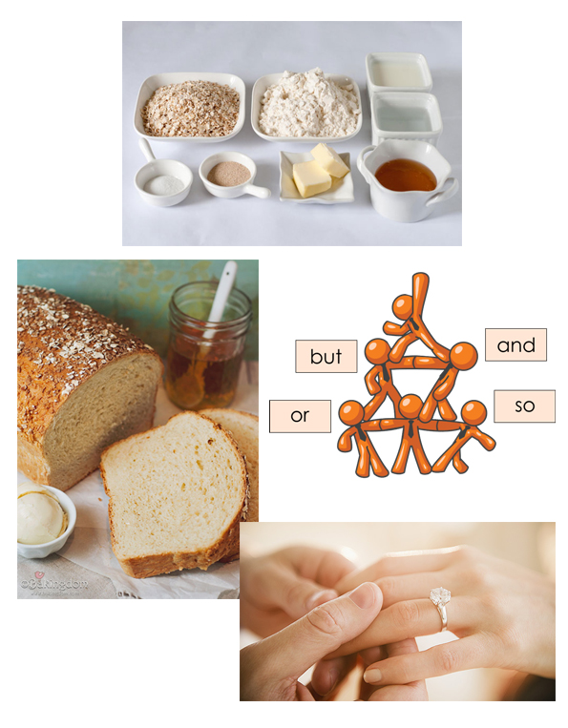

*Main article 1 (Background Knowledge )
S’more background:
Delicious history
Aug 10, 2015 National S'mores Day
S'more is a contraction of the phrase "some more". One early published recipe for a s'more is found in a book of recipes published by the Campfire Marshmallows company in the 1920s ^{[4]} where it was called a "Graham Cracker Sandwich." The text indicates that the treat was already popular with both Boy Scouts and Girl Scouts. In 1927, a recipe for "Some More" was published in Tramping and Trailing with the Girl Scouts.^{[5]} The contracted term "s'more" appears in conjunction with the recipe in a 1938 publication aimed at summer camps.^{[4]} A 1956 recipe uses the name "S'Mores," and lists the ingredients as "a sandwich of two graham crackers, toasted marshmallow and 1/2 chocolate bar". A 1957 Betty Crocker cookbook contains a similar recipe under the name of "s'mores."^{[6]} The 1958 publication "Intramural and Recreational Sports for High School and College" makes reference to "marshmallow toasts" and "s'more hikes"^{[7]} as does its related predecessor, the "Intramural and Recreational Sports for Men and Women" published in 1949,^{[8]} as the s'more is a great before and after exercise snack. In the 1993 movie, The Sandlot, Hamilton 'Ham' Porter explains to Scotty 'Smalls' Smalls how to make a s'more out of grahams, mallows, and chocolates.^{[9][10]}

*Main article2 (Recipe)
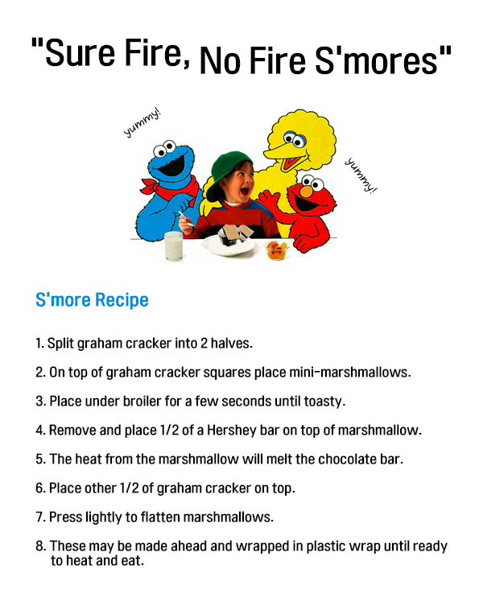
*Worksheet 1 (pre- activity )
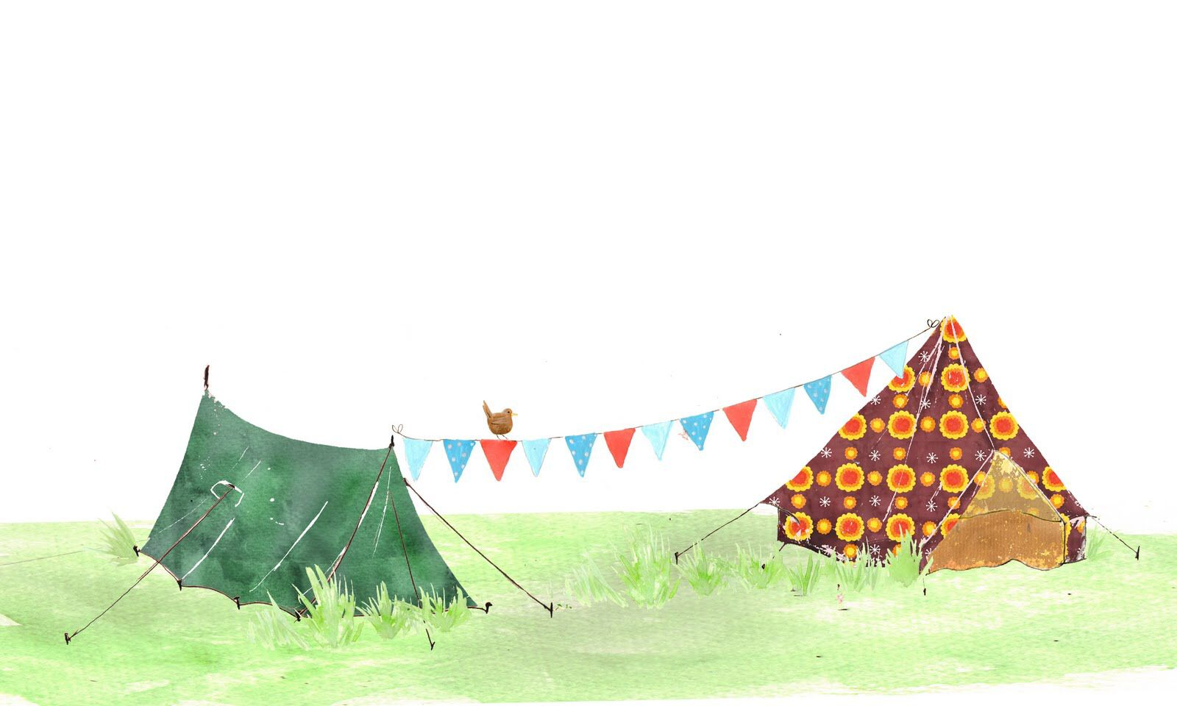
[Word Scramble]
Makes the complete words, and makes the full sentences.

1. Please makes the complete words.
- o a o t C t n n i c r .................................
- t a e i d n I c ................................
- t o C o j u n n c i n .................................
- E n p x a l i .................................
- g e e i n I n d r t .................................
2. Please makes the full sentences.
- I can’t ............... it any other way.
- Wheat is a common ................. in many food.
- the .................. of iron by cold.
- I’ll willing to wark in .................. with you.
- Those black clouds ................. that it might rain soon.
Contraction Indicate Conjunction Explain Ingredient
Worksheet 2 (main- activity )
Worksheet2:
Fill in the blanks below the contact.
S'more is a contraction of the phrase "______ ______". One early published recipe for a s'more is found in a book of _______ published by the Campfire Marshmallows company in the 1920s ^{[4]} where it was called a "Graham Cracker Sandwich." The text indicates that the treat was already popular with _____ Boy Scouts ____ Girl Scouts. In 1927, a recipe for "Some More" was published in Tramping and Trailing with the _________.^{[5]} The contracted term "s'more" appears in conjunction with the recipe in a 1938 publication aimed at ______ ______.^{[4]} A 1956 recipe uses the name "S'Mores," and lists the the ingredients as "a sandwich of two ______ ______, toasted _________ and 1/2 ________ ____". A 1957 Betty Crocker cookbook contains a _______ recipe under the name of "s'mores."^{[6]} The 1958 publication "Intramural and Recreational Sports for High School and College" makes reference to "marshmallow toasts" and "s'more hikes"^{[7]} as does its related predecessor, the "________and __________ Sports for Men and Women" published in 1949,^{[8]} as the s'more is a great before and after _________ snack. In the 1993 movie, The Sandlot, Hamilton 'Ham' Porter explains to Scotty 'Smalls' Smalls how to make a s'more out of grahams, mallows, and chocolates.^{[9][10]}

Intramural Recreational exercise graham crackers
Marshmallow chocolate bar similar summer camps
some more recipes both…and Girl Scouts

-Worksheet 3(SOS activity )
“BINGO Game”
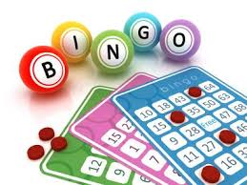
Here are the random order words in when we are reading. Please order it your mind, when you ordered like a teachers order, you’ll be the winner!

( split / Cracker / Remove / Flatten / Melt / Surmise / Stuff / Recipe / adopt / probably )

