☐ Listening ☐ Speaking Reading ☐ Grammar ☐ Writing

Topic: Inventions by Teens

Instructor:  Soweon Yoon(Renz)  Yuna Lee(Yuna) | Level:  Intermediate (Adult) | Students:  15 | Length:  30 Minutes

Materials:
■ White board and board markers
■ Realia: tea bag, earmuff
■ Visual Aids : sandwich, popsicle
■ Computer for PPT file
■ Worksheet #1 for group work paper (16 copies)
■ Board game set
■ Jigsaw cards

Aims:
■ Main aim: Students will be able to read and comprehend their own segments of the text
by jigsaw reading.
■ Secondary aim: Students will be able to complete the chart by asking and answering the questions with group members.
■Personal aim: Clear and slow teacher's talk

Language Skills:
■ Speaking: Ss will share their segments and play a board game with group members
■ Listening: Ss will listen to other students’ demonstration.
■ Reading: Ss will read their segments of the text.
■ Writing: Ss will fill in the blanks of the chart.

Language Systems:
■ Phonology
■ Lexis: New vocabularies in the class (popsicle, earmuff,)
■ Grammar: Compound adjectives
■ Function: Demonstrating to others
■ Discourse: Dialogue

Assumptions:
Students already know
■ How the class is set up and run (Ss will sit with their group members for group work)
■ Four language skills and language systems

Anticipated Errors and Solutions:
■ If students do not understand their segments during jigsaw activity
☞ make their team members help them reading.
■ If some students need more explanations about certain words
☞ give them more supplementary demonstration by pictures or photos.
■ If some students finish their tasks early
☞ offer them other tasks about today’s objectives.

References:
■ popsicle: https://goo.gl/1RM4G0
■ sandwich: https://goo.gl/V7jfM9
■ sign translator: https://goo.gl/1W4exf
■ shopping cart: https://goo.gl/N8uR9a
■ firefighter boots: https://goo.gl/4SPD7W
■ earmuff: https://goo.gl/Ym1ehm
■ Realia: tea bag, earmuff

Lead-In
Materials:
Time | Set Up | Student Activity | Teacher Talk
1min | Whole class | ■ Greeting  ■ Focusing on a teacher and answering questions | Procedure:  ■ Greeting  “Good afternoon, everyone”  “  “It’s our last day of class,  How do you feel?”  “Do you have any plan for the Christmas?”

Pre-Activity
Materials: whiteboard and board markers, realia : earmuff, tea bag. visual aids : popsicle. Sandwhich

Time | Set Up | Student Activity | Teacher Talk
3 min  2 min | Whole class  Whole class | ■ Answering the questions  ■ Listening to T carefully and answering the questions | Procedure:  Elicitating  “Who like this? (show visual aids sandwich)  “Does anyone know who invented this?”  (Give more hint if Ss can’t answer)  “Hint is in the name.”  (Answer if Ss can’t answer)  “In the past Duke Sandwich invented sandwich to save the time for card games. Like this invention is not far from our lives.”  “How about this (Tea bag)?”  (Show Realia)  (Answer if Ss can’t answer)  “How about this?” (earmuff:Realia)  “What do you call this?” (Popsicle)  (Write Earmuff, Popsicle on the board)  “Let’s find out!”  ■ Introducing the topic  “Today, we are going to learn reading passages about invention.”  ■ Introducing how to do jigsaw  “ "You will read passages with your group members. Five people for one group. Please sit with your group.”  “Very good! And I will give you these five cards to each group. On the top of the card, there is an alphabet from A to E. Do you see it?”  “YOU will have different alphabet card from your group members. There are reading passages on the card. Read your own passage on your card and fill in the blanks of the chart.  “You should only fill in the blanks on YOUR parts. I will give you 5 minutes to do it. The passages are not long, so 5 minutes will be enough. If you have any questions, raise your hand and I will help you. Start!”  ICQs  - Will you read other members’ card?  - What do you have to do after reading your card?

Main Activity
Materials: Jigsaw cards, worksheet #1

Time | Set Up | Student Activity | Teacher Talk
5min  6min | Whole class  Groups | ■ Doing worksheet #1  ■ Sharing passages with partners | Procedure  ■ Doing jigsaw activity  (Giving jigsaw cards and worksheets to students)  “Ok, Time is up! Do you fill in your blanks on the chart?”  ■ Information gap activity  “From now on, all of you ask and answer questions about what you have read. You can find the answers of blanks in other passages. When you ask questions, please use these patterns on the white board.”  ICQs  - What do you have to do while talking with group members? (Ss:fill in the blanks)  -What do you have to use when you ask questions? (Ss: patterns on the board)  “Let’s start.”  “Ok, time is up! Did you all find the answer?”  “Let’s check together”  (Answer check)

Post Activity
Materials: Pyramid game set, computer for a video file, white board and board markers

Time | Set Up | Student Activity | Teacher Talk
6 min | Group | ■ Listening to T and playing board game | Procedure  ■ Playing board game  “Ok, this is the last activity of the class.  We are going to play a board game. We will give you a game board and a dice to each group.”  “These board game questions are today’s reading passages. First, you put your pin on the start and roll a dice. When you have even numbers, you can move two spaces. But when you get odd numbers you will move just one space. The winner is someone who first arrives at the end. You will have 5 minutes to play.  (Ss playing game)  “Ok, time is over! Who is the winner of your groups? Raise your hand! Congratulations all winners! And well done everyone!”  “How was the today’s activity?”  (Get Ss feedback)  “Great, Hope you learned something.  Have a great holiday.”

SOS Activity
Materials:
Time | Set Up | Student Activity | Teacher Talk
2 min | Whole class | Fill out 'Do you know who invented' worksheet | "Since we have time left, look at your SOS worksheet with pairs"

Ⓐ  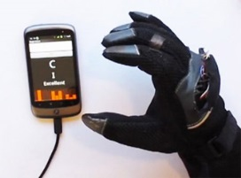  In the summer of 2000, seventeen-year-old Ryan Patterson saw a deaf boy ordering lunch at a restaurant. He had a lot of problems because he couldn't talk. Ryan used a golf glove, a small receiver, and a screen to invent a sign translator. Sensors in the glove pick up hand movements and change them into letters for the screen. | Ⓐ  In the summer of 2000, seventeen-year-old Ryan Patterson saw a deaf boy ordering lunch at a restaurant. He had a lot of problems because he couldn't talk. Ryan used a golf glove, a small receiver, and a screen to invent a sign translator. Sensors in the glove pick up hand movements and change them into letters for the screen.
Ⓐ  In the summer of 2000, seventeen-year-old Ryan Patterson saw a deaf boy ordering lunch at a restaurant. He had a lot of problems because he couldn't talk. Ryan used a golf glove, a small receiver, and a screen to inent a sign translator. Sensors in the glove pick up hand movements and change them into letters for the screen. | Ⓐ  In the summer of 2000, seventeen-year-old Ryan Patterson saw a deaf boy ordering lunch at a restaurant. He had a lot of problems because he couldn't talk. Ryan used a golf glove, a small receiver, and a screen to invent a sign translator. Sensors in the glove pick up hand movements and change them into letters for the screen.
Jigsaw cards

Ⓑ  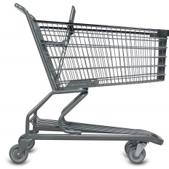  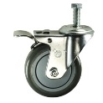  Runaway shopping carts were a common site at most grocery and large chain stores. Patricia Rincon, a seventh-grader, and two of her friends solved the problem of disappearing shopping carts at supermarkets. They put a brake on the handle of the cart, so the cart doesn't move when you don't use it. | Ⓑ  Runaway shopping carts were a common site at most grocery and large chain stores. Patricia Rincon, a seventh-grader, and two of her friends solved the problem of disappearing shopping carts at supermarkets. They put a brake on the handle of the cart, so the cart doesn't move when you don't use it.
Ⓑ  Runaway shopping carts were a common site at most grocery and large chain stores. Patricia Rincon, a seventh-grader, and two of her friends solved the problem of disappearing shopping carts at supermarkets. They put a brake on the handle of the cart, so the cart doesn't move when you don't use it. | Ⓑ  Runaway shopping carts were a common site at most grocery and large chain stores. Patricia Rincon, a seventh-grader, and two of her friends solved the problem of disappearing shopping carts at supermarkets. They put a brake on the handle of the cart, so the cart doesn't move when you don't use it.

Ⓒ  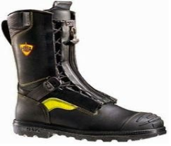  Ashley Kling, a ninth-grader from Ohio, invented a flashing light for firefighters' boots. Kling explains, "One of the biggest safety issues is the lack of visibility due to smoke. Firefighters often crawl beneath the smoke. Because it`s dark, I invented a way to illuminate the exposed bottoms of their boots." This way you can see the firefighters better in a dark place. | Ⓒ  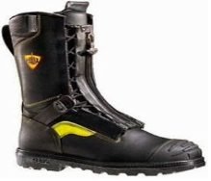  Ashley Kling, a ninth-grader from Ohio, invented a flashing light for firefighters' boots. Kling explains, "One of the biggest safety issues is the lack of visibility due to smoke. Firefighters often crawl beneath the smoke. Because it`s dark, I invented a way to illuminate the exposed bottoms of their boots." This way you can see the firefighters better in a dark place.
Ⓒ  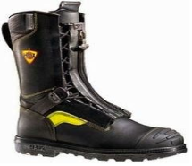  Ashley Kling, a ninth-grader from Ohio, invented a flashing light for firefighters' boots. Kling explains, "One of the biggest safety issues is the lack of visibility due to smoke. Firefighters often crawl beneath the smoke. Because it`s dark, I invented a way to illuminate the exposed bottoms of their boots." This way you can see the firefighters better in a dark place. | Ⓒ  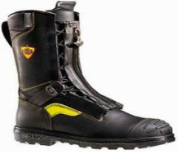  Ashley Kling, a ninth-grader from Ohio, invented a flashing light for firefighters' boots. Kling explains, "One of the biggest safety issues is the lack of visibility due to smoke. Firefighters often crawl beneath the smoke. Because it`s dark, I invented a way to illuminate the exposed bottoms of their boots." This way you can see the firefighters better in a dark place.

Ⓓ  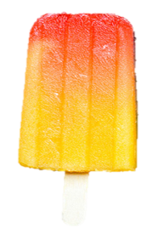  You don't have to be like Einstein to invent something clever. Have you heard of Popsicles? In 1905, an 11-year-old boy named Frank Epperson invented them. On a winter night, he left his favorite fruit drink with a stirrer in it outside. When he got up, the drink was frozen, and he invented a very delicious dessert with a handle! | Ⓓ  You don't have to be like Einstein to invent something clever. Have you heard of Popsicles? In 1905, an 11-year-old boy named Frank Epperson invented them. On a winter night, he left his favorite fruit drink with a stirrer in it outside. When he got up, the drink was frozen, and he invented a very delicious dessert with a handle!
Ⓓ  You don't have to be like Einstein to invent something clever. Have you heard of Popsicles? In 1905, an 11-year-old boy named Frank Epperson invented them. On a winter night, he left his favorite fruit drink with a stirrer in it outside. When he got up, the drink was frozen, and he invented a very delicious dessert with a handle! | Ⓓ  You don't have to be like Einstein to invent something clever. Have you heard of Popsicles? In 1905, an 11-year-old boy named Frank Epperson invented them. On a winter night, he left his favorite fruit drink with a stirrer in it outside. When he got up, the drink was frozen, and he invented a very delicious dessert with a handle!

Ⓔ  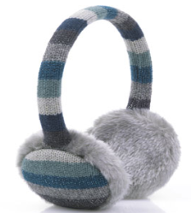  Or how about Chester Greenwood? In 1873, Chester was 15 years old, and he was ice skating. His ears got very cold, so he went home. He found two wires and he asked his grandmother to put some fur on them. These became the first earmuffs, and Chester made a lot of money with this invention. | Ⓔ  Or how about Chester Greenwood? In 1873, Chester was 15 years old, and he was ice skating. His ears got very cold, so he went home. He found two wires and he asked his grandmother to put some fur on them. These became the first earmuffs, and Chester made a lot of money with this invention.
Ⓔ  Or how about Chester Greenwood? In 1873, Chester was 15 years old, and he was ice skating. His ears got very cold, so he went home. He found two wires and he asked his grandmother to put some fur on them. These became the first earmuffs, and Chester made a lot of money with this invention. | Ⓔ  Or how about Chester Greenwood? In 1873, Chester was 15 years old, and he was ice skating. His ears got very cold, so he went home. He found two wires and he asked his grandmother to put some fur on them. These became the first earmuffs, and Chester made a lot of money with this invention.

Worksheet #1
Group work
Lesson 10. Inventions by Teens
▶ Fill in the blanks on the below chart.
The Inventor(s) | Ryan Patterson | Patricia Rincon  and two of her friends | Ashley Kling | Frank Epperson | Chester Greenwood
Age
The Invention
Materials of the invention
The motivation for the invention

▶What is common among the above inventors?
Worksheet
- Main Activity - Board game
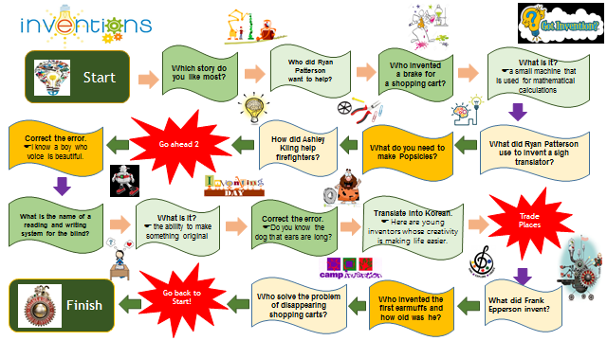

■ Visual Aids : sandwich, popsicle
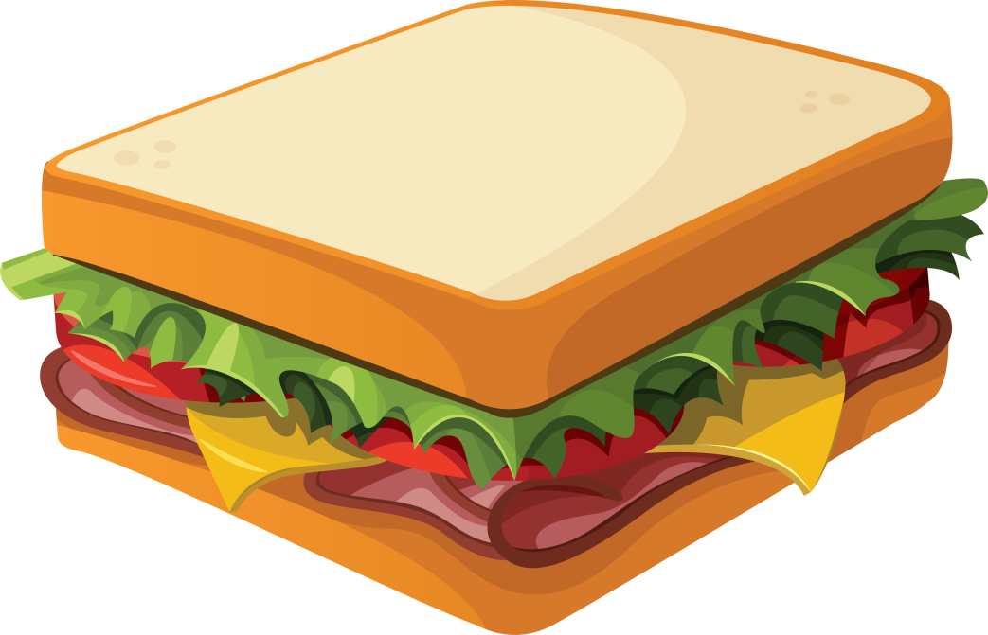
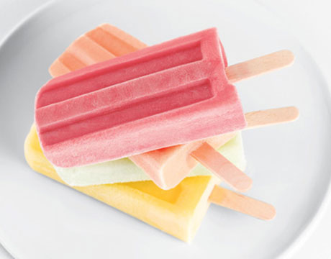

■ Realia: tea bag, earmuff

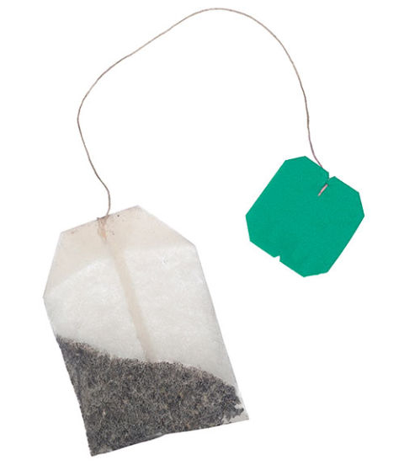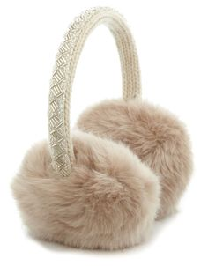

■ SOS Activity

Do you know who invented?

