☐ Listening ☐ Speaking ✓ Reading ☐ Grammar ☐ Writing
Topic: April Fool’s Day

Instructor:  Christine  Sylvia | Level:  Upper Intermediate (Adult) | Students:  15 | Length:  30 Minutes

Materials:
▶ Computer and beam projector
▶ White board and marker
▶ Video file (2’37”) (lead-in)
▶ Visual aid – pictures #1, #2, #3 #4 (voca.1 “silliness)
▶ Realia- 2 kinds of sauces
▶ Worksheet #1 –Pieces of passage (Main act; jigsaw and make a title)
▶ Worksheet #2 –Reading passage
▶ Worksheet #3 –Post passage
▶ Worksheet #4 –SOS passage

Aims:
▶Main aim: Students will be able to use their speaking skills with more grammatical accuracy when describing any situation.
▶Second aim: Students will be able to speak more fluently through learning Collocations exercises.
▶Personal aim: I want the students to apply Collocations to their daily life when they’re speaking.

Language Skills: (4- Integrated)
▶Speaking: Students will discuss with their partners and groups
▶Listening: Students will listen to other students’ opinions and video file.
▶Reading: Students will read worksheets #1 and #2.
▶Writing: Students will write short sentences in pairs.

Language Systems:
▶Phonology: listening audio of April fool’s day
▶Lexis: silliness, excuse, joke, condiment
▶Grammar: Past tense, Present tense
▶Function: asking the comprehensive questions to students
▶Discourse: Discussion
Assumptions:
Students already know
▶How the class is set up and run
▶Four language skills and language systems

Anticipated Errors and Solutions:
▶ If there is more time than planned,
>>give students extra time for discussion.
▶ If students are nervous to answer,
>> We will, as teachers, will lead them by eliciting with specific questions.

References:
▶https://goo.gl/XxFOH8
(Video- history of April Fools)
▶https://goo.gl/ILCWsZ
(Worksheet #2. Reading passage)
▶Google Image
(Pictures #1)

Lead-In
Materials: White board and marker,
Computer and beam projector
Video file (You tube – Ask History; April Fools)(2’37”)
Time | Set Up | Student Activity | Teacher Talk
2min  3min | Whole class  Whole  class | Answering T’s questions.  Watching a Video briefly. | (Have the Video ready Before class starts)  <procedure>  Greeting & Eliciting  “Hello, everyone. I’m Christine. I’m sylvia. How do you feel today? (……..)  Great. Um… Time is moving so fast. It’s already December. 2016 is almost over. Do you have any special memories from this year? (………) Great, Good! My special memory happened in April. Do you want to hear about it? On the morning of April 1st, I went to work and I sat down at my desk. (…….) The Phone rang. It’s was my boss. You know what he said? He said You fired, Get out. I was totally frozen for a few minutes. But it was a joke for April Fools. That’s my terrible and unforgettable memory from this year. Do you know about April Fools? Right. Exactly. So is there anyone who knows about April Fools’ history? (…….) No? Everyone no? Ok, then. I want to show you a short video about the history of April Fools. So Let’s see. Please enjoy the video.”  Play the video

Pre-activity
Materials: White board and marker
Visual aid #1, #2 – pictures
Realia – 2 kinds of sauces

Time | Set Up | Student Activity | Teacher Talk
5min | Whole  class | Answering T’s questions | <procedure>  1. Vocabulary  Let’s learn vocabularies that help you to read the text.  a) Silliness  -Eliciting  Look at the picture.  -Do you know Who is he? (…..) Right.  -So…. Do you know Who is he? (…..)Good. He is Mr. Bean and he is 영구.They are famous with their Character name rather than real name.  - What do you think of the first image when you see their pictures like these? Everything is okay, noun and adjective.  (……..) anything else? Great!  - Silliness describe the image is very funny and ridiculous.  b) Excuse  -When you’re late to school, what should you say? (……..) Also, you will say why you’re late to school. It is a reason.  Excuse is a similar word of a reason.  c) Joke  -When is the April Fool’s day? (…..) Right  -What do you usually do on April Fool’s day? (…….) Right.  -On April Fool’s, jokes are the most typical things.  d) Condiment  (Write “condiment” on the white board”)  -Do you like Pizza? (……) Yes. I think most students like pizza.  -So…when you eat Pizza, do you prefer to eat with Hot sauce or Garlic taste sauce? (….)Ok! Good. I think Everyone has different taste.  -Condiment is similar word of a sauce.  So, we are going to go over reading activity. Before we start, I want to ask you a question.  2. Guide Question.  -Do you know the history of 빼빼로 day?  -Have you ever seen foolish and silly ads?

Main- activity
Materials: Worksheet #1 - Pieces of passage (jigsaw and make a title.)
Worksheet #2 - Reading Passage
White board and marker

Time | Set Up | Student Activity | Teacher Talk
2Min  5min | In Pairs  Group  (4member) | checking content of story and story’s order with pair  Figure out the content of story and story’s order with group | <Procedure>  From now on we are going to game using “ April fool Story “  INSTRUCTION (S-S)  Please make groups with 4 students  I will give you an article about “ April Fool” by one group  This article dividing into 4 sections.  So, every students in your group can get a 1 section of story  For the first step, checking your story and talk about which section will be comes firstly with your pair. I will give you 3min  ICQ  Do you discuss with group or not?  How many times do you have?  Okay let’s start!  RUN THE GAME  - TIME WARING <30SEC>  Okay! Guys time’s up!  Do you check the content of story?  Great!  INSTRUCTION (Ss-Ss )  From now on please gathering with your group  Sharing your section with your group members and matching the order of story altogether.  After finishing group discussion complete the Worksheet #1 and make your own title for this story  I will give you 5 min for this activity  ICQ  Do you discuss with group or not?  How many times do you have?  RUN THE GAME  - TIME WARNING <30SEC>  Guys time’s over!  Did you find the orders of the story?  Let us know your answers of questions from first group!  (check the answers of groups)  Okay every group well done!  The correct answer is B->C->A->D  I will give you whole story to everyone.  ( Distribute the Worksheet #2 - Reading Passage to everyone for checking their answers)

Post- activity
Materials: White board and marker
Work Sheet #3 –Post passage

Time | Set Up | Student Activity | Teacher Talk
7min  3min | Individual  Whole | Doing Worksheet #3 –Post passage  Checking the answers of worksheet and sharing ideas with whole students | <Procedure>  INSTRUCTION  Did you enjoy the “are you an April fool?”  Story?  I will give you a worksheet for checking your understanding of story  I will give you 7min  ICQ  Do you discuss with group or not?  How many times do you have?  - TIME WARNING <30SEC>  Time’s up  Let’s check the answers of questions  Check the answers of questions with whole class and sharing the some of the ideas for last question  Everyone good job!  Thanks for sharing your ideas and attention  I hope you guys have great Christmas!
SOS Activity
Materials: White board and marker
Worksheet #4 – lists of jobs needed to be foolish.
Time | Set Up | Student Activity | Teacher Talk
2min  1min | In pairs  Group | Students make a list and share their opinion in pairs and groups. | We have a few minutes. So, we are going  to do a short activity.  Discuss about jobs needed to be foolish  with your partner and make 5 lists of the  jobs. If you finish, share your lists and why  do you think that job needed to be foolish  in groups.  Everyone, finish?  Good! So, we are going to wrap up the  class. I hope you guys all enjoyed this  class.  Thanks.  See you next time.

Visual aid- picture #1 (voca.1 “silliness”)

Visual aid- picture #2 (voca.1 “silliness”)

Visual aid- picture #3 (voca.1 “silliness”)

Visual aid- picture #4 (voca.1 “silliness”)

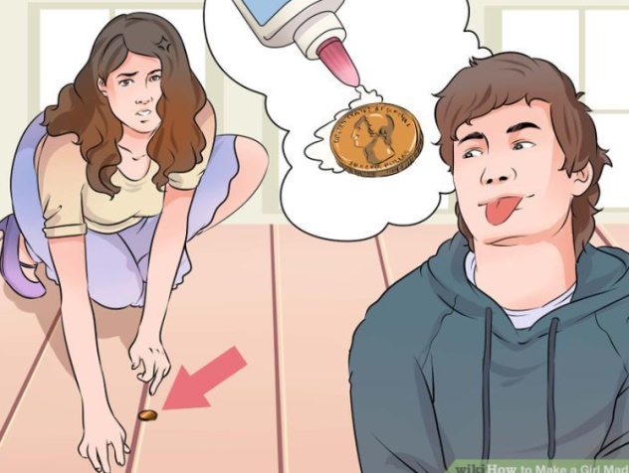
Worksheet #1 – Pieces of passage (Main act)
The first day in April is the day most commonly called “April Fool’s Day” Practical jokes, silliness, and foolishness are a big part of the day. Nobody is exactly sure where the tradition started, though many people think it can be traced back to a change in the calendar in 16th century France.

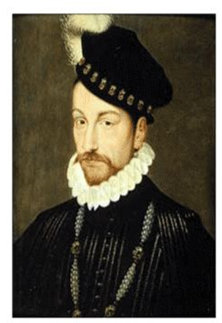
When King Charles IX introduced the Gregorian calendar in 1582, it changed the first day of the new year to January first. Before that, it was celebrated January first. Before that, it was celebrating during the week of March 25 – April 1. Those that refused to acknowledge the change continued to acknowledge the change continued to celebrate on April first and were considered “fools” for not changing. It became commonplace to play jokes on these people.

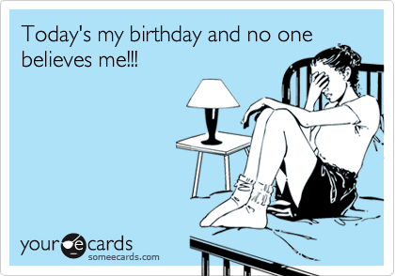

Now, people all over the world use April Fool’s Day as an excuse to play practical jokes on friends. There are not mean-spirited tricks, just silly jokes. Many newspapers, radio personalities, television shows, and internet web sites participate in the celebration.

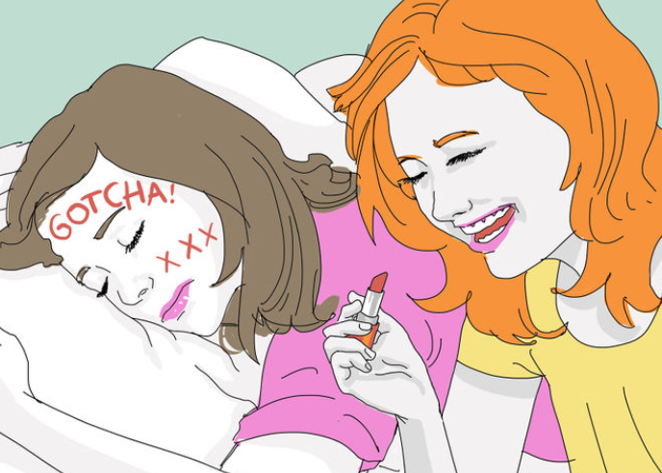
One of the most famous April Fool’s Day hoaxes was carried out in 1957. The BBC television news show, Panorama, announced the Swiss farmers had grown a wonderful “spaghetti crop” and showed a video of them picking spaghetti from trees! In 1998, Burger King advertised its new Left-Handed Whopper on Aril Fool’s Day, Saying that all of the condiments were placed especially for the left-handed eater. Both of these practical jokes fooled tons of people!

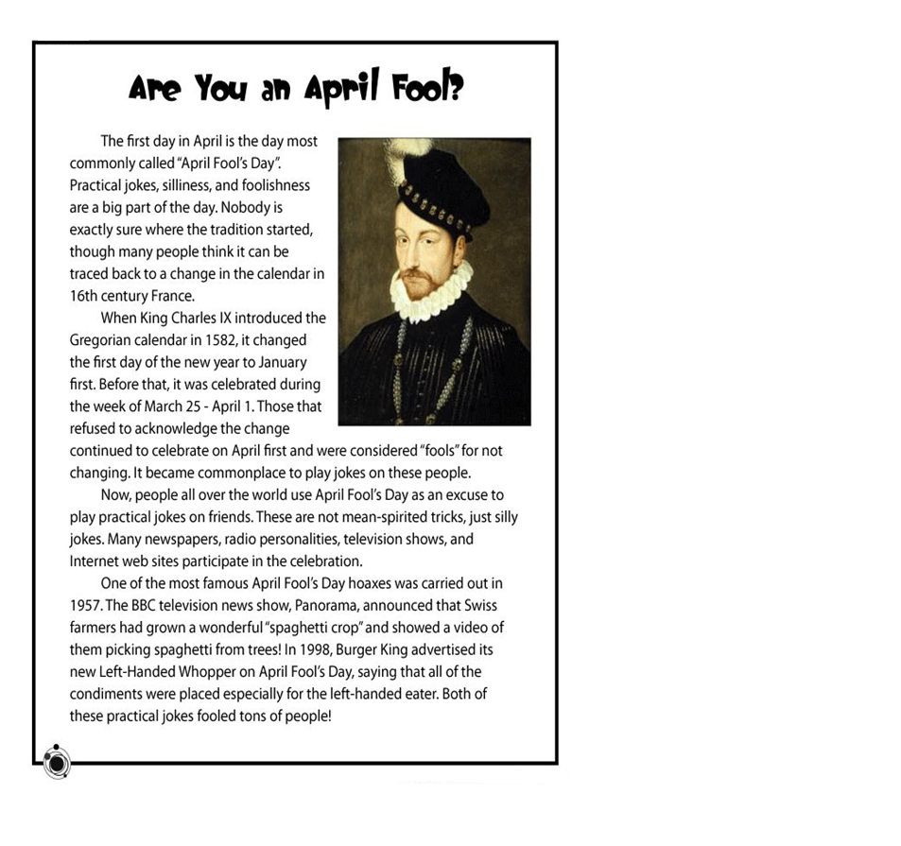
Worksheet #2 – Reading Passage

Worksheet #3 – Post activity

April’s Fool’s Day
Writing Activity

★Please fill in the blanks in below sentence

The first day in in April is the day most commonly called “April fool’s day” Practical jokes ,( ), and ( ) are the big part of the day.

★Who is introducing the Gregorian calendar in 1582?

★Why the persons who celebrate new year on April are considered as “fools”?

★What is April fool’s day hoaxes of Swiss farmer in 1957.

★What is a left-handed whopper?

★★Do you have most fun story on the April fool’s day?

★★Please make your funny plan on April fool’s day for our classmate!

Worksheet #4 – SOS activity (Make 5 lists of jobs needed to be silly.)

5 lists of jobs needed to be foolish
1._____________________

2._____________________

3._____________________

4._____________________

5._____________________

