☐ Listening ☐ Speaking ⬛ Reading ☐ Grammar ☐ Writing

Topic: Love letters

Instructor:  Amy & Joo | Level:  Intermediate | Students:  16 | Length:  30 Minutes

Materials:
- Realia (a pigeon, a Napoleon photo, vocabularies pictures)
- Video (You tube) , computer
- Board Markers & white board
- Worksheet 1,2,3,4

Aims:
- Student will be able to improve their reading skills through Napoleon's love letter
- Students will be able to comprehend the letter
- Students will be familiar with key vocabulary through T’s explanation and C.C.Q.

Language Skills:
- Reading : Napoleon's love letter and Reading Bingo game
- Listening : Watch and listen to YouTube videos about Napoleon
- Speaking : Through “Reading Bingo game
- Writing : Post activity Reading Bingo game

Language Systems:
- Function: asking for information, giving information, declaring love
- Lexis: new vocabularies (portrait, ache, set on fire…etc)
- Discourse : Letter writing

Assumptions:
- Ss already know the vocabularies
- Ss have real-life experience of letters, and are aware of general letters
- Ss know the four language skills and language systems
- Ss know how to skim and scan

Anticipated Errors and Solutions:
- Some Ss may not understand bingo game rules
- Monitor discretely while Ss do the bingo game and answer Ss’ questions.
- Some Ss may not be active during the bingo game
- Monitor carefully and make sure all students are getting the chance to speak
- Ss may not know the answers to CCQ
- Improvise other easier CCQ, or provide answer depending on time allowance

References:
- You tube : https://www.youtube.com/watch?v=t05O-iVx2R8
- Web page: Pigeon – (picture #1) https://goo.gl/ZXcQKh
- Web page: Napoleon – (picture #2) https://goo.gl/EVvbYg
- Web page: 143 -(picture #3) goo.gl/thJyMy
- Web page: Ache – (picture #4) : goo.gl/PPMgjc
- Web page: Incomparable –(picture #5) : goo.gl/PFZ4We
- Web page: Intoxicating – (picture #6 ): goo.gl/WPhr37
- Web page: Overwhelmed– (picture#7):goo.gl/NLQy7b
- Web page: Portrait – (picture #8): goo.gl/WpCahZ
- Web page: 2Set on fire – (picture #9): goo.gl/Zygcol
- Web page: OMG – (picture #10) : goo.gl/N2XMkb
- Web page: LOLO – (picture #11) : goo.gl/5BRdrb
- Web page: Love letter – (Worksheet #1)
- Web page: Napoleon – (Worksheet#2) https://goo.gl/XpwUef
- Web page: READ ME – (Worksheet#3) https://goo.gl/NgwsLE
- Web page: BINGO text passage – (Worksheet#3) https://goo.gl/nCTbdQ4/https://goo.gl/MTNdGd

Lead-In
Materials: board, markers, Picture 1: Pigeon’s letter, Picture 2: Napoleon, Picture 3 : letter

Time | Set Up | Student Activity | Teacher Talk
2min | Whole class | Greeting  Answering eliciting question | Procedure:  <Greeting & Brief Rapport>  Good afternoon, everyone.  How are you today?  <Eliciting the comparatives>  T: What does this bird do?  Has everyone written a letter before?  Have you ever written a letter to a lover? Who?  Can you expect today topic is..?  (Try to elicit the word ‘Love letter’)

Pre-Activity
Materials: Video clip, computer, vocabulary card, vocabulary picture, board, Board marker , worksheet #2

Time | Set Up | Student Activity | Teacher Talk
3min  2min  3min  2min | Whole class  individaul | Watch video  Listen to teacher& answer questions | Procedure:  <Show video clip>  Who is he in the video clip?  Is he famous?  <Worksheet #2>  Okay, now we’ll hand out another  Worksheet#2.  There are 5 questions in capital letter A.  Read the questions first.  Fill in your worksheet.  You will have 2min for this task.  <ICQ>  How many questions do you have?  How much time do you have?  <Eliciting>  (CCQ- Guiding Question)  Who said “Impossible is a word only to be found in the dictionary of fool”?  What does he do?  Where is he from?  Whom did Napoleon love?  How many times did he get married?  (Answer the guiding questions)  <Instructions>  T: Soon, I will show you a vocabulary card. As I mentioned earlier, you can see the pictures first and guess what word is  <Vocabularies>  (CCQ)  (Show to Ss)  Portrait, Intoxicating, Ache,  Overwhelmed, Set on fire,  Incomparable, OMG, LOLO, 143

Main Activity
Materials: Worksheet #1, Worksheet #2

Time | Set Up | Student Activity | Teacher Talk
3min  5min | Individual | Listen to teacher’s instruction  Read the worksheet #1  Answer the comprehensive questions of worksheet #2 | Procedure:  <Instruction>  “Okay, now we’ll hand out another  Worksheet#1.  Take a look at this letter, and answer  the questions of capital letter B.  I will give you 3 min.  <ICQ>  What do you have to read?  How much time do you have?  <Monitoring>  <answer the comprehension questions>

Post Activity
Materials: Worksheet #2 (Comprehension Question)

Time | Set Up | Student Activity | Teacher Talk
2min  5min | pair | Working on their worksheet #3 | Procedure:  Procedure:  <Instruction>  I will give you worksheet#3. Write the letter following the 4 instructions  Let’s read 4 instructions together.  We will give you 5 minutes.  <ICQ>  How many sentences do we have to write at least?  How much time do you have?  We hope today’s activity helped you to understand comparative more clearly and use them more easily.  You guys did good job!

SOS Activity
Materials: Worksheet #4

Time | Set Up | Student Activity | Teacher Talk
5 min | Individual |  | Procedure:  <Instruction>  “Okay, now we’ll hand out  Worksheet#4. We will do a bingo game  Don’t show each other.  Let’s read your bingo sheet  <ICQ>  Which game are we going to do?  How much time do you have?  <Monitoring>  (Discretely monitor and add ideas if Ss have  trouble writing.)  (give time warning if needed)

Realia (Picture #1)

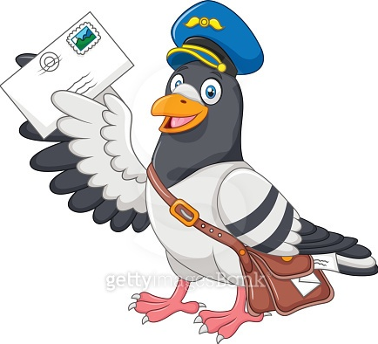

Realia (Picture #2)
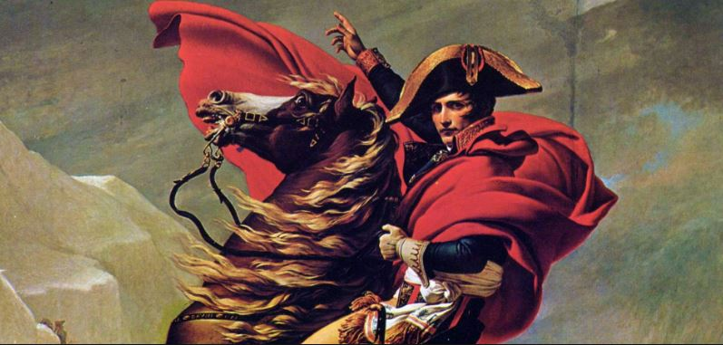

Worksheet #1
Love Letter by Napoleon Bonaparte, 1795

Dear. My Josephine

I wake filled with thoughts of you......
Your portrait and the intoxicating evening which we spent yesterday have left my senses in turmoil. OMG…..
Sweet, incomparable Josephine,
What a strange effect you have on my heart!
Are you angry?
Do I see u looking sad?
Are you worried?
My soul aches with sorrow and there can be no rest for your lover;
But is there still more in store for me when, yielding to the profound feelings which overwhelm me, I draw from your lips, from your heart a love which consumes me with fire?
Ah! It was last night that I fully realized how false an image of you your portrait gives!
You are leaving at noon; I shall see u in three hours L8R.
Until then, LOLO ... a thousand kisses.
But Please don’t give me in return, for they set my blood on fire. 143

Worksheet #2
A. Answer the questions below
a. Who said “Impossible is a word only to be found in the dictionary of fool”?
_ _ _ _ _ _ _ _ _ _ _ _ _ _ _ _ _ _ _ _ _ _ _ _
b. What does he do? _ _ _ _ _ _ _ _ _ _ _ _ _ _ _ _ _ _ _ _ _ _ _ _
c. Where is he from? _ _ _ _ _ _ _ _ _ _ _ _ _ _ _ _ _ _ _ _ _ _ _ _ _
d. Whom did Napoleon love? _ _ _ _ _ _ _ _ _ _ _ _ _ _ _ _ _ _ _ _ _ _ _ _
e. How many times did he get married? _ _ _ _ _ _ _ _ _ _ _ _ _ _ _ _ _ _ _
B. Answer the questions below.
- Where did he get her image?
_ _ _ _ _ _ _ _ _ _ _ _ _ _ _ _ _ _ _ _ _ _ _ _ _
- When did they spend the intoxicating evening?
__ _ _ _ _ _ _ _ __ _ _ _ _ _ _ _ _ _ _ _ _ _ _ _
- Where did he draw love from?
_ _ _ _ _ _ _ _ _ _ _ _ _ _ _ _ _ _ _ _ _ _ _ _ _ _
- When are they going to meet?
_ _ _ _ _ _ _ _ _ _ _ _ _ _ _ _ _ _ _ _ _ _ _ _ _ _
- Does he want her to respond to his letter?
_ _ _ _ _ _ _ _ _ _ _ _ _ _ _ _ _ _ _ __ _ _ _ _ _
- Is she still here at morning?
_ _ _ _ _ _ _ _ _ _ _ _ _ _ _ _ _ _ _ _ __ _ _ _ _
- Did he sleep yesterday?
_ _ _ _ _ _ _ _ _ _ _ _ _ _ _ _ _ _ _ _ _ __ _ _ _
- Do they love happily?
_ _ _ _ _ _ _ _ _ _ _ _ _ _ _ _ _ _ _ _ _ _ __ _ _
- Does she love him as well?
_ _ _ _ _ _ _ _ _ _ _ _ _ _ _ _ _ _ _ _ _ _ _ __ _

Vocabulary List

Portrait
Intoxicating
Ache
Overwhelmed
Set on fire
Incomparable
OMG
LOLO
143

Worksheet #3

Write the Love Letter
<Instructions>
1. Write the letter including these words
(Portrait, Intoxicating, Ache, Overwhelmed, Set on fire, Incomparable, OMG, LOLO, 143)
2. Write the sentences at least 5.
3. Write the letter to whom you love or you will love.
4. Write the letter neatly.

Dear, my
_____________________________________________
_____________________________________________
_____________________________________________
_____________________________________________
_____________________________________________
_____________________________________________
_____________________________________________
____________________________________________

SOS

you might think Napoleon was a playboy | But his heart, head,  and masculinity  belong to Josephine. | Napoleon wrote to his brother of his failing love for Josephine.
There was a stormy romance full of infidelity and drama. | Napoleon left her for another woman | When Josephine could not produce him an heir
One of the most brilliant individuals in history, Napoleon Bonaparte was a masterful soldier | Josephine fell in love with Charles who dashing young officer true love. | Napoleon never got over Josephine

you might think Napoleon was a playboy | But his heart, head,  and masculinity  belong to Josephine. | Napoleon wrote to his brother of his failing love for Josephine.
There was a stormy romance full of infidelity and drama. | Napoleon left her for another woman | When Josephine could not produce him an heir
One of the most brilliant individuals in history, Napoleon Bonaparte was a masterful soldier | Josephine fell in love with Charles who dashing young officer true love. | Napoleon never got over Josephine

