Information Sheet – Complete all sections accurately.
Name & Class |  | Date & Place | Lesson Type |  |  | Plan |  | Topic |  |  | Length | Level
144th WD  Jeannie JungHa Park |  | 2016/12/21 | Reading |  |  | PPP |  | Sleeping position tells your personality |  |  | 60min | Upper Intermediate
Class profile
Number of students: 8 Age: 20-40 Nationality: Korean
Motivations: travelling around the world, getting a job, promotion at work.
Individual or class hobbies and interests: Students love to travel and read books.
Special considerations: all women, some elderly, professional job(doctors, teachers)
Main aim
- Students will learn and understand the ideas of sleeping position and its personality.
- Students will practice their reading comprehension skills.
Subsidiary aims
- Students will practice oral fluency.
Description of language skills specifically used/practiced:  - Reading – text(news article)  - Speaking – sharing answers and discussing ideas  - Writing – writing answers on the worksheet and making poster  - Listening – to other students opinions |  |  |  |  |  |  | Description of language systems specifically used/practiced:  - Grammar – catch a glimpse of  - Lexis – glimpse, posture  - Discourse –noticing the topic and sharing ideas  - Function –finding out other person’s personality

Anticipated difficulties with lesson activities and classroom management:
- PPT projector may fail
- Passive students may not participate in class.
How I can deal with these difficulties:

Prepare printed handout to distribute to students.
- Put them in a group to share their ideas-less teacher involving
Assumptions:
- Students like to know there sleeping position which relates to the personality.

Material(s) needed:
PPT, projector, marker, whiteboard, reading material, worksheet, crayons, A3 papers,

Checklist. Mark down those included in this lesson plan ( or N/A)
 | model sentences for target language |  |  |  | concept questions for target language |  |  |  |  | analysis sheet for target language
 | stages clearly titled and separated |  |  |  | purpose of each stage indicated |  |  |  |  | anticipated timing included
N/A | interaction pattern marked |  |  | N/A | a board plan (if relevant) |  |  |  | N/A | examples of all tasks used
 | answer sheet to all exercises |  |  |  | Tape or text script |  |  |  |  | all materials labelled and numbered
Personal aim :
- What I most hope to demonstrate in this lesson is the ability to give clear instruction and increase S.T.T. in the classroom.

Stage 1:_Lead-in  The purpose of this stage is  - To relax both students and teacher and focus on the interesting subject to talk about.  - To encourage students to share ideas and opinions without under pressure and increase STT not TTT. | Inter  action | Time | Instructor’s comments
*classroom desk arrangement : students sitting as a group, 4 students in a group*  - Greet the class and ask students to discuss what they see in the picture.  - Instruction  Good morning everyone! How are you? (good,great,tired)  Did you sleep well? ( yes,no) what happened?(couldn’t sleep well enough)  I hope you will sleep well tonight!  So, guys, there is an interesting picture! (Show PPT1)  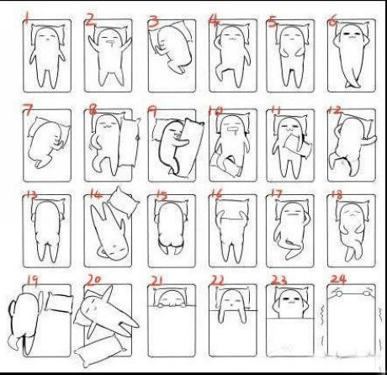  Can you discuss about this picture with your partner? I will give you 1 minutes to discuss.  So, which number tells about you? (2,3,10……etc.)  - Students share ideas teacher is monitoring  - Feedback nominate half of the class | T-S  S  T-S | 30”  1’  1’30”
Stage 2: Presentation  The purpose of this stage is  - to help predicting the context by using guiding questions and pre-teaching key words from the text  - Students may feel less challenging but they assume what they are actually going to do. | Inter  action | Time | Instructor’s comments
- Instruction: ask guiding questions and students will predict what they are doing.  - Guiding Questions:  Let’s talk more about this picture.(show PPT1)  1. How do you feel when you sleep on your belly?  2. What do you think no.1 person is like? Discuss with your partner in 2 minutes.  3. Can you guess what we are going to do? (yes,no)  Okay you will know what we are going to do today. Before we start let’s do this.  Eliciting/CCQ/drilling the vocabulary. Refer to ppt 2 and 3  catch a glimpse of : an occasion when you see something or someone for a very short time. /ɡlɪmps/ Eliciting : show facial expression(looking at something in a short time) CCQ : Am I looking at something? (yes) Am l looking long time? (no) Do you know the word?  posture : a particular position of the body. /ˈpɒstʃə/ Eliciting : Demonstrate certain posture Point the PPT1 pictures differently CCQ : do you lie down when you read a book? (no) do you lean on the wall when you have breakfast at home?(no) how do you sit when you study?(straight up)  When students get the work then write down the word on the board.  And drill the word that students need to practice orally and get the meaning. | T  S  T-S  T-S | 30”  2’  30”  5’

Stage 3: Practice - Skimming and scanning for gist comprehension  The purpose of this stage is  - students skim and scan the text to get ideas what they are doing(actual realization).  - There is no intensive reading yet. Students briefly figure out what the topic is about. | Inter  action | Time | Instructor’s comments
Distribute the worksheet 1 to the students.  - Instruction: show ppt2 and discuss questions with your partners.  You will quickly see this article and write down the answers on the worksheet to questions.  There are 4 questions and work individually. If you finish your answer then talk to your partners.  I will give you 3 minutes.  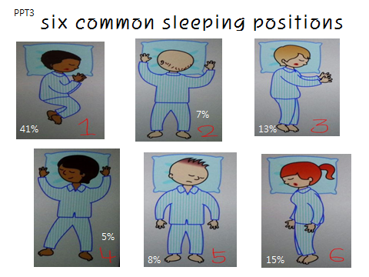  Skimming and Scanning Questions  1. What is the main idea of this article? – sleeping position and personality  2. How many positions are there and what are these? – six positions  (foetus1/log6/yearner3/soldier5/freefall2/starfish4)  3. Where does this article come from? – BBC news  4. Which category does this article belong to? – under health  <<ICQ>>  1. How much time do you have? – 3min  2. Do you work alone? – yes  3. How many questions do you have? -4 questions  - Students is working teacher is monitoring  (Show ppt5 when they answer the first question)  - Feedback nominate half of classroom | T  S  T-S | 30”  3’  30”

Stage 4: Practice – Detailed/Literal comprehension  The purpose of this stage is  - students focus on literal understanding of the context for example facts and ideas.  - exercises may use in this stage. Reading material is being given. | Inter  action | Time | Instructor’s comments
Distribute the reading material and the worksheet 2.  - Instruction  Now read the article and answer the following questions on the worksheet given.  I will give you 7 minutes to complete the questions.  After you finish, compare answers with your partners.  Questions: refer to worksheet2  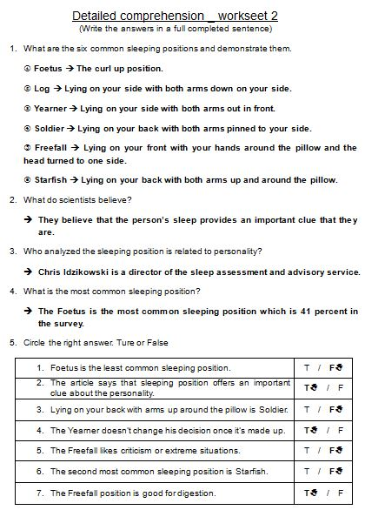  <<ICQ>>  - Do you have the article? (yes)  - Do you need to write it down? (yes)  - Do you need a pen to write down? (yes)  - How much time do you have? (7min)  - Students is working teacher is monitoring  - Feedback nominate half of classroom to check the answers. | T  S  T-S | 30”  7’  2’30”

Stage 5: Practice - More detailed/Interpretive comprehension  The purpose of this stage is that students read the text more intensively and think about the answer deeply.  They may read the text more than 2 times in order to think and get closer answers and ideas.  Intensive reading takes place. | Inter  action | Time | Instructor’s comments
Distribute the reading material and the worksheet 3.  - Instruction  Now read the article more carefully and think about the answers to following questions on the worksheet given.  I will give you 8 minutes to complete the questions.  You can discuss answers with your partners.  Questions: refer to worksheet3  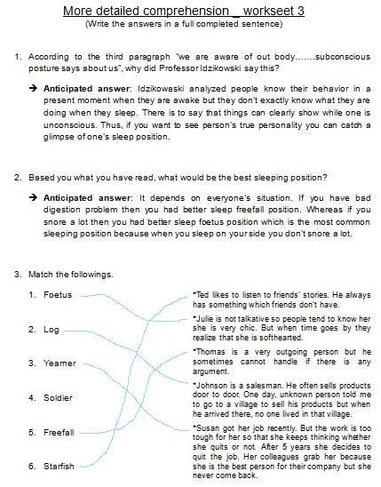  <<ICQ>>  - Do you have the article? (yes)  - Do you need to write it down? (yes)  - Do you work alone? (no)  - How much time do you have? (8min)  - Students is working teacher is monitoring  - Feedback Nominate students in each group. | T  S  T-S | 1’  8’  3’

Stage 6:_Production - Applied Comprehension  The purpose of this stage is that students will practice their oral fluency. | Inter  action | Time | Instructor’s comments
Distribute the reading material and the worksheet 4 and A3 paper.  - Instruction  Based on what you have learned, you are going to make an advertisement to sell a mattress.  Design a poster that shows beneficial for customers who have back ache and terrible snoring.  You will have 13 minutes to make a poster with your group members.  At the end, you are going to present briefly to the class for 2 min.  You can refer to below picture which is given already.  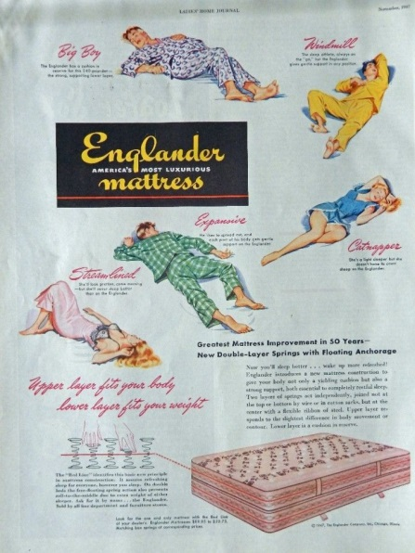  <<ICQ>>  - Do you have the article? (no)  - Do you need a poster and crayons? (yes)  - How much time do you have? (13min)  - Students is working teacher is monitoring.  - Students will present what they have made. | T  S  T-S | 1’  13’  4’

Stage 7:_Wrap-up  The purpose of this stage is  - to end the lesson with positive feedback from students.  - Collecting worksheet, giving them homework and announce the next class lesson. | Inter  action | Time | Instructor’s comments
- To wrap up, summarise the main points and ask students some questions.  <<Qs-As>>  How do you feel about the reading okay, good, interesting  Which part was fun? talking about the picture, sharing own ideas about sleeping postures.  Did you like sharing ideas with your group members? yes  Do you agree that sleeping position tells your personality? And why?  Talk to your friends in a minute.  Feedback nominate 1 or 2 students  - You all did great work! I also enjoyed the class with you sharing ideas.  Keep up the splendid work!  And there is homework. Catch a glimpse of your family while they are sleeping and see if their sleeping positions tell their personalities.  Well-done guys! And I will see you next week, bye!  - Class dismissed  - Follow up work for the next lesson  - Students will share their families’ sleeping posture and personality. | T-S  S  T-S  T | 30”  1’  2’  1’30”
Instructor’s Final Comments
Overall strengths of this lesson (planning and teaching) | Areas to work on

Overall comment

For this stage of the course, your lesson today was

- Above standard

- To standard

- Below Standard

Instructor: …………………………… Date: …………/……………/…………

Item:  catch a glimpse of | Anticipated Problems | Possible solutions
Meaning:  glimpse  an occasion when you see something or someone for a very short time.  catch a glimpse of (Idiom)  see someone or something breifly | Students may not be familiar with the meaning. | Eliciting :  show facial expression(looking at something in a short time-demonstration)  Show the picture  CCQ :  Am I looking at something? (yes)  Am I looking long period of time? (no)  Do you know the word? (yes,no)
Form:  noun | Students may not know the form because they never have heard this word before. Or they may get confused with the verb. | A noun has an articles(an,a and the)
Pronunciation:  /ɡlɪmps/  / katʃ ə ɡlɪmps əv / | Students may know how to read but not know the meaning. | Write down phonetic symbols on the board with stress.  / katʃ ə ɡlɪmps əv /  Drill it.(listen and repeat)
Item:  posture | Anticipated Problems | Possible solutions
Meaning:  a particular position of the body. | They may know the meaning but they may not know the word | Eliciting :  Show the picture or demonstrate  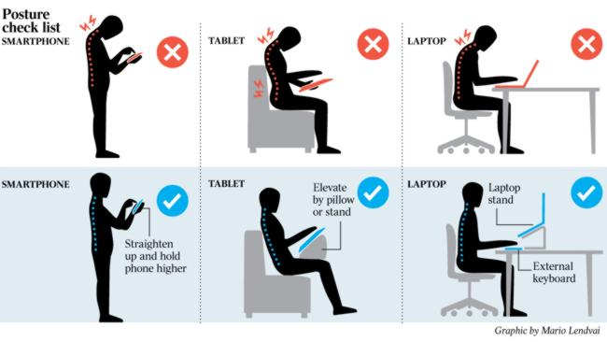  CCQ :  Are they in the same position?(no)  Do they have good position to use computer?(no)  Do you know the word? (yes,no)
Form:  noun | Students may know the form not the meaning. | A noun has an articles(an,a and the)
Pronunciation:  /ˈpɒstʃə/ | Students may have difficulty to read. | Give example and picture  Ex)  You have good posture for using computer.  You have poor posture for using computer.  /ˈpɒstʃə/  Drill it.(listen and repeat

