X Listening Speaking Reading Grammar Writing
Topic: Traveling

Instructor:  Pettra | Students Competency Level Intermediate | Number of Students: 12 | Lesson Length:  50 minutes
Materials: (List the Names of all materials used in the lesson. Materials must be shown at the end of this document)
- White Board and Markers
- Role Play Cards at the Airport
- Stinky
- Fridd
- Blablu
- Beggy
- Role Play Cards at the Traditional Craft Shop
- Cashy
- Fancie
- Gramy
- Meddy
- Role Play Cards at the Hotel
- Kiddo
- Worky
- Servie
- Nervo

Aims: (What students will be able to achieve by participating in the activities of the lesson. (Ss gain or get by doing…)
- Improve listening skills by discussion in a group, role plays, and teacher story.
- Increase interest and participate actively by role plays and sharing stories.
- Improve listening and speaking skills at the same time by role play planning and presentation.
- Improve interaction and communication skills by having discussion in groups and role play.
- Improve different phonology discussing with other students.
- Enjoy listening English by role play.

Language Skills: (Lists what activities language skills students will be using by participating in the activities of the lesson.)
- Reading: (Where did reading occur in the lesson?)
Role cards, note taking.
- Listening: (Where did listening occur in the lesson?)
Teacher story, during discussion, role play
- Speaking: (Where did speaking occur in the lesson?)
Role play, group discussion, answering teacher.
- Writing: (Where did writing occur in the lesson?)
Planning role play.
Language Systems: (Lists what language systems students will be using by participating in the activities of the lesson.)
- Phonology: (sound)
Discussion, role play, teacher story.
- Function:(situation)
Introduction, fun, adventure, culture, at the airport, at the hotel,
at the traditional crafts shop
- Lexis: (meaning)
Vocabulary about traveling.
- Grammar:(language structure)
Questions structure/ traveling nouns.
- Discourse: (communication)
Student-student discussion, teacher-student responding, Role play.

Assumptions:(What students must already be able to do and what concepts must already be mastered before the lesson in order to achieve the aims of the lesson.)
- Students know the pace of the course and teacher style
- Students probably have traveling experiences or through a movie.
- Students have dreams about traveling.

- Anticipated Errors and Solutions: (What things might go wrong in the lesson and what the solution will be. An SOS activity should also be
- If students have no international travel experience( at the airport)
Suggest for bus or train station.
- If activity lasts too long – teacher cuts unnecessary details.
- If activity is too short- teacher suggests ideas or changes situations.
- If students don’t know specialized words (check-in, lobby, concierge, etc)
Explain.

References:
Tesol Classes and text books.
Google Websites.

Lead-In or Pre-Task Part (Warm-Up Part to activate and create interest in the lesson.)
Materials: (List the Names of all materials used in the Lead-In or Pre-Task Part of the lesson. Materials must be shown at the end of this document)
- None
Time: | Classroom Set Up: | Student Activity and Goals: | Teacher Procedure &Instructions:
1 min  4 min  2 min | Whole  Whole class  Students | Ss greet the teacher  Ss listen to teacher  Ss prepare for discussion | Greeting  Teacher tells an interesting and funny travel story with a grandma or young siblings.  Ask to couple of Ss about their travel experiences.  Let’s discuss about role play in groups of 4 about traveling:  - at the airport (4 Ss)  - at the hotel (4 Ss)  - at the traditional crafts shop (4 Ss)

Pre-Activity or Task Familiarization Part (Presentation Part Presenting the language structure to be covered in the lesson. Prepares students for the communication activity.)
Materials: (List the Names of all materials used in the Pre-Activity or Task Familiarization Part of the lesson. Materials must be shown at the end of this document)
- White Board and Markers.
- Role Play Cards at the Airport
- Stinky
- Fridd
- Blablu
- Beggy
- Role Play Cards at the Traditional Craft Shop
- Cashy
- Fancie
- Gramy
- Meddy
- Role Play Cards at the Hotel
- Kiddo
- Worky
- Servie
- Nervo

Time: | Classroom Set Up: | Student Activity and Goals: | Teacher Procedure &Instructions:
2 min  1min  3min  5min | Whole  Group  Group  Group | Ss listen what teacher says.  Ss gather in groups of 4.  Ss receive, read and decide each the roles to play and discuss within groups.  Ss prepare for acting the role plays. | Introduce the role play and describe setting. Introduce the 3 different situations of traveling for each group.  Divide Ss in groups of 4  Deliver role cards. Ask to pick roles and discuss.  Ask Ss discuss the role play and ask to take notes when planning.  Transition time to present role plays.

Main Activity or Task Realization Part(Practice to Production Part Teacher lead practice of the language presented and move to communication based more student centered activity)
Materials: (List the Names of all materials used in the Main Activity or Task Realization Part of the lesson. Materials must be shown at the end of this document)
- White Board and Markers
- Role Play Cards at the Airport
- Stinky
- Fridd
- Blablu
- Beggy
- Role Play Cards at the Traditional Craft Shop
- Cashy
- Fancie
- Gramy
- Meddy
- Role Play Cards at the Hotel
- Kiddo
- Worky
- Servie
- Nervo
Time: |  | Classroom Set Up: |  | Student Activity and Goals: |  | Teacher Procedure &Instructions:
1min  3times  7 min  2min |  | Whole  Groups  Groups  Whole |  | Ss get ready for role play without cards.  Everything below happens 3 times.  Ss do the role play by groups of 4 and others listens and enjoys.  Ss listen and applause the presenting group.  Ss listen to T comments. |  | T invites each group to the front to present the role play and starts.  Everything below happens 3 times.  T monitors role playing encouraging and positive feedback.  T makes the class relax and comfortable with positive comments.
Post Activity or Post Task Part (Wrap-Up Part Close the Lesson on a high note to and consolidate language learned in a communication based activity new situation.)
Materials: (List the Names of all materials used in the Post Activity or Post Task Part of the lesson. Materials must be shown at the end of this document)
- White Board and Markers

Time: | Classroom Set Up: |  | Student Activity and Goals: |  | Teacher Procedure Instructions:
3min  3 min  2min | Whole  Whole  Whole |  | Ss talks to T possible questions that can be ask when traveling. Others Ss listen  Ss talks to T items they would like to carry for travel. Other Ss listen.  Ss listen. |  | T ask possible questions 7-8 that can be ask during traveling and write on white board.(overview role play)  Ex. When is the airplane departing?  T items-around 12-15- to carry for traveling on board (overview role play)  Example: Items to carry  camera  passport  carrier bags  Thank everybody for their participation also encourage Ss for traveling if they have an opportunity.

Role Play Cards at the Airport

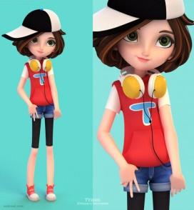  Stinky  (Traveler)  - 18 years old girl  - Just finished high school  - 1st time traveling  - Silly  - Wants to travel with boyfriend  - Rich | Fridd  (Stinky’s Boyfriend)  - Poor  - 21 years old  - Wants to take his younger sister for the trip  - Tall and skinny  - Never been outside of country  - Afraid of going trip
Blablu  (Airplane Agent)  - Talks too much  - Doesn’t want to help Stinky’s  Visa problem  - Want money for visa problems  - 10 years of working at check-in desk at airport  - Smart woman | Beggy  (Fridd’s Sister)  - 15 years old  - Needs parent permission  To travel  - Has too many luggage  - Pretty  - Exited for traveling
Role Play Cards at the Hotel
Worky  (Workaholic)  - 35 years old  - Has to travel with his son Kiddo  - Forgot to reserve a Hotel  - Have no cash  - Handsome  - Understands English but can’t speak much  - Rich | 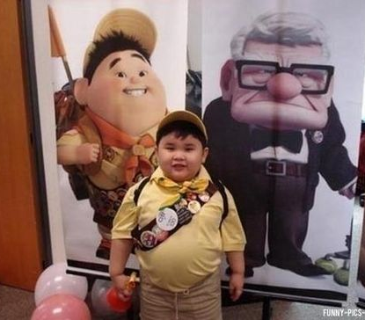Kiddo  (Worky's Son)  - 7 years old boy  - Speaks English very well  - Very excited for traveling with Daddy  - Naughty boy  - Likes chocolate  - Breaks an expensive hotel  Ornament
Servie  (Hotel Bell-Boy)  - Fat  - 28 years old  - Can’t lift heavy bags  - Likes tips  - Plays with Kiddo | Nervo  (Hotel  Manager)  - 37 years old woman  - Hysterical  - 5 star hotel manager  - Doesn’t like children  - Likes Worky

Role Play Cards at the Traditional Craft Shop
Gramy  (Traveler 1)  - 68 years old  - Fancy old woman  - Enjoys traveling  - Likes to shop traditional crafts  - Likes to travel with friends  - Rich  - Wants to buy an expensive craft  - Traveling in winter time | Francie  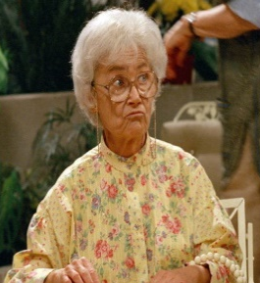  (Grammy’s Friend)  - 62 years old  - Likes Gramy because she pays for trips  - Owns a supermarket  - Very religious  - Lost passport  - Got sick in the middle of trip
Meddy  ( Photographer)  - Also working at the shop  - 47 years old man  - Annoying Gramy  - Thief  - Knows Gramy is rich  - Wants to kidnap Gramy | Cashy  (Shop Owner)  - 58 years old man  - Likes Gramy  - Wants to give a gift  - Hates Francie  - Thief, team with Meddy  - Traditional crafts shop is an uncover job

