Listening Speaking Reading Grammar Writing
Topic: Talk Show

Instructor:  Rachel Hwang | Students Competency Level: Intermediate | Number of Students: 12 | Lesson Length:  50 minutes
Materials:(List the Names of all materials used in the lesson. Materials must be shown at the end of this document)
Emma Stone Video Clip – Conan Interview
Sample Interview Questions Handout

Aims:(What students will be able to achieve by participating in the activities of the lesson. (Ss gain or get by doing…)
- Improve listening skills by watching an interview
- Improve listening and speaking skills by role play and discussion with a group and answering the questions of the teacher
- Improve writing skills by creating a role play script
- Improve listening & speaking & writing skills by summarizing the interview of other group

Language Skills:(Lists what activities language skills students will be using by participating in the activities of the lesson.)
- Reading: (Where did reading occur in the lesson?)
Sample interview questions
- Listening :(Where did listening occur in the lesson?)
Teacher talk & instruction, video clip, group discussion, during the role play
- Speaking: (Where did speaking occur in the lesson?)
During the role play, group discussion, answering the teacher’s question
- Writing: (Where did writing occur in the lesson?)
Note taking, Writing a paragraph to summary other group’s interview
Language Systems: (Lists what language systems students will be using by participating in the activities of the lesson.)
- Phonology: (sound)
Video clip, role play, discussion, teacher talk & instruction
- Function:(situation)
Being interviewer & interviewee, getting information about an artist or celebrity through an oral interview
- Lexis: (meaning)
Vocabulary about interview
- Grammar:(language structure)
Tense (present, past, future)
- Discourse: (communication)
Discussion, role play, responding to teacher

Assumptions:(What students must already be able to do and what concepts must already be mastered before the lesson in order to achieve the aims of the lesson.)
- All Ss understand the basic of role play and will enjoy interviewing an entertainer or a celebrity
- All Ss may have favorite entertainer or celebrity
- All Ss know how interview is being done with an entertainer or a celebrity
Anticipated Errors and Solutions:(What things might go wrong in the lesson and what the solution will be. An SOS activity should also be included)
- If Ss may not know what kind of interview questions should be asked
☞Solution: T reminds them about the sample interview questions they can ask and also give some other examples.
- If activity lasts too long.
☞Solution: T cuts the unnecessary parts
- If activity finished too soon.
☞Solution: T gives more questions about the interview
- If Ss have hard time to create a role play
☞Solution: T gives more clear instruction how the Ss can develop their role play
- If some students are shy:
☞Solution: T gives positive feedback for them & facilitate positive feedback from the class about those students

References:
https://www.youtube.com/watch?v=ycfXhXw0fco

Lead-In or Pre-Task Part (Warm-Up Part to activate and create interest in the lesson.)
Materials: (List the Names of all materials used in the Lead-Inor Pre-Task Partof the lesson. Materials must be shown at the end of this document)

Time: | Classroom Set Up: | Student Activity and Goals: | Teacher Procedure &Instructions:
1 min  3 min  3 min | Whole  Whole  Ss | Ss greet the teacher  Ss listen to teacher  Ss talk their stories | Greeting  Tell T’s story about her favorite entertainer or celebrity. Explain how helpful it was to watch an interview, which her favorite boy group appeared, to understand them better.  Elicit the stories from Ss. (Their favorite entertainer or celebrity // What the students did to know more about them)

Pre-Activity or Task Familiarization Part (Presentation PartPresenting the language structure to be covered in the lesson. Prepares students for the communication activity.)
Materials: (List the Names of all materials used in the Pre-Activity or Task Familiarization Part of the lesson. Materials must be shown at the end of this document)
Emma Stone Video Clip – Conan Interview
Sample Interview Questions Handout

Time: | Classroom Set Up: | Student Activity and Goals: | Teacher Procedure &Instructions:
5 min  2 min  3 min  5 min | Whole  Group  Group  Group | Ss listen what T says  Ss move into group  Ss read the sample interview questions and discuss with group members.  Ss prepare for role plays. | T plays the video clip and introduces the role play and describes the setting. The students are going to interview an entertainer or a celebrity.  Divide Ss into groups.  Hand out the sample interview questions. Ask Ss to discuss about an interview they will act out in front of the class  Ask Ss to prepare for “Interview” Role Play. T facilitates. Help the students if they have any question.  Transition time to present role plays

Main Activity or Task Realization Part(Practice to Production PartTeacher lead practice of the language presented and move to communication based more student centered activity)
Materials: (List the Names of all materials used in the Main Activity or Task Realization Partof the lesson. Materials must be shown at the end of this document)

Time: | Classroom Set Up: | Student Activity and Goals: | Teacher Procedure &Instructions:
2 min  3 X  5 min  3 min | Whole  Groups  Groups  Whole | Ss get ready for role play but don’t use notes in role plays.  Everything below happens 3 times  Ss do activity. One group at a time other group watches and listens and take notes about the interview.  Ss listen what T says. Ss applaud other students. | T gives instruction to each group to come to front and present the prepared role play. The group who is performing on stage can’t use notes while other groups can write down the interview of the performing group. After all groups perform, the teacher shall ask questions about the performed interview.  Everything below happens 3 times  T monitors role playing. Gives encouragement to each group and ask the students to identify the entertainer or celebrity’s name who was interviewed in the role play.  Give Ss positive feedback and comments. Facilitate class members’ feedback.
Post Activity or Post Task Part (Wrap-Up Part Close the Lesson on a high note to and consolidate language learned in a communication based activity new situation.)
Materials: (List the Names of all materials used in the Post Activity or Post Task Part of the lesson. Materials must be shown at the end of this document)
Time: | Classroom Set Up: | Student Activity and Goals: |  | Teacher Procedure Instructions:
3 min  5 min  5 min  2 min | Whole  Groups  Groups  Whole | Student listens to the T’s question and come up with an answer by group  Ss discuss and summarizes other group’s interview  Ss present their summaries.  Ss listen. |  | T asks questions about each groups’ interview. (Information can be found from the interview)  T asks each group to summarize other group’s interview in one paragraph.  (Group 1 will summarize Group 2’s interview, Group 2 will summarize Group 3’s and Group 3 will do the same for Group 1’s interview)  T asks each group to share their summaries and each group will check if other group wrote correct info about their interview.  Close by giving Ss feedback about their role play and summary. Praise the students for the positive aspects.

Emma Stone Video Clip – Conan Interview

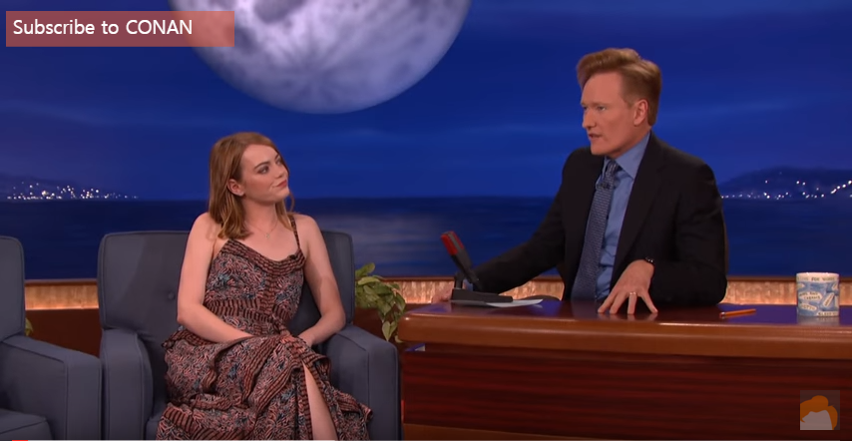

Sample Interview Questions Handout

1. What is the best and worst thing to be an entertainer or a celebrity?

2. Name one thing that you can’t live without.

3. What is the funniest thing that you’ve read about you from the internet?

4. What hair color do you enjoy having the most?

5. Who is the funniest person you know?

6. What have you learned from being an actress/actor/singer/(a)celebrity?

7. What movie/music made you to be actress/actor/singer?

8. Who do you want to shoot a love scene with?

9. What is your dream role?

10. What is your favorite to eat?

11. What was your first job?

12. What is your favorite thing to wear?

13. What is your favorite book of all time?

14. What is something that you always travel with?

15. What is your favorite television show of all time?

16. How do you describe yourself in three words?

17. What is the biggest surprise you’ve ever had?

18. Who is your favorite super hero?

19. What is something that most people don’t know about you?

20. Do you have any nicknames?

21. If your life was a song, what would the title be?

22. What is the best gift you’ve received?

23. What is the best gift you’ve ever given someone?

24. What is the name of the music or movie that you worked recently? How was it?

25. If you could change anything in your life, what would you change?

