Listening Speaking Reading Grammar Writing
Topic: Food

Instructor:  Sunny | Students Competency Level  Pre-intermediate or above | Number of Students:  12 | Lesson Length:  50 min
Materials: (List the Names of all materials used in the lesson. Materials must be shown at the end of this document)

- Computer
- Projector
- Overhead
- Pictures:
- Turkey
- Gopchang
- Burrito
- Cake
- Sushi
- Crepe
- Dumpling
- Donut
- Haggis
- Udon
- Mansaf
- Pizza
- Kebab
- Video: “American Kids Try Christmas Foods from Around the World”
- Worksheet: “What Is the Name of the Food?”

Aims: (What students will be able to achieve by participating in the activities of the lesson. (Ss gain or get by doing…)

- To increase listening to gain understanding by group discussion and problem-solving task.
- To gain ability to describe different foods to others.

Language Skills: (Lists what activities language skills students will be using by participating in the activities of the lesson.)
- Reading: (Where did reading occur in the lesson?)
Worksheet; Power-point slides

- Listening: (Where did listening occur in the lesson?)
Group discussion; teacher’s instruction

- Speaking: (Where did speaking occur in the lesson?)
Group discussion; pronunciation practice

- Writing: (Where did writing occur in the lesson?)
Worksheet
Language Systems: (Lists what language systems students will be using by participating in the activities of the lesson.)
- Phonology: (sound)
Practicing pronunciations of the names of the foods

- Function: (situation)
Writing correct names of the foods to the explanation heard

- Discourse: (communication)
Group Discussion

Assumptions: (What students must already be able to do and what concepts must already be mastered before the lesson in order to achieve the aims of the lesson.)

-Students know most of the foods introduced, but may not efficiently give description about the foods in English.
-Students know that the teacher will only speak English and they have to respond in English to the teacher and to their peers.

Anticipated Errors and Solutions: (What things might go wrong in the lesson and what the solution will be. An SOS activity should also be included)

-If time is running out, shorten the discussion time in the post-activity.
-If there is more time than expected, give students more time for the discussion and pick some students to share their thoughts to the whole class. (post-activity discussion)
-If students have difficulty spelling the foods in the worksheet, set them at ease that the spelling is not for grading.

References:
Youtube clip: https://youtu.be/-CZwFNh4utM : “American Kids Try Christmas Foods from Around the World”

Lead-In or Pre-Task Part (Warm-Up Part to activate and create interest in the lesson.)
Materials: (List the Names of all materials used in the Lead-In or Pre-Task Part of the lesson. Materials must be shown at the end of this document)

Computer
Projector
Overhead
Picture: Turkey
Time: | Classroom Set Up: | Student Activity and Goals: | Teacher Procedure & Instructions:
8 min | Whole | Get students’ attention; help them to be interested in the topic | Introduce the instructor first and do some story telling with the picture Turkey to elicit students’ stories about their special memories in foods. Divide the class into groups of three or four and to let them discuss their stories.

Pre-Activity or Task Familiarization Part (Presentation Part Presenting the language structure to be covered in the lesson. Prepares students for the communication activity.)
Materials: (List the Names of all materials used in the Pre-Activity or Task Familiarization Part of the lesson. Materials must be shown at the end of this document)

- Computer
- Projector
- Overhead
- Slide
Time: | Classroom Set Up: | Student Activity and Goals: | Teacher Procedure & Instructions:
8 min | Whole | Elicit students’ memories about foods | Food appreciation discussion  Ex. Do you also have particular food that makes you smile for a good memory? I will show you the questions again (show the first slide) so please share your stories within your group for few minutes.  (While students are sharing their stories, teacher prepares the Youtube clip in advance and the worksheets)

Main Activity or Task Realization Part (Practice to Production Part Teacher lead practice of the language presented and move to communication based more student centered activity)
Materials: (List the Names of all materials used in the Main Activity or Task Realization Part of the lesson. Materials must be shown at the end of this document)

- Computer
- Projector
- Overhead
- Pictures:
- Gopchang
- Burrito
- Cake
- Sushi
- Crepe
- Dumpling
- Donut
- Haggis
- Udon
- Mansaf
- Pizza
- Kebab
Time: | Classroom Set Up: | Student Activity and Goals: | Teacher Procedure & Instructions:
10 min  12 min | Whole  Whole | To be familiar with the different names of the food and its material  To practice listening and understanding the description of the foods | Show the pictures of the foods on the power-point slides. First clearly pronounce the name the food and let students repeat after the teacher. Ask few questions and get responses from the students.  (For example,  What do you see? Yes, it’s a cake. When do you eat a cake?  Burrito is a famous food from which country?)  Do this activity until you reach the last picture.  Hand out the worksheets to the students and let them listen to the description from the teacher about a food and guess which food it is. They work alone first and check the answers together. Relieve them that the spelling is not for grading, but the participation and listening to the explanation are important.

Post Activity or Post Task Part (Wrap-Up Part Close the Lesson on a high note to and consolidate language learned in a communication based activity new situation.)
Materials: (List the Names of all materials used in the Post Activity or Post Task Part of the lesson. Materials must be shown at the end of this document)
“American Kids Try Christmas Foods from Around the World” video

Time: | Classroom Set Up: | Student Activity and Goals: | Teacher Procedure Instructions:
5 min  7 min | Whole  Whole | To listen to and watch native speaker’s reaction to the different Christmas foods around the world  To share their opinions about the video clip | Play Youtube clip for the class  Finish up the class by having the students share their thoughts about the video clip and the foods

Materials:

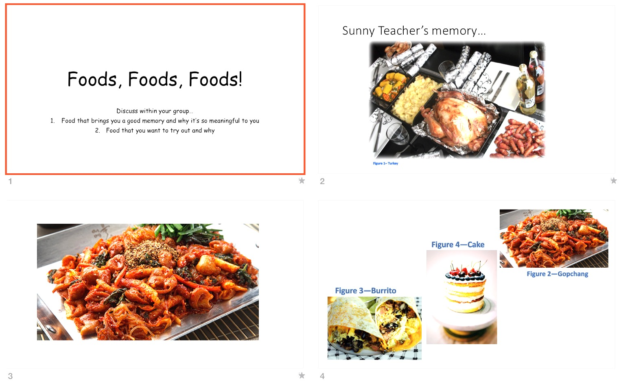
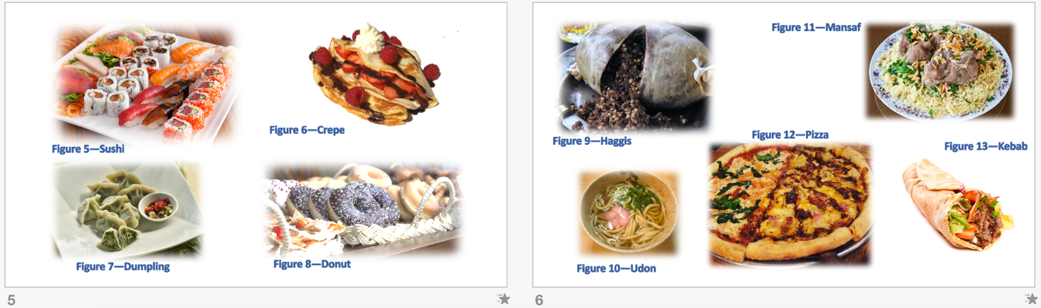

What is the Name of the Food?

Write down the name of the food you guess is the answer for the description.
1

2

3

Draw the food you think is the answer for the description.
4

5

